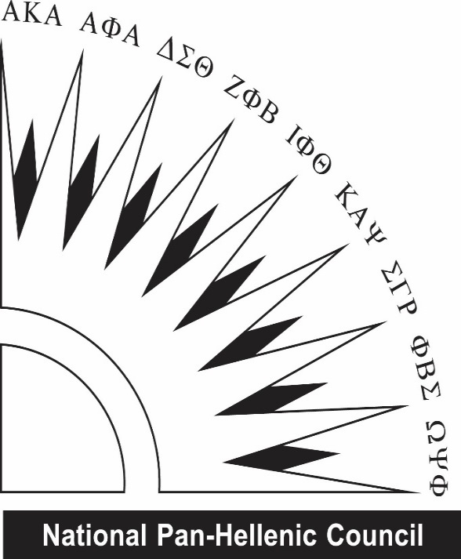
Western Kentucky University National Pan-Hellenic Council proudly sponsors & presents two (2) $700 scholarships

OUTSTANDING MINORITY STUDENT SCHOLARSHIPS

REQUIREMENTS:
- Student from an underrepresented community
- 3.0 cumulative GPA
- Fall 2021, full-time enrollment
- Open to all undergraduate students, regardless of NPHC affiliation (Previous scholarship recipients are ineligible)
- 1 letter of recommendation (from a university staff/faculty member)
- Resume included with application (include community service)
- Essays (of no more than 250 words each) answering the following prompts:
  - Why do you feel you are deserving of a NPHC Outstanding Minority Student scholarship?
  - Explain the importance of education for those in underrepresented communities.

DATES TO REMEMBER:
- October 9th - Deadline for the application. Incomplete or late applications will be accepted.
- TBA - Recipients will be emailed and recognized on WKU NPHC Instagram account.

QUESTIONS?
Contact Zahriaa Barnes-Evans, NPHC Scholarship Chair, zahriaa.barnesevans251@topper.wku.edu
Or Justin Smith, NPHC President, justin.smith749@topper.wku.edu
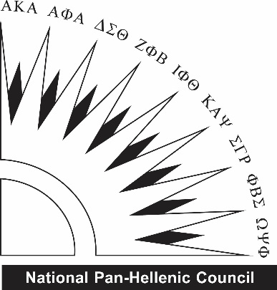
Western Kentucky University National Pan-Hellenic Council
OUTSTANDING MINORITY STUDENT SCHOLARSHIPS
All applications are due October 9th. either in a sealed envelope to Student Activities (DSU 2059) and /or emailed to andrew.rash@wku.edu. Recipients will be emailed by Andrew Rash. All questions should be directed to Zahriaa Barnes-Evans, NPHC Scholarship Chair or Justin Smith, NPHC President.

Name: | Email:
Cell Phone: | Current Class (Fr/So/Jr/Se):
Overall GPA: | WKU ID#:

Why do you feel you are deserving of a NPHC Outstanding Minority Student scholarship?

Explain the importance of education for those in underrepresented communities.

DON’T FORGET TO ALSO SUBMIT:
- Resume

