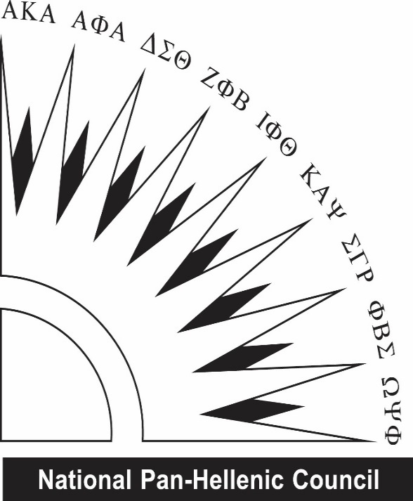
Western Kentucky University National Pan-Hellenic Council proudly sponsors & presents two (2) $700 scholarships

OUTSTANDING MINORITY STUDENT SCHOLARSHIPS

REQUIREMENTS:
- Student from an underrepresented community
- 3.0 cumulative GPA
- Fall 2020, full-time enrollment
- Open to all undergraduate students, regardless of NPHC affiliation (Previous scholarship recipients are ineligible)
- Contact Information for 1 recommender
- Resume included with application (include community service)
- Essays (of no more than 250 words each) answering the following prompts:
  - Why do you feel you are deserving of a NPHC Outstanding Minority Student scholarship?
  - Explain the importance of education for those in underrepresented communities.

DATES TO REMEMBER:
- May 8, 2020 - Deadline for the application. Incomplete or late applications will not be accepted.
- Week of May 11th-15th - Recipients will be announced via social media

QUESTIONS?
Contact Kimberly Jefferson, NPHC Scholarship Chair, kimberly.jefferson805@topper.wku.edu
Or Isiah Bigbee, NPHC President, isiah.bigbee847@topper.wku.edu
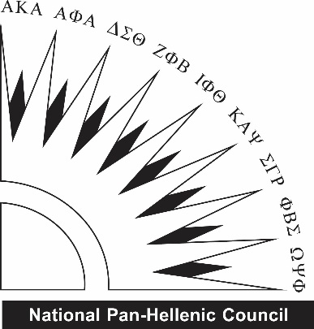
Western Kentucky University National Pan-Hellenic Council
OUTSTANDING MINORITY STUDENT SCHOLARSHIPS
All applications are due by 4:30 p.m. on May 8th and emailed to randall.bogard@wku.edu. Recipients will be emailed during finals week May 11th- 15th. All questions should be directed to Kimberly Jefferson, NPHC Scholarship Chair or Isiah Bigbee, President.

Name: | Email:
Cell Phone: | Current Class (Fr/So/Jr/Se):
Cumulative GPA: | 800#:

Why do you feel you are deserving of a NPHC Outstanding Minority Student scholarship?

Explain the importance of education for those in underrepresented communities.

DON’T FORGET TO ALSO SUBMIT:
- Resume

