Western Kentucky University National Pan-Hellenic Council proudly sponsors & presents (1) $1,500 Scholarship!

OUTSTANDING STUDENT SCHOLARSHIP

REQUIREMENTS:
- WKU Undergraduate Student
- 2.3 cumulative GPA
- Fall 2025, Spring 2026 full-time enrollment
- Open to all undergraduate students, regardless of NPHC affiliation
- 1 letter of recommendation (from a university staff/faculty member)
- Resume included with application (include community service)
- Essays (of no more than 250 words each) answering the following prompts:
  - Why do you feel you are deserving of the NPHC Outstanding Student scholarship?
  - Explain the importance of education for you in your life. What goals will your education help you achieve?
  - The NPHC highly values community service. Briefly describe how you have served your community.

DATES TO REMEMBER:
- November 21st - Deadline for the application. Incomplete or late applications will be NOT be accepted.
- TBA - Recipients will be emailed and recognized on WKU NPHC Instagram account.

QUESTIONS?
Contact Jaden Marshall, NPHC Scholarship Chair, jaden.marshall726@topper.wku.edu
Or Rayna Taylor, NPHC President, rayna.taylor656@topper.wku.edu

Western Kentucky University National Pan-Hellenic Council

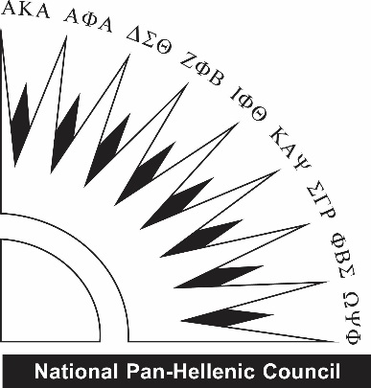
OUTSTANDING STUDENT SCHOLARSHIP

All applications are due November 21st . to nphc@wku.edu. All questions should be directed to Jaden Marshall, NPHC Scholarship Chair or Rayna Taylor, NPHC President.

Name: | Email:
Cell Phone: | Current Class (Fr/So/Jr/Se):
Overall GPA: | WKU ID#:

Why do you feel you are deserving of the NPHC Outstanding Student scholarship?

Explain the importance of education for you in your life. What goals will your education help you achieve?

Why do you feel you are deserving of the NPHC Outstanding Student scholarship?

DON’T FORGET TO ALSO SUBMIT:
- Resume

