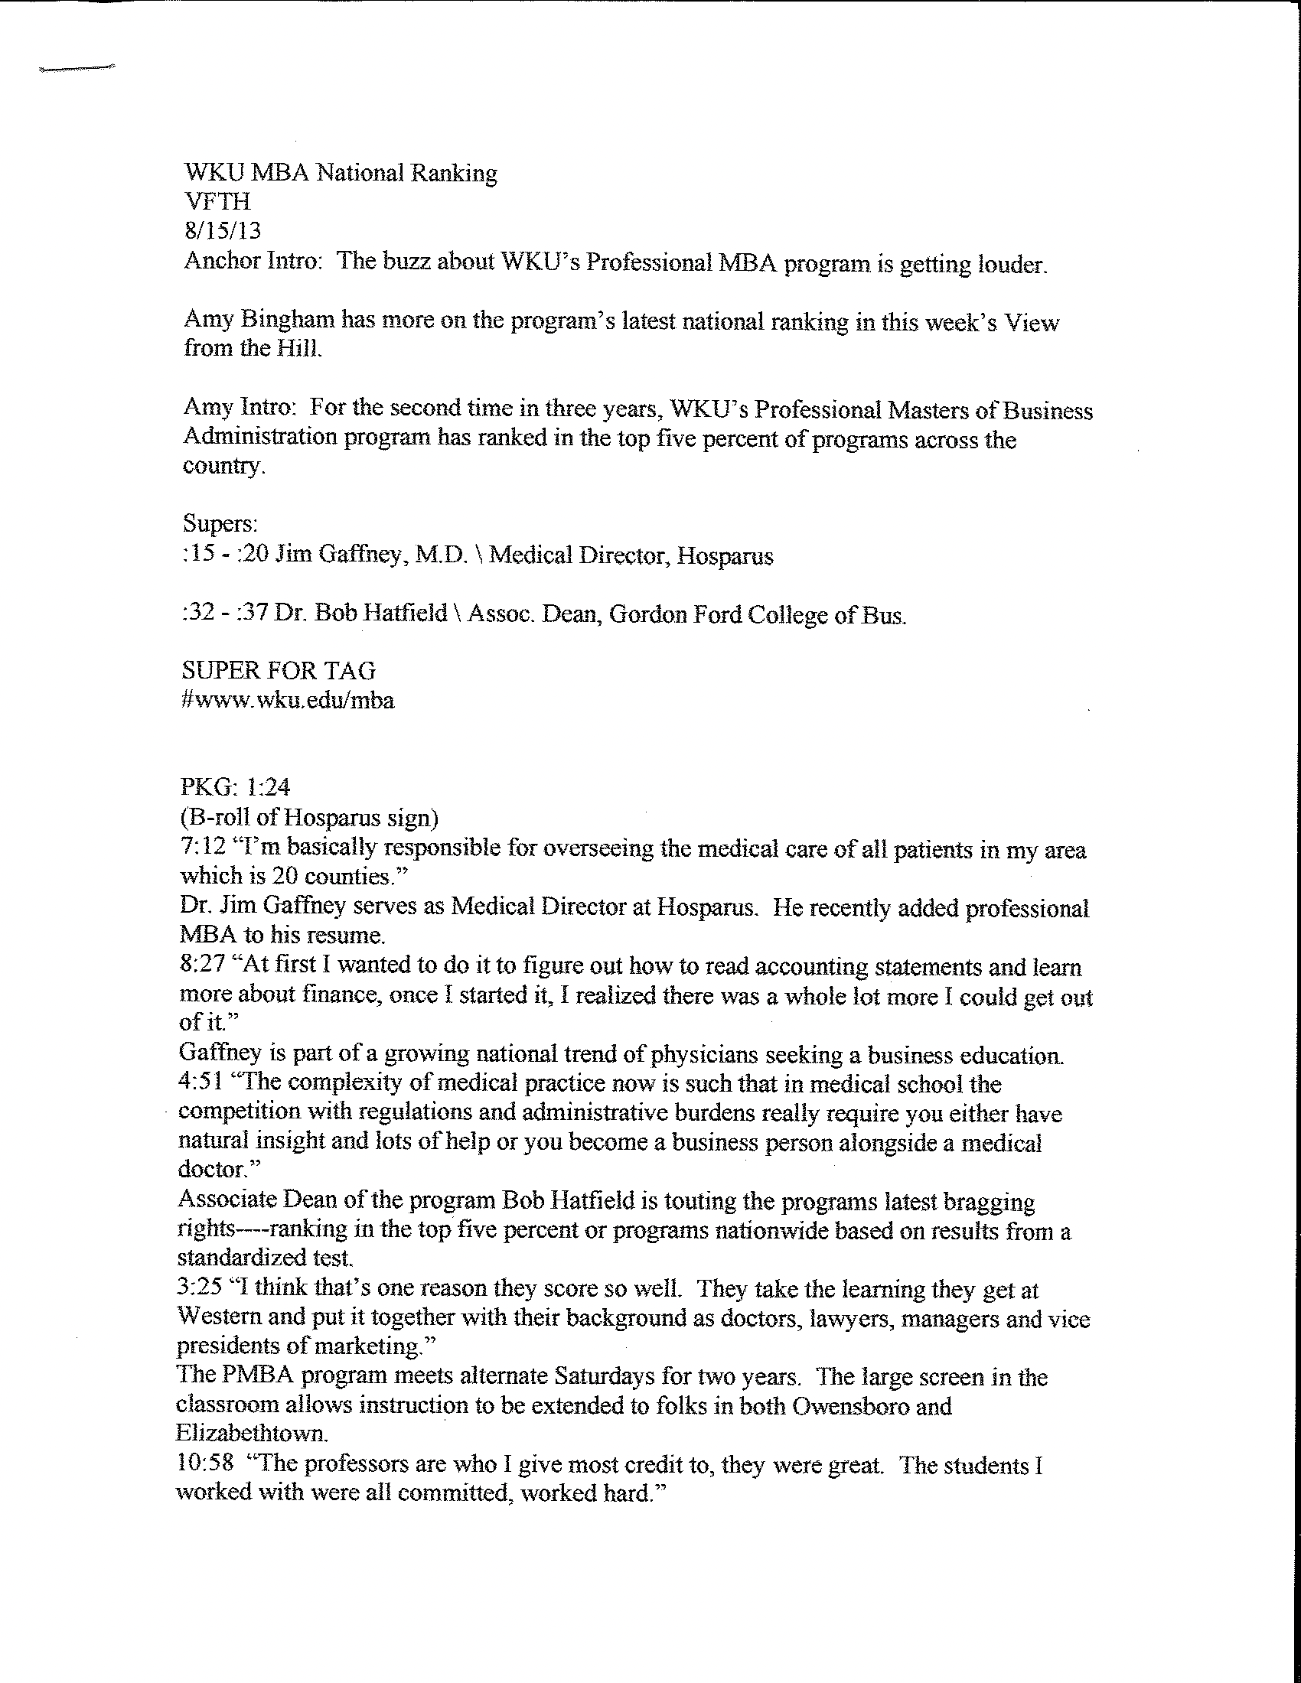
It shows, keeping WKU tops in the field.
We really stack up very well on this and again top five percent is incredible.
Chambers of Commerce in Bowling Green, Glasgow-Barren County and Hardin County offer a 500 dollar tuition waiver for the professional MBA. The same discount is available to WKU alumni as well. For details log onto wku.edu/MBA. With this week’s View from the Hill, I’m Amy Bingham.

