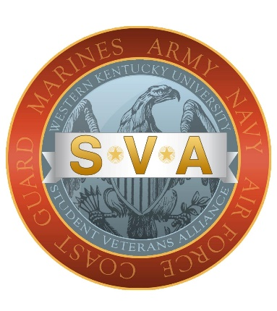

WKU Student Veterans Alliance Scholarship

The WKU Student Veterans Alliance is proud to offer three, $1,000 scholarships to eligible military affiliated students at WKU. These scholarships were made possible by the generous gift from the Jessie Ball duPont Fund. Their mission is to serve the communities that Jessie Ball duPont knew and loved. With their support the WKU Student Veteran Alliance created these scholarships to assist eligible military and veteran students in making higher education more affordable and reducing barriers to access.

Eligibility: Military affiliated students must meet the following criteria to apply for this SVA scholarship.
- Must be serving in the U.S. Military (Active Duty, Reserve, or National Guard), or be a veteran of the U.S. Military.
- Must be a current student and enrolled in at least half time for the Summer or Fall 2023 semesters at WKU.
How to apply:
- Complete the application and letter (see application below for details).
- Turn in Application and letter via email to student.veterans@wku.edu or in person at Military Student Services, Gary Ransdell Hall, 2067.

When to apply: Please submit your application by 11:59pm (Central Time) on 6/15/2023.

STUDENT VETERANS ALLIANCE
SCHOLARSHIP APPLICATION

**Application is due by 11:59pm (Central Time) June 15, 2023**

Please PRINT
Full Name ____________________________________ WKU ID: _______________
Eligibility: Military affiliated students must meet the following criteria to apply for an SVA scholarship.
1. Must be serving in the U.S. Military (Active Duty, Reserve, or National Guard), or be a veteran of the U.S. Military.
2. Must be a current student and enrolled in at least half time for the Summer or Fall 2023 semesters at WKU.
Answer these questions below:
Class: FR SO JR SR GRAD (Circle one)
Field of Study _________________________________ GPA ____________
Hours enrolled this semester _________ Expected Graduation Date ______________
Military Status/Connection ___________ Branch of Service ____________________

I confirm that the information provided in this application and the attached letter is true and correct to the best of my knowledge.

Signature ______________________________________ Date ______________

NEXT STEP:
Please type a letter that is four to six well written paragraphs in length. Include in the letter, an introduction about yourself, discuss your commitment and passion for your chosen field, and how you that ties into your career objectives. Also, please discuss briefly how this scholarship will help you reach your goals. If you have any volunteer or community outreach experience, please let us know about that as well.

