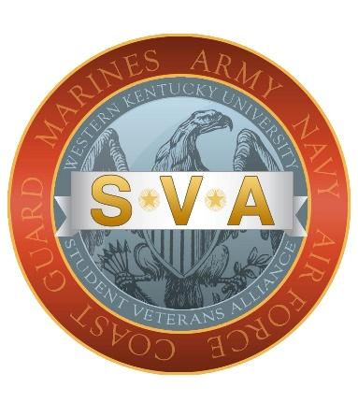

WKU Student Veterans Alliance Scholarship

The WKU Student Veterans Alliance is proud to assist in offering three, $300 scholarships to eligible military affiliated students at WKU. These scholarships were made possible by the generous gift of WKU Alumni and retired Marine, Derrick Huff. Derrick is a local business owner and an alumnus of the SVA, as well as the veteran honor society, WKU Salute. Having been a previous recipient of a scholarship through the SVA, he wanted to give back to the program and support the military connected students at WKU.

Eligibility: Military affiliated students must meet the following criteria to apply for this SVA scholarship.
- Must be serving in the U.S. Military (Active Duty, Reserve, or National Guard), be a veteran of the U.S. Military, or a contracted cadet in the WKU ROTC program.
- Must be a current student and enrolled in courses for the Fall 2022 semester at WKU.
How to apply:
- Complete the application and letter.
- Turn in Application and letter via email to student.veterans@wku.edu or in person at Gary Ransdell 2067.

When to apply: Please submit your application by 11:59pm (Central Time) on 10/30/2022.

STUDENT VETERANS ALLIANCE
SCHOLARSHIP APPLICATION

**Application is due by 11:59pm (Central Time) October 30, 2022**

Please PRINT
Full Name ____________________________________ WKU ID: _______________
Eligibility: Military affiliated students must meet the following criteria to apply for an SVA scholarship.
1. Must be serving in the U.S. Military (Active Duty, Reserve, or National Guard), be a veteran of the U.S. Military, or a contracted cadet in the WKU ROTC program.
2. Must be a current student and enrolled in courses for the Fall 2022 semester at WKU.
Answer these questions below:
Class: FR SO JR SR GRAD (Circle one)
Field of Study _________________________________ GPA ____________
Hours enrolled this semester _________ Expected Graduation Date ______________
Military Status/Connection ___________ Branch of Service ____________________

I confirm that the information provided in this application and the attached letter is true and correct to the best of my knowledge.

Signature ______________________________________ Date ______________

NEXT STEP:
Please type a letter that is four to six well written paragraphs in length. Include in the letter, an introduction about yourself, discuss your commitment and passion for your chosen field, and how you that ties into your career objectives. Also, please discuss briefly how this scholarship will help you reach your goals. If you have any volunteer or community outreach experience, please let us know about that as well.

