Electronic Budget Transfers on the Web Through TopNet and Banner Forms

Note: Screen Shots for this manual were taken from the Temp database. Production Database will be at the top of your forms once you go live with Electronic Budget Transfers.
This Manual consists of two options for creating Budget Transfers – on the Web through Topnet or Banner Finance Forms. We are now ready to continue with instructions for the Web version; instructions for using Banner Finance Form FGAJVCM are in the last pages of this Manual.
Select Financial Services from the list or the Finance Self-Service Tab – either function will route to the Finance Menu.

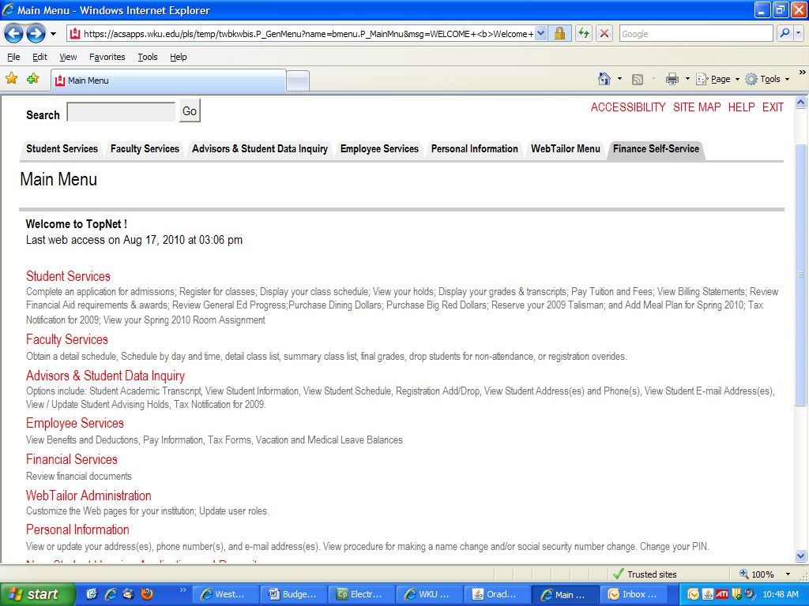
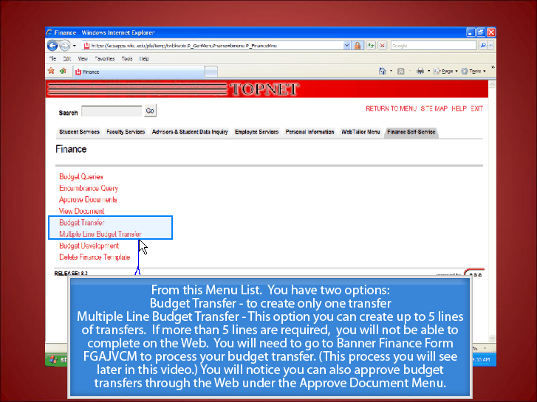
Budget Transfer only allows you to enter a transfer with one FROM and one TO Record.
Multiple Line Budget Transfer allows you to enter up to 5 lines of Debits and Credits.
Banner Finance Form FGAJVCM allows you to enter more than 5 lines.

CHOOSE FROM ANY OF THE ABOVE OPTIONS THAT WOULD MEET YOUR CRITERIA TO COMPLETE YOUR BUDGET TRANSFER.

Budget Transfer Form
Use Template field – is only if you have saved data from a previous transfer and you would like to bring that same data forward to create a new transfer with those criteria. Refer to the SAVE AS TEMPLATE instructions in this manual on more information about the Template Fields.
Transaction Date defaults – This should always be the present month. There should never be a case where you back or forward date a budget transfer.
Journal Type – With the Drop Down Arrow select BT04 for Temporary or BT03 for Permanent.
Temporary transfer (BT04) – A temporary budget transfer should be prepared when a department wishes to transfer budget funds to another index and/or account code for the current fiscal year only. In the next fiscal year, the transferred funds will be a part of the transferring department’s budget.
Permanent transfer (BT03) – A permanent budget transfer should be prepared when a department wishes to transfer budget funds to another index and/or account code for the current fiscal year and future fiscal years. This type of transfer permanently transfers the funds; in the next fiscal year, the funds will not be in the transferring department’s budget.
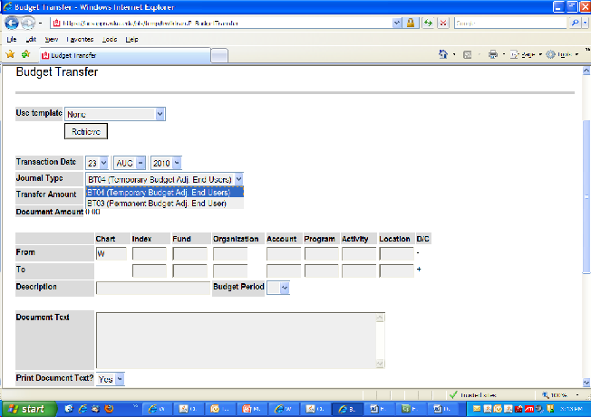

Tab to Transfer Amount field – Enter the dollar amount you are transferring. This form is the only one you enter the transfer amount instead of the document amount in the budget header. On the Multiple Line Budget Transfer on the Web Form and Banner Form FGAJVCM, you enter document amount in the budget header and under detail you have to enter transfer amount. Transfer amount totals must equal the document total. Minus = Plus
Tab to the From record and To record – Chart of Accounts will default. Tab to Index and enter Index Number and continue to tab to Account and enter Account Code. Tab to the To record and repeat entering the Index and Account fields.
Tab to Description – Enter a specific, but brief, description, as this is only a 35 character field. Give detail of the transfer. Abbreviate as needed.
Tab to Budget Period – With the drop down arrow, click on the correct period. Transaction date drives the budget period – our Budget Period runs from July to June. 01 – July, 02 – Aug, 03 – Sept, 04 – Oct, 05 – Nov, 06 – Dec, 07 – Jan, 08 – Feb, 09 – Mar, 10 – Apr, 11 – May, 12 – Jun. (If your transaction date has defaulted 13-Feb-2010, your budget period should be 08). Budget Period should always correspond with the Transaction Date. Regardless of the month the transfer is approved, the transfer will post on the date the transfer was initiated (after all required approvals are obtained).
Save as Template – This option will allow you to name a budget transfer journal that you just completed, but it will not save the Journal Voucher Number to bring forward again to edit. It is only saving the detail of that journal to allow you to have the same data in another budget transfer journal for the future. Once you retrieve that saved template, and click on the complete button, it will assign a new journal number to your budget transfer. If you are maintaining several indexes, this option will not save you time and saving templates can take up a lot of space in the database. We do not recommend using this feature.
Click on Complete for completion
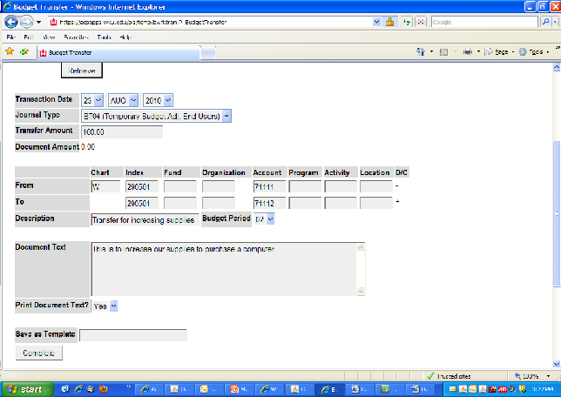
After clicking the Complete button, the Journal Voucher Number and the approval message will display at the top of the form. Please note this journal number for printing, approving and tracking. The document total will default into the form along with Fund, Organization, and Program Code. Please verify the data.

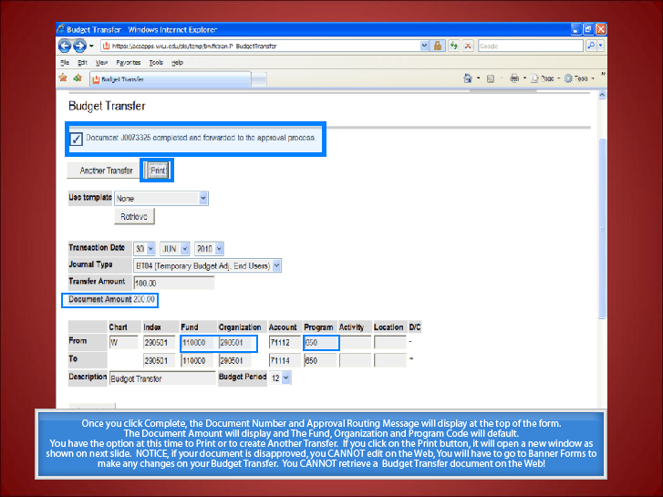

PRINT DOCUMENT
Click on the Print Button.
When printing, a new window will display with the Budget Transfer in a print format. Click on File in the Menu Bar and click on Print. Exit with the Red X and return to the Budget Transfer Form.
You can click on Another Transfer button to create another transfer or exit the form.

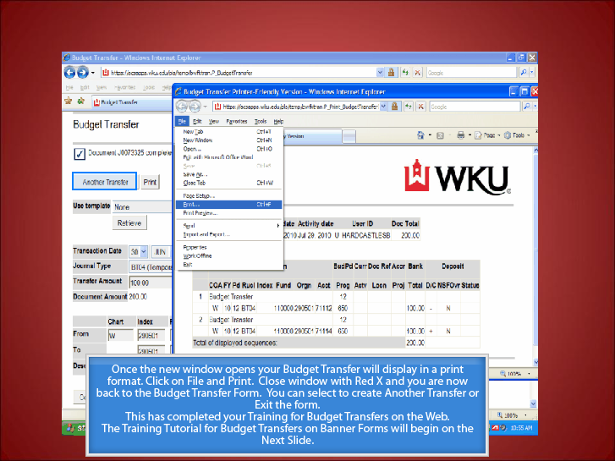

APPROVE DOCUMENTS
Approve Documents – From the main menu, click on Approve Documents. Your user ID should default and the radio button for Documents for which you are the next approver should be marked. These are the documents that you are next in line at the hierarchy level to approve. Click on the radio button for All documents which you may approve to view all transfers waiting for your approval. It is recommended that you approve only the documents that you are next in line to approve.
Document Number - Allows you to enter a specific number to approve. That document number will be the only one in the list to approve.
Click on Submit Query.
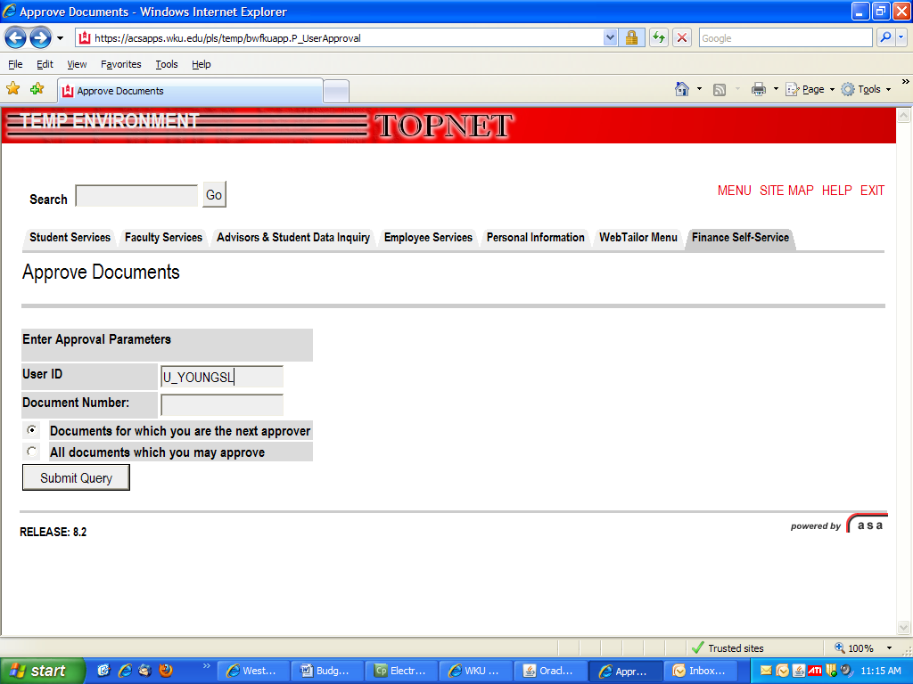

APPROVE DOCUMENT LIST

Select the Document Number link to display the details of a document.
Select the History link to display the approval history of the document.
Select the Approve or Disapprove link, if enabled, to approve or disapprove a document. If enabled, it will be highlighted in blue. You can only drill down into any of the fields highlighted in blue.
Repeat these functions for all documents on your list.
Clicking on the Approve or Disapprove links will display a new form that will allow you to enter into the comment field why you disapprove or approve it. The same type of form will display for both options as illustrated in the second screen on this page.

Another Query – Clicking on this button will take you back to the previous form.

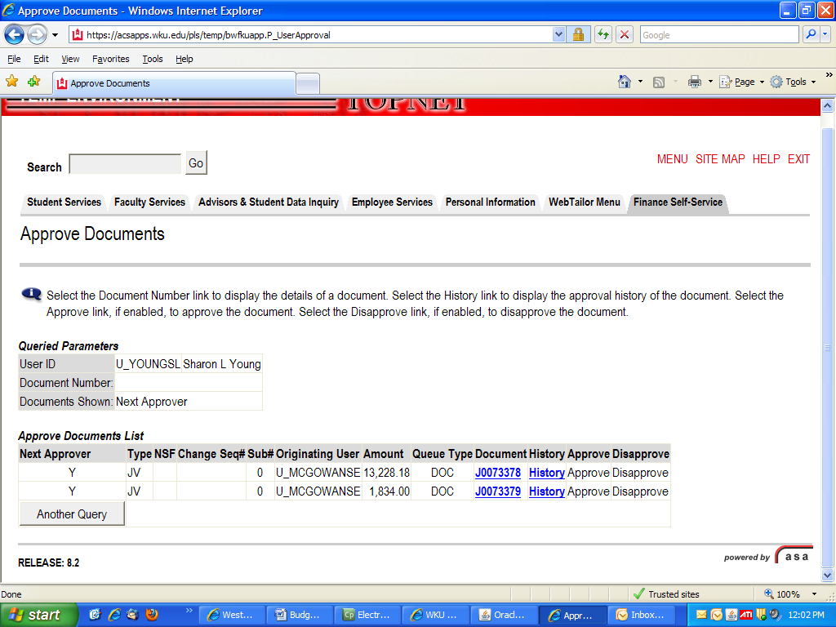
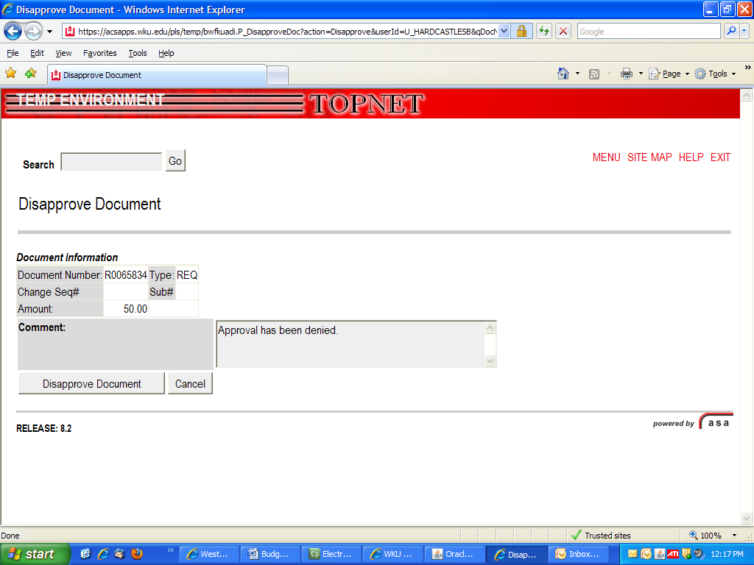
View Document
Choose Type by clicking on the down arrow and choose Journal Voucher.
Tab to Document Number and enter your Journal Number.
Click on the radio buttons to choose the following criteria:
Displaying Accounting Information – Yes
Display Document/Line Item Text – All
Display Commodity Text – All
Click on View Document or Approval History.

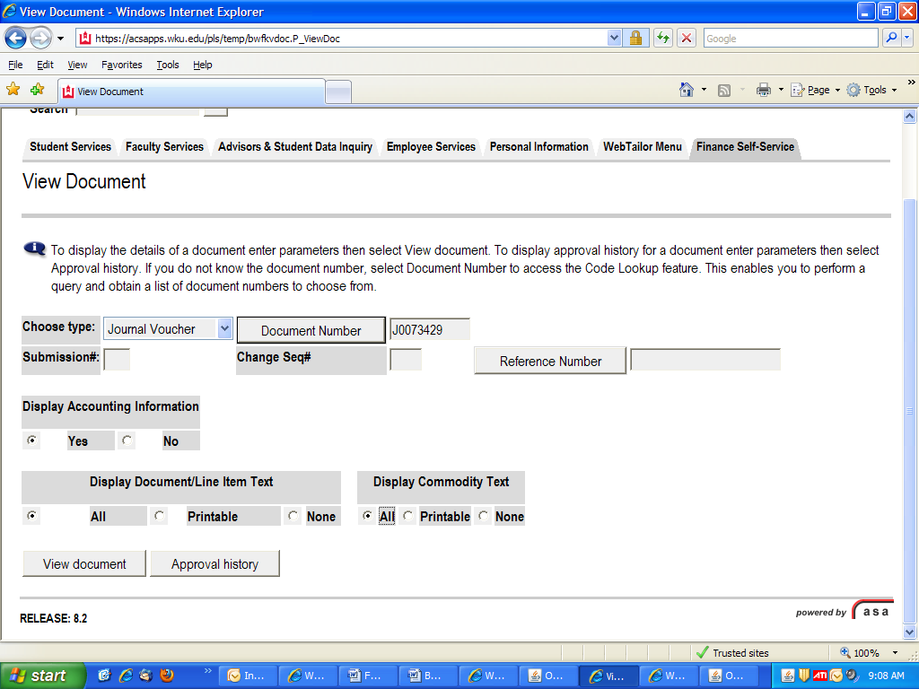
View Document and all the data of the Journal will display with document text included.
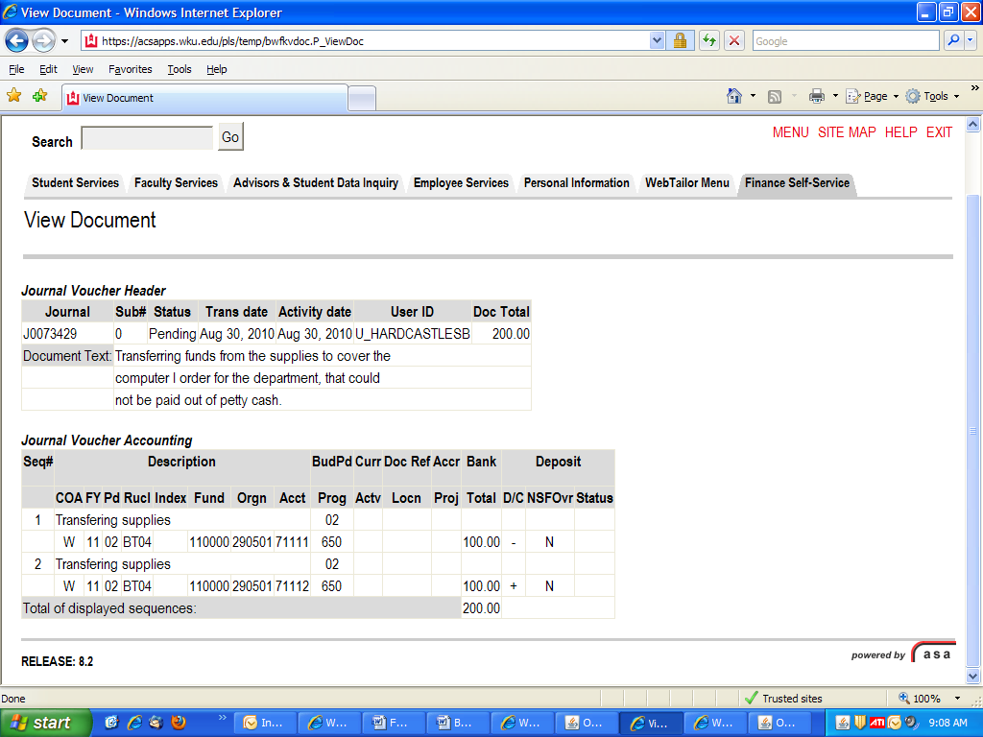
DELETING A BUDGET TRANSFER/MAKING CHANGES TO A BUDGET TRANSFER
You can only delete a budget transfer in Banner Forms.
If someone disapproves a budget transfer, it will be returned to you as an incomplete document. You will receive a message in Banner that your document has been disapproved. After the message has been read, click on the complete radio button under the message and save. You will not receive this message again. Go into your document and make changes or remove it from the system, whatever the message stated for you to do.
To make changes to a budget transfer, follow the steps below:
Go to FGAJVCM and enter the document code with the J Number and next block or control page down. You will need to re-enter the Type, Description and Budget Period. Select Next Block or control page down and the Journal Voucher Detail will be displayed. Make any necessary changes. When making changes to the index used on a transfer, it is important to type the new index in the Index field (rather than the Orgn field). Changing the index in the Index field will allow the Fund, Orgn, and Program codes to populate correctly. Once all changes have been made, select next block or control page down and hit the Complete button.
To delete, follow the steps below:
Go to FGAJVCM and enter the document code with the J Number and next block or control page down. Once all the data displays and you are sure this is the one to delete, click on Record remove twice to delete header and detail information.

Follow the steps below to create a budget transfer using Banner Forms:
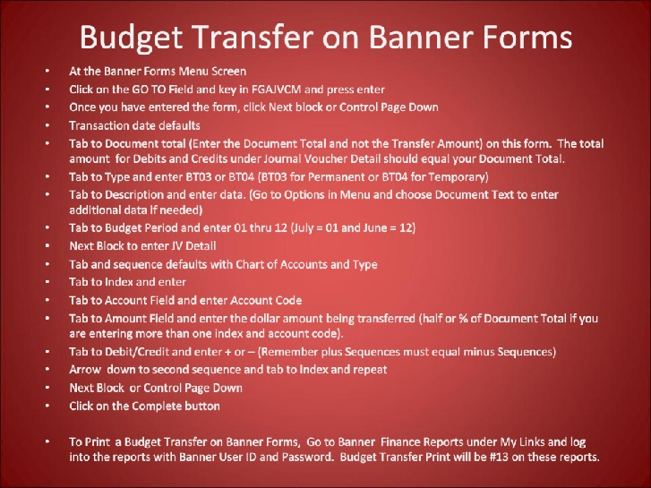
These changes have been added since Video and Manual Creation
Budget Transfer Print will be #12 for Completed and Not Approved
Budget Transfer Print will be #13 for Completed and Approved

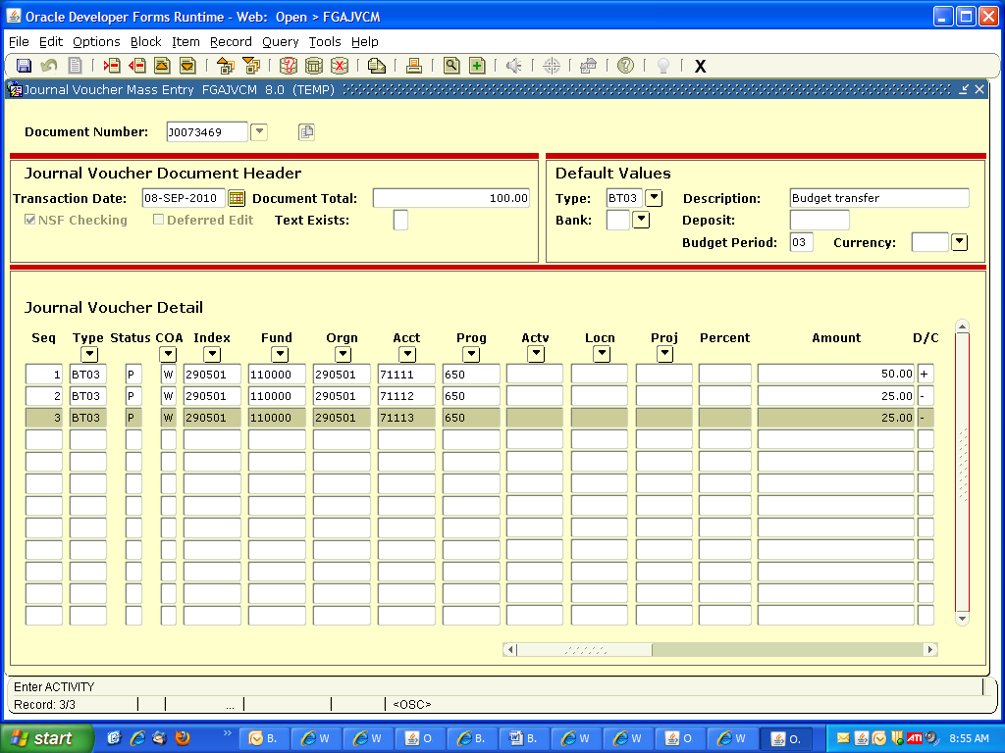

After Completion, the budget transfer is routed through an approval process. You can go to FOAAINP to track the approvals. After approved, you should continue tracking the budget transfer on FGITRND or FGIDOCR. All Budget Transfers are approved on the same form FOAUAPP as Requisitions in Banner Forms. The Budget Transfers will begin with a “J” Number, but will display in the list with Requisitions on this form.

FGIDOCR
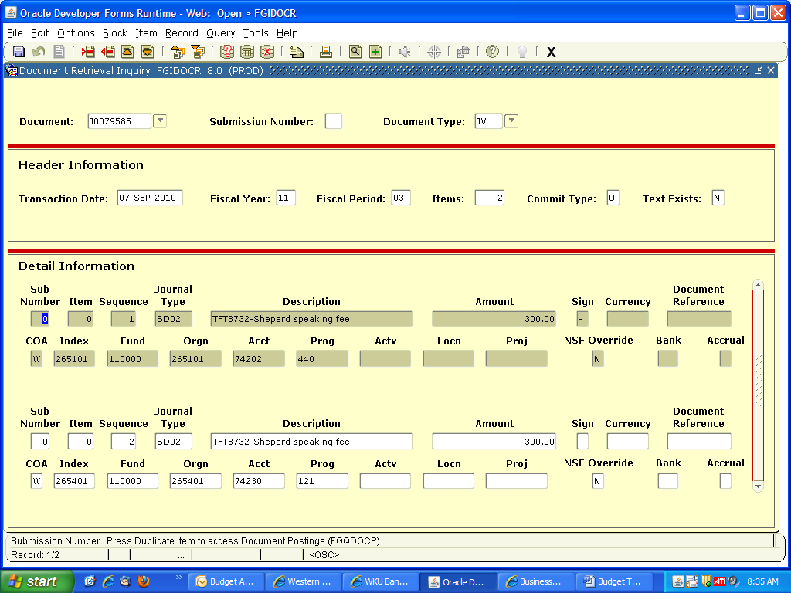
This form allows you to track your budget transfer. On this form click on Options in the Menu Bar and click on Access Document Postings (FGQDOCP) to view posting of your budget transfer.

