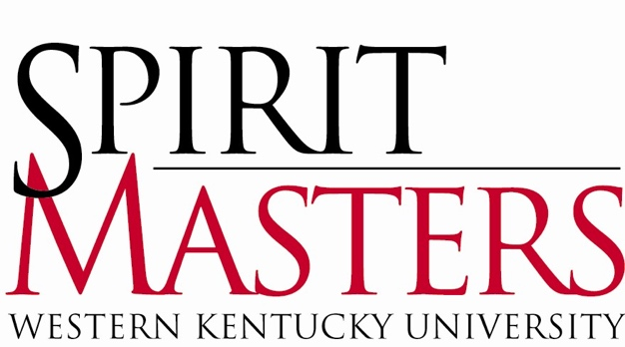

2020-2021 Spirit Master Application

Spirit Masters are the official student ambassadors of Western Kentucky University. The title “Spirit Masters” is derived from the university motto “The Spirit Makes the Master.” Our purpose is to provide an extra measure of hospitality at WKU, making visitors feel they have had a truly exceptional experience. Spirit Masters work closely with those interested in promoting WKU, including the Office of the President, the Office of Admissions, the Office of Alumni Affairs, the Office of WKU Athletics, and various community groups.

If you are interested in applying to become a Spirit Master, please take note of the following dates and deadlines:

November 6, 2019 Spirit Master ‘Meet & Greet’
Wednesday 7:00 p.m. - 8:30 p.m.
Downing Student Union, 3005

March 4, 2020 Spirit Master ‘Meet & Greet’
Wednesday 7:00 p.m. - 8:30 p.m.
Downing Student Union, 3024

March 25, 2020 Spirit Master Application Deadline
Wednesday Email packet to spirit.masters@wku.edu

OR

Wetherby Administration, Suite 109
Office Hours: 8:00 a.m. – 4:30 p.m.

April 3, 2020 Post schedule for 1st round interviews
Friday Wetherby Administration, Front Entrance

April 6-8, 2020 First-Round Interviews
Monday – Wednesday 5:30 p.m. – 9:00 p.m.
Cherry Hall, 2nd Floor
April 10, 2020 Post schedule for 2nd round interviews
Friday Wetherby Administration, Front Entrance

April 13 – 15, 2020 Second-Round Interviews
Monday – Wednesday Scheduled times, TBD
Wetherby Administration
1st Floor Conference Room, Suite #150

Wednesday, April 15, 2020 Spirit Masters, Class of 2020-2021
‘Meet Me on the Hill’
Midnight, Cherry Hall

April 18 – 19, 2020 Spirit Master Training Retreat
Saturday – Sunday Camp Loucon, Overnight
Time, TBD

ABOUT THE SELECTION PROCESS

The selection of new Spirit Masters occurs in three parts: (1) Timely submission of a completed application with references, class schedule, unofficial academic transcript, and photo; (2) first-round interview for all applicants with a panel consisting of three to four members of the University faculty, staff, and administration; and (3) a second-round interview for selected applicants with the Spirit Masters Advisory Council and additional appointed individuals. New Spirit Masters are selected based on their performance in all levels of the selection process.

Applicants participating in WKU Study Abroad or Study Away will follow the same interview process via FaceTime / Skype. Scheduling will be determined prior to first-round interviews.

Please Note: Students participating in the Semester at Sea Program (January - April)
must complete the following process before their departure:

- Email your Spirit Master Application to spirit.masters@wku.edu by Tuesday, December 3, 2019.

- Conduct a videotaped interview on Thursday, December 5, 2019, with select members of the Spirit Masters Advisory Council and additional appointed individuals. This interview will be shared with the entire Spirit Masters Advisory Council during the second-round interviews in April.

MEMBERSHIP CRITERIA

- Cumulative GPA of 2.5 or higher
- At least second-semester freshman classification
- Full-Time enrollment as an undergraduate student for the subsequent academic year.
- If selected as a new Spirit Master in the spring of 2019, you must be enrolled ‘on campus’ for the following fall semester. After your first full semester as a new Spirit Master, you may participate in the WKU Study Abroad or Study Away.
- Ability to devote at least sixty (60) hours in the fall semester and forty (40) hours in the spring semester to assignment obligations.
- Ability to attend the mandatory Spirit Masters Training Retreat; April 18 – 19, 2020.
- Desire to learn all facets of WKU and remain updated on current events and progressive changes concerning the University community.
- Willingness to learn the Office of Admissions WKU Campus Tour, both shuttle and walking, and to present it in a professional manner to prospective students, their parents, and campus visitors.
- Excellent oral communication skills and poise while interacting with diverse groups.

SPIRIT MASTER APPLICATION PACKET

Emailed application submission is preferred; however, you have the option of submitting a printed Spirit Master Application Packet (within a seal manila envelope) to the Wetherby Administration building by 4:30 p.m. on March 25, 2020. If you choose email, please submit the entire application packet as one “.pdf” document. The Spirit Master Application must contain the following:
- Personal Information
- Short Answer Questions (Typed Document)
- Recent 4”x6” color photo
- Current class schedule from TopNet
- Unofficial academic transcript from TopNet
- Three Reference Letters:

Letters must be submitted online using the Reference Form. Additional information is available on the form.

PERSONAL INFORMATION

Full Name: ________________________________________________________
Preferred Name: ___________________________________________________
WKU ID: __________________________________________________________
Email: ____________________________________________________________
Cell Phone: ________________________________________________________

Local Address (school): Permanent Address (parent/guardian):
_____________________________ _________________________________
_____________________________ _________________________________
_____________________________ _________________________________

School Classification: ___________________
Completed Credit Hours: ________________
Cumulative GPA: _______________________
Major(s): _____________________________ Minors(s): __________________
Have you applied to Spirit Masters before? __________
Place of Employment: _________________________________________________________
Hours per week: _____________________________________________________________
Are there dates or times that you would be unavailable for a first-round interview? _______
If so, when? _________________________________________________________________
If currently participating in Study Abroad or Study Away during the interview process, please specify the exact location (i.e. Harlaxton, Australia, New York, etc.) _____________________

SHORT ANSWER QUESTIONS
Please answer the following questions. Limit your responses to a maximum 500 words per question. Be sure to number each answer with the correct question number.

- List ALL campus activities, organizations, and outside interests (hobbies, volunteer work, etc.) with which you are currently involved. Briefly mention any office(s) currently held and/or past positions held. If you are a freshman, include any positions held in high school.
- What would you consider to be the most important attribute for one to possess in serving as an official representative of WKU? Why?
- Suppose that a high school senior is applying to various colleges and is interested in WKU. Aside from size and diversity, what would you consider one advantage of WKU? Additionally, what is one disadvantage?
- What do you expect to give and receive from involvement in Spirit Masters?
- What does “The Spirit Makes the Master” mean to you?

LETTERS OF REFERENCE

WKU Faculty Reference (WKU Classroom Setting)
Name: Department: Office Phone:

WKU Staff or Community Reference
Name: Department/Organization: Office Phone:

WKU Student or Peer Reference
Name:
Classification:
Phone:

If you have any questions regarding the selection process, please contact:
Jeremy Latham, Spirit Master Chair Erik Roepke, Spirit Master Vice-Chair
Jeremy.latham871@topper.wku.edu spirit.masters@wku.edu

“The Spirit Makes the Master”
Please use this page to answer the short answer questions and attach your photo, class schedule, and unofficial class transcript.

