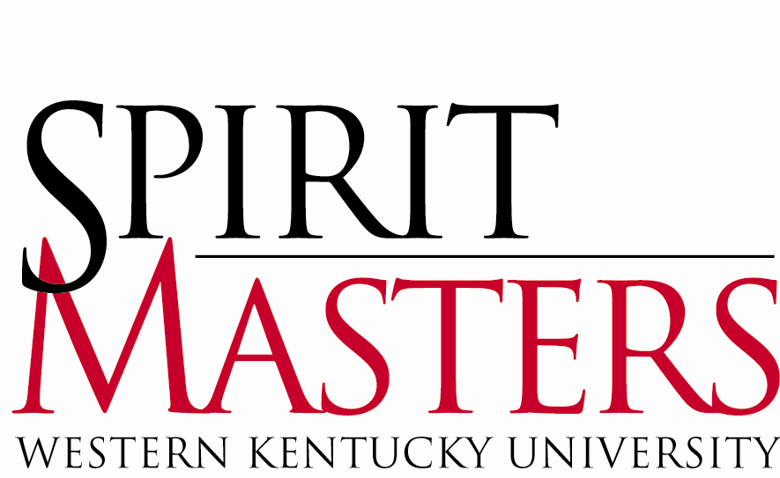
2014- 2015 Spirit Master Application

Spirit Masters are the official student ambassadors of Western Kentucky University. The title “Spirit Masters” is derived from the university motto “The Spirit Makes the Master.” Our purpose is to provide an extra measure of hospitality at WKU, making visitors feel that they have had a truly exceptional experience. Spirit Masters work closely with those interested in promoting WKU including the Office of the President, the Office of Admissions, the Office of Alumni Affairs, the Office of WKU Athletics, and with various community groups.

If you are interested in applying to become a Spirit Master please take note of the following dates and deadlines:

Monday, February 24, 2014 Stakz Yogurt (behind Raffertys) – Spirit Masters Fund Raiser / Mix & Mingle
7:00 pm – 9:00 pm

Wednesday, March 19, 2014 Spirit Masters ‘Meet & Greet’ Reception
The Faculty House (next to Garrett/behind Cherry Hall)
7:00 pm – 8:30 pm

Wednesday, March 26, 2014 Spirit Master Application Deadline
Submit applications to the Office of Special Events &
Ceremonies/Wetherby Administration Bldg./Suite #150
(Lobby Level), Attention Lucinda F. Anderson, Chair,
Spirit Masters Advisory Council
8:00 a.m. – 4:30 p.m.

Friday, March 28, 2014 Post: Schedule for First-Round Interviews
Front Door/Wetherby Administration Building
8:00 a.m.

March 31 – April 2, 2014 First Round Interviews
Monday - Wednesday Cherry Hall Second Floor; 5:30pm -9:00 pm

Thursday, April 3, 2014 Post: Schedule for Second Round Interviews
Front Door/Wetherby Administration Building
8:00 a.m.

April 7 – 9, 2014 Second Round Interviews
Monday - Wednesday Wetherby Administration Building – Lobby Level
President’s Conference Room / Suite #150
Schedule Time (evening) - TBD

April 9, 2014 Spirit Masters, Class of 2014 - 2015
“Meet Me on the Hill”- Cherry Hall at Midnight

April 12 - 13, 2014 Mandatory Spirit Master Training Retreat
Location and Time TBA (overnight stay required)

About the Selection Process

The selection of new Spirit Masters occurs in three parts: (1) Timely submission of a completed application with references, class schedule, unofficial academic transcript, and photo; (2) first-round interview for all applicants with a panel consisting of three to four members of the University faculty, staff and administration; and (3) a second-round interview for selected applicants with the Spirit Masters Advisory Council and additional appointed individuals. New Spirit Masters are selected based on their performance in all levels of the selection process. Please Note: During the interview process, those applicants participating in WKU-Collegiate Programs – Study Abroad or Study Away – will follow the same interview process via Skype. Scheduling will be determined prior to the first-round interviews. Please Note: Students who plan to participate in the Study Abroad Program, Semester at Sea (January – April), and are interested in applying to become a Spirit Master for the following academic year, must complete the following:

1. Submit the Spirit Master application during the week of finals in December.

2. Conduct a videotaped interview in December with members of the Spirit Masters Advisory Council. This interview will be shared with the entire Spirit Masters Advisory Council during the second-round interview in April.

Membership Criteria

- Cumulative GPA of 2.5 or higher
- At least second semester freshman classification
- Full-Time enrollment as an undergraduate student for the subsequent academic year.
- If selected as a new Spirit Master in the Spring of 2014, you must be enrolled ‘on campus’ for the following Fall semester. After your first full semester as a new Spirit Master, you may participate in the WKU-Collegiate Programs – Study Abroad or Study Away.
- Ability to devote at least sixty hours in the fall semester and forty hours in the spring semester to assignment obligations.
- Ability to attend the mandatory Spirit Masters Training Retreat/ April 12 – 13, 2014.
- Desire to learn all facets of WKU and remain updated on current events and progressive changes concerning the University community.
- Willingness to learn the Office of Admissions WKU Campus Tour, both shuttle and walking, and to present it in a professional manner to prospective students, their parents, and campus visitors.
- Excellent oral communication skills and poise while dealing with diverse groups of visitors.

PERSONAL INFORMATION

Please print or type:
Full Name:
Preferred Name:

WKU ID:
Email:

Local Address: Permanent Address:

Local Phone: Permanent Phone:

School Classification:
Completed Credit Hours:
Cumulative GPA:
Major: Minor:

If currently participating in Study Abroad or Study Away during the interview process, please specify exact location (i.e. Harlaxton, Washington, D.C. etc.) _______________
Place of Employment:
Work Phone: Hours per week:
Are there dates or times that you would be unavailable for a first round interview? _____
If so, when would you not be available?

SHORT ANSWER QUESTIONS

Please answer the following questions. Limit your responses to a maximum 500 words per question. Be sure to number each answer with the correct question number.

- List ALL campus activities, organizations, or outside interests (hobbies, volunteer work, etc.) with which you are currently involved. Briefly mention any office(s) currently held and/or past positions held. If you are a freshman, this can date back to high school.
- What would you consider to be the most important attribute for one to possess in serving as an official representative of WKU and why?
- Suppose that a high school senior is applying to various colleges and is interested in knowing more about WKU. Other than size and diversity, how would you describe one advantage and one disadvantage of WKU to the prospective student?
- What do you expect to give and receive from involvement in Spirit Masters?
- What does “The Spirit Makes the Master” mean to you?

REFERENCES

You are required to submit three (3) letters of recommendation to complete your application. Reference letters must be submitted to: Lucinda F. Anderson, Office of Special Events & University Ceremonies, Suite #150, Wetherby Administration Building no later than Wednesday, March 26, 2014 at 4:30 pm. Please ensure that each letter includes your name - both on the sealed envelope and the enclosed letter. All letters should be addressed to the attention of Lucinda F. Anderson.

Faculty Reference

Name:
Department:
Office Phone:
Office Hours:

Faculty/Staff/Community Reference

Name:
Department/Organization:
Office Phone:
Office Hours:

Student/Peer Reference

Name:
Classification:
Phone:
Best Time to Reach:

Please attach a recent photograph, a current class schedule from TopNet, and an unofficial academic transcript from TopNet. Applications that do not include these items will not be considered.

PLEASE INDICATE HOW YOU HEARD ABOUT SPIRIT MASTERS (i.e. website, flyer, professor, current Spirit Master (please indicate name), etc…)

If you have any questions regarding the selection process, please contact Trip Carpenter, Spirit Masters Chair, @ george.carpenter822@topper.wku.edu or Mary Boothe, Spirit Masters Vice Chair, @ spirit.masters@wku.edu .

“The Spirit Makes the Master”

