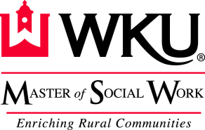

MSW Part-Time Traditional Program – 60 Credit Hours – 3-Year Curriculum
(Online Cohort Only)
Year 1 – Fall Semester
Course Number Name Credit
SWRK 501 Cultural Competency in Social Work Practice 3
SWRK 510 Human Behavior in the Social Environment 3
SWRK 540 Foundation of Social Work Research Methods 3

Year 1 – Spring Semester
Course Number Name Credit
SWRK 523 Rural Community Organization and Development 3
SWRK 530 Foundation of Social Welfare Policy 3
Elective 1 3
Year 2 – Fall Semester
Course Number Name Credit
SWRK 520 Generalist Social Work Practice 3
SWRK 560 Generalist Field Practicum I 3
Elective 2 3
Year 2 – Spring Semester
Course Number Name Credit
SWRK 522 Group Dynamics in Social Work Practice 3 SWRK 561 Generalist Field Practicum II 3

Year 3 – Fall Semester
Course Number Name Credit SWRK 610 Social Work Administration and Supervision 3
SWRK 620 Advanced Psycho-Social Approaches for Rural Practice 3
SWRK 623 Social Work Clinical Assessment and Intervention 3
SWRK 660 Advanced Generalist Field Practicum I 3

Year 3 – Spring Semester
Course Number Name Credit
SWRK 622 Integrated Social Work Practice with Families 3
SWRK 630 Rural Social Welfare Policy 3
SWRK 640 Applied Social Work Research 3
SWRK 661 Advanced Generalist Field Practicum II 3
Elective 3 3
Practice Readiness Examination
Year 3 – May
Graduation

Electives may be taken in Winter and Summer terms. If an elective is completed in the summer following graduation, the graduation date will be in August

