
The Student Government Association at WKU presents the
Gregory McKinney Leadership and Involvement Black History Month Scholarship
The application is due Friday, February 21st, 2025, no later than 5:00 pm CST. Electronic versions are accepted and can be emailed to sga@wku.edu or turned in to the WKU Student Government Association office in Downing Student Union Room 2045.
Name: __________________________________________ 800#: _______________________
WKU Email Address: __________________________________________________________
Phone #: __________________________________
Mailing Address: ______________________________________________________________
Current Academic Year: _____________________________
Anticipated Date of Graduation: _______________ Overall GPA: _________
Please list any majors/minors:____________________
After scholarships are reviewed and scored, we may ask to interview you on Feb 26th, would you be available on this day?___________
Please explain in what ways you are involved on campus.
__________________________________________________________________________________________________________________________________________________________________________________________________________________________________________
______________________________________________________________________________
______________________________________________________________________________
______________________________________________________________________________________________________________________________________________________________________________________________________________________________________________________________________________________________________________________________________________________________________________________________________

What leadership opportunities have you had, if any? (is this specific to campus or, in general, How long ago)?
____________________________________________________________________________________________________________________________________________________________________________________________________________________________________________________________________________________________________________________________________________________________________________________________________________________________________________________________________________________________________________________________________________________________________________________________________________________________________________________________________________________________________________________________________________________________________________________________________________

In your own words, what is Black History Month?
___________________________________________________________________________________________________________________________________________________________________________________________________________________________________________________________________________________________________________________________________________________________________________________________________________________________________________________________________________________________________________________________________________________________________________________________________________________________________________________________________________________________________________________________________________________________________________________________________________

What does “Spirit Makes the Master" mean to you?
_________________________________________________________________________________________________________________________________________________________________________________________________________________________________________________________________________________________________________________________________________________________________________________________________________________________________________________________________________________________________________________________________________________________________
Tell us anything else that you may want us to know about you!

__________________________________________________________________________

__________________________________________________________________________
__________________________________________________________________________

__________________________________________________________________________

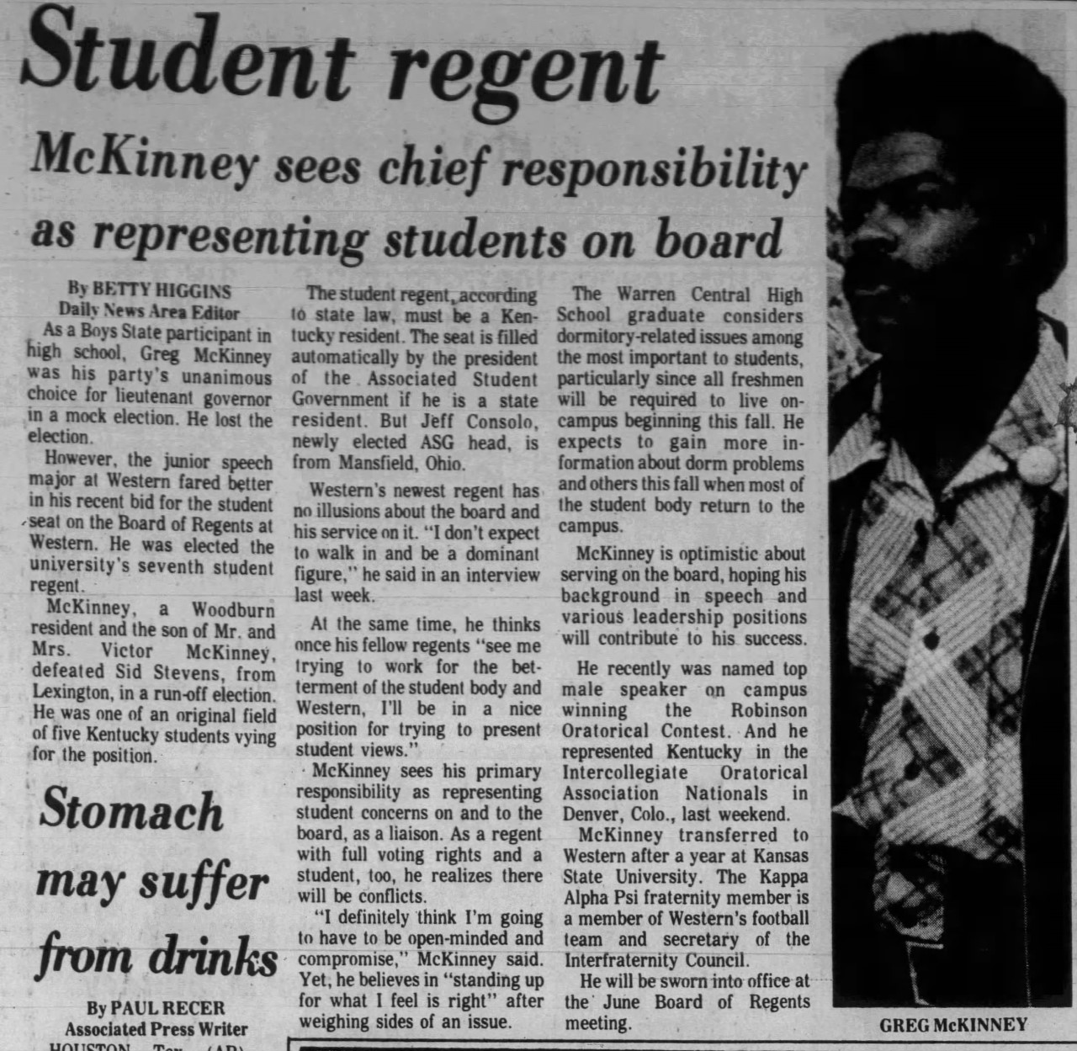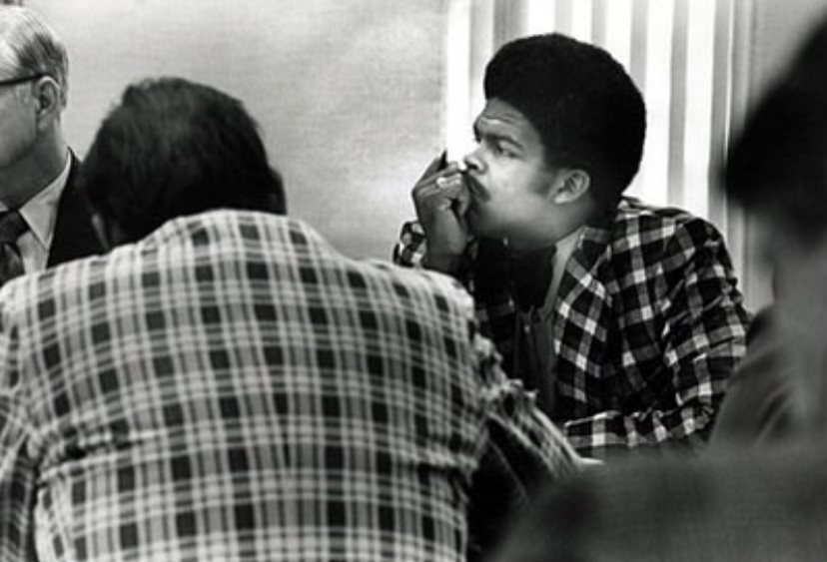
To be the first to do anything takes a courageous and determined individual. Mr. Gregory Mckinney was WKU’s first African American Regent and served from 1974 to 1975. His legacy inspires many students today. This Scholarship is designed to be awarded to a student who displays leadership skills through their involvement on campus and/or in their community. During National Black History Month, SGA will continue to celebrate the legacy of Black Americans whose power to lead, overcome, and expand the meaning and practice of American democracy by helping our Nation become a more fair and just society.
The winner will be notified by February 28th.
Please list one faculty member to justify support for your application.
Email:____________________ Phone Number:______________.
The application is due Friday, February 21st, 2025, no later than 5:00 pm CST. Electronic versions are accepted and can be emailed to sga@wku.edu or turned in to the WKU Student Government Association office in Downing Student Union Room 2045.
Thank you for taking the time to apply for an SGA scholarship. Applications are reviewed without regard to gender, sexual orientation, race, or ethnicity.

