
The Student Government Association at WKU presents the
Gregory McKinney Leadership and Involvement Black History Month Scholarship
The application is due Friday, February 23rd, 2023, no later than 5:00 pm CST. Electronic versions are accepted and can be emailed to sga@wku.edu or turned in to the WKU Student Government Association office in Downing Student Union Room 2045.
Name: __________________________________________ 800#: _______________________
WKU Email Address: __________________________________________________________
Phone #: __________________________________
Mailing Address: ______________________________________________________________
Current Academic Year: _____________________________
Anticipated Date of Graduation: _______________ Overall GPA: _________
Please list any majors/minors:____________________
After scholarships are graded we may ask to interview you on Feb 27th, would you be available on this day?___________
Please explain in what ways you are involved on campus?
__________________________________________________________________________________________________________________________________________________________________________________________________________________________________________
______________________________________________________________________________
______________________________________________________________________________
______________________________________________________________________________________________________________________________________________________________________________________________________________________________________________________________________________________________________________________________________________________________________________________________________

What leadership opportunities have you had if any?
____________________________________________________________________________________________________________________________________________________________________________________________________________________________________________________________________________________________________________________________________________________________________________________________________________________________________________________________________________________________________________________________________________________________________________________________________________________________________________________________________________________________________________________________________________________________________________________________________________

In your own words, what is Black History month?
___________________________________________________________________________________________________________________________________________________________________________________________________________________________________________________________________________________________________________________________________________________________________________________________________________________________________________________________________________________________________________________________________________________________________________________________________________________________________________________________________________________________________________________________________________________________________________________________________________

What does “Spirit makes the master" mean to you?
_________________________________________________________________________________________________________________________________________________________________________________________________________________________________________________________________________________________________________________________________________________________________________________________________________________________________________________________________________________________________________________________________________________________________
Tell us anything else that you may want us to know about you!

__________________________________________________________________________

__________________________________________________________________________
__________________________________________________________________________

__________________________________________________________________________

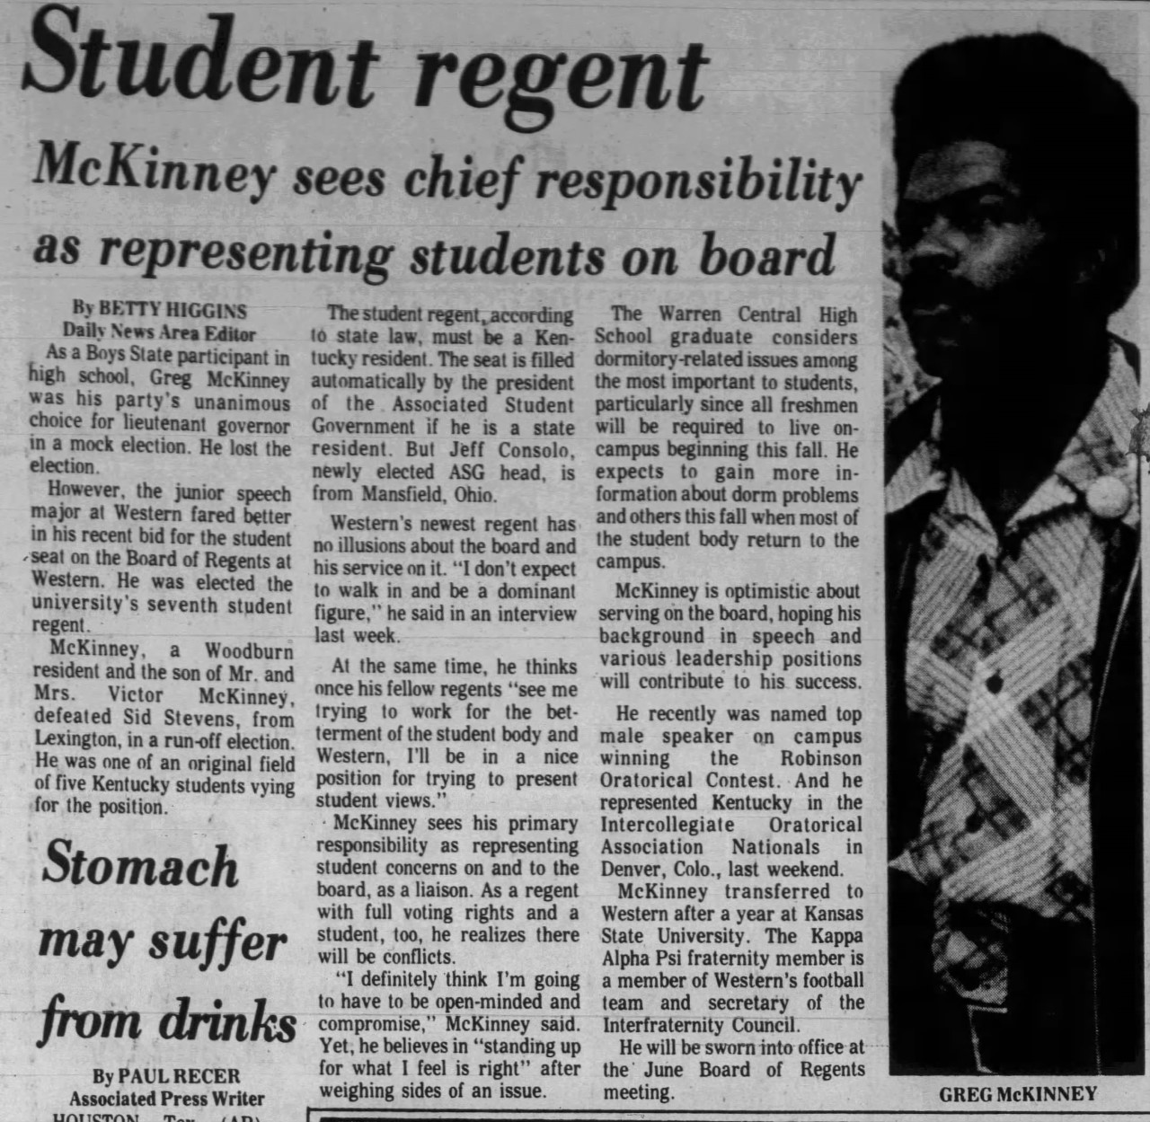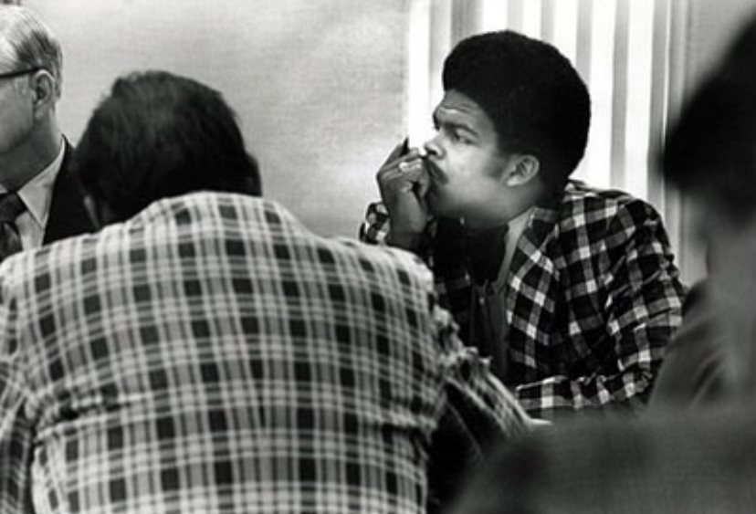
This Scholarship is designed to be awarded to an African American student who can display leadership skills through their involvement on campus and/or their community. Here In SGA we believe involvement on campus has a direct relationship with leadership. During National Black History Month, we celebrate the legacy of Black Americans whose power to lead, to overcome, and to expand the meaning and practice of American democracy has helped our Nation become a more fair and just society. Western Kentucky Alumnus Gregory Mckinney’s legacy gives inspiration to many students today. To be the first to do anything takes a very brave and headstrong individual. Mr.Mckinney, the first African American Regent and Student Regent here at WKU served during 1974-1975. The winner will be notified by March 7th.

Please list one faculty member to justify this application.
Email:____________________ Phone Number:______________.

The application is due Friday, February 23rd, 2023, no later than 5:00 pm CST. Electronic versions are accepted and can be emailed to sga@wku.edu or turned in to the WKU Student Government Association office in Downing Student Union Room 2045.
Thank you for taking the time to apply for an SGA scholarship.

