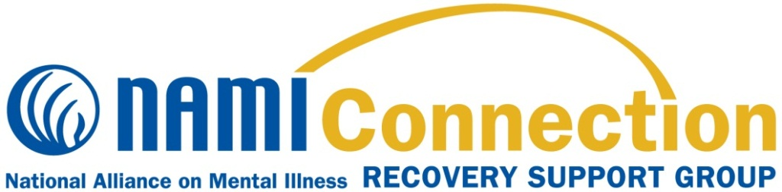

**What is the NAMI (at WKU) Student Recovery Support Group?**

NAMI Connection is recovery support group for **Current WKU Students** that offers respect, understanding, encouragement and hope **for students struggling with mental health issues such as depression, anxiety, or other mental health concerns.** NAMI Connection groups are:

* Free and confidential
* Held twice monthly for 90 minutes
* Designed to connect, encourage, and support participants using a structured support group model
* Led by NAMI trained facilitators living in recovery themselves
* Open to currently enrolled WKU students regardless of academic classification

NAMI-Bowling Green, local affiliate of the National Alliance on Mental Illness (NAMI), will offer NAMI Support Group Meetings at Western Kentucky University in Spring 2020 on the following Mondays**: 2/10, 2/24, 3/16, 3/30, 4/20, 5/4** in **Room** **201 of the Academic Complex from 6:00-7:30 pm.** Pizza and drinks are provided at meetings.

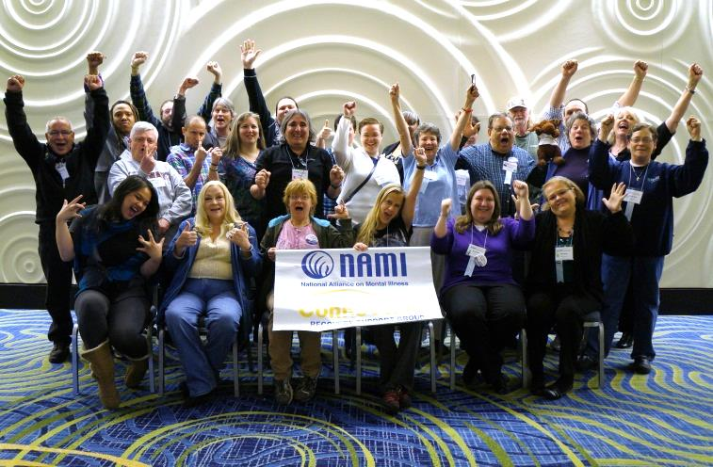

**Participant Perspectives**

“NAMI Connection has made me realize that I can truly feel comfortable around my peers and I really needed that feeling!”

“I believe NAMI Connection means hope.”

“NAMI Connection is the promise of what is and what can be in our lives.”

**Contact me at email below to find out more about NAMI-WKU Support Recovery! Group**

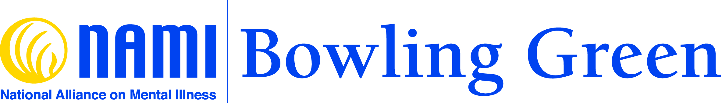

**Contact: Dr. Jay Gabbard**

**NAMI Bowling Green/WKU**

**jay.gabbard@wku.edu**

**(270) 745-8749**

**Dates listed above-6-7:30 pm**

**Academic Complex-WKU-Room 201**

**About NAMI**

NAMI, the National Alliance on Mental Illness, is the nation’s largest grassroots mental health organization dedicated to building better lives for the millions of Americans affected by mental illness. NAMI Bowling Green is an affiliate of NAMI KY. NAMI Bowling Green’s dedicated volunteer members and leaders work tirelessly to raise awareness and provide essential education, advocacy and support group programs for people in our community living with mental illness and their loved ones. 270-796-2606