Student Activities: Assistantship Opportunities

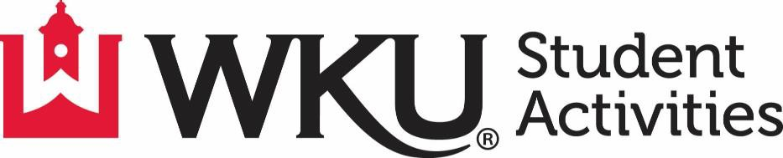

Graduate Assistantship
2026-2027

For information, please contact:
Andrew.rash@wku.edu
Amelia.kolb@wku.edu
Lilly.pottlitzer@wku.edu

Student Activities, DSU 2029
(270) 745-2484
www.wku.edu/sao

About Western Kentucky University:
Western Kentucky University aspires to be the University of choice for students who are dedicated to achieving academic excellence. True to its spirit, WKU offers an inviting, nurturing, and challenging work environment, which is responsive to the needs of a diverse and ambitious learning community. WKU's main campus is located on a hill overlooking the city of Bowling Green (population est. 60,000), and is acclaimed as one of the most beautiful in the nation. In addition, WKU serves the communities of Elizabethtown/Fort Knox, Glasgow and Owensboro through its regional campuses. We invite you to consider WKU as a place where your academic and professional dreams can be realized.

About our Department:
The Department of Student Activities is committed to fostering the learning, growth and development of graduate assistants by offering a well-rounded experience in program planning, assessment, advising, and leadership training within the Student Activities Office.
The collegiate experience is about finding opportunities for growth and development, both in and out of the classroom. Students who take advantage of opportunities to become involved at Western Kentucky University graduate from our institution at a higher rate than those who do not. The Department of Student Activities works to provide co-curricular activities for those who want to become more engaged in the WKU community. Whether it is a student organization, student government, leadership programs, student programming, Greek life, or volunteerism programs there is something for each student who wants to

Student organizations at WKU provide an incredible opportunity to meet new people, build leadership and event planning skills, share ideas, and make connections across campus. WKU is home to over 300 student organizations providing opportunities for students to engage with a wide variety of interests and activities. This involvement can provide students a foundation for success, a passion for learning, and a commitment to responsible global citizenship while fostering creativity and service to others. Organizations not only provide membership, but a safe home from which students can pursue their passions.
Student Activities consist of the following areas: Campus Activities Board, Greek Life, Leadership & Volunteerism, Student Government Association and Registered Student Organizations.

Position Description:

Student Activities is seeking high-energy, highly motivated, student-focused individuals interested in pursuing a career in Student Affairs, or related field, to assist in our department. The following are descriptions of the specific areas within Student Activities: Greek Life, Leadership & Volunteerism, Student Government Association, and Registered Student Organizations. For more information about the areas, please visit: http://www.wku.edu/sao. Graduate Assistants will have the opportunity to work with all or some of the areas within the department. Responsibilities listed may vary from year to year and will always focus around the needs of the students and department. Student Activities provides graduate assistants the ability to develop and foster relationships with students and the campus community. This 10-month appointment advises current students and student groups, on designing and delivering programs to meet the needs of the student body. Graduate Assistants are supervised by Student Activities professionals dedicated to their professional development and success.
Graduate Assistants will be involved in the following:
- Developing and fostering relationships with the students and campus community
- Advising students, student clubs and organizations
- Program planning, development and implementation
- Marketing & outreach efforts
- Presentations and facilitation
- Supervision of student employees and volunteers
- Management and oversight of various office initiatives
- Parent & Family Weekend
- Homecoming
- Admissions/Recruitment programs: Academic Transition Programs, TOPS, fairs and college visits
- Student Tailgate Patrol

Minimum Requirements:
- Bachelor’s Degree from an accredited college or university
- Must be willing to submit to a state and national criminal history background check
- Must gain admittance to WKU graduate school (as a Master’s Degree Seeking graduate student)
- Able to commit from August 1st – May 31st

Desired Requirements:
- Effective oral and written communication skills.
- Ability to form positive relationships with students, faculty, staff and the community.
- Driver’s license with clean driving record to operate vehicles for the university as needed.

Additional Information:
Compensation and Benefits include:
- 10-month appointment
- Approximately $13,000 is paid per academic year over the term of the assistantship
- 2 fall classes and 1 spring class paid for by Student Activities.
- Professional development and training opportunities within the Department, the Student Affairs Division, and University at-large.

How to Apply:
Submit a cover letter, resume, and three professional references to Andrew Rash, Associate Director of Student Activities at andrew.rash@wku.edu. Priority will be given to applications submitted by Friday, March 27, 2026.

