February 10, 2021 Governance Committee Meeting
Time: 12:30pm – 1:40pm
Attendees: Gardner, Lartey, Rust, Farrell, Kim, Eagle, Ding, Adams (PHUGAS), Macy
Agenda Item | Discussion | Next Steps
Approve minutes from November 2020 meeting | Motion to approve minutes made by Lartey; seconded by Farrell. No discussion. Motion passes unanimously.
BSPH Program Coordinator Report | Lartey gives the BSPH report.  - 3 December graduates (domestic).  - Admitted 4 new students this spring semester.  - 3-4 students who had previously paused in the program have come back now or will come back in the next year  - 2 new courses developed for BSPH program  - AmeriCorp internships, jobs, etc. – an important pipeline for us to have – BRADD district – February to August
MPH Program Coordinator Report (Appendix A) | Gardner gives the MPH report.  - Six candidates currently for Assistant Professor search.  - Curriculum review in summer and early fall  - We have 6 new JUMP students who will begin this summer.  - Schedule has a lot of “TBD” right now. Looks similar to 19/20 except the following  - 583 no longer required course  - 584 only online in the fall  - MPH did not meet threshold for graduation rates for CEPH interim report. Gardner has asked that we not have to resubmit.  - Curriculum realignment and substantial change notification as big items once new faculty positions are filled.
MPH Committee Report | No report.
BSPH Committee Report | No report.
GrAPEs (Appendix B) | Rust gives the GrAPE report.  - On the road to getting spring graduates checked off, especially thanks to the BRDHD infographic project that should start next week  - Rust shares her vision and goals for the future of GrAPEs  - Rust asks if anyone has a direct line to Melissa Cowles from HOTEL INC for some capstone possibility discussion  - Blackboard updated so any Blackboard screenshots need to be updated | - Call Melissa Cowles, make appointment
PHUGAS | Adams gives PHUGAS report.  - Certificate spotlights in the February meeting by Dr. Lartey and Dr. Gardner. Spotlights to be uploaded to Blackboard later.  - Potentially GroupMe chat for current BSPH students and one for current MPH students. Farrell worries about academic dishonesty happening thru a group chat.
KPHA (On hiatus) | No report.
Discussions with Stakeholders |  | - Eagle will email some information on an event about social determinants of health.
Diversity, Inclusion, and Equity | Diversity, Inclusion, and Equity statement for the department is being discussed. Gardner suggests it be different than our program statement.
Assessment | Gardner thanks everyone for turning in semester reports
Job Searches | Gardner asks that everyone plan to be at all teaching and research talks (with the exception of Eagle and Adams).  Lartey talks the group through the teaching days.
Motion to revise PH 410 | Motion to approve 410 and 490 revisions made by Eagle; seconded by Lartey. Motions pass unanimously.
Motion to create PH 488 | Motion to approve 488 made by Kim; seconded by Eagle. Motion passes unanimously.
Motion to revise PH 490 | Motion to approve 410 and 490 revisions made by Eagle; seconded by Lartey. Motions pass unanimously.
Motion to revise BSPH Program | Motion to approve BSPH program revisions, pending the proposal for 412, made by Farrell; seconded by Lartey. Motion passes unanimously. | - Eagle and Lartey will complete the Health Equity course (412) proposal today.  - Lartey will send proposals to Mkanta tomorrow.  - Lartey will change the highlighted XXX to 412 and a typo in Section 4.

Appendix A

MPH Report
T/T Assistant Professor Search: The search committee reviewed and rated 40 applicants for the two t/t positions. Of those, eight were selected for preliminary interviews. Afterwards, six were invited to come for virtual campus visits, which will begin next week.
MPH JUMP: We welcomed six new JUMPers in spring, and have another who will begin in the summer. We will continue our efforts to home-grow our campus-based program.
AY 21-22 Schedule: The schedule for next AY was submitted based largely on the schedule for AY 19-20, but with lots of TBDs. We will fill in and tweak the schedule based on who we hire.
CEPH: The annual report was submitted. As with the previous year, our graduation rate fell below the threshold. Given that our interim report filed last year addressed this attrition as well, I’ve asked that we not be required to re-submit an interim report. I expect to hear back from CEPH within the next few weeks.

Appendix B

GrAPEs Report
Most students expecting to graduate in the spring don’t have their GrAPE requirements completed
- Game plan for most of the students
- A few I haven’t heard from about their plan or what they need from me
What we need:
- Better/more sustainable/more embedded GrAPEs
  - Better communication with BRDHD
  - Closer partnerships with more agencies
- Telecommuting opportunities! Most of our students are online; even in the midst of COVID-19, most of the opportunities I’m getting are for in-person. These simply aren’t working for our students right now (and I don’t see them working for our students in the immediate future). Any creative ideas welcome!
If you see any old Blackboard screenshots on any of the MPH materials, please let me know. Since Blackboard updated, they need to be updated.
- MPH Guidebook for 21-22 has already been updated to reflect this update
PHUGAS: It’s just not working.
Things I will be adding to the GrAPE Guidebook (a running list):
- How to use your job for GrAPEs

Appendix C

410 Revisions
Proposal Date: January 24, 2021
College Name : College of Health and Human Services
Department Name: Public Health
Proposal to Make Multiple Revisions to a Course
(Action Item)
Contact Person: Grace Lartey, PhD; grace.lartey@wku.edu; 270-745-3941
1. Identification of course:
  - Current course prefix (subject area) and number: PH 410
  - Course title: Global Perspectives on Population Health
2. Revise course title: N/A
  - Current course title:
  - Proposed course title:
  - Proposed abbreviated title:
  - Rationale for revision of course title:

3. Revise course number: N/A
  - Current course number:
  - Proposed course number:
  - Rationale for revision of course number:

4. Revise course prerequisites/corequisites/special requirements: N/A
4.1 Current prerequisites/corequisites/special requirements: (indicate which)
4.2 Proposed prerequisites/corequisites/special requirements:
4.3 Rationale for revision of course prerequisites/corequisites/special requirements:
4.4 Effect on completion of major/minor sequence:

5. Revise course catalog listing:
5.1 Current course catalog listing: Population health focuses on the health and well-being of entire populations. Populations may be geographically defined, such as neighborhoods, states, or countries, or may be based on groups of individuals who share common characteristics such as age, gender, race-ethnicity, disease status, employee group membership, or socioeconomic status. With roots in epidemiology, public health, and demography, a key component of population health is the focus on the social determinants of health and "upstream" collaborative interventions to improve population health and variance, identify and reduce health disparities, and reduce healthcare costs.
5.2 Proposed course catalog listing: Global population health focuses on the health and well- being of entire populations. Populations may be geographically defined, such as neighborhoods, states, or countries, or may be based on groups of individuals who share common characteristics such as age, gender, race-ethnicity, disease status, employee group membership, or socioeconomic status. With roots in epidemiology, public health, and demography, a key component of population health is the focus on the social determinants of health and "upstream" collaborative interventions to improve population health and variance, identify and reduce health disparities, and reduce healthcare costs.
5.3 Rationale for revision of course catalog listing: Adding “global” to the catalog listing helps the description to reflect the title better.

6. Revise course credit hours: N/A
  - Current course credit hours:
  - Proposed course credit hours:
  - Rationale for revision of course credit hours:

7. Revise schedule type: N/A
7.1 Current schedule type:
7.2 Proposed schedule type:
7.3 Rationale for revision of schedule type:

8. Revise grade type: N/A
8.1 Current grade type:
8.2 Proposed grade type:
8.3 Rationale for revision of grade type:

10. Proposed term for implementation: Next available

11. Dates of prior committee approvals:

Department/ Unit
College Curriculum Committee
Colonnade Committee (if applicable)
Undergraduate Curriculum Committee
University Senate

Appendix D

410 Course Inventory Form
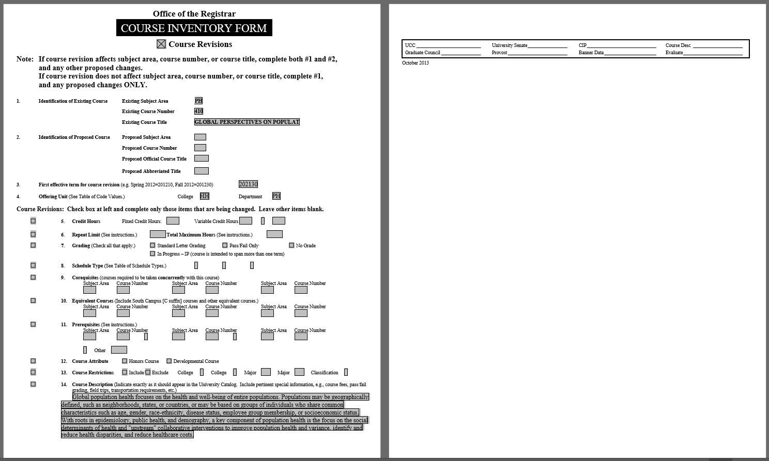

Appendix E

488 Proposal

Proposal to Create a New Course: Instructions
Section 1: Proponent Contact Information
1.1 Name/Title: Grace Lartey, PhD
1.2 Email address: grace.lartey@wku.edu
1.3 Phone #: 270-745-3941
Section 2: Course Catalog Information
  - Course prefix (subject area) and number: PH 488
  - Course CIP code: 51.2208
  - Course title: Public Health Senior Seminar
  - Abbreviated Course title: PH Senior Seminar
  - Credit hours/Variable credit: 3 credit hours
  - Repeatability: N/A
  - Course Term: Fall 2021
  - Course Catalog Description: Course allows students to synthesize and apply public health skills and knowledge acquired in their prior coursework to design an action plan to solve a health problem in a selected community. Course will expose students to public health professional preparation skills.
  - Prerequisite/Corequisites/Restrictions: Restricted to Public Health majors
  - Additional Enrollment Requirements: Senior standing; instructor permission required.
  - Other Special Course Requirements: N/A
  - Grade Type: Pass/Fail grade
  - Schedule Type: Seminar
Section 3: Description of proposed course

3.1 Course Content Summary: Students in PH 488 will synthesize and apply knowledge and skills acquired in needs assessment, communication, program planning and health disparities to identify a health issue within a community. Students will apply such knowledge to design an action plan to solve the identified problem. Course will expose students to public health professional preparation skills of resume preparation, job search and interviewing skills.
  - Learning Outcomes: By the end of the course, students should be able to:
- Locate databases/websites with information about communities, agencies and jobs.
- Identify the major health issues facing their selected community.
- Discuss the health trends and their impact on communities and populations.
- Prioritize the health issues and select the top issue needing immediate attention.
- Outline the contributing factors contributing to the priority issues.
- Discuss the challenges to addressing the issues.
- Plan/design an action plan to solve the problem.
- Prepare a resume for a public health-related job.
- Apply and interview for a public health-related job.

  - Assessment/Evaluation: The learning outcomes will be assessed through discussions, mock interviews and the final project.
Section 4: Rationale
4.1 Reason for developing this proposed course: As part of the BSPH accreditation process, the program had to identify new, overarching competencies for assessment. The program recently identified three new competencies as required. While the internship has been the program’s culminating experience course, the diversity in the activities of the various site makes it difficult to assess the competencies effectively at each site. Tasks assigned to students during the internship experience differ by site; at the same time, all students will be assessed equally and fairly on these newly developed competencies. It is therefore necessary for the program to ensure that all students receive the same public health experience, knowledge and skills and also meet accreditation requirements.

Reducing the internship hours (from 6 hours to 3) gives the program room to create a new course that would expose students to the same experience and skills. All students can then be assessed on these new competencies using the same assessment tools thereby meeting the accreditation requirements.
SPECIAL NOTE REGARDING NEW COLONNADE PROGRAM COURSES
To be included in the WKU Colonnade general education program, courses must meet criteria unique to that program, and as such, the Colonnade program has its own distinct course approval process: new courses being designed and proposed specifically for inclusion in WKU Colonnade program must include that information here, in item 4.1, and must be pre-approved by the Colonnade Committee as meeting their unique requirements prior to being acted on by the university’s Undergraduate Curriculum Committee. For information, proposal forms and instructions unique to the Colonnade approval process, please refer to the Faculty Resources page of the WKU Colonnade Program Website.

4.2 Relationship to similar courses offered by other university departments/units: While several departments on campus offer senior seminar courses such as Math 498 (Senior Seminar); HIST 498 (Senior Seminar); PHIL 496 (Senior Seminar); PHYS 498 (Senior Seminar); SOCL 449 (Senior Seminar); RELS 496 (Senior Seminar); PSYS 499 (Senior Seminar); ENV 486 (Senior Seminar); CRIM 499 (Senior Seminar); HMD 459 (Senior Seminar); none of these courses share the same content with this proposed course. This course is unique to the BSPH program as it is aligned to the newly developed competencies specific to the Public Health program.

Similar Senior Seminar/Capstone courses are offered in other public health programs such as: Central Washington University PUBH 479 (Senior Seminar in Public Health); University of South Carolina PUBH 498 (Public Health Capstone Seminar); University of Louisville PHPH 491 & PHPH 492 (Senior Capstone 1 & 2); University of Kentucky CPH 470 (Public Health Capstone); and the University of North Carolina, Charlotte HLTH 4600 (Public Health Capstone).

This is the first and only public health seminar course developed at the university that seeks to encourage students to apply knowledge and skills acquired in previous courses in solving real health problems within communities and among populations.

Section 5: Projected Enrollments/Resources
5.1 How many students per section are expected to enroll in this proposed course? 5-10 students
  - How many sections of this course per academic year will be offered? One section
  - How many students per academic year are expected to enroll? Ten students per year
  - How were these projections calculated? Explain any supporting evidence/data you have for arriving at these projections: The number is based on previous years’ internship enrollment
  - Proposed method of staffing: The course will be taught by faculty in the Public Health program. The program is currently hiring three new faculty.
  - Instructional technology resources: Current instructional technology resources are sufficient to support the course.
  - Library resources: Yes
Section 6: Proposed term for implementation: Next available
Section 7: Supplemental Documentation (Optional): None

Department of Public Health _________________

College of Health and Human Services _________________

Undergraduate Curriculum Committee _________________

University Senate _________________

Appendix F

Library Resources for 488
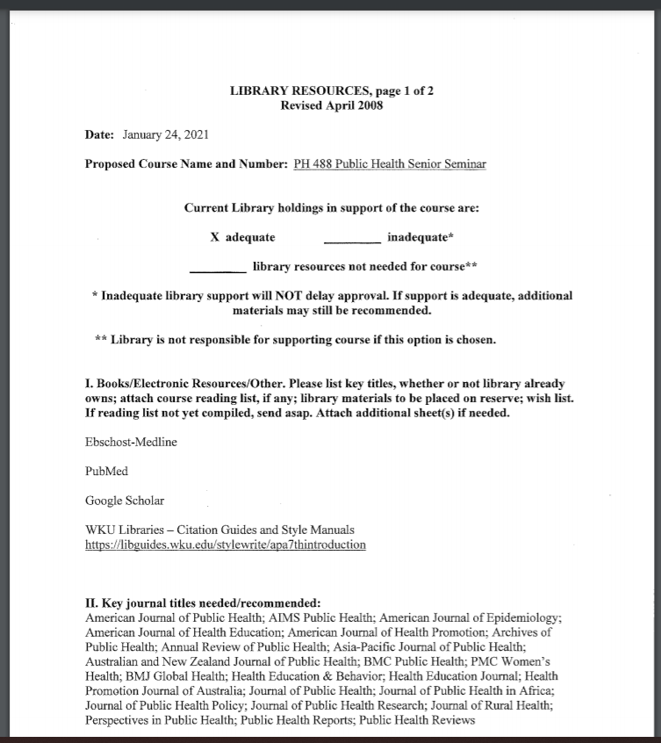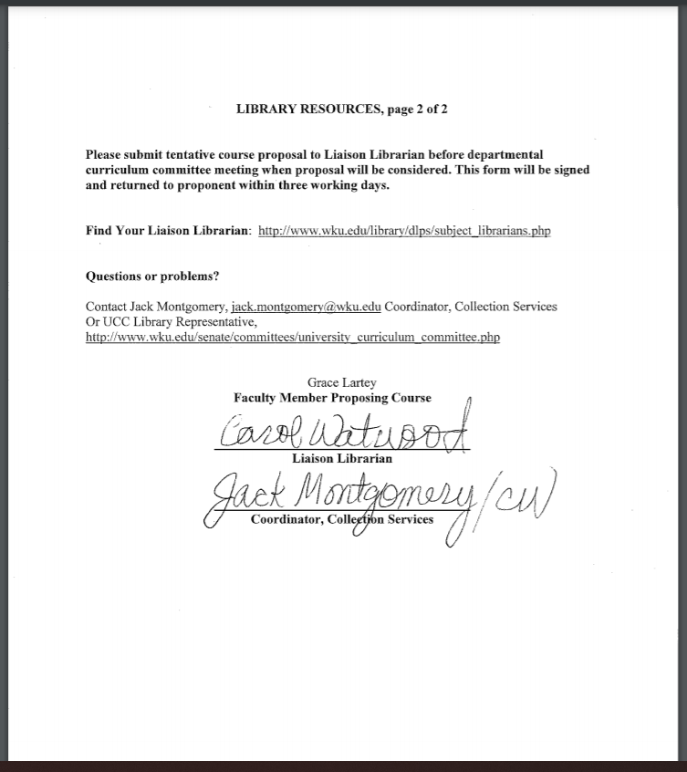

Appendix G

490 Revisions
Proposal Date: January 24, 2021
College Name: College of Health and Human Services
Department Name: Public Health
Proposal to Make Multiple Revisions to a Course
(Action Item)
Contact Person: Grace Lartey, PhD; grace.lartey@wku.edu; 270-745-3941
1. Identification of course:
  - Current course prefix (subject area) and number: PH 490
  - Course title: Internship
2. Revise course title: N/A
  - Current course title:
  - Proposed course title:
  - Proposed abbreviated title:
  - Rationale for revision of course title:
3. Revise course number: N/A
  - Current course number:
  - Proposed course number:
  - Rationale for revision of course number:
4. Revise course prerequisites/corequisites/special requirements: N/A
4.1 Current prerequisites/corequisites/special requirements: (indicate which)
4.2 Proposed prerequisites/corequisites/special requirements:
4.3 Rationale for revision of course prerequisites/corequisites/special requirements:
4.4 Effect on completion of major/minor sequence:
5. Revise course catalog listing: N/A
  - Current course catalog listing:
  - Proposed course catalog listing:
  - Rationale for revision of course catalog listing:
6. Revise course credit hours:
  - Current course credit hours: 3-6 hours
  - Proposed course credit hours: 3 hours
  - Rationale for revision of course credit hours: To create room for the newly developed public health seminar course (culminating experience) to be used to assess the newly developed BSPH program competencies to meet accreditation requirements.
7. Revise schedule type: N/A
7.1 Current schedule type:
7.2 Proposed schedule type:
7.3 Rationale for revision of schedule type:
8. Revise grade type: N/A
8.1 Current grade type:
8.2 Proposed grade type:
8.3 Rationale for revision of grade type:
10. Proposed term for implementation: Next available
11. Dates of prior committee approvals:
Department/ Unit
College Curriculum Committee
Undergraduate Curriculum Committee
University Senate

Appendix H

490 Course Inventory Form
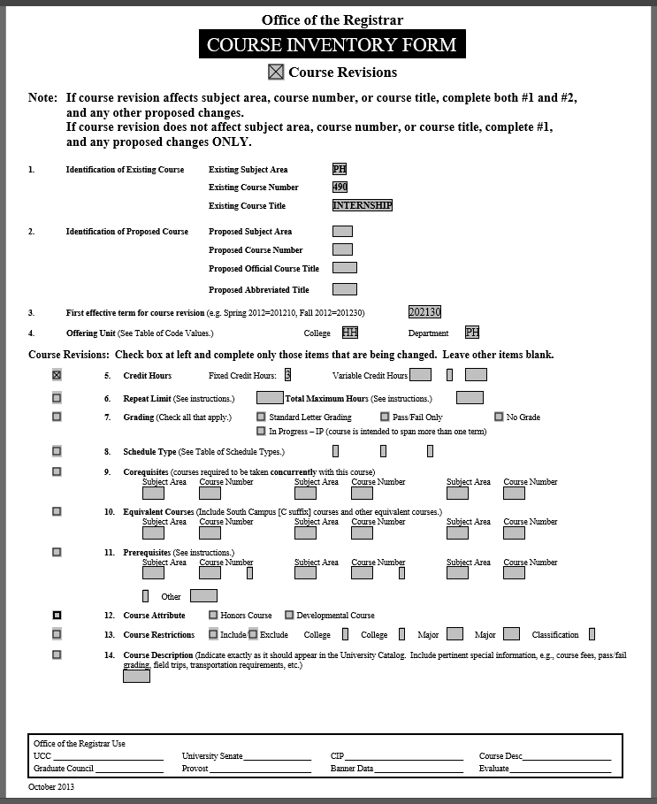

Appendix I

Proposal to Revise a Program
Proposal to Revise a program: Bachelor of Science in Public Health
College: Health and Human Services
Department/Unit: Public Health
Section 1: Proponent Contact Information
1.1 Name/Title: Grace Lartey, PhD
1.2 Email address: grace.lartey@wku.edu
1.3 Phone #: 270-745-3941
Section 2: Program Information
  - Classification of Instructional Program (CIP) reference number: 521P/521
  - Current Program title: Public Health
  - Current total number of credits required in the program: 70
Section 3: Proposed program revisions and rationales
  - Remove PH 483 from core courses as it does not align to the newly required competencies. PH 483 will be listed as an elective. Two new courses, which align with the competencies better have been proposed and will be added to the core courses
  - Add PH 488 and PH XXX to the core courses.
  - Reduce PH 490 hours from 6 credit hours to 3 credit hours.
  - Add PH 483 to electives.
  - Change PH 410 description to better reflect title.
Section 4: Consultations: No consultaions required.
Section 5: Proposed term for implementation: Next available
Section 6: Approval Flow Dates:
Department of Public Health _________________

College of Health and Human Services _________________

Undergraduate Curriculum Committee _________________

University Senate _________________
7.1: Current BS Public Health

Requirements for Admission to Public Health (reference number 521P/521)
30 hours including the following courses with an overall GPA of 2.3 or better.

The program in public health consists of a core of 30 credit hours of coursework, 28 credit hours of other required courses, and 12 hours of electives for a total of 70 hours in the major.

BIOL 131 Human Anatomy and Physiology 4
CHEM 109 Chemistry for the Health Sciences 4
COMM 145 Fundamentals of Public Speaking &
Communication 3
PH 100 Personal Health 3

Select one of the following courses 3
PSY/PSYS 100 Introduction to Psychology
PSY/PSYS 220 Introduction to Lifespan Developmental
Psychology
SOCL 100 Introduction to Sociology

Select Additional 13 hours

Core Courses Credits
PH 261 Foundations of Public Health Education 3
PH 381 Public and Community Health 3
PH 384 Introduction to Epidemiology 3
PH 385 Environmental Health 3
PH 410 Global Perspectives on Populaton Health 3
PH 483 Administration of Public Health Programs 3
PH 484 Community Organization for Health Education 3
PH 485 Fundamentals of Public Health Planning 3
PH 490 Internship 6
Total 30

Additional Required Courses
BIOL 131 Anatomy & Physiology 4
BIOL 207 & 208 General Microbiology &
General Microbiology Laboratory 4
CHEM 109 Chemistry for the Health Sciences 4
MATH 109 General Mathematics OR
MATH 115 Applied College Algebra 3
PH 100 Personal Health 3
PH 383 Biostatistics in the Health Sciences 3
SFTY 171 Safety & First Aid 1
COMM 145 Fundamentals of Public Speaking &
Communication 3

Select one of the following courses 3
PSY/PSYS 100 Introduction to Psychology
PSY/PSYS 220 Introduction to Lifespan Developmental
Psychology
SOCL 100 Introduction to Sociology
Total 28

Electives (six hours must be upper division) 12
Biology 315 Ecology 3
CHEM 330 Quantitative Analysis 5
ENV 280 Introduction to Environmental Science 3
ENV 321 Fundamentals of Industrial Hygiene 3
ENV 323 Fundamentals of Industrial Hygiene Laboratory 1
ENV 360 Air Poluution Control 3
ENV 375 Introduction to Water Resources 3
ENV 380 Principles of Environmental Toxicology 3
ENV 410 Water Treatment Processes 3
ENV 410 Water Treatment Processes Laboratory 1
ENV 430 Radiological Health 3
ENV 460 Environmental Management 3
ENV 474 Environmental Risk Assessment 3
ENV 490 Food Safety 3
GEOG 310 Global Hydrology 3
AH/HIM 290 Medical Terminology 2
SFTY 290 General Safety 3
HMD 211 Human Nutrition 3
HCA 340 Health Care Organization and Management 3
HCA 347 International Comparisons of Health Care Systems 3
HCA 459 Global Health Service Practicum 3
LEAD 200 Introduction to Leadership Studies 3
LEAD 300 Leadership Theory and Application 3
LEAD 325 Leading Change 3
LEAD 330 Leadership Ethics and Decision-Making 3
PH 365 Human Sexuality 3
PH 382 Peer Health Education 3
PH 390 Wellness and Fitness Assessment 3
PH 402 Worksite Health Promotion 3
PH 443 Health and Aging 3
PH 444 Death, Dying and Bereavement 3
PH 447 Human Values and the Health Sciences 3
PH 456 Independent Study in Health & Safety 3
PH 464 Women’s Health 3
PH 467 Drug Abuse Education 3
PH 468 Sexuality Education 3
PS 338 Government and Ethics 3
SOCL 260 Race & Ethnic Relations 3
SOCL 270 Introduction to Community, Environment &
Development 3
SOCL 350 Systems of Social Inequality 3
SOCL 362 Social Institutions: Race, Class and Gender 3
SOCL 375 Diversity in American Society 3
SOCL 376 Sociology of Globalization
STAT 330 Introduction to Statistical Software 3
SWRK 101 Foundations of Human Services 3
Total 12
Total Hours 70

7.2: Proposed BS Public Health

Requirements for Admission to Public Health (reference number 521)
30 hours including the following courses with an overall GPA of 2.3 or better.

The program in public health consists of a core of 30 credit hours of coursework, 28 credit hours of other required courses, and 12 hours of electives for a total of 70 hours in the major.

BIOL 131 Human Anatomy and Physiology 4
CHEM 109 Chemistry for the Health Sciences 4
COMM 145 Fundamentals of Public Speaking &
Communication 3
PH 100 Personal Health 3

Select one of the following courses 3
PSY/PSYS 100 Introduction to Psychology
PSY/PSYS 220 Introduction to Lifespan Developmental
Psychology
SOCL 100 Introduction to Sociology
Select Additional 13 hours

Core Courses Credits
PH 261 Foundations of Public Health Education 3
PH 381 Public and Community Health 3
PH 384 Introduction to Epidemiology 3
PH 385 Environmental Health 3
PH 410 Global Perspectives on Populaton Health 3
PH 484 Community Organization for Health Education 3
PH 485 Fundamentals of Public Health Planning 3
PH XXX 3
PH 488 Public Health Senior Seminar 3
PH 490 Internship 3
Total 30

Additional Required Courses
BIOL 131 Anatomy & Physiology 4
BIOL 207 & 208 General Microbiology &
General Microbiology Laboratory 4
CHEM 109 Chemistry for the Health Sciences 4
MATH 109 General Mathematics OR
MATH 115 Applied College Algebra 3
PH 100 Personal Health 3
PH 383 Biostatistics in the Health Sciences 3
SFTY 171 Safety & First Aid 1
COMM 145 Fundamentals of Public Speaking &
Communication 3

Select one of the following courses 3
PSY/PSYS 100 Introduction to Psychology
PSY/PSYS 220 Introduction to Lifespan Developmental
Psychology
SOCL 100 Introduction to Sociology
Total 28

Electives (six hours must be upper division) 12
Biology 315 Ecology 3
CHEM 330 Quantitative Analysis 5
ENV 280 Introduction to Environmental Science 3
ENV 321 Fundamentals of Industrial Hygiene 3
ENV 323 Fundamentals of Industrial Hygiene Laboratory 1
ENV 360 Air Poluution Control 3
ENV 375 Introduction to Water Resources 3
ENV 380 Principles of Environmental Toxicology 3
ENV 410 Water Treatment Processes 3
ENV 410 Water Treatment Processes Laboratory 1
ENV 430 Radiological Health 3
ENV 460 Environmental Management 3
ENV 474 Environmental Risk Assessment 3
ENV 490 Food Safety 3
GEOG 310 Global Hydrology 3
AH/HIM 290 Medical Terminology 2
SFTY 290 General Safety 3
HMD 211 Human Nutrition 3
HCA 340 Health Care Organization and Management 3
HCA 347 International Comparisons of Health Care Systems 3
HCA 459 Global Health Service Practicum 3
LEAD 200 Introduction to Leadership Studies 3
LEAD 300 Leadership Theory and Application 3
LEAD 325 Leading Change 3
LEAD 330 Leadership Ethics and Decision-Making 3
PH 365 Human Sexuality 3
PH 382 Peer Health Education 3
PH 390 Wellness and Fitness Assessment 3
PH 402 Worksite Health Promotion 3
PH 443 Health and Aging 3
PH 444 Death, Dying and Bereavement 3
PH 447 Human Values and the Health Sciences 3
PH 456 Independent Study in Health & Safety 3
PH 464 Women’s Health 3
PH 467 Drug Abuse Education 3
PH 468 Sexuality Education 3
PH 483 Administration of Public Health Programs 3
PS 338 Government and Ethics 3
SOCL 260 Race & Ethnic Relations 3
SOCL 270 Introduction to Community, Environment &
Development 3
SOCL 350 Systems of Social Inequality 3
SOCL 362 Social Institutions: Race, Class and Gender 3
SOCL 375 Diversity in American Society 3
SOCL 376 Sociology of Globalization
STAT 330 Introduction to Statistical Software 3
SWRK 101 Foundations of Human Services 3
Total 12
Total Hours 70

