Graduate Applied Practice Experience (GrAPE) Report

Opportunities
- Reminder: if you are looking into embedding a GrAPE into your course, speak with me about the reflection piece and estimated hours
- HACU, HBCU lists for recruiting
  - Shared Drive
- Preceptor Evaluation (appendix A)
  - Attachment on agenda
- CEPH Webinar, Cumulative, Integrative, and Practice-Based Experience
  - https://ceph.org/constituents/schools/faqs/pres/
- Green River District Health Department (appendix B)

Changes
- New proposal (appendix C)
- New summary report (appendix D)
- Another Embedded-GrAPE (3 total this semester!)
- Handbook - step-by-step, things to know, how to report issues
  - Attachment on agenda

Non-GrAPE
- Collecting policy and procedures to put them all in one place
  - Attachment on agenda

Appendix A: Preceptor Evaluation Samples
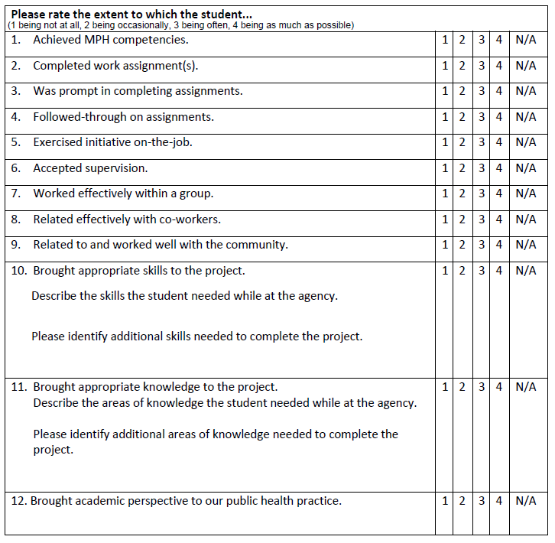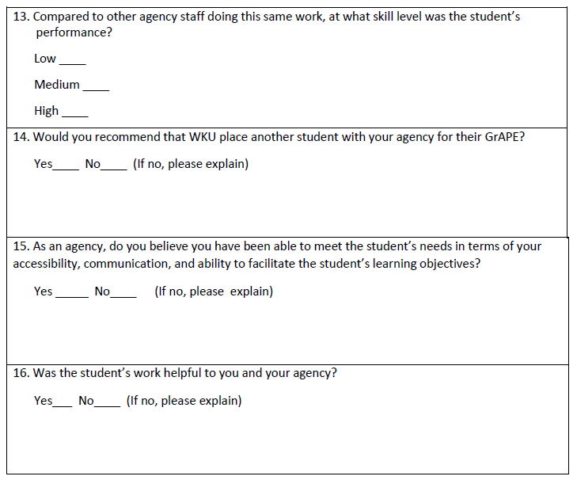
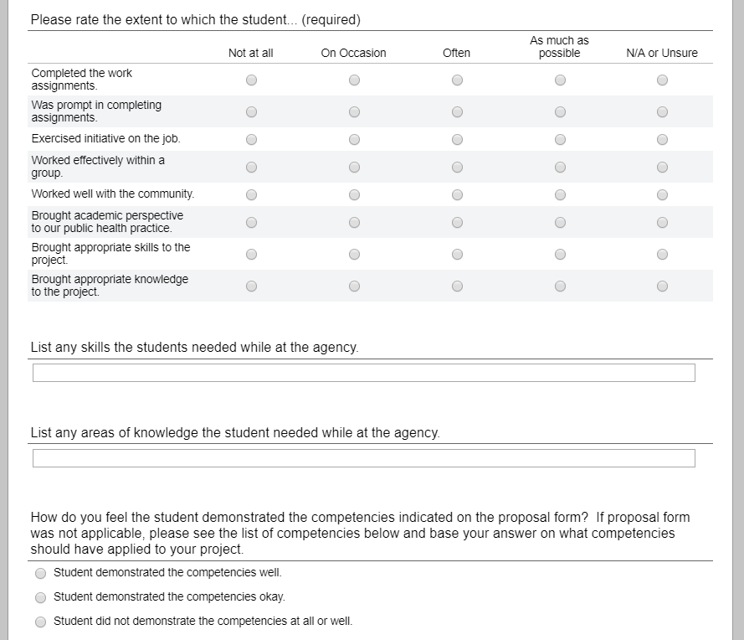
Then, a list of the competencies is pictured.
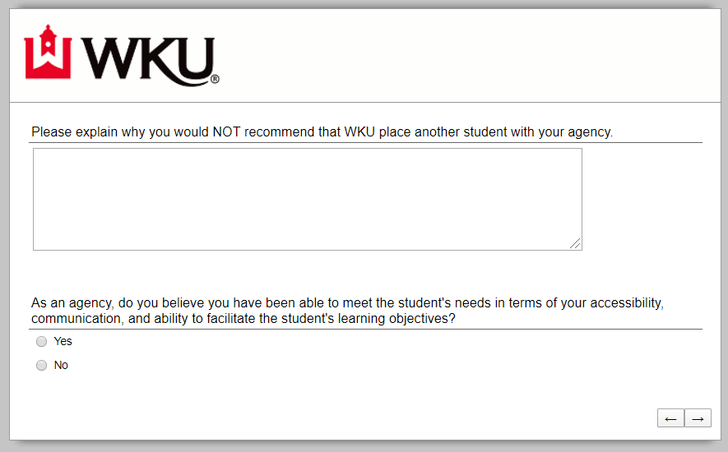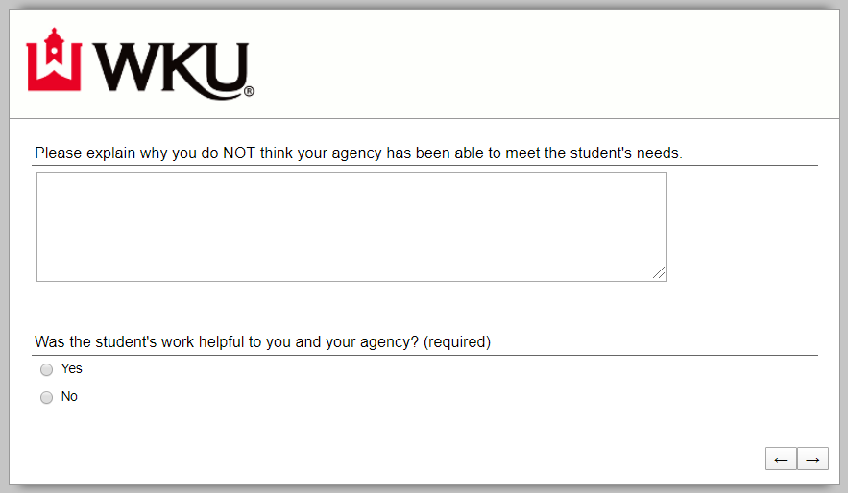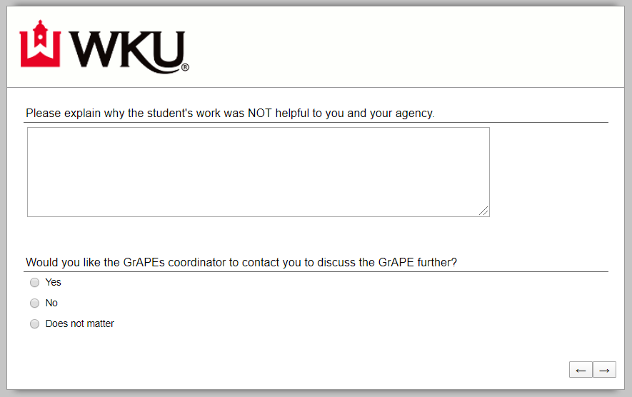

Appendix B: Email from GRDHD
Hey Marina,
We have an idea for a rather large project around health department "Customer Service" and Health Equity/Cultural Diversity/Adverse Childhood Experiences. I was hoping you might be able to help.
I realize you assist MPH students, but we aren't sure if this might be something we could pull Psychology into? Do you have any contacts there?
Open to your thoughts, ideas, suggestions. Here are a few more details about what our overall goal/purpose is for this project.
- Provide training for all staff around gaining insight on Customer Service through the lens of cultural diversity, health equity, and consideration of "where people are coming from" (Adverse Childhood Experiences - ACE).
- We would love to have maybe graduate level student create the training and then even provide a Train-the-trainer course, if possible?
What are you initial thoughts on this? We are thinking this might all take place in the Fall 2020 semester?
Thanks,
Jessica

Appendix C: New Proposal
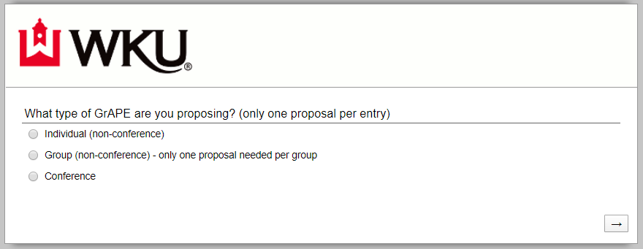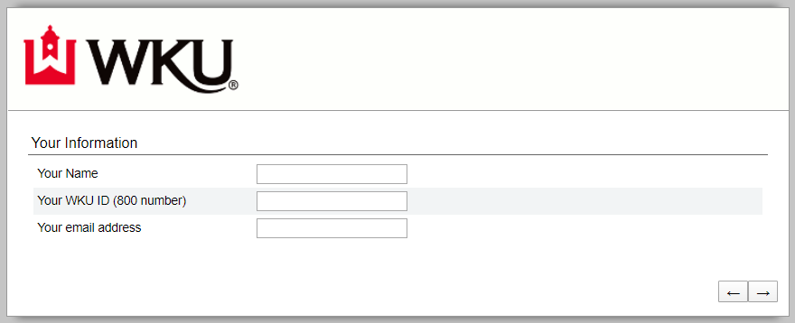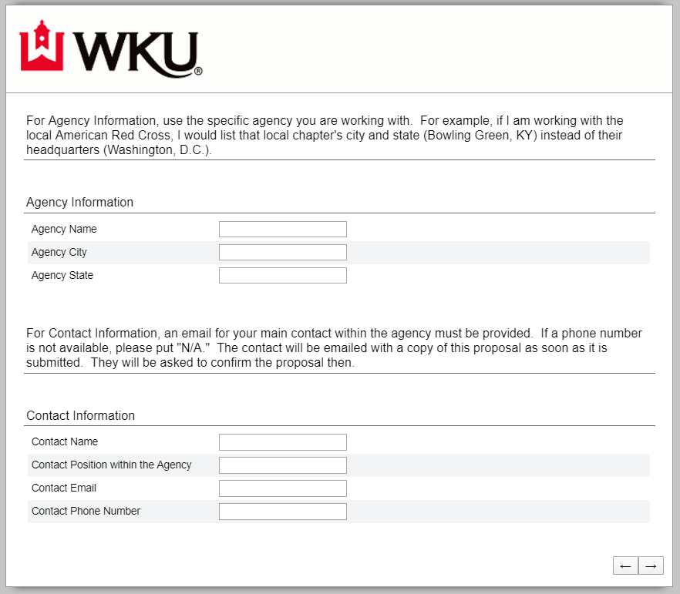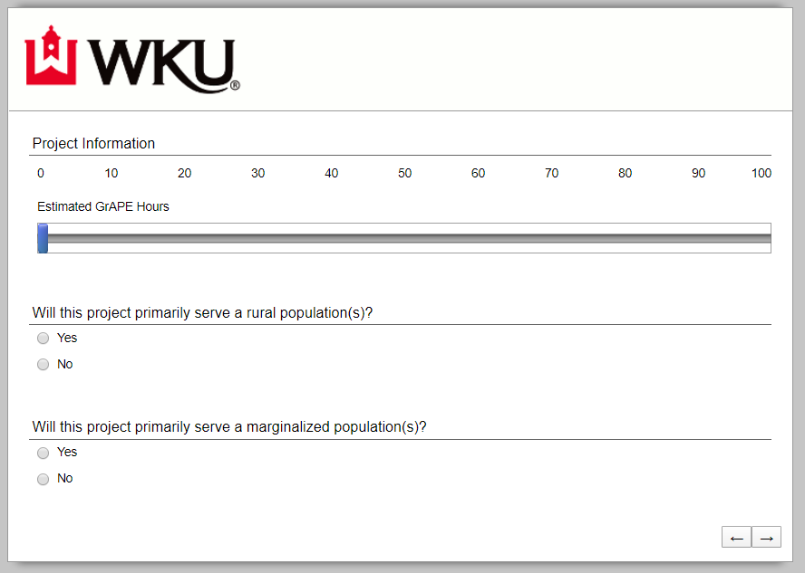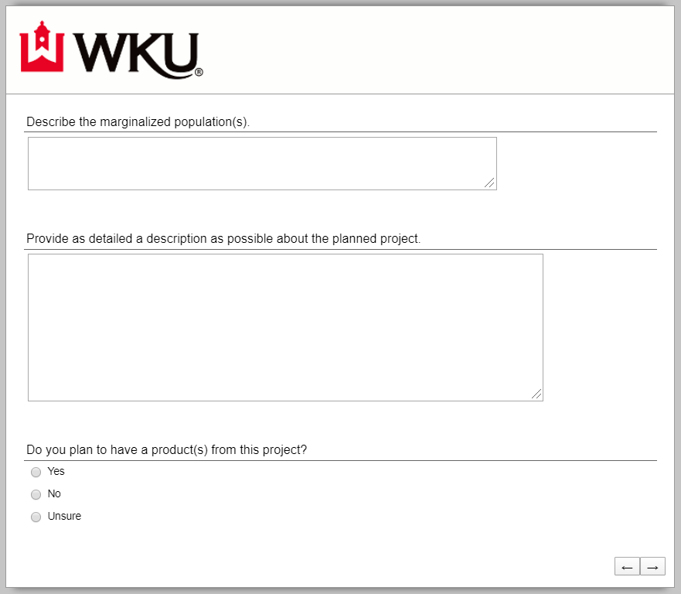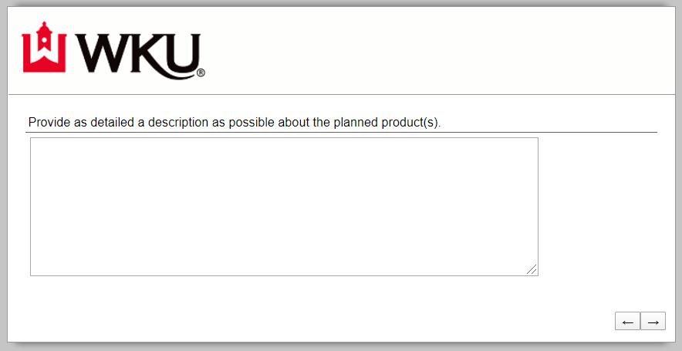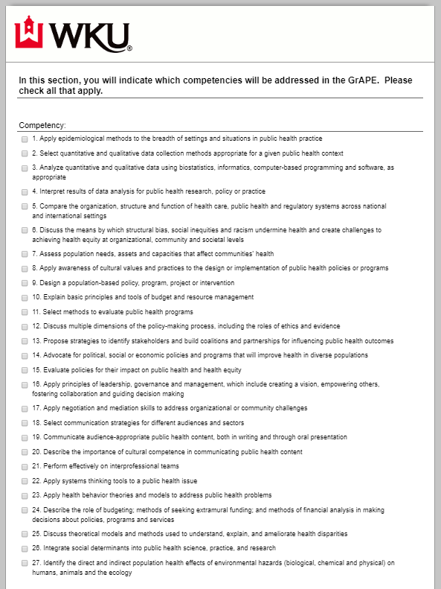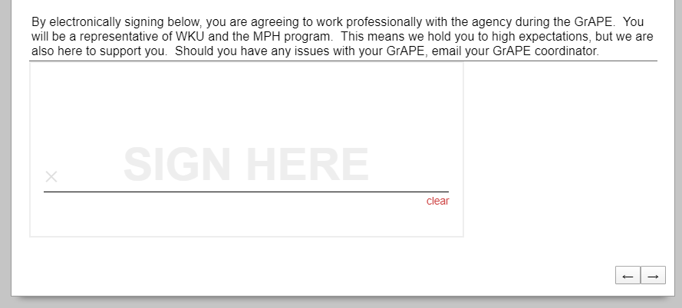

Appendix D: New Summary Report
