Graduate Applied Practice Experience Handbook
  - Western Kentucky University
  - College of Health and Human Services
  - Master of Public Health Program

Last edited February 2020

Contents
Frequently Asked Questions 3
What is a graduate applied practice experience? 3
What is the GrAPE requirement? 3
When should I start thinking about my own GrAPE work? 3
Where can I find more information about the GrAPE requirement? 3
Who do I contact about the GrAPE requirement? 3
What is a product? 3
What is the difference between a GrAPE and an ILE? 4
Step One 5
Find a Project 5
Tips 5
Step Two 5
Determine the Type of Project 5
Tips 6
Step Three 6
Complete a Proposal 6
Tips 20
Step Four 20
Complete the Project 20
Tips 21
Step Five 21
Gather and Submit Products 21
Tips 21
Step Six 21
Complete the Summary Report 21
Tips 22
Step Seven 22
Check your Blackboard Grade 22
Tips 22
Relevant Links 22

Frequently Asked Questions

What is a graduate applied practice experience?
The graduate applied practice experience is referred to as the GrAPE requirement. It’s similar to a required internship but is more flexible in a lot of ways. GrAPEs provide you opportunities to apply content learned in your courses to real-world, real-time public health issues. We believe it is important for all MPH students to be exposed to, and involved in, public health practice throughout the program, and the GrAPE requirement is one way we insure that happens.

What is the GrAPE requirement?
In short, the GrAPE requirement states that you should spend at least 100 hours working with or working in a practice setting. From the work you do, you must also produce a minimum of two products from your GrAPEs that demonstrate a minimum of five competencies, of which at least three must be foundational competencies. All of this will be broken down more in this handbook.

When should I start thinking about my own GrAPE work?
You should always be on the lookout for GrAPE opportunities. It is never too early to being working on your GrAPE requirement. However, you should start your GrAPE work by the semester BEFORE the semester you expect to graduate. In other words, if you plan to graduate in Spring of 2022, you should start GrAPE work no later than Fall 2021. This helps us insure you are on track to get 100 hours and 2 products before your expected graduation date. There are a few exceptions to this, including if you choose to take PH 546 or PH 588. However, these exceptions should be known by the GrAPE coordinator by the semester BEFORE the semester you expect to graduate.

Where can I find more information about the GrAPE requirement?
The official GrAPE requirement can be found in your MPH Handbook. Templates for proposals and summary reports can be found on Blackboard within the MPH Students organizational page. Once you are in the MPH Students organizational page on a computer, look for “Program Requirements” on the left-hand menu. The “GrAPEs” page can be found under that heading.

Who do I contact about the GrAPE requirement?
If you have more questions about the GrAPE requirement, reach out to the GrAPE coordinator, Marina Rust, at marina.rust@wku.edu. All proposals, summary reports, and products should be sent to the GrAPE coordinator as well.’

What is a product?
Products are tangible items or documents that benefit the agency you worked with and reinforce the MPH competencies. While they act as a sort of "proof" of the work you've done for the agency, the MPH faculty and GrAPE coordinator look at the products you've created to see how you have incorporated course knowledge into your work with public health agencies. Some examples of products include, but are not limited to, the following:
- Reports you create or collaborate on with an agency
- Social media or marketing campaigns you created for an agency
- Descriptive statistics you've run for an agency with their data
- Lesson plans you create for an agency
- Surveys you create for an agency to give to its community
- Focus group guides, prompts, or analysis you create for an agency

What is the difference between a GrAPE and an ILE?
GrAPEs are projects in which you work with public health related agencies. The ILE requirement is an immersive paper. You can have the same focuses in your GrAPE work and ILE paper. In doing this, you could “double up” your work. For instance, if your GrAPE work includes doing a literature review for an agency and you choose to do your ILE on the same topic, you can use your literature review for both with the permission of your GrAPE agency. For more information on the ILE, see Blackboard or talk to your advisor.

Step One

Find a Project

Tips
- If you have a full-time job, look for potential projects at your worksite. Is there a special public health project you could take on to fulfill your GrAPE requirements? The project you choose for your GrAPE work should be beyond your everyday duties. In other words, your everyday job alone cannot fulfill GrAPE requirements, but a special project you take on in your workplace can!
- Look for potential opportunities on the MPH Students organizational site through Blackboard. Within the GrAPEs pages, there is a folder labelled “The GrAPE Vine.” You can find some opportunities there.
- Keep an eye out for organizations in your community that deal with your specific interests, and reach out to them. Your GrAPE coordinator can vouch for you to some extent, so feel free to share that contact information with any organization to which you reach out.

Step Two

Determine the Type of Project
It is important to know what type of project you are doing so that you use the correct proposal and summary report templates. The types of projects include:
- Individual
  - You have found a project for you to do.
  - You have taken up a project advertised on Blackboard.
- Group
  - You have found a project for you and other MPH students to do together.
  - You have joined another MPH student’s project by their request.
  - A student organization, such as KPHA, is doing a project with multiple students.
- Conferences and Trainings
  - You are attending conferences or trainings for GrAPE hours.
  - NOTE: Conferences and trainings can only be used for a maximum of 25 GrAPE hours. They will not result in any products. There are two exceptions to this:
    - If a training is required before you complete work for an agency, then the training hours would be included in the entire project. The training hours would then not count toward the maximum of 25 hours.
    - If you are helping a public health agency organize a conference or training, then it would be another type of project. The maximum hours and no products only applies if you are only attending the conference or training.
- PH 546, Internship
  - You are enrolled in PH 546 for a formal internship.
- PH 588, Capstone
  - You are enrolled in PH 588 for a capstone project.
- Course-Embedded
  - An MPH course you are taking has a GrAPE project embedded within the course work.
  - Current courses that have embedded projects include:
    - PH xxx Biostatistics
    - PH xxx Program Planning
    - PH 581
  - You must earn a C or higher on the class project.
  - You must complete a summary report once the project is complete to earn GrAPE hours. Some instructors may require their own summary report for a grade; some may require the GrAPE summary report for a grade. Others may not require a summary report for a grade at all. Your instructor or the GrAPE coordinator will make the requirement clear to you. Even if a summary report is not part of the project grade, to get GrAPE hours or use any products toward the GrAPE requirement, you must complete a summary report.
  - You must submit any products to the GrAPE coordinator once the project is complete.
  - Course-Embedded GrAPEs do not require a proposal, so skip to step four if this applies to your project.

Tips

Step Three

Complete a Proposal
A proposal is required for every GrAPE project, except course-embedded projects. An “okay” from your advisor or the GrAPE coordinator is not an acceptable alternative to a formal proposal. You should work with your contact in the agency to outline the project and the competencies that will be addressed before you submit your proposal. Once you submit your proposal, it will be sent to the person you have identified as your contact within the agency. That contact will be asked to verify that they have agreed to work with you.
There are three (3) main types of GrAPEs for which you should complete a proposal. In addition to these, there are two (2) types of GrAPEs that you complete with course credit (PH546 and PH588); these courses will have a proposal as part of the curriculum.
Step one for the three main types is to choose the type of GrAPE.
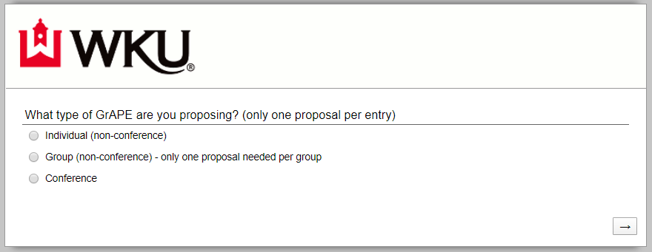
- Individual (seven additional steps)
  - Step Two:
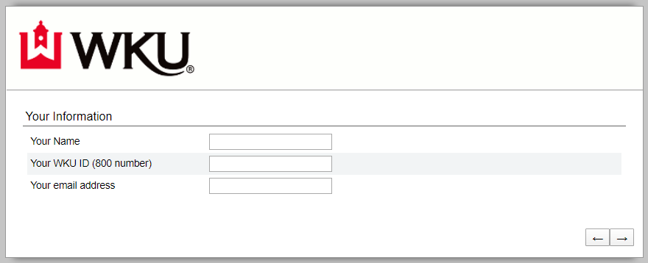
  - Step Three: 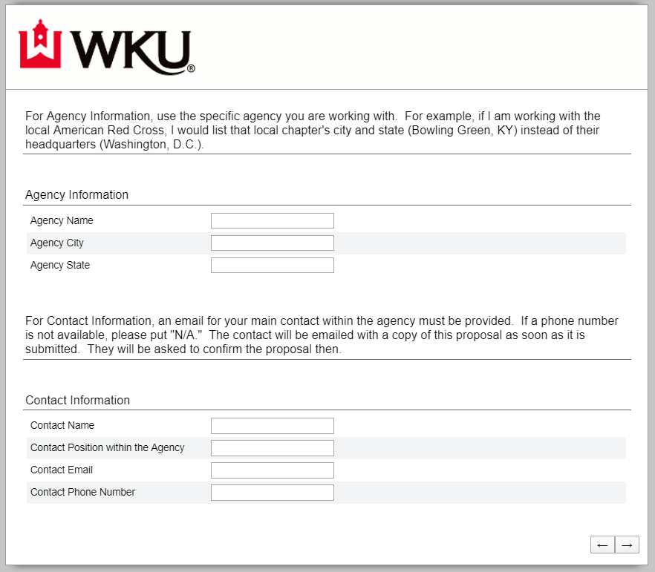
  - Step Four: 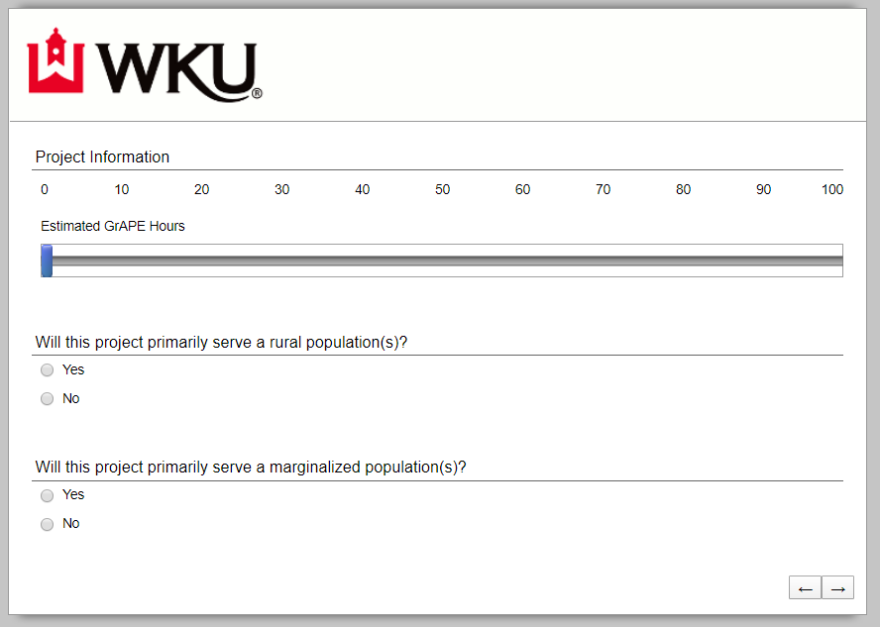
  - Step Five: 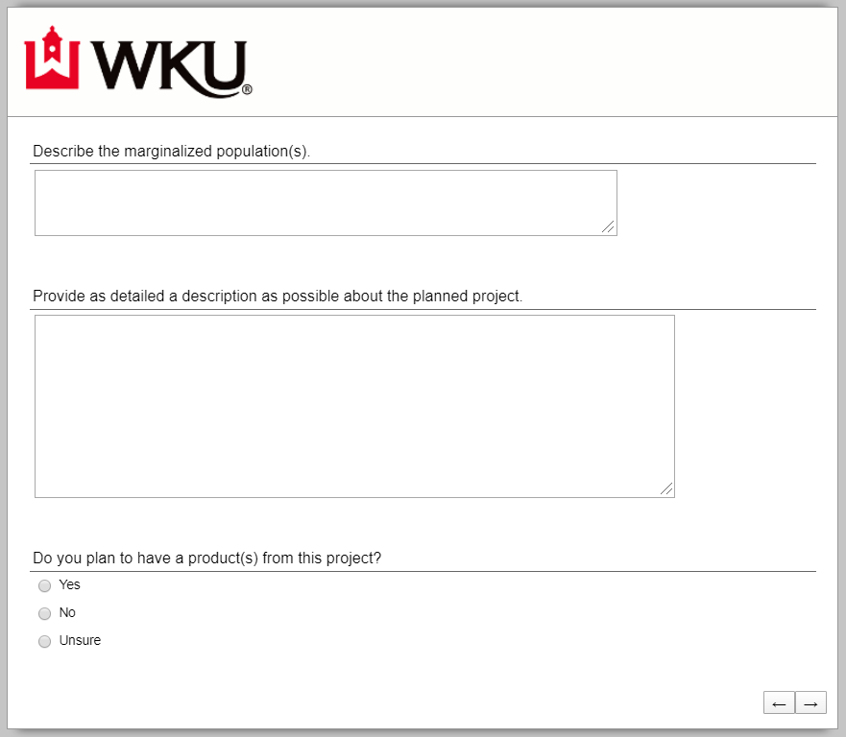
    - Note: The first question on this step will only appear if you answer “yes” to the previous question.
  - Step Six:
    - This step will only appear if you answer “yes” to the previous question.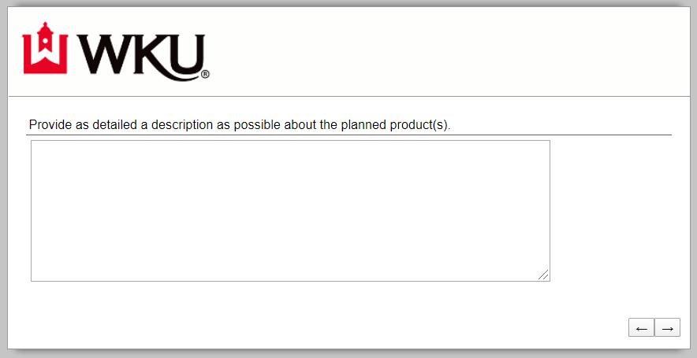
  - Step Seven:
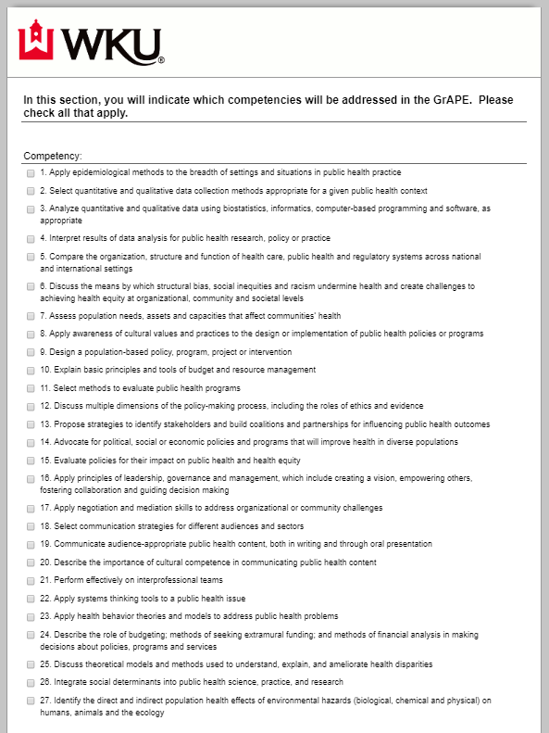
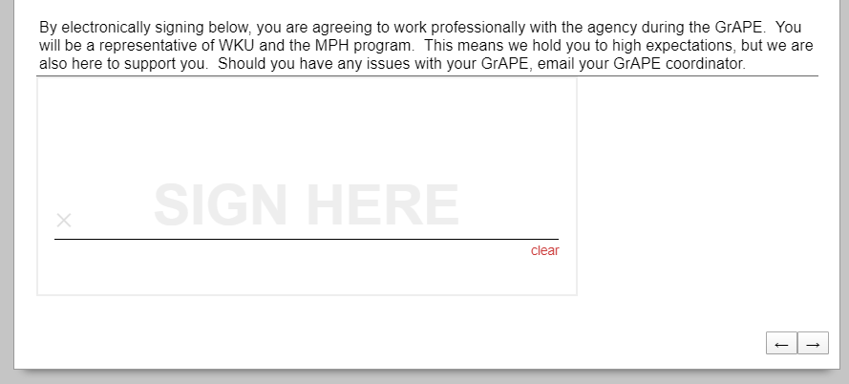
  - Proposal is complete when you see this page:
- Group (eight additional steps)
  - Note: Only one group proposal is needed per group project as long as everyone is working the same amount. If a group is split into separate projects, in which they plan to work different amounts of time and produce different work, each member should fill out an individual GrAPE form.
  - Step Two: 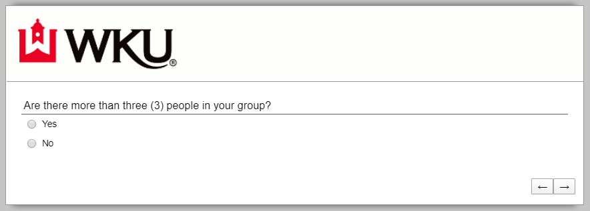
  - Step Three, if you answer “yes” to the previous question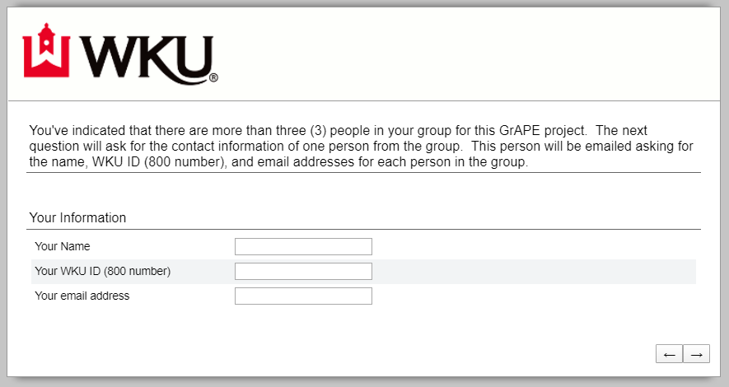
  - Step Three, if you answer “no” to the previous question 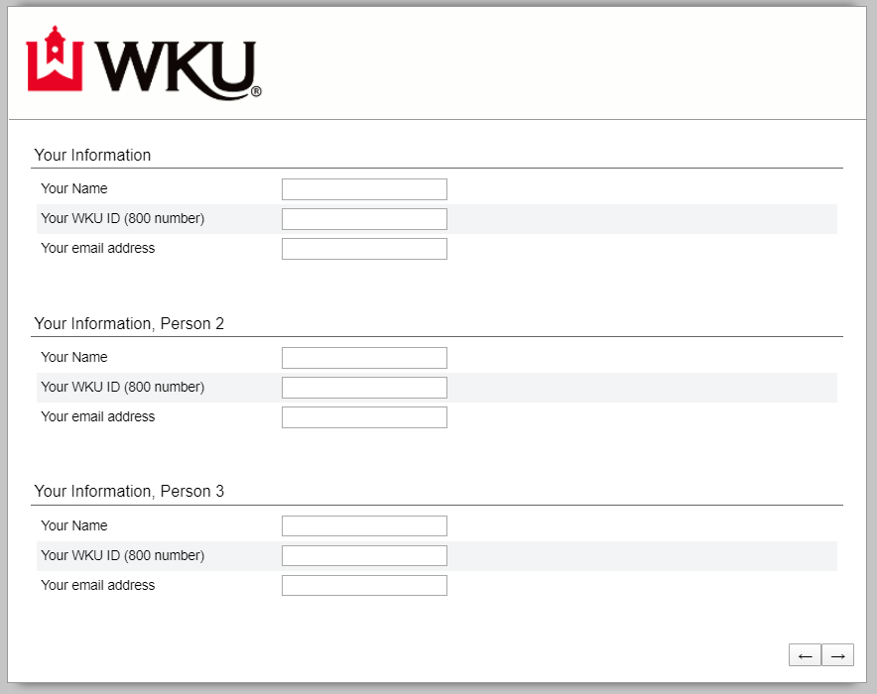
  - Step Four:
  - Step Five:
  - Step Six:
    - Note: The first question on this step will only appear if you answer “yes” to the previous question.
  - Step Seven:
    - This step will only appear if you answer “yes” to the previous question.
  - Step Eight:
    - Note: If there are more than three people in the group, the person whose contact information is on the initial proposal should sign. If there are two to three people in the group, all can sign or one “leader” can sign for all. In either case, each member needs to have read this agreement and act accordingly.
  - Proposal is complete when you see this page:
- Conferences, Trainings, Workshops (one additional step)
  - Step Two: 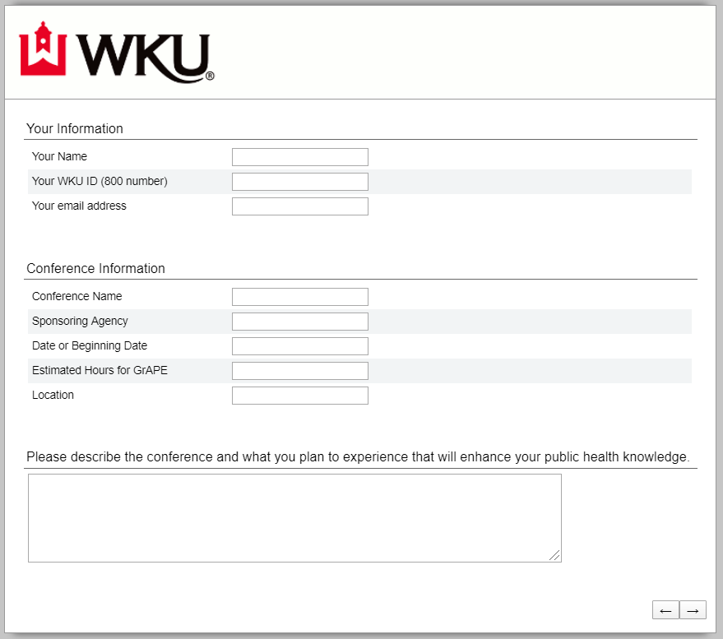
  - Keep in mind you will later be asked to submit the conference or training agenda with your summary report. Proposal is complete when you see this page:
- PH 546, Internship
  - Because this is for course credit, your main contact from the MPH program will not necessarily by the GrAPE coordinator. However, the Internship Agreement, which will serve as the GrAPE proposal, should still be sent to the GrAPE coordinator.
  - The Internship Agreement will be available through your internship coordinator.
- PH 588, Capstone
  - Because this is for course credit, your main contact from the MPH program will not necessarily by the GrAPE coordinator.
  - If an Internship Agreement is used, it will be available through your internship coordinator and should also be sent to the GrAPE coordinator.
  - If an Internship Agreement is not used, complete your proposal using the individual or group proposal above.

Tips
- Do not start working on the project until you submit your proposal and get approval from the GrAPE coordinator. If your proposal does not fit GrAPE requirements, you will need to re-design or better explain your project plan. Beginning work before you get approval could result in you having to do more work than necessary.
- Be prepared to complete every part of the proposal at one time. Collaborate with your contact from the agency to answer the questions that will be asked, even if you do not complete the proposal with them. A great way to do that is to pull up a copy of this handbook with them to go over the questions that will be asked.
- After the proposal is submitted, it will be sent to the contact you identified as your contact from the agency. They will be asked to look over it and confirm that they will work with you. They will also be asked to complete an evaluation after your project is complete. Therefore, you should be honest in completing your proposal and use any discrepancies between your expectations and the agency’s expectations as a way to refocus your project.
- If you or the agency ever need a copy of the proposal, contact your GrAPE coordinator.
- If you mess up in filling out your proposal, contact your GrAPE coordinator.

Step Four

Complete the Project
This step is fairly straight-forward. Once your proposal has been submitted and approved, you can begin your work with the agency to complete your GrAPE project.
If you have any issues while completing your project that the agency cannot address or that you feel uncomfortable talking to the agency about, contact your GrAPE coordinator immediately. We are working on a formal process of how to report instances of discrimination students may face during their work with outside agencies. We expect all agencies we work with to be held accountable to federal law, including ADA regulations and Title VII. However, we also expect public health and related agencies to go beyond what is required by law and uphold our program’s diversity, inclusion, and equity standards. If you feel as if the agency you are working with is not, please report it to your GrAPE coordinator. Actions will not be made with the agency as long as you are working with them unless you feel uncomfortable or unsafe. In those instances, we will communicate with you before we talk to the agency so as not to put you in a more uncomfortable situation or hurt your work. Reporting sources will be kept confidential as much as possible.

Tips
- Keep the GrAPE requirements in mind as you complete your project. Are you hitting all of the necessary competencies in your products?
- Keep a professional appearance and approach anytime you are working with the agency.
- This is a great opportunity to network. You can make connections through your GrAPE project that could help you with your research, your ILE, and your career.

Step Five

Gather and Submit Products
Before your work is complete with the agency, get their permission to submit your products to the GrAPE coordinator. Products are not made public with other students; MPH faculty, the GrAPE coordinator, and the accrediting body do see the products. Any confidential information can and should be blacked out or removed, especially in accordance with HIPAA. Even if information is blacked out, you should get permission from the agency you work with to submit documents as products. Any and all products you choose to submit should be emailed to the GrAPE coordinator. If a document is too big to email, please reach out to your GrAPE coordinator for an alternative option.

Tips
- Any products you want used toward your product requirement must be turned in within a month of you completing your project with the agency. If there is an issue with this timeline, please contact your GrAPE coordinator and CC your contact from the agency.
- You are only required to meet the requirements for two products, but if you want to send more to give the GrAPE coordinator and MPH faculty a better idea of the work you did with the agency, you are free to do so.
- Remember, at the end of your GrAPE work in total, you should have two (2) products that meet at least five (5) competencies, of which three (3) must be foundational. The foundational competencies are listed as #1 through #22.

Step Six

Complete the Summary Report
Need to get screenshots from the summary report

Tips
- Summary reports must be turned in within a month of you completing your project with the agency. This insures that post-GrAPE evaluations done by the agencies are as accurate as possible.

Step Seven

Check your Blackboard Grade
Once all of your work for one project has been submitted and looked over by the GrAPE coordinator, you should see your grade in Blackboard change for the MPH Students organizational site. There are two grades that you want to keep an eye on: (1) hours, of which you need 100 to be done, and (2) products, of which you need 2 to be done. If the work you submit is not acceptable, the GrAPE coordinator will email you to discuss a plan of action.

Tips
- If you think your GrAPE grades are incorrect, contact your GrAPE coordinator to have them revisit the work you have submitted to them.
- Remember, GrAPE hours will not be updated in Blackboard until a summary report is received. GrAPE products will not be updated in Blackboard until the products are sent to your GrAPE coordinator.

GrAPE Coordinator
Name: Marina Rust
Office: Academic Complex, 2nd floor, Room xxx
Email: marina.rust@wku.edu

Relevant Links
Proposal
Summary Report
Blackboard
GrAPE Coordinator Email

