Graduate Applied Practice Experience (GrAPE) Report

Opportunities
- Hooding Ceremony – missing things from some students
  - Slides may not be needed anymore
  - Orientation surveys are still required and I’m missing some from expected graduates
- 6 students out of expected graduates that are on my radar
  - Only 2 that I’m a little concerned about
- TFC Project – probably not going to be an option this time around
- GRDHD Project – still haven’t heard back, 1 voicemail and 2 emails
- If you have any creative ideas for student GrAPE projects now/this summer, please let me know. With closings, it is nearly impossible for students to work at an office. Really need telecommuting opportunities!
- Potential to make short Mediasite “how-to” videos to go along with GrAPE handbook
  - Maximum accessibility?

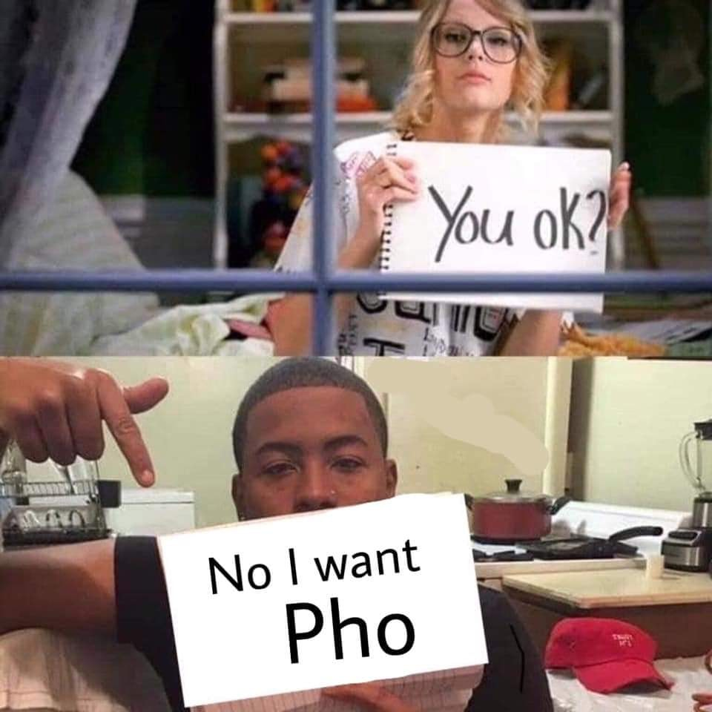
Changes
- The whole world
- Priority on two products connected to GrAPE projects for expected graduates
- Individual BRDHD projects are “closed” for the time being, except to those students who may also be employees of BRDHD

