Graduate Applied Practice Experience (GrAPE) Report

Opportunities
*We are getting GrAPE opportunities, but students are not taking them. However, there are still many students who have not completed their GrAPE work. Only about 4/53 have all GrAPE requirements filled.
*“What are products” – the question I was getting the most from students – if there are any faculty who don’t know how, reach out to me! I’ve added a little section on Blackboard for the students.
Course-embedded GrAPE with biostats and BRDHD!
RSO meetings to recruit – what will students pay attention to?
JUMP outreach – looking for students who fit criteria and ways to recruit them
Newsletter – looking to see if Publisher is more accessible; want more diversity of students highlighted next semester
Met with some independent health departments around the state (Hopkins Co, Lawrence Co)
Met with Scott Gordon to talk about outreach and recruiting
All active students should have received emails from me at the end of January for GrAPEs
Listserv for MPH alumni from most comprehensive list received from Scott Gordon

Changes
Changed unit language to hours on Blackboard; still waiting on MPH site update; will also need to update handbook
Access Database for MPH to run reports that are more accurate for what we need
Began tracking the career paths of our alumni on the Access Database
Active Course List per the request of Green River District Health Department
Finished up newsletter and accessible outline, sent out to alumni, MPH students, MPH faculty, public health partners
Lining up accreditation criterion with various surveys with Gardner
Started tracking GrAPE vine

Database Snip – student names, ids, and emails blacked out for privacy
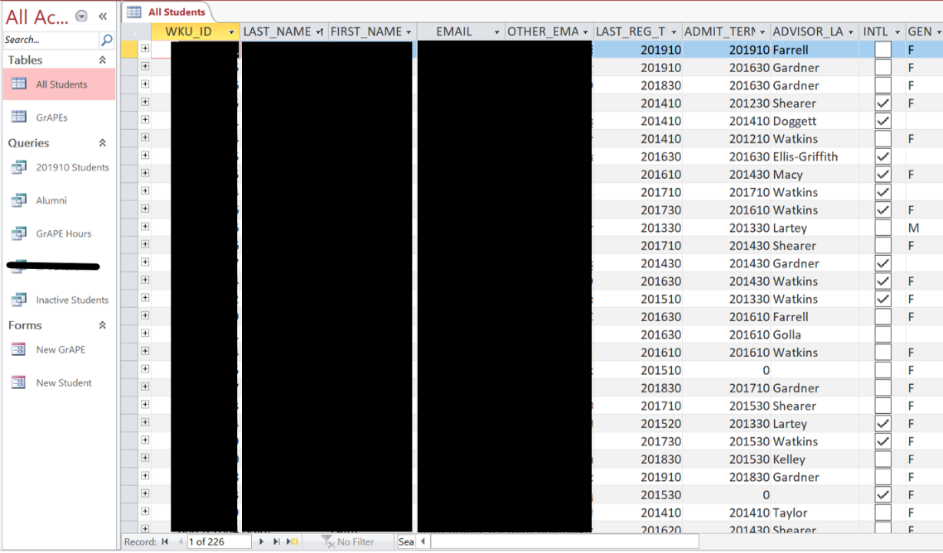
Spring 2019 Newsletter
