Department of Public Health
Hooding Ceremony
May 12, 2017 – HCIC 1011

Faculty INSTRUCTIONS

Please be in the HCIC lobby no later than 9:15 a.m. We will be taking group photos before the ceremony. Academic regalia is preferred, but your presence is more important than your outfit.

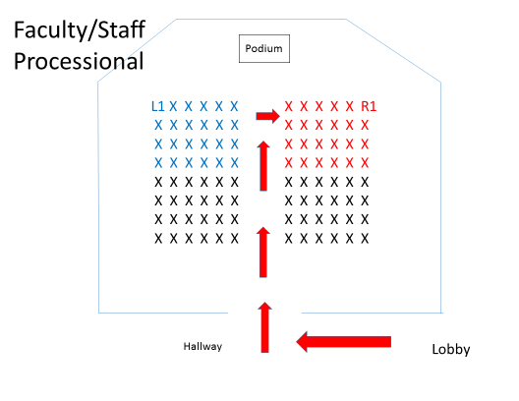
Faculty Processional
At 10 a.m., Gary will begin the faculty/staff processional, by walking up the central aisle and going to seat R1. He will be followed by Deans Lyon and Chumbler, then the graduate program coordinators. The rest of the faculty and staff will follow. Music will be cued and the student processional will begin. Please remain standing for the student processional.

Gary will walk to the podium once the last student is in place and we will all take our seats at that time.

You’ll remain seated throughout the ceremony. Afterwards, Gary will dismiss the students and they’ll do a formal recessional down the middle aisle. Faculty can follow, or exit on the side.

Next, we will eat cake and congratulate our grads. =)

