presents

Recital Name

featuring

Performer, Instrument/Voice Part

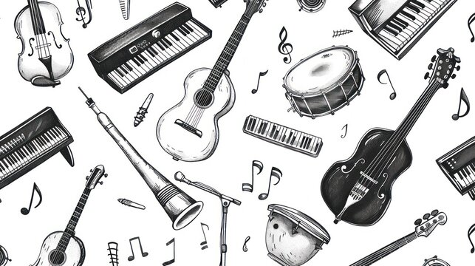

Long Date & Time (ex: Monday, March 31st, 2025 at 7:30 PM)
Location (ex: Fine Arts Center Recital Hall)

Program
(EXAMPLE) Vier Lieder Alma Mahler
- Licht in der Nacht (1879 – 1964)
- Waldseligkeit
- Ansturm
- Erntelied

Piece Title Composer
- Movement I (Yrs living)
- Movement II
- Movement III
Accompanist Name, Instrument

Piece Title Composer
- Movement I (Yrs living)
- Movement II
- Movement III
Accompanist Name, Instrument

Piece Title Composer
- Movement I (Yrs living)
- Movement II
- Movement III
Accompanist Name, Instrument

Program (or program notes if applicable)

Upcoming Events/Acknowledgements

