Processing a Faculty Applicant Pool in
Interview Exchange
Below are step by step instructions to process your search through Interview Exchange (IE). Click on the tabs below for instructions related to each topic. Contact Human Resources at 5-5934 with any additional questions.

LOG IN
Using Chrome or Firefox, access Interview Exchange by going to MyWKU and selecting Interview Exchange from the menu or by clicking this link:
https://www.interviewexchange.com/moduleredirect.jsp

MANAGE JOBS
“Manage Jobs” is the default Interview Exchange dashboard. The jobs to which you have been given access will be displayed under one of two tabs. “Open Jobs” is the default tab selection. Jobs in this list are still posted on the internet for applicants to apply. Access jobs that are no longer posted on the internet by clicking the “Closed Jobs” tab. If you are unable to see a particular job, contact your office associate and request to be given access to the job. It is the responsibility of the Office Associate/ Coordinator in your area to establish access to the job for the Search Committee.
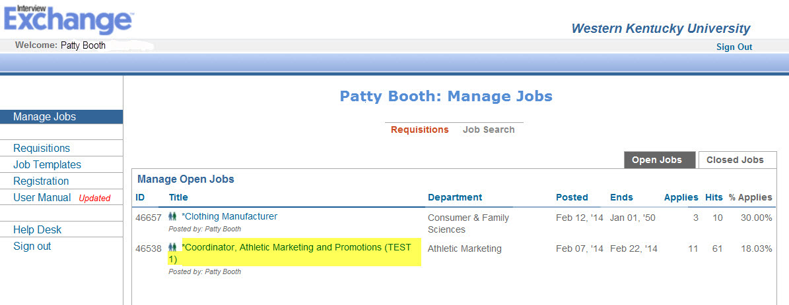
At the top of the screen you will also see a toolbar containing time saving tools to help you process your applicant pool. The toolbar is displayed in the screenshot below:
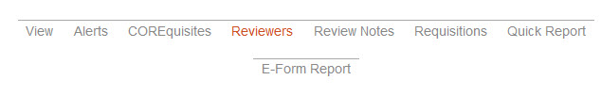

TOOLBAR OPTIONS
View
Click “View” to see the job posting. Scroll to the bottom to see the ”Posting URL” and the “Apply URL” which can be sent to applicant sources if desired.
Alerts
Hiring Officials and Search Committee members can begin evaluating the applicant pool as soon as applicants apply. To receive an email each time a candidate applies, click the Alerts link in the toolbar at the top of the page. By default, this function is turned off but the options available allow you to specify preferences that will generate an email each time someone applies.
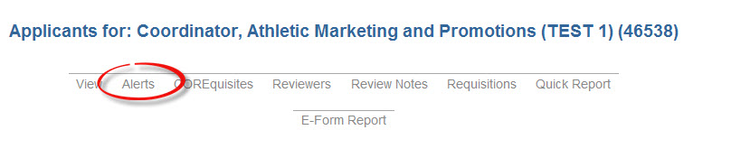
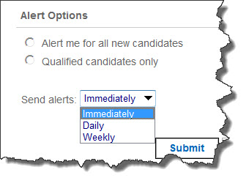

COREquisites (Comprehensive Occupational Requirements Evaluator)
Clicking the COREquisites link in the toolbar reveals the questions which appear in the position announcement. This OPTIONAL feature presents questions to applicants which are based on the required qualifications as they are listed in the position announcement. Applicants who answer all COREquisites “YES” are viewed under the “Qualified” tab on the shortlist. Applicants who answer at least one of the COREquisites “NO” are viewed under the “All Applicants” tab. This optional questionnaire which can include up to 10 questions, serves as a screening tool and is helpful in identifying qualified applicants vs. unqualified job seekers. The questions address specific skills, experience, and education judged to be essential to job success. They are created during the posting process by staff in Human Resources working in conjunction with the Search Committee Chair or Hiring Official.
Reviewers
Click the “Reviewers” link to see the list of all who have access to view this job. Those who have access are assigned a permissions level of either “Hiring Manager” or “Reviewer”. The permissions level assigned determines options that are available as described in the “Processing Applicants” section below. The Office Associate/Coordinator is responsible to add the members of the committee to this job so that each member will be able to access the applicant pool. To add reviewers:
- Click on “Reviewers” in the toolbar at the top of the screen as shown in the screenshot below:
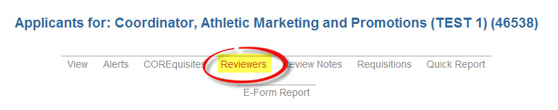
- Click “Search” and enter the email address of the committee member you wish to add
- Click “Select” to the left of the name and choose the applicable role (Hiring Mgr. or Reviewer)
- Click “Add Reviewers” to save.
If you are unable to find the name of a person on your search committee, contact Human Resources so an Interview Exchange account can be added for that individual.

Review Notes
Review Notes is a feature through which all communication regarding the search is stored. Communication between committee members, the chair and HR, EEO and HR is all generated through Review Notes. Notes originated from the “Review Notes” link from the shortlist screen pertain to the job in general. Notes originated from an applicant’s screen will pertain to that specific applicant. Click this option from the toolbar to see all activities which have transpired since the job was posted.

Requisitions
The Requisitions link displays a table containing a list of all requisitions that are associated with this job. Click on the title of the requisition to open it in a new window.

Quick Report
The Quick Report link allows the user to create an Excel spreadsheet that displays a list of options related to the applicants that are included in the report. This option is helpful in order to create custom lists of applicants. The report is available as a screen display if preferred.

PROCESSING APPLICANTS
Faculty positions generally remain “open” until the position is filled. An open position remains posted to the HR website and applicants can continue to apply until the position is moved to “closed” status.
The Shortlist
Access the Shortlist of applicants who have applied for particular job by clicking the title of that job from the “Manage Jobs” screen. Two tabs labeled “Qualified” and “All Applicants” appear on the top right corner on the Shortlist screen as shown below:
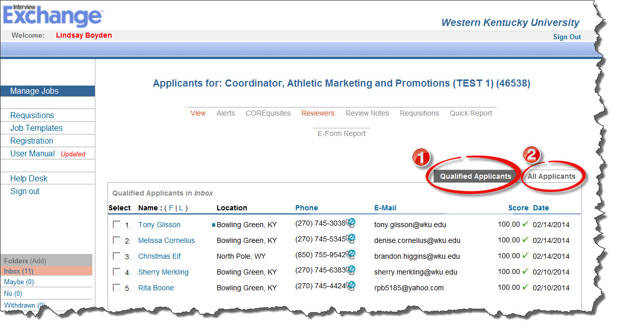

- contains only applicants who answered all CORErequisites “Yes”
- contains all applicants regardless of answers to COREquisites

Clicking a name in the Shortlist accesses the Applicant Screen from which a person with Reviewer permissions can:
- view all documents submitted i.e., CV, letter of interest, examples of work, etc.
- access links to electronic forms that were uploaded during the application process
- view answers to the COREquisites
- record notes about the candidate

In addition, a person with Hiring Manager permissions will be able to:
- email the candidate a question
- record interview dates and times for interviewees
- record the hire date of the successful candidate
- log a disposition for the candidate and list strengths/weaknesses

CONTACTING THE APPLICANT
A Hiring Manager can electronically communicate with the applicant from within the system using one of two methods provided:
- Use the “Ask this Candidate a Question” box: Use this method if the answer to the question does not require uploading documents or attaching additional information. Scroll to the bottom of the applicant screen and type your question in the box indicated. Submitting the question will generate an email to the applicant that contains a link and instructions to access their WKU Career Account. The applicant will see the question, type a response in the answer field and click “Submit”. The person who sent the question will then receive a notification. The answer provided by the applicant will appear on that individual’s applicant screen.
- Use the “Send an Email” feature: Use this method if you want to send the question to multiple applicants or if the response requires the attachment of a document. Access this feature by pulling down on the “Move to:” menu at the top right hand side of the applicant screen and choosing “Send Email”. From the email screen, you may either use the sample email templates or compose your own email.

INCOMPLETE APPLICATION
If the faculty profile appears to be incomplete, click “Mark as Incomplete” in the Electronic Form box. Then, using the email function described immediately above, send the applicant an email to notify him/her of the need to log back in to their account and complete the faculty profile. Marking the application “incomplete” resets the faculty profile so the applicant can access and edit it. This feature is only available to users with Hiring Manager permissions.

NOTES FROM REVIEW TEAM
Search Committee members should document their evaluation of each applicant by using the “Add a Note” feature in the “Notes from Review Team” field near the bottom of the applicant screen. By default, these notes are marked “Public” meaning they are viewable by anyone who has been given access to that job. Optionally, notes may be marked “Private” meaning they are viewable only to the author of the note and HR. The author can delete or edit notes.

MOVING APPLICANTS TO FOLDERS
Applicant information is contained within a set of electronic folders that appears on the lower left side of the Shortlist screen. All applicants start out in the INBOX folder. In order to move an applicant to another electronic folder, click “Move to:” as shown in the screenshot below and select the destination folder.
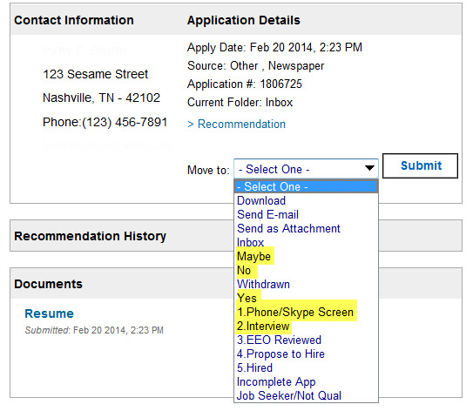
Click “Submit” and then “Next” at the top right corner of the screen.

Using the “Notes from Review Team” documentation, the Search Committee will evaluate each applicant. The Chair will sort the applicants to the YES, NO and MAYBE folders based on the committee’s level of interest pursuing that applicant. As the evaluation process is refined, applicants can be moved between folders as many times as necessary. Move Interviewees to the Phone/Skype Screen or Interview folder as appropriate.

JOB SEEKERS
View “Job Seekers” by clicking on the “All Applicants” tab. By definition, a Job Seeker is an applicant who applies for a position and, based on the answers given to the COREquisite questions, is deemed to lack at least one minimum qualification as specified in the job posting. Such an applicant will have a red X in the “Score” column of the ShortList. Follow steps 1-6 shown in the screenshot below to move all Job Seekers to the JOB SEEKER folder.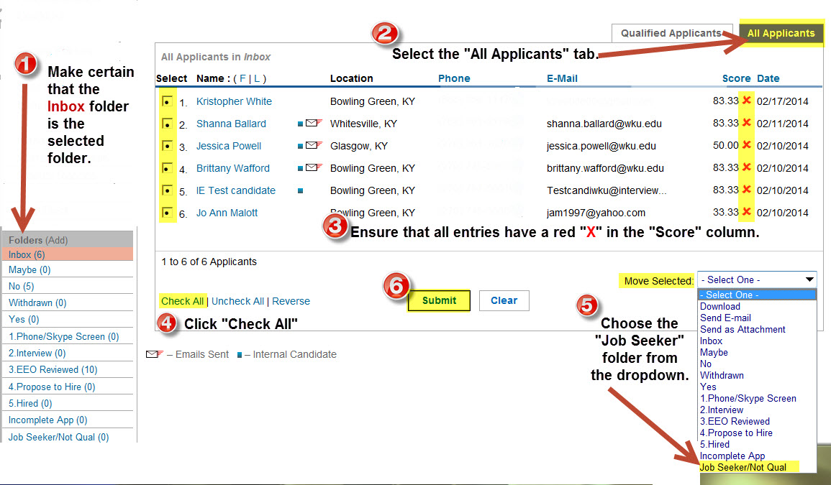

After moving the Job Seekers to the “Job Seeker” folder, there should be a zero in the parentheses next the Inbox folder.
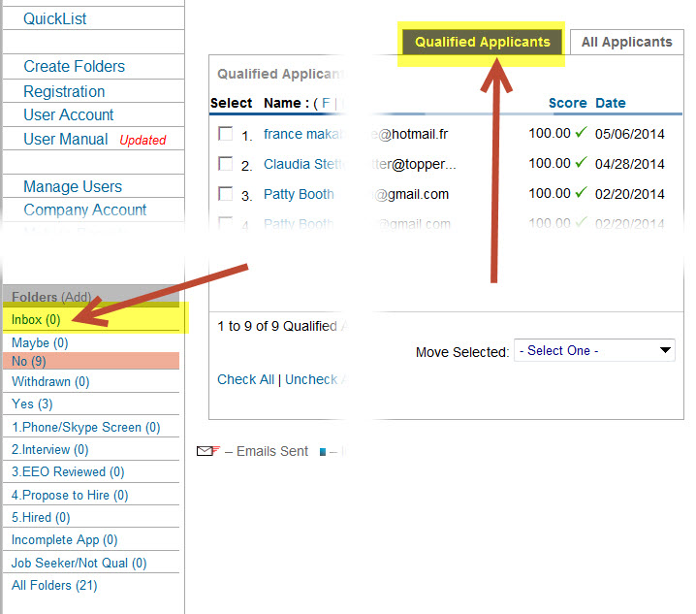

SUPPLEMENTAL APPLICANTS
Application instructions for faculty searches provide a deadline for receiving application materials. Committees have the option of moving materials received AFTER this date into the ‘Supplemental Applicant’ folder. These materials do not have to be reviewed; however, if at any point in the search, this folder is reviewed, ALL materials must evaluated. This will include new applicants going forward.

REASONS FOR REJECTION/DISPOSITION CODE
The Search Committee Chair assigns all applicants a “Reason for Rejection/Disposition Code” except for the hired person. Do not assign the Reason for Rejection until a candidate has been ruled out of consideration. Follow these steps to assign the Reason for Rejection:
- Click on the candidate’s name to access the applicant screen.
- Scroll down to the “Candidate Report Fields” to record a code for that individual.
- When the reason chosen is “Other”, provide justification in the “Strength & Weaknesses/Justification” field directly beneath the code field.
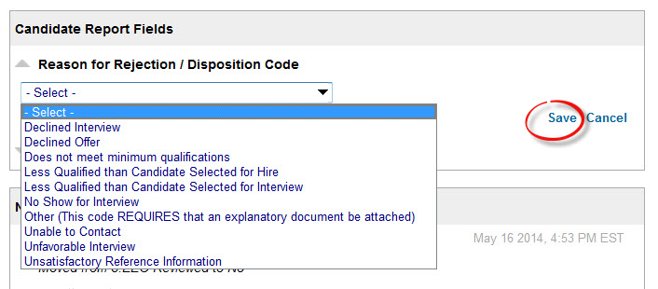

INTERVIEW PROCESS- (Approval Required)
After all applicants have been reviewed and moved to the appropriate folder, and ensuring that all candidates that you want to interview are in the Interview folder, notify HR by clicking on the “Review Notes” feature in the toolbar at the top of the screen above the Shortlist. Scroll to the bottom to the “Add Job Notes” field. Follow steps 1-4 in the screenshot below to send the email directly to HR.
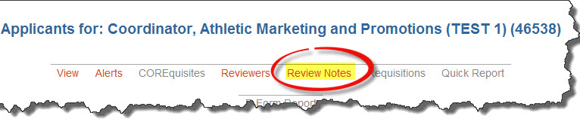
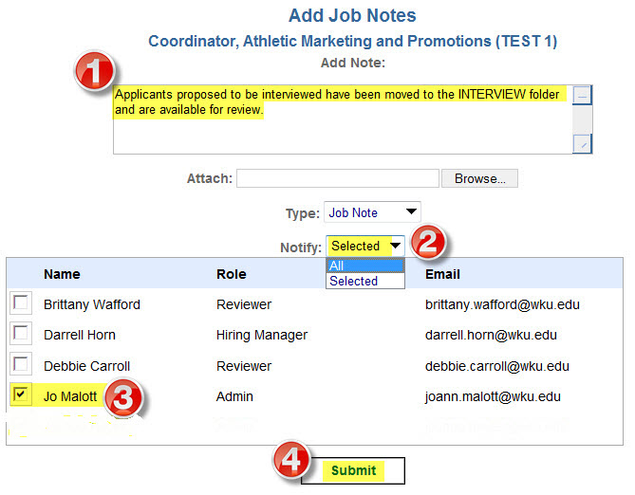
Clicking “Submit” will generate an email to HR.
HR will evaluate the work that has been completed on the applicant pool up to this point. Attention will be given to ensure that:
- all applicants who self-identified as minorities and females are fairly evaluated and considered
- an appropriate Reason for Rejection code has been selected for all applicants in the “No” folder
Once applicants to be interviewed have been reviewed, the Search Committee Chair will be notified that interviews can be scheduled through the “Review Notes” feature. Prospective interviewees will now appear in the EEO REVIEWED folder.
NOTE: Do not schedule interviews until you receive notification to do so.
Once interviews are scheduled, record the dates and times of the interviews in the “Report Dates” field at the bottom of each applicable applicant screen. To save the date and time, click the arrow highlighted in yellow as shown in the screenshot below. To create an Outlook meeting invitation to send to the members of the search committee, click the Outlook icon which is highlighted in green below.
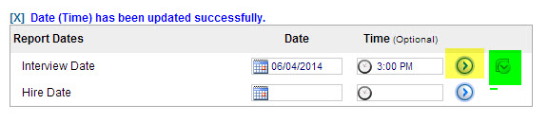
Record a list of Strengths and Weaknesses for each candidate who participates in a face-to-face interview. The Strengths and Weaknesses are logged as free form text in the field that appears below the disposition codes.
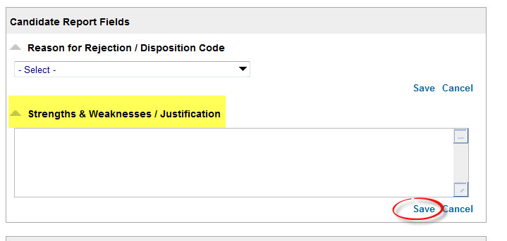

CHECKING REFERENCES
The Applicant Screen contains a References section that displays the names and phone numbers of the individuals whom the applicant listed as professional references. Contact referees by at least one of the methods described below:
- Contact the referee using the contact info provided and record the information in Review Notes.
- Click “Request Candidate for References” (highlighted in yellow below) to send an email to the applicant inviting them to request that their reference providers confidentially submit a letter of reference via the online system. A trigger is contained within the email that will then send an email from the applicant to the referee inviting the referee to submit a confidential reference on behalf of the applicant. The reference provided by the referee will show up as a link on the Applicant Screen.
- Click “Request Directly” (highlighted in green below) to send an email directly to the referee inviting them to submit a confidential reference on behalf of the applicant The reference provided by the referee will show up as a link on the Applicant Screen.
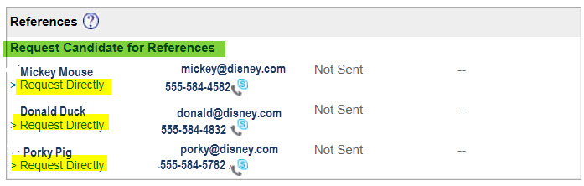

HIRING PROPOSAL- (Approval Required)
Once the Search Committee Chair has completed Strengths and Weaknesses for those candidates who were interviewed, the Hiring Official should be notified using the “Review Notes” feature. At that time, the Hiring Official will review the work of the Search Committee and make a hiring decision. The Hiring Official should move the successful candidate to the “Propose to Hire” folder and the Office Associate/Coordinator should be notified to complete a Hiring Proposal in the following manner:
- . From the Candidate page, select the “Recommendation” link as shown in the screenshot below:
- This provides a link to the Hiring Proposal:
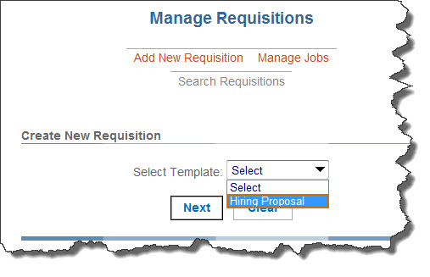
The highlighting on the screenshot below indicates the fields required to be completed.
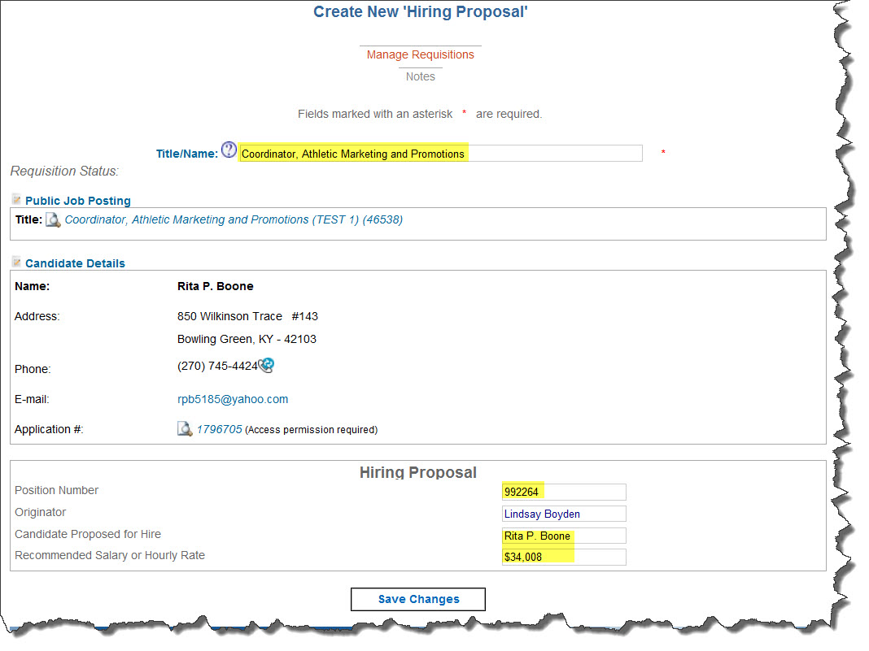

- After clicking “Save Changes” on the Hiring Proposal, complete the Approval Queue as shown in the screenshot on the following page. Based on the “Approver Title” listed, enter the name of the appropriate individuals to approve the Hiring Proposal. Names which are already selected in certain fields cannot be overridden. If a particular title is not applicable to your Hiring Proposal, simply leave it blank. Include approvers whose title does not appear in the blank spaces that will generate the proper approval order.
**IMPORTANT** Click “SAVE” before clicking “Send for Approval”.
Once the Hiring Proposal has been submitted, move this candidate to the “Propose to Hire” folder.
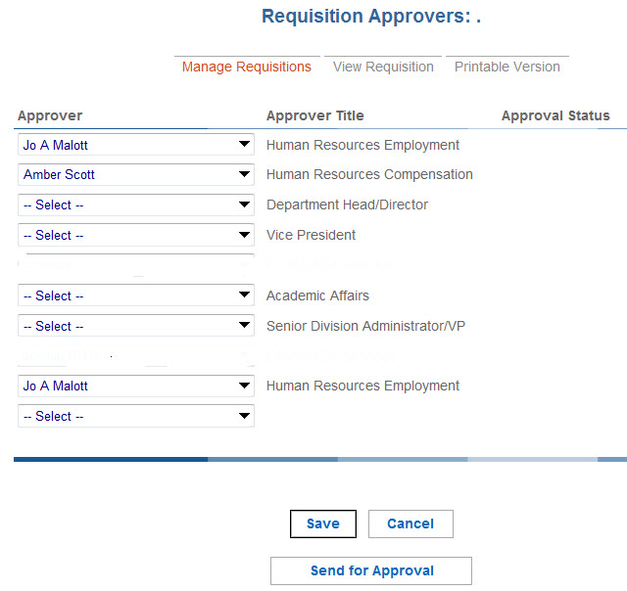
The originator of the Hiring Proposal will receive email notification from Interview Exchange when the Hiring Proposal has been approved by all approvers. Upon receipt of that email, the offer of employment can be extended.
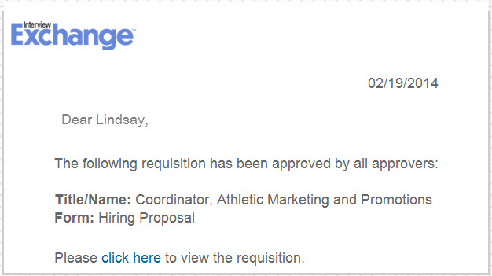
If the offer is rejected, go back to the EEO REVIEWED folder to select another candidate to whom an offer can be made. Following the instructions above, create a Hiring Proposal for that individual. Proceed with the offer once that proposal is approved. Repeat this process until a candidate is hired or until the search is declared failed.

BACKGROUND CHECK and EPAF
Once the employment offer is accepted, create the EPAF and initiate the Background Check using this form:
https://intranet.wku.edu/php/prod/Forms/BCR1.php
When completing the background check request form, you will be asked who needs to be notified when the check is complete. Once the check is complete, an email will be sent to that person. Move the successful candidate to the “Hired” folder once the EPAF is approved.
**NOTE: The initiator of the background check request form will need the applicant’s 800 number OR last 4 of the SSN. Only enter the last 4 of SSN if an 800 has never been created. If last 4 of SSN is submitted, an 800 will be created and sent to initiator for epaf submission. Human Resources can verify this information, if needed.

The requestor and the individual named in the “Notify” section of the form will receive a notification when the Background Check is complete. Move the successful candidate to the “Hired” folder once the EPAF is approved.
Record the Hire Date in the “Report Dates” field as shown:
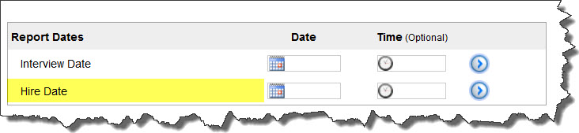

FINAL DETAILS- MUST BE COMPLETED TO CLOSE JOB
- ELECTRONIC FOLDERS
Candidates whose application materials are in the “Yes”, “Phone/Skype Screen”, “Interview” or “EEO Reviewed” folders should remain in those folders. Do not move them to the “No” folder. No candidates should remain in the “Inbox” or “Maybe” folders at the conclusion of the search. Ensure that every candidate, other than the candidate hired, has been assigned a Reason for Rejection/Disposition Code.
- NOTIFY UNSELECTED CANDIDATES THROUGH INTERVIEW EXCHANGE*
Candidates appreciate knowing where they stand in terms of employment in job searches. A professional, thoughtful and kind communication lets them know. Whether you prefer to make personal contact with the individuals via a phone call or if you prefer written communication via mail or email, it is imperative that you follow up with each candidate. Interview Exchange provides two template regrets emails, one for candidates who were interviewed and another for candidates who were not interviewed. To access and utilize the templates, follow these steps:
- Click on the electronic folder called “All Folders” and choose the “All Applicants” tab
- Click “Check All” and then deselect the applicant who was hired as well as those applicants who were interviewed since they will receive a different email
- From the “Move Selected” dropdown, choose “Send Email” and click “Submit”
- Click Sample Mail Templates
- Choose the appropriate template pertinent to the situation and recipients listed and click “Select”. You may edit the text if you wish.
- Click the radio button next to “This email message does not require a response.”
- Check the box next to “Check this box when you are ready to send”
- Click “Send Email”
- Repeat these steps for the applicants who WERE interviewed choosing the applicable template for interviewed candidates.
*NOTE - If you wish to contact the applicants outside the Interview Exchange email system, please “Add a Note” at the bottom of the Applicant Screen denoting that you did contact the person to inform them that another applicant had been hired.

