600 B Bill Ferguson Rd.
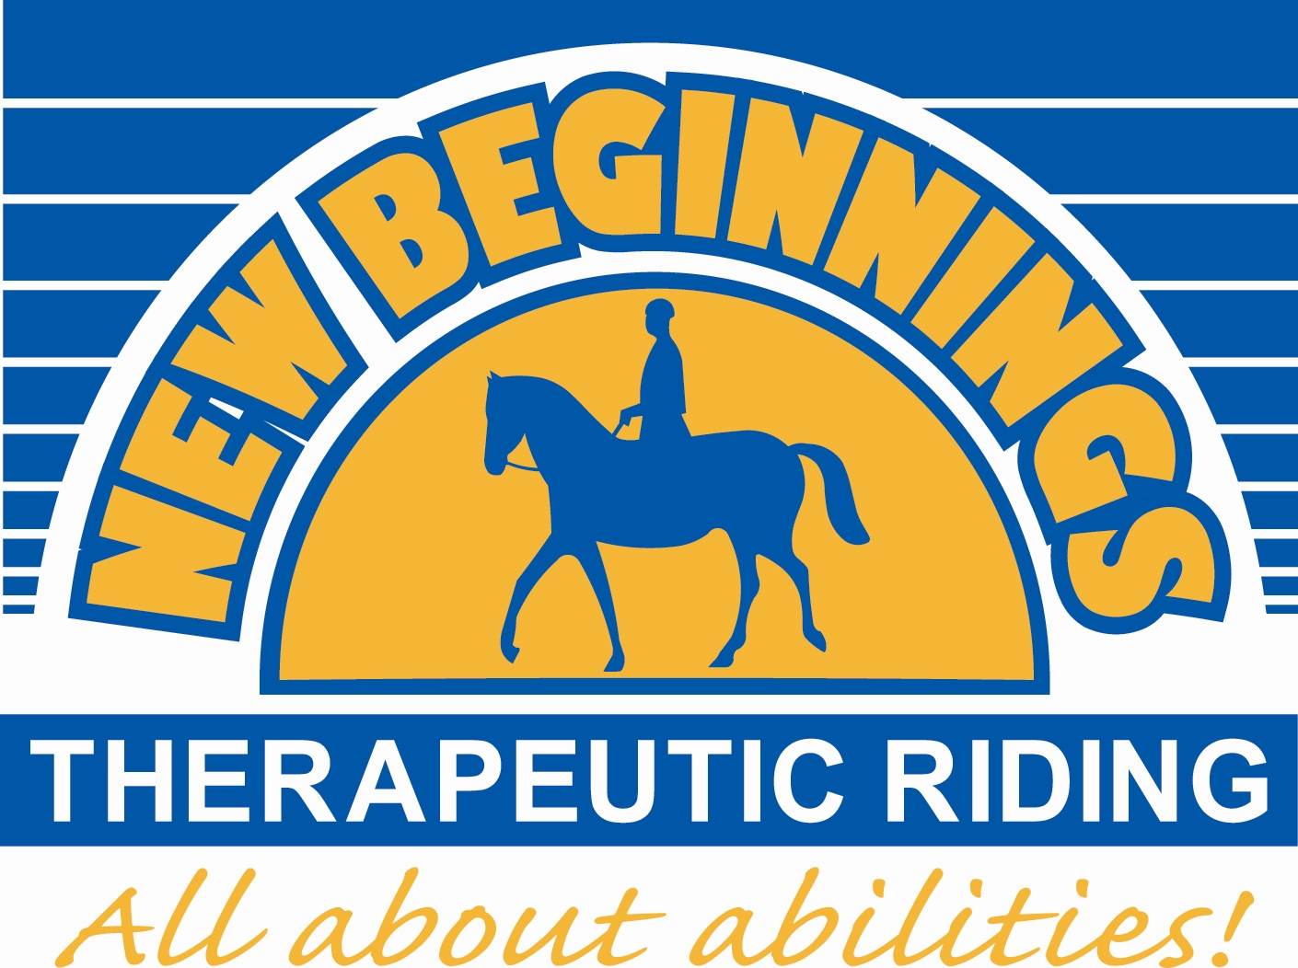
Bowling Green, KY 42101
Phone: (270) 777-3600
newbeginningstrc@gmail.com
www.nbtr-bg.org
Dear 2021 Prospective and Returning Volunteer,

We are very excited that you have shown an interest in volunteering at New Beginnings Therapeutic Riding, Inc. (NBTR). Volunteers are a vital part of this program and without them the program will cease to exist. All new and returning volunteers must complete the following volunteer packet and attend a volunteer orientation. If at any point in time information changes please contact us immediately.

NBTR is a Premier Accredited Center with the Professional Association of Therapeutic Horsemanship, Intl. (PATH, Intl.), one of four within the state of Kentucky. What does this mean? We offer Warren and surrounding counties the highest quality and safest equine assisted activities and therapies to individuals with behavioral, emotional, mental and physical disabilities. NBTR is very dependent upon volunteers to help us reach our mission.

Volunteers are needed in many aspects of the organization: being a horse leader, side walker, helping in the office, fundraising, help feed and care for the program horses and much more.

When we schedule students for their riding lessons, we look for volunteers that can assist at the student’s scheduled time. If you need to cancel, we ask that you notify us at least 24 hours in advance so that we can try to locate another volunteer to fill your spot or cancel our rider(s) accordingly. Please notify NBTR staff of your scheduled date of absence via phone, email, or note it on the wall calendar in the office.

Our Insurance carrier requires orientations for all volunteers, students and parents/guardians before participating in our program. Mandatory orientations are scheduled and must be attended prior to participation in our program. Please contact our office, view our website www.nbtr-bg.org or visit our Facebook page for scheduled orientation dates.

We appreciate your interest and look forward to working with you. Your experience will be rewarding and satisfying, leaving you with a good feeling about individuals with disabilities and their capabilities working a horse. Thank you in advance for your commitment and please feel free to contact us at 270-777-3600 if you have any questions or concerns.
Sincerely,
NBTR Staff

Volunteer area definitions:
Groom: retrieving needed horses from stall/field, thoroughly brushing horse and cleaning hooves, putting on the correct tack needed, leading horse to arena for class, retrieving horse after lesson, taking off tack after lesson, disinfecting tack, putting tack back in correct spots, and taking horse back to stall/field as needed.

Horse Leader (HORSE EXPERIENCE A MUST and additional training necessary): maintain control of the horse throughout the entire lesson. Maintaining control of horse will vary with each student and their ability. Horse Leaders guide the horse with a lead rope attached to the horse’s bridle. This requires being able to walk/jog beside horse’s head, stop, turn, and back horse as needed. The horse leader will retrieve the horse from the Groom, proceed with the lesson, and Groom will retrieve horse from Horse Leader after lesson.

Side Walker: students could have 1-2 side walkers and their primary responsibility is keeping the student safe and an extension of the instructor. Could be asked to jog beside the horse and student while ensuring student stays balanced/centered in the saddle. Side Walker may be required to perform different “holds” on student (ankle hold, knee hold, over-thigh hold, belt hold) and encourage student to stay on task/focused during lesson by keeping their attention directed to the instructor and their directions. Instructor will always inform Side Walker of interaction needed during lessons depending on student.

Closer: Closer is required to arrive at barn by the time the last scheduled class starts. Duties include but not limited to, taking horses to correct field after lessons, cleaning stalls/aisleway, sweeping grooming bay, help disinfect and put away tack/equipment after use, locking gates, closing/locking doors, turning off lights/fans, giving minis hay, etc. Closers are typically the last volunteers to leave the barn before instructors/staff leave and lock main entrance doors. This position is accessible to JR. Volunteers as well.

Feeding Crew AM/PM (HORSE EXPERIENCE A MUST and additional training necessary): While there is no “set” time for horses to be fed in the AM or PM there must be at least 4 hours between AM and PM feeding. It is encouraged that horses are fed in the morning between the times of 7:00AM-10:00AM and before 4PM in the afternoons. On average, feeding takes between 1hr-1 ½ hrs. so please plan accordingly. Feeder is required to take grain to horses in designated fields, safely tie horses to fence post, dump grain in buckets, untie horses once finished, and refill grain buckets for next feeder. During winter months haybales may be required to be taken to fields and disbursed. After feeding is done, feeder is required to clean the mini’s aisleway and fill sensory trail water trough if needed.

Groups: Volunteers who wish to help with group classes will be informed of the days/times groups plan to arrive at barn. Volunteer will arrive at least 1 hour before scheduled group time to help prepare for group. Preparing for groups includes bringing horses in from fields, preparing needed equipment, and discussing with instructors the goal/activities planned for the group. This position requires interacting with horses and people while modeling correct horse safety throughout planned activities and maintaining an appropriate and professional attitude throughout session. After group has finished volunteer is expected to help put away equipment, clean up, and take horses back to field as needed.

Junior Volunteer Program: Designed for our young volunteers between the ages of 9 and 14 years old, typically have the opportunity to volunteer at the barn 1-2 scheduled Saturday mornings of the month. Parents/guardians will be notified at least 2 week prior to scheduled Jr. Volunteer day/times. The Junior Volunteer Program is designed to help educate young volunteers on horse safety and care, barn maintenance, and working in a therapeutic program through a fun and safe environment. The time Jr. Volunteers spend at the barn is a combination of work, play, and interactive learning! Juniors will spend time helping with needed barn chores that will vary, helping with the care/wellbeing of the program horses, and learning how to safely interact with horses on the ground. NO horse riding will take place during Jr. Volunteer hours.

VOLUNTEER GUIDELINES

A orientation will be scheduled each month and one must be attended before volunteering
- Volunteer arrives at least 15 minutes prior to their scheduled times.
- Always sign in and note your volunteer start and end time.
- ALL volunteers MUST wear their volunteer name tags.
- Always check the main communication board located across from the tack room when you arrive for your job assignment and what projects need to be completed that day.
- Volunteers should never be alone with a student or junior volunteers. Always have another Volunteer or Instructor present with you.
- Junior Volunteers (ages 9 to 14). Will be supervised by the Volunteer Assistant, Volunteer Coordinator or Head Instructor
- When volunteers are assigned to students:
- Must be at least 14 years of age and physically fit to walk approximately an hour and jog occasionally.
- Volunteer MUST have completed a horse leader and/or primary/secondary side walker training before they can work with students.
- The volunteer will be under the supervision of the assigned instructor
- The volunteer should meet with the instructor prior to the student’s riding lesson to discuss any goals/concerns
- When they are to receive their student
- When they assist the student with the proper equipment and activities throughout the lesson
- After the lesson, the instructor will direct the student to their parent/guardian
- Students do not to enter the barn/class area unless accompanied by an instructor/designated volunteer/NBTR staff.
- Inform us of any accidents or injury occurring on the premises immediately.
- No smoking, chewing tobacco or chewing gum on premises.
- No pets allowed on the premises (unless service dogs).
WEATHER AND CANCELLATIONS
NBTR follows the Warren County School Polar Report for school cancellations for snow, ice and any inclement weather. Classes will be cancelled if a tornado warning is in our area, if the actual inside barn temperatures reach 100 degrees or above, or lower than 40 degrees or if the heat index is above 100 degrees. If anytime you feel uncertain if your time is needed please call the office or check our Facebook page.
SCHEDULING
Volunteering is a commitment. Volunteers are needed in many aspects of the organization: being a horse leader, side walker, helping in the office, fundraising, help feed and care for the program horses and much more. We need to have enough volunteers available for each rider so their ride can be safe and enjoyable. It is paramount that when you commit to a time that this time is kept because if we do not have enough volunteers for the day, a rider may not be able to ride. However, we do understand that special circumstances can occur and you may need to cancel your scheduled time. When this occurs, we ask that you contact us immediately or at least 24 hours before your scheduled time.
PROPER ATTIRE
Volunteers need to wear long pants, thigh length shorts, NO tank tops or spaghetti strap tops, NO dangly jewelry, NO tops with inappropriate advertisements and closed-toe shoes. Hats, caps and sunglasses are good. NBTR has the right to refuse a volunteer if not properly attired. Aftershave and perfumes can attract stinging insects, please be careful of wearing these while at the barn.

LIABILITY RELEASE
As a volunteer at New Beginnings Therapeutic Riding, Inc., I acknowledge the risk and potential for risks of a horseback riding program. However, I feel that the possible benefits to me and the clients I work with are greater than the risk assumed. I am aware that horses can kick, bite, throw riders or otherwise cause injury to riders or other persons in the vicinity. I am aware that horses can act in accordance with their own will. I am aware that horseback riding or working in close proximity with horses, or performing maintenance tasks on the program’s grounds or facilities, including those grounds which may comprise part of the Pine Spring Stables property owned by Kenny and Jackie Reynolds, is a hazardous activity, and am voluntarily participating in this activity with knowledge of the danger involved and accept any and all risks of injury. I hereby, intending to be legally bound, for myself, my heirs and assigns, executors or administrators, waive and release forever all claims for damages against New Beginnings Therapeutic Riding, Inc., its board of directors, instructors, therapist, volunteers and/or employees for any and all injuries and/or losses I may sustain while participating in New Beginnings Therapeutic Riding, Inc.’s program.

The following reprint of Kentucky Statute is provided for information:
WARNING Under Kentucky law, a farm animal activity sponsor, farm animal professional, or other person does not have the duty to eliminate all risks of injury of participation in farm animal activities. There are inherent risks of injury that you voluntarily accept if you participate in farm animal activities.
(Kentucky Statute Title XXI Chap. 247)

VOLUNTEER CONFIDENTIALITY AND NON-DISCLOSURE AGREEMENT
As a volunteer or parent/guardian for New Beginnings Therapeutic Riding, Inc. you may obtain information about the medical condition, diagnosis or treatment of program participants. This information is highly confidential, and NBTR makes every effort to protect the confidentiality of program participant medical information. As a volunteer, you must respect this confidentiality and not share such information with any person or organization outside NBTR, or utilize the information for any purpose not directly related to your provision of volunteer services to NBTR.

VOLUNTEER DISMISSAL POLICY
Volunteers and guests may be asked to leave the center for any of the following reasons:
- Disruptive behavior that is counterproductive to the benefit of anyone equine or human at NBTR.
- Threatening of the safety of any equine, human or self at NBTR.
- No longer suited, or perform the activities assigned at NBTR safely.
Procedure:
- All volunteers who meet the criteria of dismissal will be asked to meet with the Volunteer Coordinator and Program Director to discuss the behavior in question.
- The Volunteer Coordinator and Program Director will work to educate and outline the appropriate expected behavior at NBTR.
- If the volunteer is receptive and willing to perform the expected behavior, then support and education will be implemented by the NBTR staff.
- If the volunteer is not receptive to the expectation of behavior, the volunteer will be asked to leave the NBTR program. Therefore, dismissed from the NBTR property or returning in the future without permission.
- The volunteer will be sent a signed, dated letter confirming the expected actions as a result of the meeting.
- An additional copy of the letter will be printed and placed in the volunteer’s file.

PHOTO/NAME RELEASE
I (CIRCLE ONE) consent non-consent to and authorize the use and reproduction by New Beginnings Therapeutic Riding Inc. (NBTR) of any and all photographs and any other audio-visual materials taken of me/my son/my daughter/my ward for promotional material, educational activities, and exhibitions or for any other use for the benefit of the program. I also hereby consent to and authorize New Beginnings Therapeutic Riding, Inc. (NBTR) to identify me/my son/my daughter/my ward by full name and use my/my son’s/my daughter’s/my ward’s full name for promotional printed material, educational activities or for any other use for the benefit of the program.

IF YOU MUST CANCEL
If you need to cancel, we ask that you notify us at least 24 hours in advance so that we can try to locate another volunteer to fill your spot or cancel our rider(s) accordingly. Please notify NBTR staff of your scheduled date of absence via phone, email, or wall calendar in the office.
I have read and understood all of the above information given to me by New Beginnings Therapeutic Riding Inc. (NBTR) and agree to abide by this. Failure to do so could result in dismissal of the program.

Date: ___________ Signature: _____________________________________________________________________
Volunteer or Parent/Guardian (if volunteer under 18 yrs of age)
Volunteer’s Name (Please print): ___________________________________________________________________
Volunteer or Parent/Guardian (if volunteer under 18 yrs of age
For Staff ONLY VO: ___ SW: ___ HL: ___
Notes: ____________________________________
VOLUNTEER INFORMATION

Volunteer Name (Please print): __________________________________________________________________ Date: __________
Home Phone: ___________________________ Cell Phone: _______________________________ Work Phone: ________________ Birthdate: _________________ Age: ________ Female: _____ Male: _________ Email address:______________________________
Occupation: ____________________________________________ Employer: ______________________________________________

How do you want to be reached? (circle any that apply) Text Call Email

What days during the week would you be available to volunteer? (circle any that apply)
“Morning” ranges between 8:00am-noon. “Afternoon” ranges between 4:00pm-7:30pm
Monday (morning/afternoon) Tuesday (morning/afternoon) Wednesday (morning/afternoon) Thursday (morning/afternoon) Friday (morning/afternoon) Sat. (morning/afternoon) Sun.(morning/afternoon)

What areas of the program are you interested in? (PICK more than one) (REFER to page 1 and 2 for definitions)
WEEKLY OPTIONS: These volunteer positions are needed weekly to ensure classes will take place and horses will be taken care of. Side Walker____ Horse Leader____ Groom____ Closer____ Feeding Crew AM____ Feeding Crew PM____ Group Classes____ Junior Volunteer Program (ages 9-14)____

“AS NEEDED” OPTIONS: These volunteer positions vary upon date/time when volunteers will be needed.
Barn/Work Crew____ Fundraising/Special Events____ School Groups____ Office Work____ Marketing/Advertising____ Photography/Video____

Depending on your choices above, what skills/experience do you have relating to the options you picked? (Note: No horse experience is required for any positions (except for horse leader); we simply want to ensure you are put in positions where you are comfortable and willing to learn.) __________________________________________________________________________________________________________________________________________________________________________________________________________________________
Would your employer be interested in receiving information about our Program, become a fundraiser sponsor, contributor/donor to our scholarship program? YES or NO If so, who should we contact? _____________________________________________________
Returning volunteer, do you wish to work with a particular rider? Yes: ___ No: ___ If yes, list the rider’s name: __________________
How did you hear about NBTR? ___________________________________________________________________________________
What would you like to achieve by volunteering for NBTR? ______________________________________________________________
Do you have any limitations (asthma, joint or back issues, etc.)? Explain: ________________________________________________

Are you able to jog a lesson (at least 30 minutes off and on): Yes ___ No ___

List any health concerns (diabetes, heart disease, allergies, joint issues, epi pen etc.): ______________________________________
_____________________________________________________________________________________________________________
What horse experience do you have? (None is required) ________________________________________________________________
Do you have any experience working with individuals with disabilities? ____________________________________________________
_____________________________________________________________________________________________________________
Have you ever been convicted of any crime not including a traffic violation? If yes, please explain: _______________________________________________________________________________________________________

Do you have a driver license? Yes ___ No ___ Please provide your driver license #: _______________________________________
600 B Bill Ferguson Rd.
Bowling Green, KY 42101
Phone: (270) 777-3600
newbeginningstrc@gmail.com
www.nbtr-bg.org
Authorization for Emergency Medical Treatment Form & Background Check
MANDATORY

In the event of emergency medical aid/treatment is required due to illness or injury during the process of receiving services, or while being on the property of the agency, I authorize New Beginnings Therapeutic Riding, Inc. to:
1. Secure and retain medical treatment and transportation if needed.
2. Release client records upon request to the authorized individual or agency involved in the medical emergency treatment

Volunteer’s Name (Please print): _______________________________________________________________________________
Address: _____________________________________________________________________________________________________
City: ___________________________________________________________________ State: _____________ Zip Code: _________
County: ____________________ Home Phone: ___________________________ Cell Phone: _______________________________ Work Phone: ____________________________ Birthdate: _________________ Age: ________ Female: _____ Male: _________
Physician Name: _______________________________________________________________________________________________
Preferred Medical Facility: ________________________________________________________________________________________
Health Insurance Co: ____________________________________________________Policy #: _______________________________
List any health concerns (diabetes, heart disease, allergies, joint issues, epi pen, etc.): ______________________________________ _____________________________________________________________________________________________________________
List any medications: ___________________________________________________________________________________________
Name of Parent/Guardian of Volunteer under the age of 18 (Please print): __________________________________________
Address: _____________________________________________________________________________________________________
City: ____________________________________________________________________State:__________Zip Code: ______________
County: _____________________ Home Phone: __________________________ Cell Phone: _________________________________
Work Phone: _____________________ Email address: ________________________________________________________________
Occupation: ____________________________________________Employer:__________________________
In case of emergency Contact: _______________________________________ Phone: ___________________
Contact: ____________________________________________ Phone: __________________

Information Background Check
AUTHORIZATION FOR A RECORD CHECK – over age 18 ONLY

I, ________________________________________________________________________________________________________
(Print first name, middle name, and last name)
Living At: __________________________________________________________________________________________________
(Street Address, City, State, Zip Code)

Do you hereby authorize any lawful enforcement agency to which this request is directed, to search their police records for any arrest, conviction, or information they may have regarding me, and to make this information available to New Beginnings Therapeutic Riding, Inc., for which I have applied to perform volunteer work.

My Description: Birthdate: _____________________ SS#: _____________________________ Eye Color: ______________
Hair Color: ________ Height: _______Weight: ___________ Scars, Marks, or Tattoos: _____________________________________

Date: ___________ Signature: __________________________________________________________________
Volunteer’s Name
Date: ___________ Signature: __________________________________________________________________
(Signature of NBTR Staff member requesting this information)

