EXECUTIVE SUMMARY

Funding Trends

While private gifts serve as the margin of excellence, state appropriations and tuition and fees are the financial drivers of Western Kentucky University’s 2008-2012 Strategic Plan, Challenging the Spirit. State appropriations and tuition and fees combined ($214 million) accounted for 65 percent of WKU’s original FY 2009 budget. For decades state appropriation was the largest source of annual financial support for WKU; in FY 2005 tuition and fees became the largest source of revenue for the first time. The bar graph shows budgeted revenue sources for FY 2002 and FY 2009 and clearly depicts the shift in funding to a greater reliance on tuition and fees for operating support.

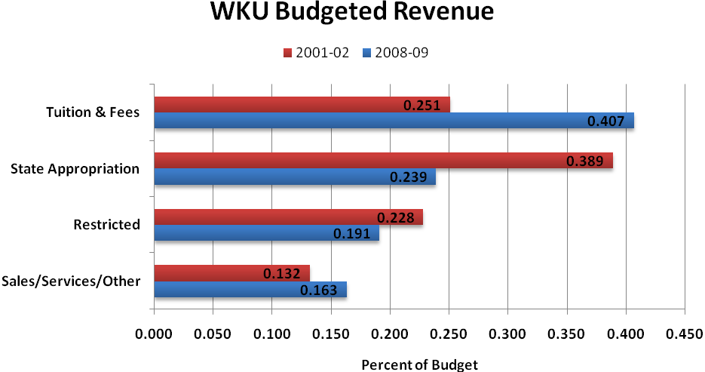

Historical State Funding

The Council on Postsecondary Education (CPE) has used varied funding models over the years to make biennial budget recommendations to the governor and to the General Assembly. Models based on state funding and public funds (state appropriation plus tuition and fees) have all demonstrated that WKU has been underfunded in comparison to comparable universities.

As illustrated in the following graph, the State budget reductions were required six out of the last eight years. Annual reductions have totaled almost $12 million since FY 2002. While the General Assembly often has enacted budgets with increased funding for postsecondary education, fiscal constraints led the Administration to reduce funding allocations across virtually all agencies including postsecondary education. Most reductions have occurred after operating budgets have been set for the year. Mid-year reductions pose a different set of challenges in terms of less flexibility in implementing reductions.
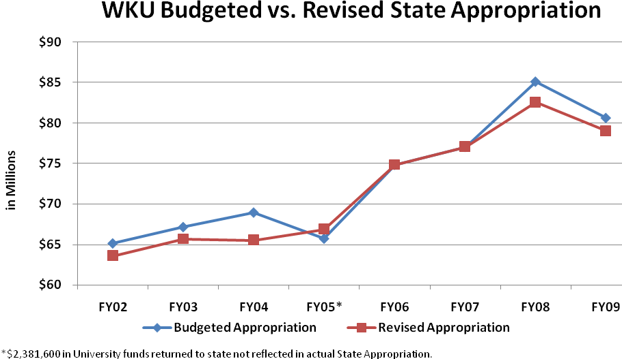

State funding per full-time equivalent (FTE) student has increased $60 or 1.3 percent since FY 2002. In constant dollars adjusted for inflation, state support per FTE student is estimated to decline by $690 (14.6%) from $4,736 in FY 2002 to $4,046 in FY 2009.

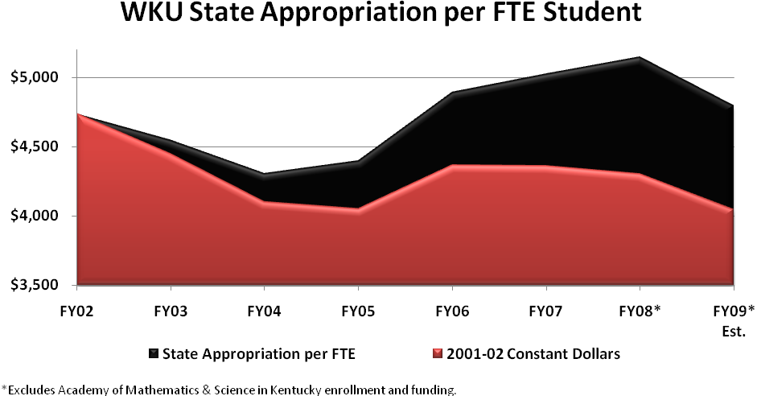

2008-10 Biennial Budget

The Executive Budget for the 2008-2010 biennium represents the necessary response to an unprecedented and challenging fiscal environment for the Commonwealth. The imbalance between the state's recurring revenues and recurring expenditures, often referred to as a "structural imbalance," of the Commonwealth's General Fund budget combined with dampened revenue growth frame the conditions into which Governor Beshear recommends his first biennial budget to the 2008 Regular Session of the General Assembly.

- 2008-2010 Executive Budget, Executive Summary

On April 2, 2008 the Kentucky General Assembly passed the 2008-10 Branch Budget Bill, HB 406. Less than a year later, Governor Steven L. Beshear addressed the General Assembly with his “State of the Commonwealth.” The Governor’s speech stated that “Kentucky faces economic challenges as steep and as stubborn as any in its history, created by a global crisis that has shaken the foundation of the entire nation's financial health. Here in state government we are confronted with a mid-year shortfall of almost half a billion dollars – on top of cuts just last year of more than $430 million.”

Prior to implementing the FY 2009 budget, the University made difficult decisions to reduce the base budget by $5,047,100 due to a six percent reduction in state funding. Midyear, the budget was reduced an additional two percent or $1,612,500. In recognition of the General Assembly’s support of postsecondary education, HB 406 includes a one percent increase in state funding for postsecondary education institutions in the second year of the biennium. However, it is not expected to be allocated in FY 2010.

With postsecondary education accounting for 13.8 percent of the FY 2009 Executive Branch budget, reductions may be minimized but are unavoidable without a significant adverse impact on primary and secondary education and to services provided by other state agencies.

Tuition

Significant progress has been made in implementing strategic initiatives, but this has been primarily due to enrollment growth and tuition rate increases. From FY 2002 to FY 2009 the tuition rate for full-time, resident, undergraduate students increased from $1,422 to $3,465 per semester – an increase of $1,501 in constant dollars adjusted for inflation. Double digit rate increases were necessary in five of the eight years.

There is a general sentiment that, during this extraordinarily difficult economic time, increases in resident undergraduate tuition rates should be moderated and significantly below their historical rates of increase over the past decade. WKU has minimized the tuition increase to an inflationary level for FY 2010. It is anticipated that future increases will be modest. Thus, tuition revenue can no longer cover the growing budgetary needs that significant enrollment growth demands nor will it supplant state funding necessary for continuation of basic services.

Commitment to Effective Use of Resources

WKU continues to analyze programs and services for additional efficiencies, cost avoidance, and funding reductions. Our priorities at WKU are to remain financially stable, ensure a high level of quality for our students, continue to achieve diversity in our campus population, and enhance the lives of those in our surrounding communities.

In response to fiscal constraints, WKU has implemented a number of efficiencies and has reduced expenditures across divisions. Our priority has been to ensure quality while protecting the core mission of the University, which includes growth and access to higher education for Kentuckians. Primary efficiencies have been achieved in academic, personnel, information technology, energy consumption, and financial operations. Some examples include the following:

- Reduced the number of hours to graduate from 128 to 120 hours in most degree programs and implemented online degree completion for 21 academic programs.

- The purchase of the new communications system allowed us to reconfigure our outside local telephone service line resulting in annual savings of $327,000.

- Changing computer replacements for faculty and student labs from a three-year to a four-year replacement cycle will generate savings of $115,000 per year.

- WKU purchased the outside cable plant from Bell South, which we had been previously leasing, for an annual savings of $96,000.

- WKU’s first Energy Savings Performance Contract affected energy usage in eight buildings with over 487,000 square feet and generated annual savings of $252,000.

- WKU has adopted a sustainability plan to include a new Energy Policy for the campus and has engaged in a second Energy Savings Performance Contract to identify opportunities for improvements in campus energy consumption (e.g. lighting retrofits, mechanical upgrades, changes in building controls, etc.) to minimize utility cost increases in the future. A full energy audit is being performed and will impact 30 campus buildings.

- Western Kentucky University’s energy savings initiative over the winter break resulted in an energy reduction of 1,052,932 kilowatt hours of electricity and 1,112 metric tons of greenhouse gas emissions, with a cost avoidance savings of $128,340 for the three-week period.

- Many departments across campus have redistributed job responsibilities, combined duties and eliminated or restructured positions, moving some to part time and eliminating others completely. Some full-time staff positions have been replaced with graduate assistants or student workers where possible. Funds saved are redirected to partially offset inflationary increases in areas such as travel, printing, and postage within the respective divisions.

- Numerous paper-to-electronic efficiencies have been created across the campus. Paperless transactions now include student applications, employee applications, performance evaluations, personnel forms, student registration, student billing, electronic invoicing and payments, department and college newsletters, directories, electronic travel reimbursements, bid procedures, purchasing, and on-line ordering of text books in the WKU Bookstore.

- WKU has implemented a self-funded workers’ compensation program with an emphasis on workplace safety and achieving savings of approximately $1.8 million in its first three years of operation.

- The WKU Board of Regents approved a more cost effective approach for issuing agency bonds that resulted in elimination of the debt service reserve requirement. Savings accrued to the University base budget and are dedicated to capital renewal and reduction of deferred maintenance. Not having a debt service reserve included in the most recent agency bond sale saved the University $265,000 annually in debt payments.

- WKU eliminated credit card payments for tuition and fees and contracted with a company to provide payment alternatives and payment plans thus reducing bank charges by 81% or $242,000.

FY 2010 Budget Assumptions

State Appropriation

While no permanent reduction has been announced by Governor Beshear, the WKU administration has to proceed cautiously and under the assumption that the two percent reduction of FY 2009 will be made permanent. To best position the University for a slow economic recovery, we are proceeding with the plan we developed equal to a four percent reduction in State funding or approximately $3.2 million. The funds will be budgeted in a Budget Reduction Reserve until the State’s financial picture is clearer. The Reserve also will include $787,200 in additional state funding which was included in HB 406. HB 406 includes an increase of $288,100 for existing state-supported bonds’ debt payments and this amount will be budgeted for debt payments.

Recurring Budget Reduction included in FY 2010 Budget

A total reduction of $3,225,050 was distributed by division based on each division’s state funding. The funds are being budgeted in the Budget Reduction Reserve in anticipation of an additional reduction in state funding in FY 2010. Implementation of the budget reduction is summarized as follows:

Spending Reductions Effective July 1, 2009

Academic Affairs $2,279,987  $1,020,841 (13 full-time faculty positions, 3 partial faculty positions, 4 full-time staff positions, 4 partial staff positions); $337,518 operating; $21,628 travel; $100,000 capital; and $800,000 from additional tuition dollars to partially offset reduction. | $2,279,987
Athletics 38,264  Contingency funds in Athletic Facilities are being reduced. These funds would have been used for operating expense increases as WKU fully becomes IA football. | 38,264
Finance and Administration 108,997  Eliminating 1 full-time staff position and reducing postage, travel, and most of vehicle replacement budget. | 108,997
Public Affairs 40,115  Reducing consulting service. | 40,115
Information Technology 205,298  Eliminating replacement of voicemail system and slowing upgrade of the telephone switch. Eliminating Content Management Web Developer position which eliminates implementation of the Content Management project. Reducing infrastructure hardware and software upgrades. | 205,298
Institutional Advancement 72,118  Eliminating one Kentucky Challenge direct mail piece, one Campaign Newsletter, Director of Development Athletics position, Development Fiscal Services operating account, and one issue of the Western Planner newsletter. | 72,118
Presidential/Chief of Staff 24,736  Eliminating one full time staff position in President's Office thus reducing staff from three to two. | 24,736
Student Affairs 94,225  Reducing Police overtime, Student Activities, Organizations & Leadership personnel dollars (moved 29% of position to CAB), student worker dollars for Counseling & Testing, contingency salaries for Health & Fitness Lab and Career Services, Intramural equipment, Health & Fitness travel, eliminating Career Services Office Assistant, and moving Director of University Centers & Leadership position to Auxiliary Services budget. | 94,225
Campus Services 324,438  Reducing $145,997 from Physical Plant Facilities Reserve and $178,441 from Facilities Improvements Matching. This will reduce the capacity to address existing building deficiencies and the backlog of deferred maintenance. | 324,438
Total Reductions by Divisions | 3,188,178
Central Budgets 36,872  Reducing Instruction Contingency, General Institutional capital equipment, and Staff Benefits Undistributed contingency. | 36,872
Total | $3,225,050
Tuition and Mandatory Fees

The Council on Postsecondary Education (CPE), by statute, has the authority to set tuition rates for all public colleges and universities. At its March 6, 2009 meeting, the CPE approved a maximum base tuition (including mandatory student fees) rate increase of 4 percent for all of the comprehensive universities. WKU’s recommended Tuition and Fees Schedule was approved by the CPE at its May 22, 2009 meeting and is provided at the end of the Executive Summary. Budget development includes a projection of tuition revenue based on fall 2008 enrollment and a tuition rate increase of 4 percent in all tuition rate categories.

Based on Board policy, the Higher Education Price Index (HEPI) is the basis for the increase in the Student Athletics Fee and the Centers Fee. The Restricted Tuition budgets (i.e., Student Technology, Health Services, and Student Government Association and Programming) reflect budget adjustments due to enrollment growth and the HEPI one year change. HEPI increased 3.6 percent in 2008.

Investment Income

The FY 2010 budget reflects minimal interest earnings on overnight deposits, debt service reserve and pooled investments from the Commonwealth of Kentucky. The University’s banking contract for overnight deposits states "all collected funds...automatically earn interest at a rate of Federal Funds + .10 percent.” The projected total reduction of $733,000 (FY 2009 and FY 2010) will be offset by growth in tuition revenue.

Statewide and WKU Strategic Plans

WKU remains committed to the Postsecondary Education Reform Act of 1997 and the Council on Postsecondary Education’s Five Questions – One Mission: Better Lives for Kentucky’s People, A Public Agenda for Postsecondary and Adult Education, 2005-2010. Our common goal is to improve Kentucky’s economic base and quality of life for its citizens.

Student enrollment clearly plays a key role in developing the overall institutional operating budget. To this end, WKU continues to set and achieve its student enrollment goals. In addition to goals for total enrollment, targets are set for a variety of other performance indicators that serve to drive enrollment increases. These include indicators for international students, nontraditional students, KCTCS transfer students, and distance learning students. Although the CPE’s 2011-12 target for WKU total enrollment is set at 20,000 students, all indications are that this number will be achieved in fall 2009.

WKU, however, is now at a point where inadequate funding is leaving us no choice but to reassess priorities identified in WKU’s Strategic Plan through 2012. That plan calls for a number of significant investments in programs that are designed to increase student learning and aimed at attracting, retaining, and supporting high quality faculty and staff. The Strategic Plan also focuses on faculty and student engagement in regional initiatives to improve the quality of life for Kentuckians and calls for new investments in our regional campuses. Additionally, the Strategic Plan focuses on addressing needs within the campus physical plant. In the coming months we will scale this plan back significantly to an affordable and more limited range of initiatives, slowing the volume and pace of our institution’s responsiveness to the needs of our constituents.

It is likely that WKU will minimize spending on developmental education and change our admissions standards. WKU must be able to serve those students who are seeking a quality educational experience and who intend to complete a degree program. Access in the future will be limited to those students with the capacity and the desire to succeed. New minimum admissions requirements and directed admission for under-prepared students will result in improved retention and graduation rates.

It is imperative for the Commonwealth that Kentucky’s public universities offer the highest quality educational experience possible for Kentucky students. We must use our intellectual capacity to focus on regional outreach efforts, including economic development, health care services, agriculture and energy research, and support for STEM initiatives and other programs that benefit the citizens of our state. These important functions, however, must be evaluated based on the value added to the educational experience of our students. WKU’s focus for the future will be on ensuring that we can serve our student population and remain engaged in our region but with a significantly smaller impact than we had originally envisioned.

Proposed 2009-10 Budget

The WKU 2009-10 Budget is WKU’s financial plan for the fiscal year beginning July 1, 2009 and ending June 30, 2010, and it includes the proposed Operating Budget and Capital Budget. The budget document includes the following components:

- Narratives by area that summarize Strategic Plan priorities;
- Revenue Summary;
- Expenditure Summary by Organizational Area (Unrestricted, Restricted, and Auxiliary Enterprises) and Program Classification Structure (PCS);
- Expenditure Detail by unit (not included in the Summary Budget);
- Capital Budget; and
- Glossary of Terms and Abbreviations.

The Operating Budget includes Educational and General (E&G) and Auxiliary Enterprises revenues and expenditures. E&G revenue consists of unrestricted revenue – primarily state appropriation and tuition and fees – and restricted revenue (e.g., federal and state funds for student financial aid and for grants and contracts). Auxiliary Enterprises revenue is derived from the self-supporting activities of WKU such as housing (reimbursed costs from the Student Life Foundation), food services, and bookstore operations.

The Capital Budget provides a listing of major capital and lease/purchase projects, funding sources, and the current status of these projects. It is noted that the General Assembly authorizes a maximum funding for each project for a biennium. However, depending on funding available, some projects may be completed at less than the authorized amount or in a year other than the year authorized. Projects that are authorized but are not likely to be started in FY 2010 are separately identified.

Operating Budget Summary

The 2009-10 Operating Budget and the dollar and percent increases, in comparison to the 2008-09 budget, are distributed as follows:

 | 2009-10 Budget | Dollar Increase | Pct Increase
Total Budget | $349,445,000 | $17,005,000 | 5.1%
Total E&G | 328,773,000 | 16,224,000 | 5.2%
Unrestricted E&G | 262,047,000 | 10,741,000 | 4.3%
Restricted E&G | 66,726,000 | 5,483,000 | 9.0%
Total Auxiliary Enterprises | 20,672,000 | 781,000 | 3.9%

It is important to note that the above summary includes a Budget Reduction Reserve of $4,012,250 and budgeted net asset allocation (nonrecurring funds) of $15,621,000.

Revenue Highlights

The 2009-10 budgeted revenue by source is summarized as follows:

Total Budgeted Revenue by Source

Amount Pct of Budget

Tuition and Fees $142,338,000 40.7%
State Appropriations
Operating 77,401,200 22.1
Budget Reduction Reserve 4,012,300 1.2
Debt Service 1,958,100 0.6
Restricted Funds
Grants and Contracts 25,319,000 7.2
Student Financial Aid 41,407,000 11.8
Net Asset Allocation (nonrecurring) 15,621,000 4.5
Other 20,716,400 6.0
Auxiliary Enterprises 20,672,000 5.9

TOTAL $349,445,000 100.0

The proposed 2009-10 Operating Budget includes the following adjustments to state appropriations and projected tuition and fees revenue available for allocation:

State Appropriation, Operating (Budget Reduction Reserve) $ 787,200
State Appropriation, Debt Service (Existing Bonds) 288,100
Tuition, Fall & Spring (Excluding Restricted Tuition) 4,384,000
Tuition, Summer 75,000
Tuition, Professional MBA 206,000
Tuition, EdD Program 300,000
DELO Tuition, Winter 158,000
DELO Online Learning (Fall, Spring, Winter & Summer) 879,000
DELO Contract Learning 84,000
DELO, Other 525,000
Student Athletics Fee 240,000
Restricted Tuition (Fall, Spring & Summer) 140,000
Other Student Fees 190,000

TOTAL INCREASE $8,256,300

The Operating Budget includes the projected revenue based on the 2009-10 tuition and fees rates and actual enrollment from fall 2008. The budget includes tuition and fees totaling $142.3 million and is an increase of $7.2 million or 5.3 percent. Tuition and fees revenue will account for approximately 43.3 percent of the total E&G budget and 54.3 percent of the unrestricted E&G budget of WKU.

The state appropriation reflects the actions taken by the most recent Kentucky General Assembly. The budget includes state appropriations totaling $83.4 million, an increase of $1,075,300. However, based on the state funding reduction in FY 2009 and the fiscal outlook, $4,012,250 is being held in a Budget Reduction Reserve. State appropriation will account for 25.4 percent of total E&G budget and 31.8 percent of the unrestricted E&G budget of WKU.

Actual and projected state support per FTE student are calculated as follows:

State Appropriation
Year FTE Students State Appropriation Per FTE Student

1998-99 12,055 $54,040,300 $4,483
2008-09 (Revised) 16,020 $76,297,800 $4,763
10-Yr Pct Change 6.2%
Constant Dollars Adjusted for Inflation (10.4%)

2009-10 (Projected) 16,020 $74,793,900 $4,669
1-Yr Pct Change (2.0%)

Note: The state support per FTE student calculations exclude state-supported debt service, the Academy of Mathematics and Science, and the Budget Reduction Reserve. Projected 2009-10 is based on actual fall 2008 enrollment without the Academy enrollment.

The unrestricted E&G revenue includes the following noteworthy changes:

- The Division of Extended Learning and Outreach (DELO) offers very popular alternatives to traditional instruction and this is reflected in the projected revenue growth of $1,646,000 or 21.8 percent above the FY 2009 budget. Should the revenue estimates be met, this will allow DELO to invest in expanded program offerings and facility improvements, reward departments and faculty based on participation, and contribute to the base budget of the University.
- WKU Health Services is projecting health services operating revenue to increase $214,000 or 33.3 percent due to its ability to provide expanded services in its new facility. Funds will be allocated to a staffing plan necessary to accommodate current and projected growth in patient contacts and to maintain Health Services commitment to quick, high-quality patient care.

- Athletics’ revenue is projected to decrease approximately $1.0 million primarily due to less game guarantees.

- The Center for Research and Development is projecting an increase in revenue of $294,000 due to strong leasing growth and a successful partnership with the WKU Foundation resulting in increased leasable space.

- Services provided by the Waters Lab support a revenue increase from professional services of $150,000.

- The income estimate for investments is being decreased $242,000 as the result of minimal interest earnings on overnight deposits, debt service reserve and pooled investments from the Commonwealth of Kentucky.

- A budget increase of $280,000 is being recommended for the Study Tour Harlaxton Program based on increased participation and corresponding program fees.

Restricted Funds, including grants and contracts and student financial assistance, comprise 19.1 percent of the total budget. Grants and contracts include an increase of $1,203,000 over the FY 2009 budget. The projected revenue for grants and contracts expenditures is projected to increase by five percent across all sources (i.e., federal, state, and private).

An increase of $4.3 million in student financial assistance reflects actual FY 2009 awards data and projected student eligibility with an increase in Pell Grant maximum awards. The largest projected increases are in the federal programs of Pell Grants (15.7 percent) and Academic Competitiveness Grants (20.0 percent) and the state programs of KEES Program (3.0 percent) and College Access Program (15.6 percent).

The Auxiliary Enterprises 2009-10 revenue estimates are being increased by a total of $781,000 above the approved FY 2009 budget. The increase is accounted for primarily by the mandatory Student Centers Fee increase of $2 per full-time student per semester, increased Bookstore sales, and food and vending contract commissions.

Expenditures Highlights

Fixed costs were identified early due to less anticipated state funding and a smaller tuition revenue increase over last fiscal year. Even though salary increases for the University are a top priority, there is no capacity to cover a permanent increase for FY 2010 based on the information currently available. Full- time employees, who were hired on or before December 1, 2008, will receive a 1.5 percent one-time payment with a floor of $500 and a ceiling of $1,000.

Programs responsible for generating revenue are allocated the projected revenue increases or decreases. A majority of these programs are called “Revenue Dependent” which identifies them as programs responsible for funding all of their direct programmatic needs. Revenue Dependent programs’ budgets are listed separately in the Expenditure Summary as the last listing within the Educational and General Budgeted Expenditures, Unrestricted Funds by Organizational Area.

Based on the projected state appropriations, investment income, and fall and spring tuition revenue, the following allocations are included in the 2009-10 Operating Budget:

UNAVOIDABLE COST INCREASES
Minimum Wage Increase |  | $342,000
Debt Service Increase (State Bonds) |  | 288,000
KERS Rate Increase |  | 135,000
Campus Additions, Maintenance and Operations |  | 742,000
Utility Increase (New and Existing Buildings) |  | 951,000
Employee Educational Benefits (Faculty/Staff and Dependent Child) |  | 77,000
Vehicle, Fire and Tornado Insurance Premium |  | 80,000
Contractual Obligations
CCTV Police Department | 8,000
System Software Contracts Increases | 83,000
Chiller Contract | 95,000
Sodexho Contract | 28,000
Sexual Harassment License Contract | 10,000
Owensboro Lease (1/2 Year) | 43,000
Subtotal |  | 267,000
CCTV Personnel (Maintain Oversight of Video Surveillance) |  | 56,000
Faculty Promotions |  | 265,000
Subtotal |  | 3,203,000
STUDENT FINANCIAL ASSISTANCE
Undergraduate Scholarships/Grants-in-Aid/Mandated, Offset Rate Increase |  | 582,000
Gatton Academy Scholarships, 2nd Year |  | 157,000
Graduate Assistantships and International Fellowships, Offset Rate Increase |  | 170,000
Subtotal |  | 909,000
SALARY/BENEFITS
Health Insurance (1/2 year funding of approx. 6% University Increase) |  | 260,000
Subtotal |  | 260,000
OTHER CAMPUS POLICIES
Parking and Transportation (Year 8 of 10) |  | 58,000
Restricted Tuition Programs |  | 143,000
State Appropriations Reduction Reserve |  | 787,000
Subtotal |  | 988,000
TOTAL |  | $5,360,000
SOURCES
Tuition Increase (Fall/Spring) @ 4% |  | $4,527,000
Projected Shortfall, Investment Income |  | 242,000
State Appropriations |  | 1,075,000
TOTAL |  | $5,360,000
The FY 2010 budgeted expenditures, by major classification of expenditure, are summarized as follows:

Total Budgeted Expenditures (In Millions)

Major Classification Unrestricted Restricted Auxiliary Total

Personnel $148.2 $ .8 $7.0 $156.0
Operating Expenses 58.6 24.9 9.9 93.4
Budget Reduction Reserve 4.0 0 0 4.0
Utilities 8.9 0 2.5 11.4
Capital Outlay 5.3 0 .8 6.1
Student Aid 22.9 41.0 0 63.9
Debt Service 14.1 .1 .5 14.7
Total $262.0 $66.8 $20.7 $349.5

The Restricted Fund budget for grants and contracts are budgeted in pools: instruction, research, public service, and student financial aid. Funds are allocated to specific grants and contracts once awards are made by the respective entities. Thus, the actual distribution of expenditures by major classification will likely be different than the pool budgets.

The Unrestricted Educational and General (E&G) budget represents 75 percent of WKU’s total budget and is where WKU has the most flexibility in allocating its resources. Thus, it is important to highlight how these unrestricted funds are anticipated to be expended.

Budgeted FY 2010 unrestricted E&G expenditures by major classification of expense:

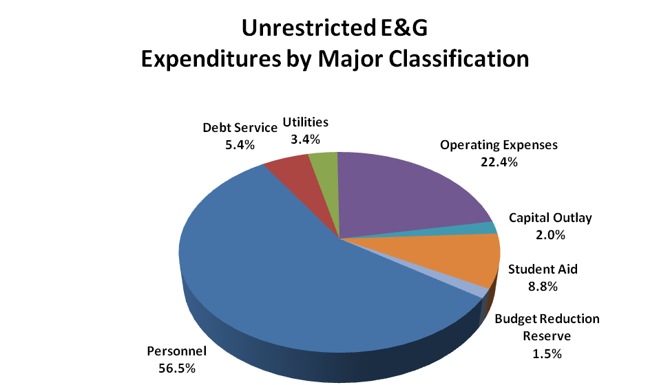

Personnel expenditures include salary and benefits for approximately 1,900 budgeted, full-time filled positions and 190 budgeted, full-time vacant positions. Also included in personnel costs are pool budgets for part-time faculty and staff, graduate assistants, and student employees.

The following graph summarizes FY 2010 budgeted unrestricted E&G expenditures by organizational area. The Narrative section of the budget sets forth each division’s strategic priorities for FY 2010.

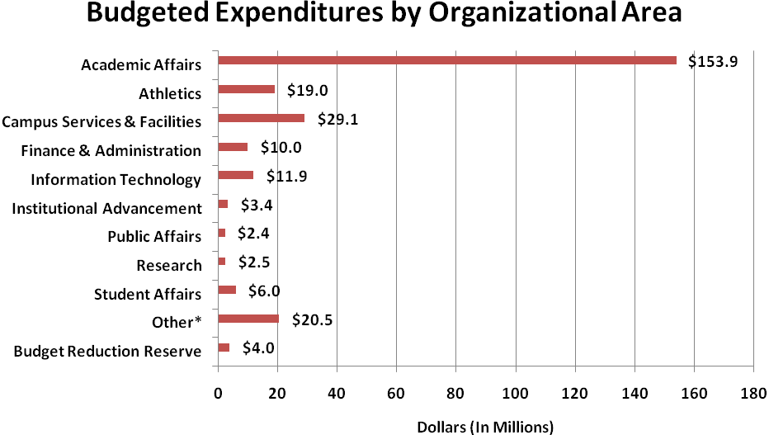
*Other includes Office of the President, Chief of Staff, and University-Wide.

Budgeted expenditures include $657,600 of restricted, federally-funded College Work Study that cannot be separately identified. Work Study funds are distributed throughout the divisions.

- The Division of Academic Affairs, including institutional scholarships and fellowships, totals $153.9 million or about 59 percent of the unrestricted E&G budget.

- The Division of Campus Services and Facilities, the second largest division, has a budget totaling $29.1 million or about 11 percent of the unrestricted E&G budget.

- Other includes Office of the President, Chief of Staff, and University-Wide. The most significant funding items in University-Wide include funding for statutorily-mandated scholarships, undistributed staff benefits, general institutional expenses and funding for principal and interest payments on bonded debt.

Capital Budget Summary

The Capital Budget includes legislatively-authorized capital projects that will be under way next year or are currently under way including the source of funding, estimated cost, and the status of each respective project. Projects with a scope less than $600,000 do not require General Assembly approval and are not included in the Capital Budget. Many projects with a scope of less than $600,000 will address deferred maintenance needs and classroom improvements.

The 2008-10 budget includes authorization to proceed with agency bond-funded projects. Bonds were issued in 2009 and no additional projects will be bonded in 2010.

Funding for a limited number of projects is in the approved biennial budget with the source being the Contingency Plan in 2010. These projects are listed in the Capital Budget, but there is no indication yet as to whether funding will be available.

Most of the capital projects reflect legislative authorization; projects started at an amount less than the authorized amount are displayed at the intended scope. Projects authorized but not funded or scheduled for FY 2010 are identified separately.

Excluding Contingency Plan projects, the FY 2010 Capital Budget totals $138,252,300 from all sources of funds.
TUITION AND MANDATORY STUDENT FEES SCHEDULE
PER SEMESTER

Summer 2010/
Student Level FY 2009 FY 2010 Rate per Credit Hour

Undergraduate
Resident $3,465 $3,600 $300
Nonresident 8,544 8,892 741
Incentive 4,380 4,560 380

Graduate
Resident 3,820 3,960 396 Nonresident, International 9,180 9,550 478
Nonresident, Domestic 4,180 4,350 435

Distance Learning (Per Credit Hour)
Undergraduate 349 360 360
Graduate 458 475 475

Professional MBA (Per Semester) 4,142 4,142 N/A

GoArmyEd (MOA, Per Credit Hour) 250 250 250

Dual Credit (Per Credit Course) 200 200 200

Independent Learning (Per Credit Hour) 289 300 300

The above full-time rates, excluding Distance Learning and the Professional MBA Program, include the following mandatory student fees:

Student Athletics Fee $200
Student Centers Fee $ 58

Mandatory student fees are not assessed to GoArmyEd, Dual Credit, or Independent Learning courses.

