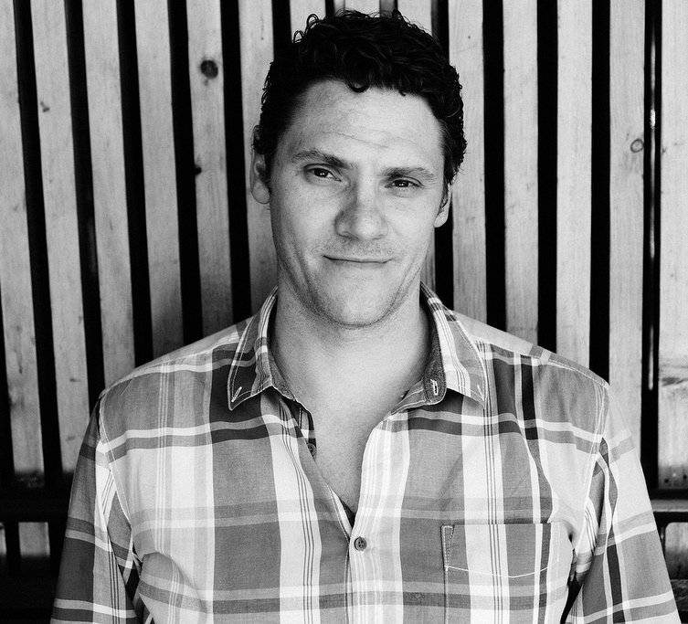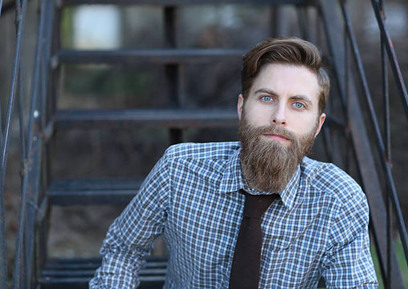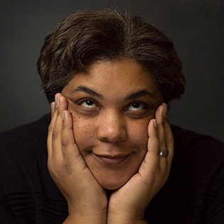 ­­

**Friday, April 13th @ 3:00 PM – Cherry Hall 125­**

Writer/Director **Brad Riddell** has written **four produced feature films** for Hollywood studios including **Paramount**, **MTV**, and **Universal**. His first film, ***American Pie: Band Camp***, remains one of the highest-grossing live-action DVD releases in history, and is now syndicated on TBS. His most recent film, ***Crooked Arrows***, was released nationally in theaters in 2012, and is the first mainstream lacrosse movie ever produced. Brad’s other credits include films in the ***Road Trip*** and ***Slap Shot*** franchises. His award-winning directorial debut, ***Ten More***, is now playing on the festival circuit, and his series, ***Other People’s Children***, is available online and has screened in WebFests around the world. Brad holds a **MFA in Screenwriting from USC**, is a **member of the Kentucky Film Commission**, and is a **professor at DePaul University in Chicago**, where he chairs the screenwriting program.

**Monday, March 26th @ 7:00 – Cherry 125**

**Brad Aaron Modlin** is the author of ***Everyone at This Party Has Two Names***, which features the poem “**What You Missed that Day You Were Absent from Fourth Grade.”** He is also the author of the collection of short stories ***Surviving in Drought***. His nonfiction has appeared in **River Teeth**, **Fourth Genre**, **DIAGRAM**, and elsewhere. He **grew up in Bowling Green** and **took classes at WKU**. Now he is an **assistant** **professor at Missouri Southern**, where the squirrels are boring, normal colors.

**Roxane Gay** has authored many works appearing in **Best American Mystery Stories** **2014**, **Best American Short Stories 2012**, **A Public Space**, **McSweeney's**, **Tin House**, **Oxford American, American Short Fiction**, **Virginia Quarterly Review**, and many others. She is a contributing opinion writer for the **New York Times**. She is the author of the books ***Ayiti***, ***An Untamed State***, the New York Times bestselling ***Bad Feminist***, and ***Difficult Women*** and ***Hunger***. She is also the author of ***World of Wakanda*** for Marvel.

**Thursday, February 8th @ 7:30 PM – Van Meter Hall**

**as part of the PCAL *Cultural Enhancement Series***

**Follow us!**

**WKU Creative Writing**

**@WKUCW**

SPRING 2018

**CREATIVE**

**WRITING**

**READING SERIES**