Steps to the MFA Thesis & Timeline
To prepare for a successful thesis, we recommend you begin thinking about this final project as early as your first year, as you choose your courses, attend readings, and experience the many life events which may contribute to the writing of your thesis.
Below we have mapped out the three years based on a full-time course load, culminating with your thesis defense.
Year 1, Semester 1 (9 hours)
MFAs usually start with a set regimen of courses the first semester:
ENG 507, Introduction to Creative Writing Studies
ENG 501, Workshop (Multigenre)
ENG 510, Rhetoric and Writing (GAs must take this course)
GAs also take ENG 509, a 0-credit hour mentoring/planning course, Practicum in One-to-One Writing Instruction.
Year 1, Semester 2 (9 hours)
Course choices are chosen with personal writing, literature, advanced composition, and concentration interests in mind. Most MFAs take their 2nd 501 workshop as well.
Year 2, Semester 1 (9 hours)
Most MFAs take ENG 515, Internship, and ENG 512, Reading as a Writer, plus another 501 Workshop or a class of interest (literature, composition, concentration).
Year 2, Semester 2 (9 hours)
This semester allows for increased course choices as you work to complete your literature, composition, and concentration requirements. Most MFAs take a 4th 501 workshop as an elective course.
During this semester, you will secure your Thesis Defense Chair and this is largely decided by your genre:
Dr. Bell—Fiction
Dr. Dinan—Fiction
Dr. Hunley—Poetry
Prof. Folk—Screenwriting

We recommend that you set up an in-person meeting to make the formal request and to discuss your thesis plan.
Once you have secured your defense chair, then you must also secure 2 readers. Readers can be selected from all faculty, to include those outside the Department of English, who have a specialization that aligns with your thesis. We also recommend this request be made in person, so please set up a meeting with potential readers. Be prepared to describe your creative work and how you see their expertise as helpful to the reading, defense, and advancement of your work.
Upon securing your thesis committee, you need to complete 2 important steps:
- Declare your committee members by completing this form.
- Apply to graduate by logging into your TopNet account and following the prompt.
Please alert both the MFA Director and the Graduate Coordinator to the members of your committee members and the completion of these steps.
Year 3, Semester 1 (6 hours)
You will take 3 hours of ENG 599, Thesis hours, with your Thesis Chair. The Graduate Coordinator will ensure that you are placed in these hours. You will meet regularly with your Thesis Chair to best ensure you are making sufficient progress on your thesis.
You will take one other course, depending upon what requirements you have left for your degree.
Please consult your DegreeWorks tab in your TopNet account to ensure you are on track to graduate (i.e., you only have a second ENG 599 and 1 other course required) and that all your courses are located in the correct areas (literature, composition, concentration). If a course needs to be moved into a different category, please alert the Graduate Coordinator about which course and the location of its correct placement. This often happens when a special topics course is taken that is not designated for a particular area, transfer credit is awarded, or a course outside the Department is taken.
Year 3, Semester 2 (6 hours)
You will take your final 3 hours of ENG 599, Thesis hours, with your Thesis Chair. The Graduate Coordinator will ensure that you are placed in these hours. You will meet regularly with your Thesis Chair to best ensure you are making sufficient progress on your thesis to defend this semester.
You will take one other course, depending upon what requirements you have left for your degree.
Your thesis defense needs to occur by the end of week 10 of the given semester you plan to graduate, so that any changes and formatting can be completed before the deadline for binding to occur. You can check this webpage for the exact date by which your final thesis must be submitted.
By week 5 of the semester in which you plan to defend your thesis, secure your defense date and time with your committee members. MFA defenses take approximately 2 hours, so plan the time frame for 2.5 hours.
Once you have a date and time for your defense, please alert the Graduate Coordinator and the English office to reserve an appropriate room for the defense (some students require projectors, audio, and such).
Your thesis must be sent to your committee members 2 weeks prior to your defense date.
At the Defense
Your Thesis Committee will determine whether or not your thesis is sufficient to pass.
Even if your thesis is sufficient to pass, your committee is likely to have a list of revisions for you to make prior to submission to the Graduate School (graduate.school@wku.edu). If minor revisions are required, your committee will provide a date by which you must complete these changes and by which you must resubmit the final thesis to the Chair or to the entire committee.
If your thesis passes, you must also ensure your committee sign this form, which will be submitted along with your thesis to the Graduate School.
If your thesis does not pass, your committee will determine whether or not you may defend in a future semester (e.g., SU or FA post an initial SP defense; SP post an initial FA defense).
Post Successful Defense
You will submit your final, formatted thesis and signature page to the Graduate School (graduate.school@wku.edu).
Your Thesis Chair will enter your successful completion of your thesis through TopNet. The steps for completing this are as follows:
- Chairs will log into their TopNet account using My WKU.
- They will go to the Advisor & Student Data Inquiry tab.
- On their Advisor & Student Data Inquiry tab, they will select the Graduate Matriculation Forms tap, see image below:
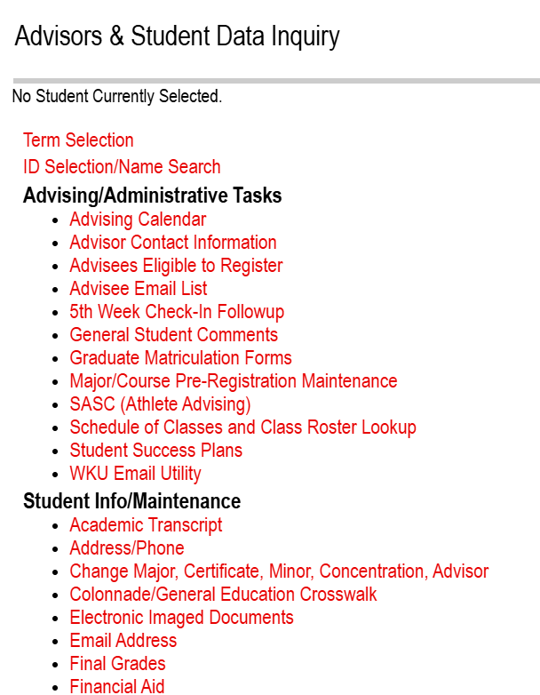
- This will bring them to this link:

- This will allow them to select the current term:
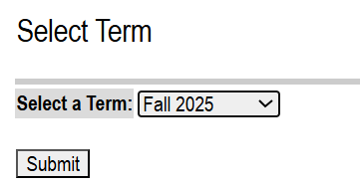
- This will allow them to select the your name (from their list of advisees):
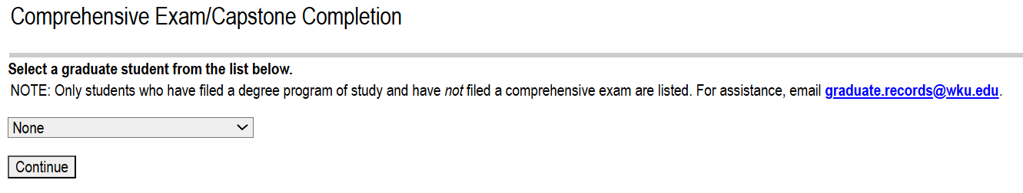
- Once they select your name, this will allow them to put in the pass/pass date. Here is an example with the student’s name and ID number obscured:
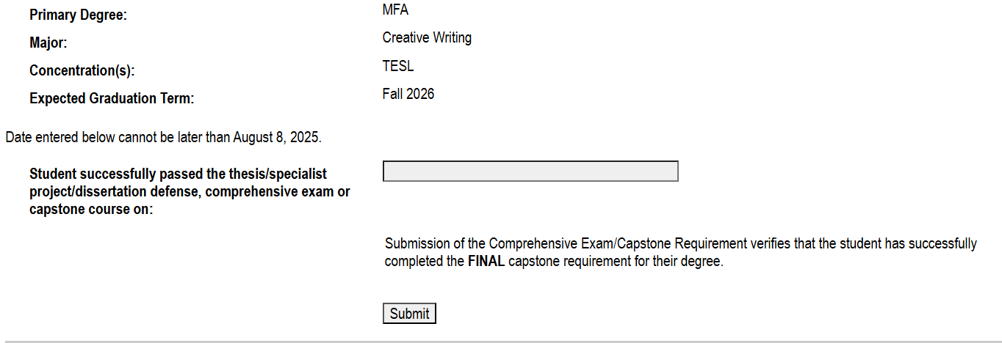
- This should complete the steps for you to graduate!

