Steps to Thesis & Timeline
To prepare for a successful thesis, we recommend starting during your first semester with the perspective of how each class, paper, and life event may contribute to your M.A. capstone project (i.e., thesis, portfolio, exam).
Below we have mapped out the two years culminating in a successful defense.
Year 1, Semester 1
(9 hours, recommended; 6 hours, full time; GAs must be at 9 hours)
ENG 520, Introduction to English Graduate Studies
ENG 510, Rhetoric & Writing (GAs must take this)
One of the two required literature courses or one of the two required advanced composition courses
GAs also take ENG 509, a 0-credit hour mentoring/planning course, Practicum in One-to-One Writing Instruction.
Year 1, Semester 2
(9 hours, recommended; 6 hours full time; GAs must be at 9 hours)
One of the two required literature courses and/or one of the two required advanced composition courses
1 or 2 courses aligned with your professional or scholarly goals
During this semester, you will secure your Capstone Defense Chair
Your chair must be selected from the English Graduate faculty. Please consult this list.
We recommend that you set up an in-person meeting to make the formal request and to discuss your capstone plan.
Once you have secured your defense chair, then you must secure 2 readers. Readers can be selected from any faculty, to include those outside the Department of English. They are not required to be graduate faculty. We also recommend this request be made in person, so please set up a meeting with potential readers. Be prepared to describe your creative work and how you see their expertise as helpful to the reading, defense, and advancement of your creative work.
Upon securing your thesis committee, you need to complete 2 important steps:
- Declare your committee members by completing this form.
- Applying to graduate by logging into your TopNet account and following the prompt.
Please alert the Graduate Coordinator to your committee members and the completion of these steps.
Please consult your DegreeWorks tab in your TopNet account to ensure you are on track to graduate (i.e., you only have a second ENG 599 and 1 other course required) and that all your courses are located in the correct areas (literature, composition, concentration). If a course needs to be moved into a different category, please alert the Graduate Coordinator about this and state which course and the correct area. This often happens when a special topics course is taken that is not designated for an area, transfer credit is awarded, or a course outside the Department is taken.
Year 2, Semesters 1 and 2 (6 hours, full time; GAs must be at 6 hours)
If you are completing a thesis, one of these courses must be ENG 599, Thesis hours plus one course aligned with your professional or scholarly goals.
If you are completing a portfolio or an exam, choose two courses aligned with your professional or scholarly goals.
Theses, Portfolio, Exam Defenses
Thesis defenses need to occur by the end of week 10 of the given semester that you plan to graduate. This will ensure any changes and formatting can be completed before the deadline for the binding of your thesis to occur. You can check this webpage for the exact date by which your final thesis must be submitted.
Portfolio defenses and exams can be scheduled through week 12 of the given semester that you plan to graduate.
By week 5 of the semester in which you plan to defend, secure your defense date and time with your committee members. MA defenses take approximately 1 hour, so plan the time frame for 1.5 hours.
Once you have a date and time for your defense, please alert the Graduate Coordinator and the English office to reserve an appropriate room for the defense (some students require projectors, audio, and such).
Your thesis or portfolio materials must be sent to your committee members 2 weeks prior to your defense date. Your exam must be completed prior to your defense date.
For more information on portfolio options and guidance, consult the portfolio document. For more information on arranging a capstone exam, consult the exam guidance document.
At the Defense
Your committee chair will determine whether or not your materials and defense of those materials are sufficient to pass, allowing you to graduate at the end of the current semester.
Even if your materials are sufficient to pass, your committee is likely to have a list of revisions to make prior to submission to the Graduate School (graduate.school@wku.edu). If minor revisions are required, your committee will provide a date by which you must make these changes and resubmit the final thesis to the Chair or to the entire committee.
If your thesis passes, you must also ensure your committee sign this form, which will be submitted along with your thesis to the Graduate School. Portfolio and exam defenses do not require this form.
If you do not pass your defense, your committee will determine whether you may defend in a future semester (e.g., SU or FA post an initial SP defense; SP post an initial FA defense).
Post Successful Thesis Defense
For thesis defenses, you will submit your final, formatted thesis and signature page to the Graduate School (graduate.school@wku.edu).
Post ALL Successful Thesis Defenses
Your Defense Chair will enter your successful completion of your thesis through TopNet. The steps for completing this are as follows:
- Chairs will log into their TopNet account using My WKU.
- They will go to the Advisor & Student Data Inquiry tab.
- On their Advisor & Student Data Inquiry tab, they will select the Graduate Matriculation Forms tap, see image below:
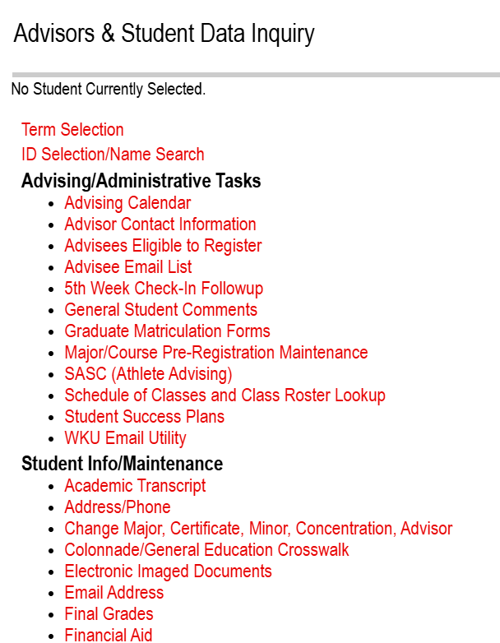
- This will bring them to this link:

- This will allow them to select the current term:
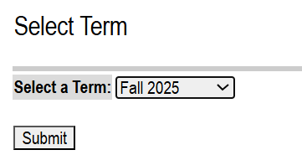
- This will allow them to select the your name (from their list of advisees):
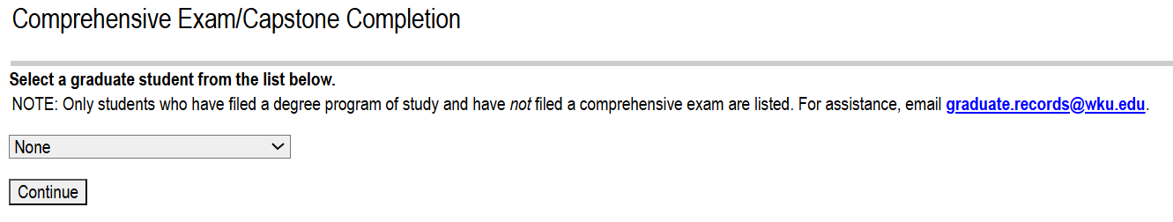
- Once they select your name, this will allow them to put in the pass/pass date. Here is an example with the student’s name and ID number obscured:
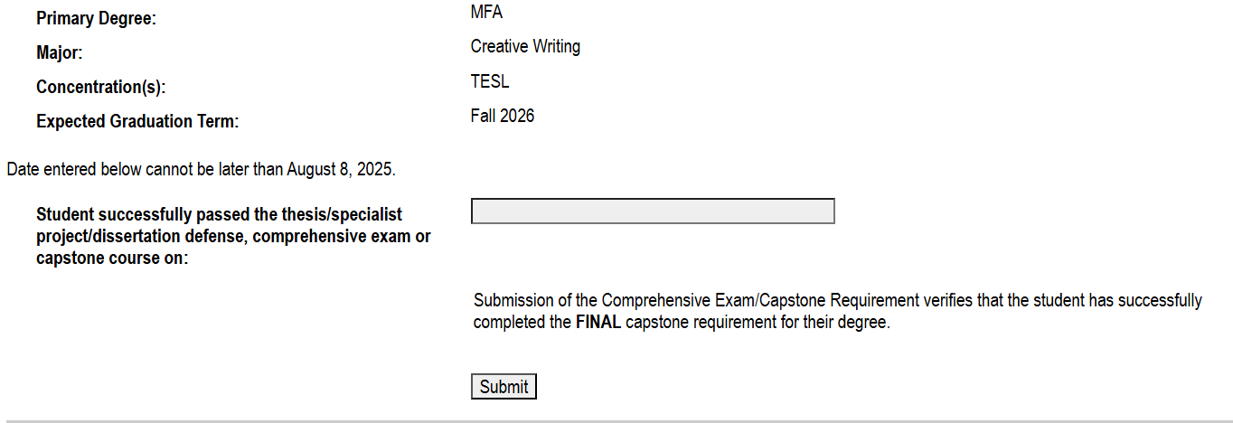
- This should complete the steps for you to graduate!

