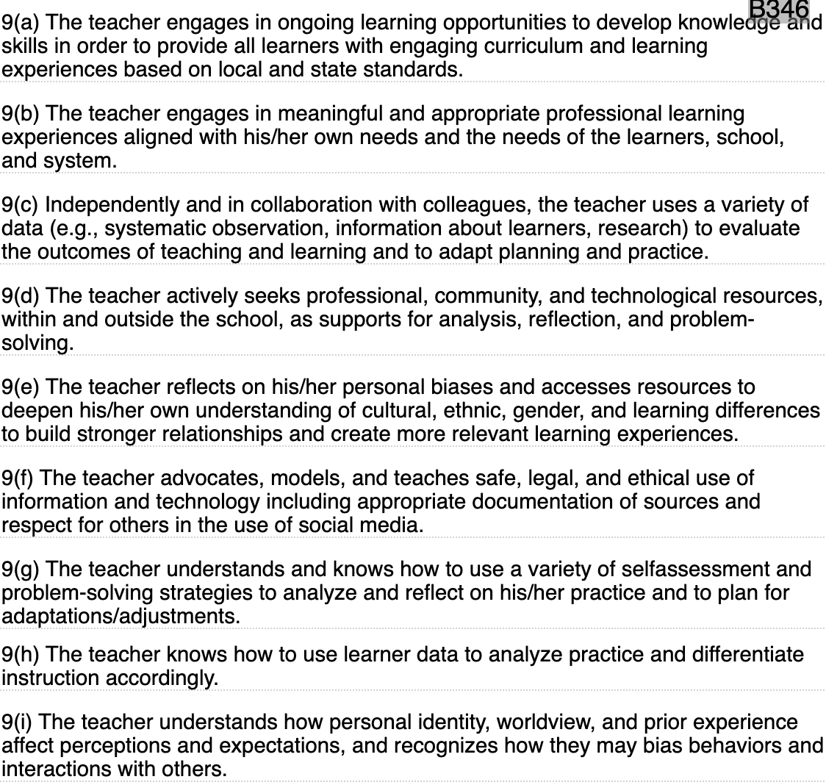
4.A.5 Implications of cultural stereotyping in school setting
4.A.6 Ability to model positive attitudes towards second language learners
4.A.9 Understanding teacher’s personal and cultural experiences and how it may influence teaching style
4.A.10. Knowing how to explain U.S. cultural norms to English-language learners
4.B.1. ethical implications of laws an court decisions related to education of English language learners
4.B.3. Ethical issues in assessment of English language learners
4.C.2. Planning to act as a resource and advocate for students and families
4.C.5. Strategies for planning and conducting collaborative conference with English language learners families, school colleagues, and community resources
4.C.6 Techniques for collaborating with paraprofessionals, content-area teachers, and instruction staff
4.D.1. Locating current info, research, and issues pertaining to English language learners
4.D.3 Opportunities to grow in the field of ESL

