THE IDAAFA CONSTRUCTION (الإضافة)
The idaafa construction is a fundamental component of Arabic grammar. It is Absolutely Essential that you understand this concept. Without understanding the idaafa, you will not be able to read any authentic Arabic material or write anything above the level of individual words. The idaafa closely resembles a number of completely different constructions, and the only way you can identify it is by the grammar rules: particularly where ال goes in an idaafa.
- an idaafa is made up of two or more nouns. Let us pause there. In the drill below, identify the phrases that could be idaafas, based on this rule.
بيت الأستاذ _______
كلب جميل ________
جامعة كنتاكي ______
القاهرة ________
- the idaafa is equivalent to saying “the____ of the_____” in English, or a possessive using ‘s, such as “The teacher’s book” or “the book of the teacher”. Note that “possession” is a very loose concept here (“friend of the student”). Based on this, in the drill below identify the English phrases that could be expressed as idaafas:
John’s car ________
The big dog _________
The city of New York _______
Salt and pepper _________
- notice that in English, the word order doesn’t matter (“the city of New York” and “New York city” are the same thing; “The teacher’s book” and “the book of the teacher” are also the same). In Arabic, the word order is absolutely standard. The first term is always the thing possessed, the second term is the possessor (the format is always “_____ of the_____”). Another way to think of this is we always start with the thing being discussed (in “the book of the teacher” “the book” is the thing you’re describing. We may not learn anything about the teacher). Based on this, in the drill below, indicate which Arabic phrases are equivalent to the English phrases with them:
The City of New York مدينة نيو يورك _________
The door of the house بيت الباب __________
friend of the teacher صديق الأستاذ ________
the University of Florida فلوريدا جامعة _________
Please review and ensure you have this down. If you reverse the word order, it becomes a different construction with a different meaning. The word order is the only way someone can tell what you mean.
- Finally, we come to what is probably the most important grammar rule in Arabic. If you do not commit this to permanent memory, you’re really wasting your time learning other concepts. ONLY THE LAST TERM in AN IDAAFA CAN EVER BE DEFINITE!!! “Ever”, in this case, means ever, ever, ever. Once you put an ال on the first term, you automatically sever its relationship to the second term. There is no possession once you do that.
- It is also worth remembering that there are three ways a word can be definite, as in English:
  - with الـ
  - a proper noun (name, place, etc.)
  - with a possessive suffix (“my book” “your friend” كتابي، صديقك، بيتنا)

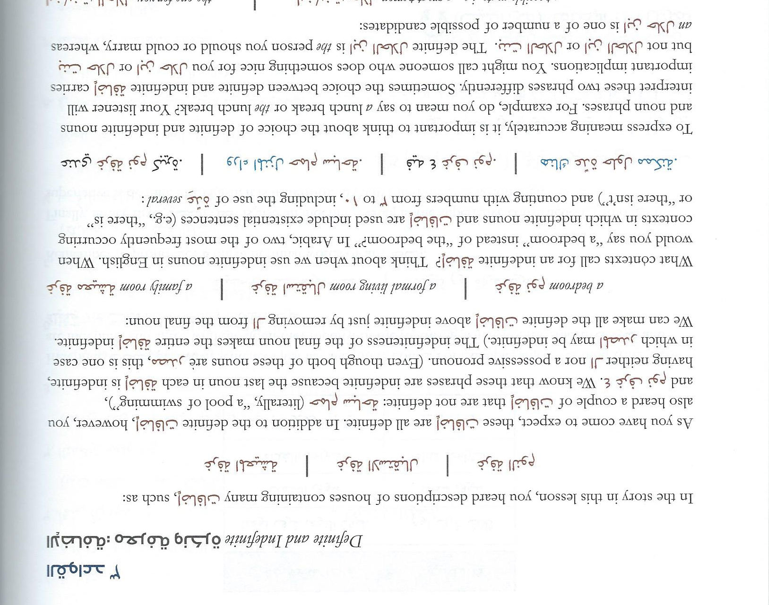
- Broken Idaafas. You have heard about the idaafa structure many times, and how the last word makes the whole thing definite or indefinite:
كتاب الطالب the student’s book
كتاب طالب a student’s book
What if, however, we want a mix of these – like to say a friend of the President? Obviously, the all-or-nothing idaafa structure won’t work. This is done by inserting the preposition ل before the last word. This is no longer an idaafa.
صديق للرئيس a friend of the President

Answers:
- an idaafa is made up of two or more nouns. Let us pause there. In the drill below, identify the phrases that could be idaafas, based on this rule.
بيت الأستاذ __Y___
كلب جميل ___N (the second word is an adjective)___
جامعة كنتاكي ____Y__
القاهرة ____N (only one word)____
- the idaafa is equivalent to saying “the____ of the_____” in English, or a possessive using ‘s, such as “The teacher’s book” or “the book of the teacher”. Note that “possession” is a very loose concept here (“friend of the student”). Based on this, in the drill below identify the English phrases that could be expressed as idaafas:
John’s car ___Y___
The big dog ___N (not a possession)____
The city of New York ___Y___
Salt and pepper ___N (two separate nouns)____
- notice that in English, the word order doesn’t matter (“the city of New York” and “New York city” are the same thing; “The teacher’s book” and “the book of the teacher” are also the same). In Arabic, the word order is absolutely standard. The first term is always the thing possessed, the second term is the possessor (the format is always “_____ of the_____”). Another way to think of this is we always start with the thing being discussed (in “the book of the teacher” “the book” is the thing you’re describing. We may not learn anything about the teacher). Based on this, in the drill below, indicate which Arabic phrases are equivalent to the English phrases with them:
The City of New York مدينة نيو يورك __Y___
The door of the house بيت الباب ___Y____
friend of the teacher صديق الأستاذ __Y___
the University of Florida فلوريدا جامعة ___N (this says “Florida of University”)___

