Assurance of Student Learning Report
2023-2024
PCAL |  | English
TESOL undergraduate certificate 1782
Mark McAndrews
Is this an online program? Yes No | Please make sure the Program Learning Outcomes listed match those in CourseLeaf . Indicate verification here Yes, they match! (If they don’t match, explain on this page under Assessment Cycle)
*** Please include Curriculum Map as part of this document (at the end), NOT as a separate file.
Use this page to list learning outcomes, measurements, and summarize results for your program. Detailed information must be completed in the subsequent pages. Add more Outcomes as needed.
Program Student Learning Outcome 1: Analyze the linguistic features of the English language.
Instrument 1 | Rubric-based assessment of students’ TESOL portfolios, which they constructed during the capstone course, ENG 471. Students’ portfolios include ESL lessons plans, teaching materials, and reflections centered around their ESL practicum teaching experience.
Instrument 2
Instrument 3
Based on your results, check whether the program met the goal Student Learning Outcome 1. |  | Met | Not Met
Program Student Learning Outcome 2: Apply the key theories and methods for the fields of psycholinguistics, sociolinguistics, and second language acquisition to teach English.
Instrument 1 | Rubric-based assessment of students’ TESOL portfolios, which they constructed during the capstone course, ENG 471. Students’ portfolios include ESL lessons plans, teaching materials, and reflections centered around their ESL practicum teaching experience.
Instrument 2

Instrument 3

Based on your results, check whether the program met the goal Student Learning Outcome 2. |  | Met | Not Met
Program Student Learning Outcome 3: Demonstrate skills to teach English as a second language for speaking, listening, reading, writings, pragmatics, and semantics, particularly for communicative competence.
Instrument 1 | Rubric-based assessment of students’ TESOL portfolios, which they constructed during the capstone course, ENG 471. Students’ portfolios include ESL lessons plans, teaching materials, and reflections centered around their ESL practicum teaching experience.
Instrument 2

Instrument 3
Based on your results, check whether the program met the goal Student Learning Outcome 3. |  | Met | Not Met
Assessment Cycle Plan:
We do not anticipate any changes to the assessment cycle or timeline; all three SLOs will be assessed annually. However, since the TESOL undergraduate certificate only began as a program in Fall 2023, we anticipate that the sample of students assessed will be larger in future years.

Program Student Learning Outcome 1

Program Student Learning Outcome | Analyze the linguistic features of the English language.
Measurement Instrument 1 | In the capstone course (ENG 471 – TESL Practicum), each student constructs a portfolio that includes ESL lessons plans, teaching materials, and reflections centered around their ESL practicum teaching experience. For each lesson plan, students must describe the learning target for that lesson using linguistic-analytical concepts and terms. Learning targets are typically linguistic features of English (e.g., sounds, words, grammatical constructions, etc). Subsequently in a lesson plan, students describe the sequence of teaching and learning activities designed to facilitate ESL learners’ acquisition of the learning target. It is primarily through these components of students’ lesson plans that SLO 1 was assessed using the rubric below:  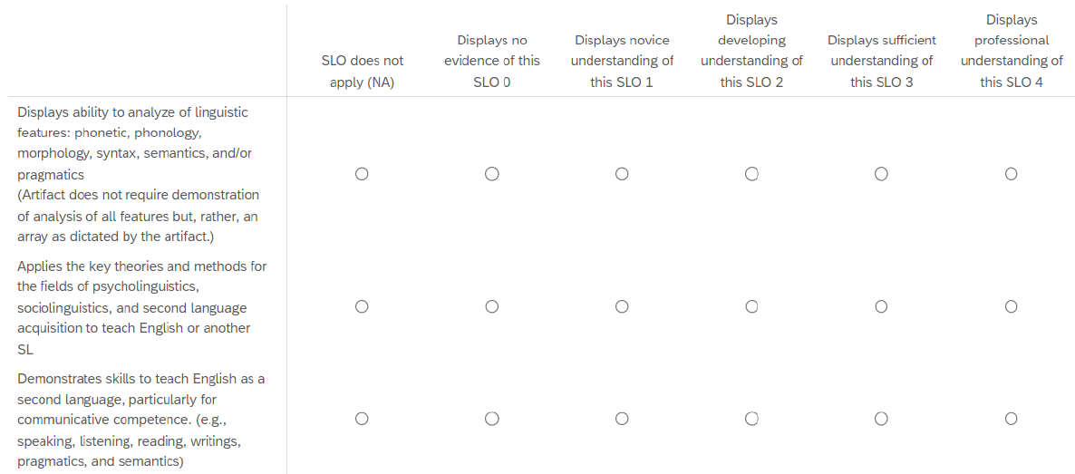
Criteria for Student Success | Student’s portfolio will have an average rating of “Displays sufficient understanding of this SLO” or higher for SLO 1.
Program Success Target for this Measurement |  | 80% of student portfolios in the sample will have an average rating of “Displays sufficient understanding of this SLO” or higher for SLO 1. | Percent of Program Achieving Target | 100% (i.e., 3 out of 3) of student portfolios met the program success target.
Methods | Three TESOL undergraduate certificate students were enrolled in the capstone course. Each of these students submitted a portfolio, which formed the basis for assessment. The three student portfolios were uploaded to Qualtrics, where each of the three WKU TESOL faculty members assessed them using the attached rubric. Ratings were averaged across the three raters. The results were analyzed by the TESOL programs coordinator.
Based on your results, highlight whether the program met the goal Student Learning Outcome 1. |  |  |  | Met | Not Met
Results, Conclusion, and Plans for Next Assessment Cycle (Describe what worked, what didn’t, and plan going forward)
Results: The results were expected. The three students whose portfolios were assessed are bright, diligent, and motivated to learn and practice ESL teaching skills. It is, therefore, not surprising that all three achieved the criteria for success.

Conclusions: 2023-2024 was the first year of the TESOL undergraduate certificate. Based on the current assessment, the program is effective in meeting SLO 1.

**IMPORTANT - Plans for Next Assessment Cycle: In analyzing ratings across the three raters, instances of substantial disagreement were observed for SLO 1. During the next assessment cycle, our unit will plan a more extended and rigorous pre-assessment discussion and norming procedures. For example, we will discuss in more depth what it means for a student’s portfolio to be “sufficient” in terms of SLO 1, including discussing specific examples of evidence to look for, as well as calibration across raters in a training session in which we rate and discuss our ratings as a group. This should make our assessment more valid, including in its reliability.

Program Student Learning Outcome 2
Program Student Learning Outcome | Apply the key theories and methods for the fields of psycholinguistics, sociolinguistics, and second language acquisition to teach English.
Measurement Instrument 1 | In the capstone course (ENG 471 – TESL Practicum), each student constructs a portfolio that includes ESL lessons plans, teaching materials, and reflections centered around their ESL practicum teaching experience. For each lesson plan, along with describing learning targets and teaching and learning activities, students write a justification of the pedagogical decisions they made as part of their lesson design process. Students are encouraged to draw on psycholinguistic, sociolinguistic, and second language acquisitional theory to explain and justify their lesson designs. It is primarily through this latter component of students’ lesson plans that SLO 2 was assessed using the rubric below:
Criteria for Student Success | Student’s portfolio will have an average rating of “Displays sufficient understanding of this SLO” or higher for SLO 2.
Program Success Target for this Measurement |  | 80% of student portfolios in the sample will have an average rating of “Displays sufficient understanding of this SLO” or higher for SLO 2. | Percent of Program Achieving Target | 100% (i.e., 3 out of 3) of student portfolios met the program success target.
Methods | Three TESOL undergraduate certificate students were enrolled in the capstone course. Each of these students submitted a portfolio, which formed the basis for assessment. The three student portfolios were uploaded to Qualtrics, where each of the three WKU TESOL faculty members assessed them using the attached rubric. Ratings were averaged across the three raters. The results were analyzed by the TESOL programs coordinator.
Based on your results, circle or highlight whether the program met the goal Student Learning Outcome 2. |  |  |  | Met | Not Met
Results, Conclusion, and Plans for Next Assessment Cycle (Describe what worked, what didn’t, and plan going forward)
Results: The results were expected. The three students whose portfolios were assessed are bright, diligent, and motivated to learn and practice ESL teaching skills. It is, therefore, not surprising that all three achieved the criteria for success.

Conclusions: 2023-2024 was the first year of the TESOL undergraduate certificate. Based on the current assessment, the program is effective in meeting SLO 2.

Plans for Next Assessment Cycle: In analyzing ratings across the three raters, instances of substantial disagreement were observed for SLO 2. During the next assessment cycle, our unit will plan a more extended and rigorous pre-assessment discussion and norming procedures. For example, we will discuss in more depth what it means for a student’s portfolio to be “sufficient” in terms of SLO 2, including discussing specific examples of evidence to look for, as well as calibration across raters in a training session in which we rate and discuss our ratings as a group. This should make our assessment more valid, including it its reliability.

Program Student Learning Outcome 3
Program Student Learning Outcome | Demonstrate skills to teach English as a second language for speaking, listening, reading, writings, pragmatics, and semantics, particularly for communicative competence.
Measurement Instrument 1 | In the capstone course (ENG 471 – TESL Practicum), each student constructs a portfolio that includes ESL lessons plans, teaching materials, and reflections centered around their ESL practicum teaching experience. For each lesson plan, along with describing learning targets and justifying pedagogical decisions, students described the teaching and learning activities and materials they designed to conduct the lesson. This latter lesson plan component was assessed as part of SLO 3 using the rubric below. Furthermore, students completed written reflections for three of their lesson plans; in these reflections, students explained what was successful in their execution of the lesson and what they would improve on for the next time. Finally, students wrote an extended reflection on their practicum experience as a whole, including explanations of how they grew as ESL teachers and their beliefs and identities as ESL teachers. These reflective components of the portfolio were also assessed in terms of SLO 3 using the rubric below:
Criteria for Student Success | Student’s portfolio will have an average rating of “Displays sufficient understanding of this SLO” or higher for SLO 3.
Program Success Target for this Measurement |  | 80% of student portfolios in the sample will have an average rating of “Displays sufficient understanding of this SLO” or higher for SLO 3. | Percent of Program Achieving Target | 100% (i.e., 3 out of 3) of student portfolios met the program success target.
Methods | Three TESOL undergraduate certificate students were enrolled in the capstone course. Each of these students submitted a portfolio, which formed the basis for assessment. The three student portfolios were uploaded to Qualtrics, where each of the three WKU TESOL faculty members assessed them using the attached rubric. Ratings were averaged across the three raters. The results were analyzed by the TESOL programs coordinator.
Based on your results, circle or highlight whether the program met the goal Student Learning Outcome 3. |  |  |  | Met | Not Met
Results, Conclusion, and Plans for Next Assessment Cycle (Describe what worked, what didn’t, and plan going forward)
Results: The results were expected. The three students whose portfolios were assessed are bright, diligent, and motivated to learn and practice ESL teaching skills. It is, therefore, not surprising that all three achieved the criteria for success.

Conclusions: 2023-2024 was the first year of the TESOL undergraduate certificate. Based on the current assessment, the program is effective in meeting SLO 3.

Plans for Next Assessment Cycle: In analyzing ratings across the three raters, instances of substantial disagreement were observed for SLO 3. During the next assessment cycle, our unit will plan a more extended and rigorous pre-assessment discussion and norming procedures. For example, we will discuss in more depth what it means for a student’s portfolio to be “sufficient” in terms of SLO 3, including discussing specific examples of evidence to look for, as well as calibration across raters in a training session in which we rate and discuss our ratings as a group. This should make our assessment more valid, including it its reliability.

Curriculum map

Department: English
College: PCAL
Contact person: Mark McAndrews
Email: mark.mcandrews@wku.edu

KEY: I = Introduced R = Reinforced/Developed M = Mastered A = Assessed

LO1: Analyze the linguistic features of the English language
ENG 407/407G Linguistic Analysis I/R
ENG 408/408G Psycholinguistics and Sociolinguistics I/R
ENG 565 Integrated TESOL R/M
ENG 566 Teaching and Assessing Grammar for TESOL R
ENG 471/471G TESOL Practicum M, A

LO2: Apply the key theories and methods of the fields of psycholinguistics, sociolinguistics, and second language acquisition to teach English
ENG 407/407G Linguistic Analysis I/R
ENG 408/408G Psycholinguistics and Sociolinguistics I/R
ENG 565 Integrated TESOL R/M
ENG 566 Teaching and Assessing Grammar for TESOL R/M
ENG 471/471G TESOL Practicum M, A

LO3: Demonstrate skills to teach English as a second language for speaking, listening, reading, writings, pragmatics, and semantics, particularly for communicative competence
ENG 407/407G Linguistic Analysis I/R
ENG 408/408G Psycholinguistics and Sociolinguistics I/R
ENG 565 Integrated TESOL R/M
ENG 566 Teaching and Assessing Grammar for TESOL R
ENG 471/471G TESOL Practicum M, A

