Assurance of Student Learning Report
2023-2024
PCAL |  | English
TESOL graduate certificate 0416
Mark McAndrews
Is this an online program? Yes No | Please make sure the Program Learning Outcomes listed match those in CourseLeaf . Indicate verification here Yes, they match! (If they don’t match, explain on this page under Assessment Cycle)
*** Please include Curriculum Map as part of this document (at the end), NOT as a separate file.
Use this page to list learning outcomes, measurements, and summarize results for your program. Detailed information must be completed in the subsequent pages. Add more Outcomes as needed.
Program Student Learning Outcome 1: Analyze the linguistic features of the English language.
Instrument 1 | Rubric-based assessment of student-designed ESL unit plans from ENG 566.
Instrument 2
Instrument 3
Based on your results, check whether the program met the goal Student Learning Outcome 1. |  | Met | Not Met
Program Student Learning Outcome 2: Apply the key theories and methods for the fields of psycholinguistics, sociolinguistics, and second language acquisition to teach English.
Instrument 1 | Scores on psycholinguistics test from ENG 408G.
Instrument 2

Instrument 3

Based on your results, check whether the program met the goal Student Learning Outcome 2. |  | Met | Not Met
Program Student Learning Outcome 3: Demonstrate skills to teach English as a second language for speaking, listening, reading, writings, pragmatics, and semantics, particularly for communicative competence.
Instrument 1 | Rubric-based assessment of student-designed ESL unit plans from ENG 566.
Instrument 2

Instrument 3
Based on your results, check whether the program met the goal Student Learning Outcome 3. |  | Met | Not Met
Assessment Cycle Plan:
Program student learning outcomes (SLOs) are normally assessed using artifacts from the capstone course, ENG 471G. However, this semester, there were no students from this program (i.e., 0416) enrolled in the capstone course. As such, we assessed SLOs using artifacts from non-capstone courses. In future years, we plan on basing our assessments on artifacts from the capstone course, whenever possible. We will continue to assess all three SLOs annually.

Program Student Learning Outcome 1

Program Student Learning Outcome | Analyze the linguistic features of the English language.
Measurement Instrument 1 | At the conclusion of ENG 566, students submitted an ESL unit plan to cover one week’s worth of ESL instruction for primary-aged students. As part of their unit plan, students identified and described linguistic features of English (e.g., vocabulary, discourse structures) that were targeted for instruction. Additionally, students made connections between targeted linguistic features and elements in the Kentucky Academic Standards for Reading and Writing, described lessons to facilitate learning of the targeted linguistic features, and described assessments to measure student learning of the targeted linguistic features. It is primarily through these components of students’ unit plans that SLO 1 was assessed. The rubric used (see below) is the same one used to assess student portfolios in the capstone course ENG 471G.  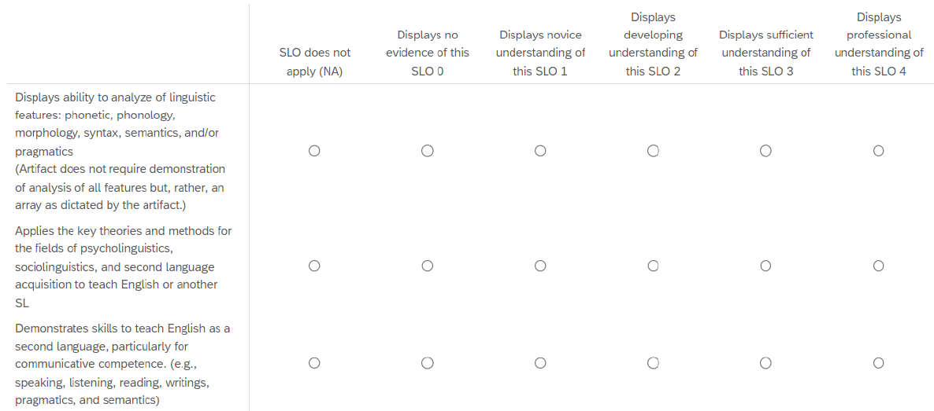
Criteria for Student Success | Student’s ESL unit plan will have a rating of “Displays developing understanding of this SLO” or higher for SLO 1. When students are assessed at the completion of the capstone course, the criterion for student success is a rating of “Displays sufficient understanding of this SLO” or higher for SLO 1. This assessment cycle, since students were assessed midway through the program (as opposed to at completion), achieving a rating of “Displays developing understanding” was deemed successful.
Program Success Target for this Measurement |  | 80% of student ESL unit plans in the sample will have an average rating of “Displays developing understanding of this SLO” or higher for SLO 1. | Percent of Program Achieving Target | 33% (i.e., 1 out of 3) TESOL graduate certificate students met the program success target.
Methods | Three students in ENG 566 submitted ESL unit plans. These unit plans were assessed by the TESOL programs coordinator using the rubric attached above for SLO 1.
Based on your results, highlight whether the program met the goal Student Learning Outcome 1. |  |  |  | Met | Not Met
Results, Conclusion, and Plans for Next Assessment Cycle (Describe what worked, what didn’t, and plan going forward)
Results: The results were not altogether surprising, given that the students assessed in the current cycle had not yet taken the course in our program that is chiefly focused on helping students develop SLO 1 (i.e., ENG 407G Linguistic Analysis).

Conclusions: This was the first assessment cycle (as far as we can tell) that did not involve assessment of student artifacts from the capstone course (as there were no TESOL graduate certificate students enrolled in that course this year), but rather from courses midway through the program. For that reason (i.e., use of a new assessment instrument and timeline), it is difficult to speculate about the impact of any programmatic changes on students’ achievement of SLO 1. Furthermore, the students who were assessed in the current cycle had not yet taken ENG 407G (Linguistic analysis), the course in our program which, as the name suggests, is chiefly focused on helping students develop the ability to analyze the linguistic features of English (i.e., SLO 1); for this reason, assessing SLO 1 in this context may not provide us with a valid picture of students’ progress through the program.

Plans for Next Assessment Cycle: In future assessment cycles, we will, whenever possible, assess student artifacts from the capstone course. Further, if, in future years, we are again unable to assess artifacts from the capstone course, we will select an artifact from ENG 407G (Linguistic analysis) to assess for SLO 1.

Program Student Learning Outcome 2
Program Student Learning Outcome | Apply the key theories and methods for the fields of psycholinguistics, sociolinguistics, and second language acquisition to teach English.
Measurement Instrument 1 | In ENG 408G (“Sociolinguistics and Psycholinguistics”), at the conclusion of the psycholinguistics portion of the course, all students took a psycholinguistics test that assessed their knowledge of psycholinguistic theory and its applications in teaching English as a Second Language. The test was designed by the course instructor who is also the TESOL programs coordinator, and consisted of 30 multiple-choice and fill-in-the-blank questions. It was delivered through the Blackboard learning management system. Upon submission, the test was graded automatically by Blackboard.
Criteria for Student Success | Students will achieve a score of 24 out of 30 or higher on the psycholinguistics test in ENG 408G.
Program Success Target for this Measurement |  | 80% of students will achieve a score of 24 out of 30 of higher on the psycholinguistics test in ENG 408G. | Percent of Program Achieving Target | 100% (i.e., 4 out of 4) TESOL graduate certificate students met the program success target.
Methods | Four TESOL graduate certificate students enrolled in ENG 408G took the psycholinguistics test. Test scores were recorded from Blackboard by the course instructor/TESOL programs coordinator.
Based on your results, circle or highlight whether the program met the goal Student Learning Outcome 2. |  |  |  | Met | Not Met
Results, Conclusion, and Plans for Next Assessment Cycle (Describe what worked, what didn’t, and plan going forward)
Results: The results were somewhat surprising because the content being assessed was at a high level, the test included several challenging questions, and not all students always appeared fully engaged in class during delivery of the content.

Conclusions: This was the first assessment cycle (as far as we can tell) that did not involve assessment of student artifacts from the capstone course (as there were no TESOL graduate certificate students enrolled in that course this year), but rather from courses midway through the program. For that reason (i.e., use of a new assessment instrument and timeline), it is difficult to speculate about the impact of any programmatic changes on students’ achievement of SLO 2. Based on this year’s assessment in a vacuum, the program appears to be effective in facilitating students’ progress for this SLO midway through the program.

Plans for Next Assessment Cycle: In future assessment cycles, we will, whenever possible, assess student artifacts from the capstone course.

Program Student Learning Outcome 3
Program Student Learning Outcome | Demonstrate skills to teach English as a second language for speaking, listening, reading, writings, pragmatics, and semantics, particularly for communicative competence.
Measurement Instrument 1 | At the conclusion of ENG 566, students submitted an ESL unit plan to cover one week’s worth of ESL instruction for primary-aged students. As part of their unit plan, students provided overviews of instruction, including learning targets for each day, related curricular standards from the Kentucky Academic Standards, and brief descriptions of teaching and learning activities that they planned. It is primarily through these components of students’ unit plans that SLO 3 was assessed. The rubric used (see below) is the same one used to assess student portfolios in the capstone course ENG 471G.
Criteria for Student Success | A student’s ESL unit plan will have a rating of “Displays developing understanding of this SLO” or higher for SLO 3. When students are assessed at the completion of the capstone course, the criterion for student success is a rating of “Displays sufficient understanding of this SLO” or higher for SLO 3. This assessment cycle, since students were assessed midway through the program (as opposed to at completion), achieving a rating of “Displays developing understanding” was deemed successful.
Program Success Target for this Measurement |  | 80% of student ESL unit plans in the sample will have a rating of “Displays developing understanding of this SLO” or higher for SLO 3. | Percent of Program Achieving Target | 33% (i.e., 1 out of 3) TESOL graduate certificate students met the program success target.
Methods | Three students in ENG 566 submitted ESL unit plans. These unit plans were assessed by the TESOL programs coordinator using the rubric attached above for SLO 3.
Based on your results, circle or highlight whether the program met the goal Student Learning Outcome 3. |  |  |  | Met | Not Met
Results, Conclusion, and Plans for Next Assessment Cycle (Describe what worked, what didn’t, and plan going forward)
Results: The results were not altogether surprising because the assignment selected for assessment did not provide substantial opportunities for students to demonstrate their level of achievement in terms of SLO 3.

Conclusions: This was the first assessment cycle (as far as we can tell) that did not involve assessment of student artifacts from the capstone course (as there were no TESOL graduate certificate students enrolled in that course this year), but rather from courses midway through the program. For that reason (i.e., use of a new assessment instrument and timeline), it is difficult to speculate about the impact of any programmatic changes on students’ achievement of SLO 3. The artifact selected to assess SLO 3 this cycle did not provide enough opportunities for students to demonstrate their level in terms of SLO 3.

Plans for Next Assessment Cycle: In future assessment cycles, we will, whenever possible, assess student artifacts from the capstone course. Further, if, in future years, we are again unable to assess artifacts from the capstone course, we will select a different artifact from ENG 566 to assess for SLO 3; the chosen assignment should be designed in such a way as to elicit more evidence of students’ level of achievement in terms of SLO 3. It is likely that we will use artifacts produced for the “ESL micro-teaching” assignment in this case.

Curriculum map

Department: English
College: PCAL
Contact person: Mark McAndrews
Email: mark.mcandrews@wku.edu

KEY: I = Introduced R = Reinforced/Developed M = Mastered A = Assessed

LO1: Analyze the linguistic features of the English language
ENG 407/407G Linguistic Analysis I/R
ENG 408/408G Psycholinguistics and Sociolinguistics I/R
ENG 565 Integrated TESOL R/M
ENG 566 Teaching and Assessing Grammar for TESOL R
ENG 471/471G TESOL Practicum M, A

LO2: Apply the key theories and methods of the fields of psycholinguistics, sociolinguistics, and second language acquisition to teach English
ENG 407/407G Linguistic Analysis I/R
ENG 408/408G Psycholinguistics and Sociolinguistics I/R
ENG 565 Integrated TESOL R/M
ENG 566 Teaching and Assessing Grammar for TESOL R/M
ENG 471/471G TESOL Practicum M, A

LO3: Demonstrate skills to teach English as a second language for speaking, listening, reading, writings, pragmatics, and semantics, particularly for communicative competence
ENG 407/407G Linguistic Analysis I/R
ENG 408/408G Psycholinguistics and Sociolinguistics I/R
ENG 565 Integrated TESOL R/M
ENG 566 Teaching and Assessing Grammar for TESOL R
ENG 471/471G TESOL Practicum M, A

