Assurance of Student Learning Report
2023-2024
PCAL |  | English
Creative Writing, Master of Fine Arts, 0478
Dr. Nancy Dinan, interim MFA Director; Dr. Trini Stickle, Graduate Coordinator
Is this an online program? Yes No | Please make sure the Program Learning Outcomes listed match those in CourseLeaf . Indicate verification here Yes, they match! (If they don’t match, explain on this page under Assessment Cycle)
*** Please include Curriculum Map as part of this document (at the end), NOT as a separate file.
Use this page to list learning outcomes, measurements, and summarize results for your program. Detailed information must be completed in the subsequent pages. Add more Outcomes as needed.
Program Student Learning Outcome 1: SLO 4 Demonstrate the ability to write a comprehensive analysis of a literary work
Instrument 1 | Sampling of 10 MFA graduate literature papers completed in literature courses during AY23-24
Instrument 2 | NA
Instrument 3 | NA
Based on your results, check whether the program met the goal Student Learning Outcome 1.  The AY23-24 assessment of SLO 4 is a baseline measure of our MFA students’ ability to conduct literary analysis at the graduate level.  The sample papers are comprised of MFA students at each level of the MFA 3-year program. As such, we expect just over one third (35%) to be conducting literary analysis at a minimum of a 3.0 score on a four point scale; 45% to be at a developing stage of literary analysis, a 2.0-2.99 score on the four point scale; and no more than 20% to be deemed insufficient in literary skills.  Our baseline results show 40% at a 3.0 or higher rating (n = 4); 50% at a developing stage of graduate literary analysis (n = 5); and 10% scoring insufficient for literary analysis (n = 1). It is important to note that the one student who scored insufficient for literary analysis is close to an acceptable level with a score of 1.80. |  | Met | Not Met
Program Student Learning Outcome 2: SLO 6: Students will demonstrate understanding of professional and pedagogical practices and opportunities within and related to the field of creative writing.
Instrument 1 | The artifact selected to measure SLO 6 is particularly aligned as the paper from the ENG 515 final artifact is a summary and reflection of the 150-hour internship required within a professional setting for all MFA second year students. The experience and final product are designed to allow MFA students to explore the variety of professional avenues to which their skills and abilities can be applied. Selecting and designing the internship is meant to expand students’ professional skills, and as they reflect on their experiences, students are expected to discuss the pedagogical value of their particular internship, the educational value of skills they acquired, or ways that their classes could help prepare future MFA students for the internship.
Instrument 2 | NA
Instrument 3 | NA
Based on your results, check whether the program met the goal Student Learning Outcome 2.  This is a reassessment of SLO 6 of the four third-semester students using the same course and course artifact as we did for our assessment of SLO 6 for the AY23-24 cohort of six students. Since our AY23-24 cohort fell below our expectations for this SLO, we have developed a recursive assessment process to help determine whether our response to those results move us closer to our desired program goals.  Complicating the analyses, however, is the small sample size of students each year. That said, this year’s cohort did, overall, better display an understanding of professional and pedagogical practices within the field of creative writing as well as a stronger knowledge of opportunities within and related to the field of creative writing with 75% scoring at the desired level of a 3.0 for each skill.  We believe changes to the course assignments and explicit instruction on the development of 1) an appropriate internship, 2) increased instructor leadership, and 3) revision of course assignment documents, expectations, and final products are responsible for students achieving outcomes for this SLO.  Thus, this reassessment of SLO 6 suggests positive movement of SLO 6 as students displayed sufficient rather than a developing understanding of the skills subsumed within SLO 6.  In the aggregate, the students met the threshold of 3.0 for all skills; however, individually, 75% achieved the goal for each skill.  On a six-point scale in which a 4 indicates a display of professional knowledge, the four 3rd semester students (of the 6-semester program) had an aggregate score of 3.69 as opposed to the AY23-24 students whose aggregate score was 2.65.  Assessment was calculated based on the assessment of the three skills—professional practices, pedagogical application, and other opportunities.  The scale is as follows:  NA—Skill not applicable to project; 0 Skill is applicable but not demonstrated; 1—novice; 2 developing; 3 sufficient; 4 professional level.  Our students were evaluated by four MFA faculty members and the program coordinator, for a total of five raters.  SLO 6 is truly comprised of three subskills.  Our assessment survey does provide a nuanced view of each subskill and the results show an even more promising development for our second-year students.  Subskill 1) Upon completing their professional internship, on displays of professional practices, the aggregate score of our four students was 3.87 as opposed to last year’s cohort average of 2.67.  Individually, the AY23-24 cohort, three of the four scored over a 3.0 on this skill (75%).  Subskill 2) On displays of professional opportunities, the aggregate score for the four students was 3.25 as opposed to our last year’s cohort average of 2.54.  Individually, the AY23-24 cohort, three of the four scored over a 3.0 on this skill (75%).  Subskill 3) The area for which we need to further develop, even at the second-year level, is knowledge of pedagogical opportunities; the aggregate score for the four students was 3.95 as opposed to our last year’s cohort average of 2.12.  Individually, the AY23-24 cohort, three of the four scored over a 3.0 on this skill (75%). |  | Met | Not Met
Assessment Cycle Plan:
We have created a five-year assessment plan to ensure all SLOs are assessed for a baseline score using a variety of program artifacts; thus, we hope to identify any deficits or insufficiencies. We will then use each year’s data to instantiate changes to the curricula or in delivery of instruction to address such issues. Within the five-year assessment plan, we will reassess each SLO to measure the effects of our improvement measures.
Below is our five-year assessment plan:

MFA Assessment AY2223—YR 1 (AY2223)
Course: 515 Internship—final paper (n=6)
Baseline score for SLO 6
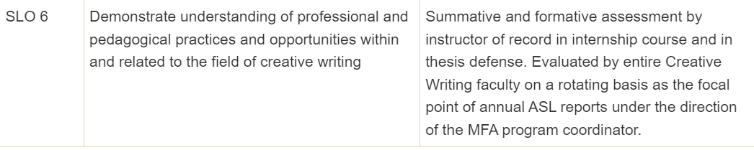

MFA Assessment AY23-24—YR 2 (AY23-24)
SLO 4 will be examined using papers written in literature courses by MFAs (n = 8-10) Baseline score for SLO 4
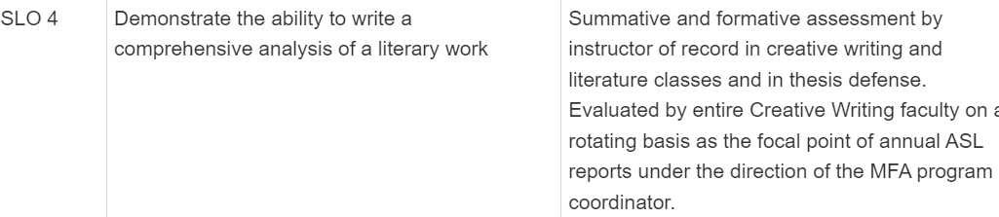

Course: 515 Internship—final paper (n=5)
Recheck SLO 6 to ensure deficits met or approaching goals; add in a second measure for third-year students to see the level of achievement. This could be the final reflection essay to their theses or their CVs.

MFA Assessment AY2425—YR 3 (AY2425)
SLO 1 and SLO 2: One product from each MFA student from across ENG 501 workshops and the theses of graduating MFAs (n = 15)
Baseline score for SLO 1 and 2

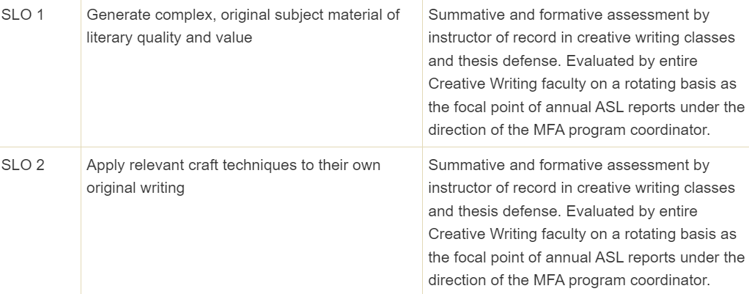

SLO 4
SLO 4 will be reassessed using papers written in literature courses by MFAs (n = 8-10) in year, AY23-24

MFA Assessment AY2526—YR 4 (AY2526)
ENG 512 Reading as a Writer (n = 8-10) Baseline check for SLO 3 and 5
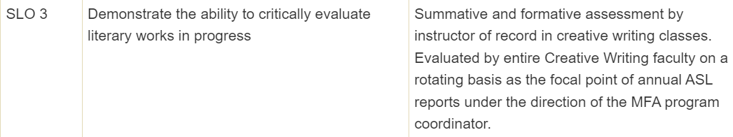
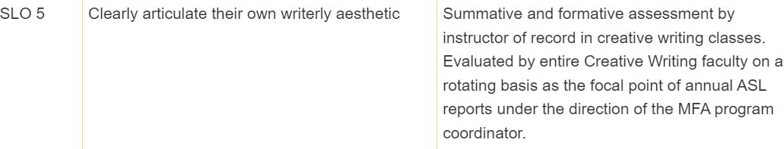

MFA Program Assessment AY2627—YR 5 (AY2627)
Recheck SLO 1 and SLO 2 to ensure deficits met or approach goals: One product from each MFA student from across the AY23-24 501 workshops and the theses of graduating MFAs (n = 15)

Recheck SLOs 3 and 5 to ensure deficits met/approaching goals, ENG 512 Reading as a Writer (n = 8- 10)

Any additional SLO that has not yielded sufficient results may be subject to recheck in year 5.
End of five-year plan. This may involve additional artifacts.
Data will be used for MFA program assessment occurring in year 5; data will be used to set the next five-year sequence.

Program Student Learning Outcome 1

Program Student Learning Outcome | SLO 4: Demonstrate the ability to write a comprehensive analysis of a literary work
Measurement Instrument 1 | NOTE: Each student learning outcome should have at least one direct measure of student learning. Indirect measures are not required.  Courseleaf Measurement Plan: Summative and formative assessment by instructor of record in creative writing and literature classes and in thesis defense. Evaluated by entire Creative Writing faculty on a rotating basis as the focal point of annual ASL reports under the direction of the MFA program coordinator.  For AY23-24 assessment of SLO 4, the MFA Assessment Committee of five (four MFA faculty and the graduate coordinator) reviewed 10 anonymized MFA graduate literature papers compiled from three literature courses during the SP24 semester. The committee evaluated each paper for students’ demonstration of comprehensive literary analysis on a four-point scale, shown below, with the point value of each evaluation.  Here is the link to the actual survey.
Criteria for Student Success | For any given year, our program has 15-18 MFA students enrolled. Each year 4-6 graduate with the MFA. Considering our literature courses are populated with MFA graduate students in each year of the three-year program and 1-3 of those students are often part-time students, the range of ability, to include literary analysis, is great. To achieve success for SLO 4, we expect just over one third (35%) to be conducting literary analysis with a minimum of a 3.0 on a four point scale, 45% to be at a developing stage of literary analysis, a 2.0-2.99 score on the four point scale, and no more than 20% to be deemed insufficient in literary skills.
Program Success Target for this Measurement |  |  | 35% scoring a 3.0 or higher at an adequate level; 45% at a developmental level; no more than 20% at an insufficient level of literary analytic skills. |  | Percent of Program Achieving Target | 100%  The breakdown of the individual scores their reflection by percentage of students assessed demonstrates the program is meeting its goals for SLO 4.
Methods | Because the MFA admits 5-7 full time MFA students per year with the occasional part-time MFA student, when we SLO 4, we collect the literature papers from all the graduate literature courses in one semester (either FA or SP). We eliminate the duplicative individual student papers across multiple literature classes and use the sampling of papers for assessment. Thus, for any given assessment period , we have a sampling of MFA students from all levels in the program (first year, second year), the current MFA body of students is 17 (AY23-24), so we expect to receive a sampling of 8-12 papers. The graduate coordinator anonymizes the papers and prepares and distributes the survey measure each year.
Measurement Instrument 2 | NA
Criteria for Student Success | NA
Program Success Target for this Measurement |  | NA |  | Percent of Program Achieving Target |  | NA
Methods | NA
Measurement Instrument 3 | NA
Criteria for Student Success | NA
Program Success Target for this Measurement |  | NA |  | Percent of Program Achieving Target |  | NA
Methods | NA
Based on your results, highlight whether the program met the goal Student Learning Outcome 1. |  |  |  |  |  | Met | Not Met
Results, Conclusion, and Plans for Next Assessment Cycle (Describe what worked, what didn’t, and plan going forward)
Results: We note that a meeting with the graduate literature professors is warranted for us to discuss the SLO 4 and how best they can guide our graduate students in their development from an undergraduate-level analysis to a graduate or professional one.

Conclusions: In addition to developing their skills as creative writers, we strongly believe that our MFA students achieve professional competencies in writing and analysis due to our literature and composition/rhetorical requirements. Each MFA student must also select a concentration from the following: CompRhet, Lit, or TESOL. What we see from our assessment is a sequential development from first to third year students as supported by the range and distribution of assessment scores.

**IMPORTANT - Plans for Next Assessment Cycle: As noted earlier, we have instantiated a five-year recursive assessment plan. We are working to identify both strengths and weaknesses and for the latter, we will institute changes in the coursework and modality of instruction to ensure better outcomes. For SLO 4, we plan to reassess this SLO in year 3 having put into place the guidance generated by our literature professors.

Program Student Learning Outcome 2
Program Student Learning Outcome | SLO 6: Students will demonstrate understanding of professional and pedagogical practices and opportunities within and related to the field of creative writing.
Measurement Instrument 1 | Exit papers for ENG 515, the Internship course. This course is a second-year degree requirement.  Here is the link to the rubric designed through Qualtrics that was used to assess the artifacts. Below is an image of the assessment rubric:  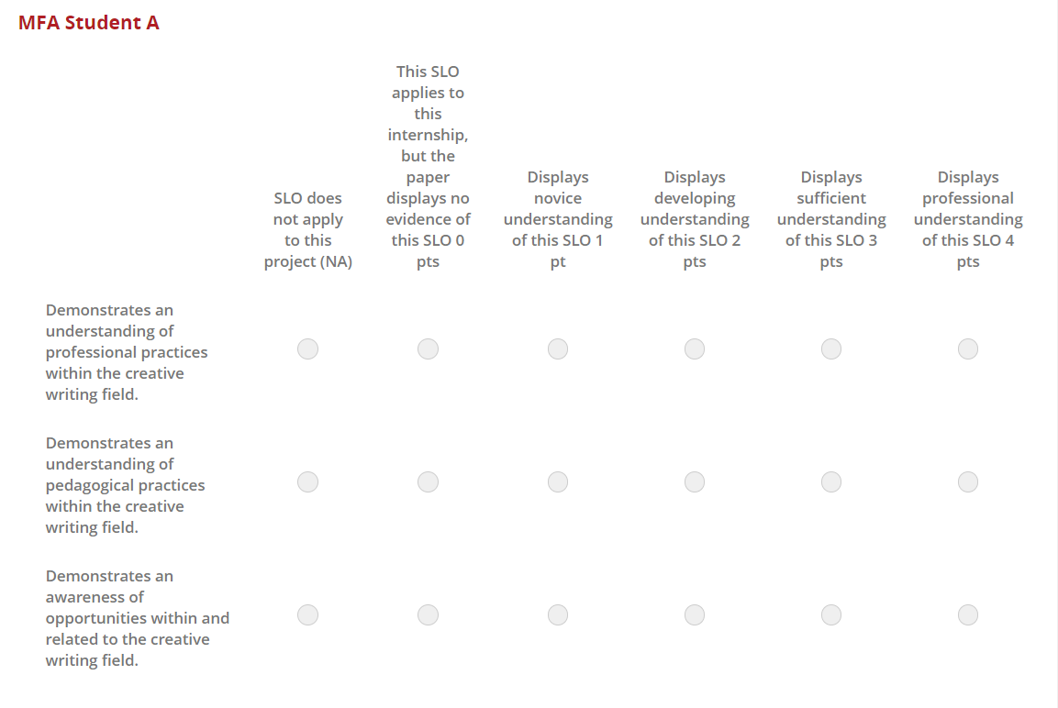
Criteria for Student Success | For any given year, there are 15-18 MFA students. Each year 4-6 graduate with the MFA. To achieve success for SLO 6, we expect 80% of our students can show evidence of a sufficient understanding of professional practices—publications, conference attendance, teaching of courses, and other career experiences—reflected in their final thesis reflection piece and evidenced on their vitas.  The outcomes or achievements students should achieve from the internship itself, and in the writing of the final paper for 515 is an awareness of the possibilities-professional, pedagogical—that exists as someone working toward an MFA. As the second-year cohort engage in the internship process together, they are also being made aware of these professional and pedagogical opportunities and practices from each other.  The redesign of the MFA program from a two-year to a three-year commitment speaks directly to the criteria for success: Our students are preparing themselves and we are helping prepare them for a future of professional opportunities. At this first step, the evaluation of SLO 6 at semester 3, we expect 80% of the students to achieve a sufficient knowledge of professional and pedagogical practices and opportunities, i.e., a 3 on the survey scale.
Program Success Target for this Measurement |  |  | We plan for our MFA incoming student cohort to be 8. We expect 80% will demonstrate a sufficient understanding of professional and pedagogical practices and opportunities by the end of the third semester and a professional understanding by the time they graduate. |  | Percent of Program Achieving Target | To evaluate the development of this knowledge, the EN 515 paper at the second-year mark should show at least 80% scoring a 3 or higher for SLO 6. In this measure, 50% MFA student scored at least 3, but all had an average score of 2+, moving toward our expectation.
Methods | Because the MFA admits 5-7 full time MFA students per year with the occasional part-time MFA student, we opted to evaluate 100% of the second-year class, all of whom must take the ENG 515 internship. We have also adopted for other measures the practice of sampling no less than 75% of the entire class for any measure. Thus, for assessments in which all levels of MFA students are involved, the current total 17 MFA body of MFAs (AY23-24), we would sample no fewer than 10 students.
Measurement Instrument 2

Criteria for Student Success

Program Success Target for this Measurement |  |  |  | Percent of Program Achieving Target
Methods

Measurement Instrument 3

Criteria for Student Success

Program Success Target for this Measurement |  |  |  | Percent of Program Achieving Target
Methods

Based on your results, circle or highlight whether the program met the goal Student Learning Outcome 2. |  |  |  |  |  | Met | Not Met
Results, Conclusion, and Plans for Next Assessment Cycle (Describe what worked, what didn’t, and plan going forward)
Results: We note that continual guidance in exploring, designing, and assimilating the types of internships available to MFA students is needed for the required internship to achieve the goals set for it. However, the changes enacted from last year’s assessment appear to be moving us in positive directions. Additionally, students need better guidance in the what types of observations should be included in the final exit artifact, and we have plans in place to better achieve the SLO 6 goals for AY24-25.

Conclusions: We strongly believe that the internship (ENG 515) has professional and pedagogical value. Most students displayed a stronger understanding of professional practices and an awareness of opportunities. Most did not connect their experiences in any pedagogical way. Going forward, we are ensuring that ENG 515 has clear guidance on the hours required for the internship, the supervisory role of internship mentors is defined, as are the parts and goals of the exit artifact.

**IMPORTANT - Plans for Next Assessment Cycle: As noted earlier, we have instantiated a five-year recursive assessment plan. We are working to identify both strengths and weaknesses and for the latter, we will institute changes in the coursework and modality of instruction to ensure better outcomes.
Curriculum MAP is copied to the end of this document.

