Assurance of Student Learning Report
2023-2024
Potter College |  | School of Media & Communication
Communicating in Organizations Gradute Certificate #471
Jieyoung Kong, Ph.D.
Is this an online program? Yes No | Please make sure the Program Learning Outcomes listed match those in CourseLeaf . Indicate verification here Yes, they match! (If they don’t match, explain on this page under Assessment Cycle)
*** Please include Curriculum Map as part of this document (at the end), NOT as a separate file.
Use this page to list learning outcomes, measurements, and summarize results for your program. Detailed information must be completed in the subsequent pages. Add more Outcomes as needed.
Program Student Learning Outcome 1: Identifies and analyzes communication challenges in organizational life.
Instrument 1 | Direct: Analysis of a course assignment paper.
Based on your results, check whether the program met the goal Student Learning Outcome 1. |  | Met | Not Met
Student Learning Outcome 2: Applies communication theories, principles, and/or research to construct practical recommendations.
Instrument 1 | Direct: Analysis of a course assignment paper.
Based on your results, check whether the program met the goal Student Learning Outcome 2. |  | Met | Not Met
Student Learning Outcome 3: Evaluates and/or develops messages/strategies that affect organizational outcomes.
Instrument 1 | Direct: Analysis of a course assignment paper.
Based on your results, check whether the program met the goal Student Learning Outcome 3. |  | Met | Not Met
Assessment Cycle Plan:
We assessed all three SLOs this year and plan to do so again next year. The Communicating in Organizations Graduate Certificate Program is a 12-credit hour program focusing on applied organizational communication and integrates communication theory, practice, and problem-based research in dealing with real-world communication challenges. Students can complete it fully online, or partially online, or fully in person, if they choose. Also, there is no fixed sequence of courses for this program; rather, students choose any two courses from two clusters of elective courses: one group in organizational communication and its processes, and the other in message design and communication contexts. Assessing student learning outcomes for this particular program is a challenge, however, because there is no set of core courses nor a culminating capstone experience to tap for student learning outcomes and program assessment. The student learning objectives for the certificate program are as follows: (1) Identifies and analyzes communication challenges in organizational life, (2) Applies communication theories, principles, and/or research to construct practical recommendations, and (3) Evaluates and/or develops messages/strategies that affect organizational outcomes. Similar to the 2022-2023 ASL assessment, we identified an elective course with the highest concentration of students in the certificate program for this year’s assessment of all three learning outcomes. The result of this year’s assessment indicate that for SLO 1, the mean scores of the sampled student papers had reached and/or exceeded the self-reported assessment goals, but for SLO 2 and SLO 3, the mean scores fell short of meeting the assessment goals. There is an opportunity to close the loop by consulting the course instructor to ensure the course learning objectives align with the program learning objectives and to make tweaks to assignment instructions and explicitly emphasize the importance of applying communication theories in the student white papers.

Program Student Learning Outcome 1

Program Student Learning Outcome | Identifies and analyzes communication challenges in organizational life.
Measurement Instrument 1 | DIRECT measure of student learning: Student artifacts chosen for this SLO assessment were a 12+ page white paper where students propose a communication strategy for a hypothetical organization/group facing an unfamiliar cultural audience.
Criteria for Student Success | Success is “proficient” or higher on the rubric developed from program learning outcomes. Scores on the rubric item for this SLO ranged from “insufficient (1 point),” “weak (2 point),” “proficient (3 points),” and “excellent (4 points).”
Program Success Target for this Measurement |  | 75% | Percent of Program Achieving Target | 100%
Methods | Direct: Artifacts from 4 students (n = 4) enrolled in the course listed in the certificate program were collected out of a total of seven students enrolled in the certificate program (N = 7). All identifiers were removed (student name, course name, and faculty name) from the artifacts and each was assigned to two full-time graduate faculty who teach in the graduate communication program so that each paper was read twice by two different reviewers. The mean of the reviewer scores was used as the final score. The rubric used for scoring was developed from the program learning outcomes; for this SLO, there was a single corresponding rubric item which could be scored along four different levels.
Based on your results, highlight whether the program met the goal Student Learning Outcome 1. |  |  |  | Met | Not Met
Results, Conclusion, and Plans for Next Assessment Cycle (Describe what worked, what didn’t, and plan going forward)
Results: Overall, the results from this assessment indicate that the mean scores for all of the sampled student papers for these SLOs have not only met but also exceeded the self-declared goal.

Conclusions: The assessment results suggest there is good alignment between the elective course learning outcomes and this particular program learning outcome. In terms of actions for program improvement, faculty who teach courses in the certificate program should update their course learning objectives and course assignments to reflect the latest program learning objectives starting next academic year.

**IMPORTANT - Plans for Next Assessment Cycle: The course instructors will then be consulted to ensure the course learning objectives align with the program learning objectives and to identify the most appropriate student artifacts for program assessment purposes.

Program Student Learning Outcome 2
Program Student Learning Outcome | Applies communication theories, principles, and/or research to construct practical recommendations.
Measurement Instrument 1 | DIRECT measure of student learning: Student artifacts chosen for this SLO assessment were a 12+ page white paper where students propose a communication strategy for a hypothetical organization/group facing an unfamiliar cultural audience.
Criteria for Student Success | Success is “proficient” or higher on the rubric developed from program learning outcomes. Scores on the rubric item for this SLO ranged from “insufficient (1 point),” “weak (2 point),” “proficient (3 points),” and “excellent (4 points).”
Program Success Target for this Measurement |  | 75% | Percent of Program Achieving Target | 50%
Methods | Direct: Artifacts from 4 students (n = 4) enrolled in the course listed in the certificate program were collected out of a total of seven students enrolled in the certificate program (N = 7). All identifiers were removed (student name, course name, and faculty name) from the artifacts and each was assigned to two full-time graduate faculty who teach in the graduate communication program so that each paper was read twice by two different reviewers. The mean of the reviewer scores was used as the final score. The rubric used for scoring was developed from the program learning outcomes; for this SLO, there was a single corresponding rubric item which could be scored along four different levels.
Based on your results, circle or highlight whether the program met the goal Student Learning Outcome 2. |  |  |  | Met | Not Met
Results, Conclusion, and Plans for Next Assessment Cycle (Describe what worked, what didn’t, and plan going forward)
Results: The results from this assessment indicate that the mean scores of half of the sampled student papers for these SLOs met or exceeded the "proficient" level.

Conclusions: The assessment results indicate an opportunity to enhance the alignment between the core course learning outcomes and this particular program learning outcome. In terms of actions for program improvement, the course instructor will be consulted to ensure the course learning objectives align with the program learning objectives and to make tweaks to assignment instructions. The instructor will also explicitly emphasize the importance of applying communication theories in students' white paper projects.

**IMPORTANT - Plans for Next Assessment Cycle: Instructors who teach courses in the certificate program will be consulted to update their course learning objectives and course assignments to reflect the latest program learning objectives starting next academic year. Additionally, course instructors will be consulted to ensure the course learning objectives align with the program learning objectives and to identify the most appropriate student artifacts for program assessment purposes.

Program Student Learning Outcome 3
Program Student Learning Outcome | Evaluates and/or develops messages/strategies that affect organizational outcomes.
Measurement Instrument 1 | DIRECT measure of student learning: Student artifacts chosen for this SLO assessment were a 12+ page white paper where students propose a communication strategy for a hypothetical organization/group facing an unfamiliar cultural audience.
Criteria for Student Success | Success is “proficient” or higher on the rubric developed from program learning outcomes. Scores on the rubric item for this SLO ranged from “insufficient (1 point),” “weak (2 point),” “proficient (3 points),” and “excellent (4 points).”
Program Success Target for this Measurement |  | 75% | Percent of Program Achieving Target | 50%
Methods | Direct: Artifacts from 4 students (n = 4) enrolled in the course listed in the certificate program were collected out of a total of seven students enrolled in the certificate program (N = 7). All identifiers were removed (student name, course name, and faculty name) from the artifacts and each was assigned to two full-time graduate faculty who teach in the graduate communication program so that each paper was read twice by two different reviewers. The mean of the reviewer scores was used as the final score. The rubric used for scoring was developed from the program learning outcomes; for this SLO, there was a single corresponding rubric item which could be scored along four different levels.
Based on your results, circle or highlight whether the program met the goal Student Learning Outcome 3. |  |  |  | Met | Not Met
Results, Conclusion, and Plans for Next Assessment Cycle (Describe what worked, what didn’t, and plan going forward)
Results: The results from this assessment indicate that the mean scores of half of the sampled student papers for these SLOs met or exceeded the "proficient" level.

Conclusions: The assessment results indicate an opportunity to enhance the alignment between the core course learning outcomes and this particular program learning outcome. In terms of actions for program improvement, the course instructor will be consulted to ensure the course learning objectives align with the program learning objectives and to make tweaks to assignment instructions. The instructor will also explicitly emphasize the importance of applying communication theories in students' white paper projects.

**IMPORTANT - Plans for Next Assessment Cycle: Instructors who teach courses in the certificate program will be consulted to update their course learning objectives and course assignments to reflect the latest program learning objectives starting next academic year. Additionally, course instructors will be consulted to ensure the course learning objectives align with the program learning objectives and to identify the most appropriate student artifacts for program assessment purposes.

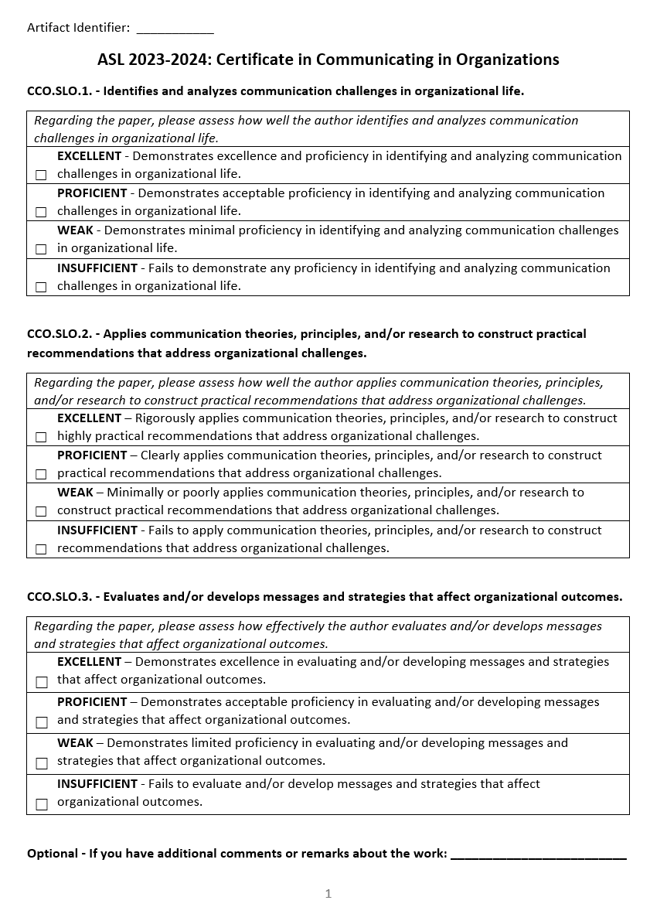

*** Please include Curriculum Map (below/next page) as part of this document
CURRICULUM MAP TEMPLATE
Program name: | Communicating in Organizations Graduate Certificate Program (#0471)
Department: | Communication
College: | PCAL
Contact person: | Dr. Jieyoung Kong
Email: | Jieyoung.Kong@wku.edu
KEY:  I = Introduced  R = Reinforced/Developed  M = Mastered  A = Assessed |  |  | Learning Outcomes:  LO1: Identifies and analyzes communication challenges in organizational life.  LO2: Applies communication theories, principles, and/or research to construct practical recommendations.  LO3: Evaluates and/or develops messages/strategies that affect organizational outcomes.
 |  |  |  | Learning Outcomes
Course Subject | Number | Course Title |  | LO1: | LO2: | LO3:
(Restricted Electives: Communication Strategies)
COMM | 528 | Communication in the Nonprofit Sector |  | I/R/M | I/R/M | I/R/M
COMM | 561 | Multinational Organizational Communication |  | I/R/A | I/R/A | I/R/A
COMM | 564 | Crisis Communication |  | I/R/M | I/R/M | I/R/M
COMM | 571 | Organizational Communication in the Digital Age |  | I/R/A | I/R/A | I/R/A
COMM | 581 | Applied Organizational Communication |  | I/R/A | I/R/A | I/R/A
COMM | 586 | Process of Group Communication |  | I/R | I/R | I/R
(Restricted Electives: Communication Contexts)
COMM | 523 | Health Communication |  | I/R | I/R | I/R
COMM | 553 | Health Communication Campaigns |  | I/R | I/R/M | I/R
COMM | 566 | Corporate & Organizational Advocacy |  | I/R/M | I/R/M | I/R/M
COMM | 568 | Communication and Organizational Identification |  | I/R/M | I/R/M | I/R/M
COMM | 578 | Seminar in Interpersonal Communication |  | I/R | I/R/M | I/R
COMM | 590 | Intercultural Communication |  | I/R/A | I/R/A | I/R/A

