Assurance of Student Learning Report
2023-2024
Potter College |  | School of Media & Communication
Communicating in Healthcare Graduate Certificate #0475
Jieyoung Kong, Ph.D.
Is this an online program? Yes No | Please make sure the Program Learning Outcomes listed match those in CourseLeaf . Indicate verification here Yes, they match! (If they don’t match, explain on this page under Assessment Cycle)
*** Please include Curriculum Map as part of this document (at the end), NOT as a separate file.
Use this page to list learning outcomes, measurements, and summarize results for your program. Detailed information must be completed in the subsequent pages. Add more Outcomes as needed.
Program Student Learning Outcome 1: Identifies communication variables (including culture, technology) that affect communicating in healthcare contexts (SLO#3 in CourseLeaf).
Instrument 1 | Direct: Analysis of a course assignment paper.
Based on your results, check whether the program met the goal Student Learning Outcome 1. |  | Met | Not Met
Program Student Learning Outcome 2: Critiques the effectiveness of health communication campaigns (SLO#4 in CourseLeaf)..
Instrument 1 | Direct: Analysis of a course assignment paper.
Based on your results, check whether the program met the goal Student Learning Outcome 2. |  | Met | Not Met
Assessment Cycle Plan:
The program has two core courses students must take and a list of restricted elective courses from communication, public health, health care administration, and nursing that students can choose from, all of which can be completed fully online. The student learning objectives for the certificate program are as follows: (1) Apply communication and health theories to explain factors that affect the delivery of healthcare, (2) Evaluate communication behaviors in health care relationships, health care teams, and health care organizations, (3) Identify communication variables (including culture and technology) that affect communicating in healthcare contexts, (4) Critique the effectiveness of health communication campaigns, (5) Develop a well-rounded understanding of communication processes within healthcare contexts, and (6) Understand the centrality of communication in health care administration, public health, and health behavior. For the 2022-2023 ASL assessment, we assessed learning outcomes 1, 5, and 6 from one of the program's core courses (i.e., COMM 523). For 2023-2024, we assessed learning outcomes 3 and 4 from the other core course (i.e., COMM 553). Next year, we plan to assess outcome 1 and 2?

Program Student Learning Outcome 1
Program Student Learning Outcome | Identifies communication variables (including culture, technology) that affect communicating in healthcare contexts.
Measurement Instrument 1 | DIRECT measure of student learning: The student artifact chosen for this SLO assessment was a 30+ page group project health campaign paper where students were required to develop a health campaign targeting a specific group within the larger WKU community and evaluate its success.
Criteria for Student Success | Success is “proficient” or higher on the rubric developed from program learning outcomes. Scores on the rubric item for this SLO ranged from “insufficient (1 point),” “weak (2 point),” “proficient (3 points),” and “excellent (4 points).”
Program Success Target for this Measurement |  | 75% | Percent of Program Achieving Target | 60%
Methods | Direct: Artifacts of five students (n = 5) in COMM 553, one of two program core courses, were collected during the assessment period out of a total of seven students enrolled in the certificate program (N = 7) during 2023-24. All identifiers were removed (student names) from the artifact and each were assigned to two full-time graduate faculty who teach in the graduate communication program so that each paper was read twice by two different reviewers. The mean of the reviewer scores were used as the final score. The rubric used for scoring was developed from the program learning outcomes; for this SLO, there was a single corresponding rubric item which could be scored along four different levels.
Based on your results, circle or highlight whether the program met the goal Student Learning Outcome 1. |  |  |  | Met | Not Met
Results, Conclusion, and Plans for Next Assessment Cycle (Describe what worked, what didn’t, and plan going forward)
Results: The results from this assessment indicate that the mean scores of 60% of the sampled student papers met or exceeded the "proficient" level for this SLO.

Conclusions: The assessment results indicate an opportunity to enhance the alignment between the core course learning outcomes and this particular program learning outcome. In terms of actions for program improvement, the course instructor will be consulted to ensure the course learning objectives align with the program learning objectives and to make tweaks to assignment instructions.

**IMPORTANT - Plans for Next Assessment Cycle: The instructor who teaches the two core courses in the certificate program will be consulted to update their course learning objectives and course assignments to reflect the latest program learning objectives starting next academic year. Additionally, the core course instructor will be consulted to ensure the course learning objectives align with the program learning objectives and to develop the most appropriate student artifacts for program assessment purposes. These actions will be implemented to close the loop and facilitate continuous improvement in the certificate program.

Program Student Learning Outcome 2
Program Student Learning Outcome | Critiques the effectiveness of health communication campaigns.
Measurement Instrument 1 | DIRECT measure of student learning: The student artifact chosen for this SLO assessment was a 30+ page group project health campaign paper where students were required to develop a health campaign targeting a specific group within the larger WKU community and evaluate its success.
Criteria for Student Success | Success is “proficient” or higher on the rubric developed from program learning outcomes. Scores on the rubric item for this SLO ranged from “insufficient (1 point),” “weak (2 point),” “proficient (3 points),” and “excellent (4 points).”
Program Success Target for this Measurement |  | 75% | Percent of Program Achieving Target | 0%
Methods | Direct: Artifacts of five students (n = 5) in COMM 553, one of two program core courses, were collected during the assessment period out of a total of seven students enrolled in the certificate program (N = 7) during 2023-24. All identifiers were removed (student name, course name, and faculty name) from the artifact and each were assigned to two full-time graduate faculty who teach in the graduate communication program so that each paper was read twice by two different reviewers. The mean of the reviewer scores were used as the final score. The rubric used for scoring was developed from the program learning outcomes; for this SLO, there was a single corresponding rubric item which could be scored along four different levels.
Based on your results, circle or highlight whether the program met the goal Student Learning Outcome 2. |  |  |  | Met | Not Met
Results, Conclusion, and Plans for Next Assessment Cycle (Describe what worked, what didn’t, and plan going forward)
Results: Overall, the results from this assessment indicate that the mean scores for all of the sampled group papers for these SLOs had not been met. The common issues that assessors observed include insufficient critique and evaluation of the campaign, superficial integration of theory, inadequate rationale and evidence for the target audience, unclear methodology and data presentation, limited use of sources, and the need for improved formatting.

Conclusions: The assessment results indicate an opportunity to enhance the alignment between the core course learning outcomes and this particular program learning outcome. In terms of actions for program improvement, the course instructor will be consulted to ensure the course learning objectives align with the program learning objectives and to make tweaks to assignment instructions based on common issues that assessors had observed. However, the most urgent task is for the instructor to work with the program coordinator to develop an individual student assignment that will allow for a more precise assessment of individual student learning in relation to coprogram learning outcomes.

**IMPORTANT - Plans for Next Assessment Cycle: The instructor who teaches the two core courses in the certificate program will be consulted to update their course learning objectives and course assignments to reflect the latest program learning objectives starting next academic year. Additionally, the core course instructor will be consulted to ensure the course learning objectives align with the program learning objectives and to develop the most appropriate student artifacts for program assessment purposes. These actions will be implemented to close the loop and facilitate continuous improvement in the certificate program.

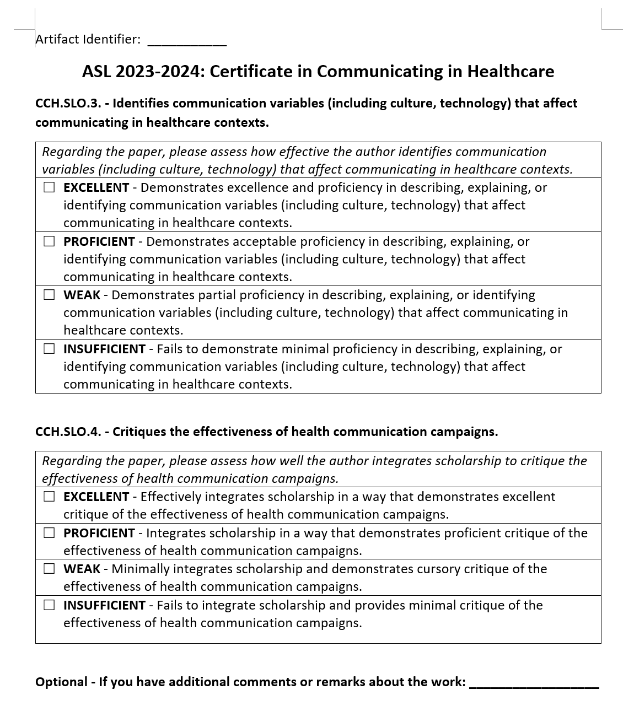
*** Please include Curriculum Map (below/next page) as part of this document
CURRICULUM MAP TEMPLATE
Program name: | Communicating in Healthcare Graduate Certificate Program (#0475)
Department: | Communication
College: | PCAL
Contact person: | Dr. Jieyoung Kong
Email: | Jieyoung.Kong@wku.edu
KEY:  I = Introduced  R = Reinforced/Developed  M = Mastered  A = Assessed |  | Learning Outcomes:  LO1: Analyze and apply communication and health theories to help explain factors that affect the delivery of health care.  LO2: Evaluate communication behaviors in health care relationships, health care teams (multidisciplinary, interdisciplinary, and transdisciplinary), and health care organizations.  LO3: Identify communication variables (i.e. culture, technology) that affect communicating in health care contexts.  LO4: Critique the effectiveness of health communication campaigns.  LO5: Develop a well-rounded understanding of communication processes within contexts that apply to healthcare including interpersonal, organizational, and intercultural.  LO6: Understand the centrality of communication in health care administration, public health, and health behavior.
Course Subject | Number | Course Title | Learning Outcomes
(Core Courses) |  |  | LO1: |  | LO2: | LO3: |  |  | LO4: |  | LO5 | LO6
COMM | 523 | Health Communication | I/R |  | I/R/A | I/R |  |  | I |  | I/R/M/A | I
COMM | 553 | Health Communication Campaign | I/R/M/A |  |  | I/R/A |  |  | I/R/A |  | I/R | I/R/A
(Restricted Elective Courses)
COMM | 528 | Communication in the Nonprofit Sector | I/R |  | I/R |  |  |  |  |  | I/R
COMM | 564 | Crisis Communication | I |  |  | I/R |  |  | I/R |  | I/R | I/R
COMM | 578 | Seminar in Interpersonal Communication | I/R |  | I/R |  |  |  |  |  | I/R
COMM | 581 | Applied Organizational Communication |  |  | I/R | I/R |  |  |  |  | I/R
COMM | 586 | Process of Group Communication |  |  | I/R | I/R |  |  |  |  | I/R
COMM | 590 | Intercultural Communication |  |  | I/R | I/R |  |  |  |  | I/R
HCA | 540 | Health Care Orgnization and Management | I/R |  |  | I |  |  | I/R |  | I | I/R
HCA | 541 | Strategic Management & Marketing of Health Service | I/R |  | I/R | I |  |  |  |  | I | I/R
PH | 548 | Community Health Organization | I |  | I/R | I |  |  | I |  | I/R | I/R
PH | 578 | Health Disparities | I/R |  |  | I/R |  |  | I/R |  |  | I/R
PH | 580 | Introduction to Public Health |  |  |  | I/R |  |  |  |  |  | I/R
PH | 581 | Applied Methods in Public Health Practice/Field Epidemiology | I/R |  |  | I/R |  |  | I/R |  | I/R | I/R
PH | 587 | Health Behavior | I/R |  |  |  |  |  | I/R |  |  | I/R
NURS | 501 | Nursing, Politics and Health Policy |  |  |  | I/R |  |  | I/R |  |  | I/R
NURS | 528 | Leadership and Management in Nursing Administration | I/R |  | I/R | I/R |  |  |  |  | I/R | I/R

