Assurance of Student Learning Report
2022-2023
PCAL |  | Department of Communication
M.A. in Organizational Communication (0012)
Jieyoung Kong, Ph.D.
Is this an online program? Yes No | Please make sure the Program Learning Outcomes listed match those in CourseLeaf . Indicate verification here Yes, they match! (If they don’t match, explain on this page under Assessment Cycle)

Use this page to list learning outcomes, measurements, and summarize results for your program. Detailed information must be completed in the subsequent pages. Add more Outcomes as needed.
Program Student Learning Outcome 1: Demonstrate mastery in written communication
Instrument 1 | Direct: Capstone Project (Thesis/Non-thesis options)
Instrument 2
Instrument 3
Based on your results, check whether the program met the goal Student Learning Outcome 1. |  |  |  |  |  | Met |  | Not Met
Program Student Learning Outcome 2: Explain theories and concepts
Instrument 1 | Direct: Capstone Project (Thesis/Non-thesis options)
Instrument 2

Instrument 3

Based on your results, check whether the program met the goal Student Learning Outcome 2. |  |  |  |  |  | Met |  | Not Met
Program Student Learning Outcome 3: Demonstrate ability to apply communication concepts in organizational contexts.
Instrument 1 | Direct: Capstone Project (Thesis/Non-thesis options)
Instrument 2

Instrument 3
Based on your results, check whether the program met the goal Student Learning Outcome 3. |  |  |  |  |  | Met |  | Not Met
Assessment Cycle Plan:
Overall, the result from this assessment indicate that students who complete our program successfully achieve the program learning outcomes. Our current program learning outcomes are as follow: 1. Demonstrate mastery in research, 2. Demonstrate mastery in written communication, 3. Explain theories and concepts, 4. Identify distinct communication practices of culturally diverse groups, and 5. Demonstrate ability to apply communication concepts in organizational contexts.
For individual courses, these learning outcomes are assessed using multiple tools such as exams, application papers, presentations, research proposals, and qualitative, quantitative, and rhetorically grounded primary research studies. For the program as a whole, the above learning outcomes are assessed through the capstone experience, either the thesis option or the non-thesis option. In other words, learning outcome assessment for the program as a whole has been embedded in the capstone experience. In the 2021-2022 ASL assessment, we had assessed learning outcomes 1, 2, and 4. So we alternated to assess learning outcomes 2, 3, and 5 for this year’s ASL assessment.
Student Learning Outcome 1
Student Learning Outcome |  | Demonstrate mastery in written communication.
Measurement Instrument 1 |  | DIRECT measure of student learning: For the thesis option, students complete original research and successfully defend their thesis. A thesis typically focuses on answering a specialized question(s) in communication research. In their first semester of thesis work, students prepare a prospectus, which includes a rationale, literature review, methodology sections, and a timeline for thesis completion. When they successfully defend their prospectus, they then proceed with the rest of the research project to collect, analyze data, and then write up the findings and implications in their second semester of the thesis work. Completion of a thesis depends on student demonstrating mastery in written communication. For the non-thesis option, students must take the comprehensive exam for their degree completion. The exam is composed of three questions to assess each of the following: theoretical knowledge, methodological mastery, and application of theories and concepts to specific context. The design of the exam and the questions written by faculty take into account the learning outcomes. Students must demonstrate mastery in written communication to convey their knowledge, critical thinking, and application skills.
Criteria for Student Success |  | In the case of the thesis option, students should successfully defend their thesis. In the case of the non-thesis option, the student must “Pass” their comprehensive exam for each of the areas tested. Student exam paper is evaluated by a set of rubrics adapted from the Widener University Doctor of Education Program (see attachment). The first rubric for the theory answer assesses for concept mastery, foundational content, literature use, organization, and language. The second rubric for the method answer assesses for the link of problem to design, research design, method, measurement, procedures, data analysis, and quality of writing. The third rubric for the application answer assesses on concepts, application to problem/case, literature use, organization, and language. Scores for each dimension per area range from “Insufficient” (1 point), “Emergent” (2 points), “Proficient” (3 points), and “Distinguished” (4 points). The scores from each dimension in each question area are summed up, which are then translated by a scale to determine success level into Fail, Pass, or Pass with Honors. To get a “Pass” on their exam answer, students must receive 13 out of a maximum of 20 points and no more than two individual dimension below “emergent” for each question area from each of their faculty committee member. A score that is 18 or above is considered “Pass with Honors.” For the final step, scores from the committee members are combined by each question area, and then translated by a scale to determine success level. If the total combined score for each question area is less than 38, it is “Fail.” If the combined score is 39-53 points, it gets “Pass.” Scores that are 54 or above, with 60 points being maximum possible points, get “Pass with Honors.” Success is defined as pass or higher.
Program Success Target for this Measurement |  |  | 100% | Percent of Program Achieving Target | 100%
Methods |  | Direct: Artifacts from capstone experience (N = 1) were used for this assessment. In this academic year, only one student was completing their master’s degree program and this student chose the thesis track (n = 1). Three faculty members who are members of the student’s thesis committee reviewed the work and approved its quality before the student was allowed to defend orally.
Based on your results, highlight whether the program met the goal Student Learning Outcome 1. |  |  |  |  | Met |  | Not Met
Results, Conclusion, and Plans for Next Assessment Cycle (Describe what worked, what didn’t, and plan going forward)
Results: The student successfully defended the thesis in their first attempt. Thus, these results have not indicated a need for program improvement or change.

Conclusions: The assessment result suggest there is good alignment between the capstone experience and the program learning outcome.

**IMPORTANT - Plans for Next Assessment Cycle: After consulting the Graduate Program Committee, program will be assessed using the same process but SLO criteria 1, 2, and 4.

Student Learning Outcome 2
Student Learning Outcome | Explain theories and concepts
Measurement Instrument 1 | DIRECT measure of student learning: For the thesis option, students complete original research and successfully defend their thesis. A thesis typically focuses on answering a specialized question(s) in communication research. In their first semester of thesis work, students prepare a prospectus, which includes a rationale, literature review, methodology sections, and a timeline for thesis completion. When they successfully defend their prospectus, they then proceed with the rest of the research project to collect, analyze data, and then write up the findings and implications in their second semester of the thesis work. Completion of a thesis depends on student demonstrating mastery in written communication. For the non-thesis option, students must take the comprehensive exam for their degree completion. The exam is composed of three questions to assess each of the following: theoretical knowledge, methodological mastery, and application of theories and concepts to specific context. The design of the exam and the questions written by faculty take into account the learning outcomes. Students must demonstrate mastery in written communication to convey their knowledge, critical thinking, and application skills.
Criteria for Student Success | In the case of the thesis option, students should successfully defend their thesis. In the case of the non-thesis option, the student must “Pass” their comprehensive exam for each of the areas tested. Student exam paper is evaluated by a set of rubrics adapted from the Widener University Doctor of Education Program (see attachment). The first rubric for the theory answer assesses for concept mastery, foundational content, literature use, organization, and language. The second rubric for the method answer assesses for the link of problem to design, research design, method, measurement, procedures, data analysis, and quality of writing. The third rubric for the application answer assesses on concepts, application to problem/case, literature use, organization, and language. Scores for each dimension per area range from “Insufficient” (1 point), “Emergent” (2 points), “Proficient” (3 points), and “Distinguished” (4 points). The scores from each dimension in each question area are summed up, which are then translated by a scale to determine success level into Fail, Pass, or Pass with Honors. To get a “Pass” on their exam answer, students must receive 13 out of a maximum of 20 points and no more than two individual dimension below “emergent” for each question area from each of their faculty committee member. A score that is 18 or above is considered “Pass with Honors.” For the final step, scores from the committee members are combined by each question area, and then translated by a scale to determine success level. If the total combined score for each question area is less than 38, it is “Fail.” If the combined score is 39-53 points, it gets “Pass.” Scores that are 54 or above, with 60 points being maximum possible points, get “Pass with Honors.” Success is defined as pass or higher.
Program Success Target for this Measurement |  | 100% | Percent of Program Achieving Target | 100%
Methods | Direct: Artifacts from capstone experience (N = 1) were used for this assessment. In this academic year, only one student was completing their master’s degree program and this student chose the thesis track (n = 1). Three faculty members who are members of the student’s thesis committee reviewed the work and approved its quality before the student was allowed to defend orally.
Based on your results, circle or highlight whether the program met the goal Student Learning Outcome 2. |  |  |  | Met | Not Met
Results, Conclusion, and Plans for Next Assessment Cycle (Describe what worked, what didn’t, and plan going forward)
Results: The student successfully defended the thesis in their first attempt. Thus, these results have not indicated a need for program improvement or change.

Conclusions: The assessment result suggest there is good alignment between the capstone experience and the program learning outcome.

**IMPORTANT - Plans for Next Assessment Cycle: After consulting the Graduate Program Committee, program will be assessed using the same process but SLO criteria 1, 2, and 4.

Student Learning Outcome 3
Student Learning Outcome | Demonstrate ability to apply communication concepts in organizational contexts.
Measurement Instrument 1 | DIRECT measure of student learning: For the thesis option, students complete original research and successfully defend their thesis. A thesis typically focuses on answering a specialized question(s) in communication research. In their first semester of thesis work, students prepare a prospectus, which includes a rationale, literature review, methodology sections, and a timeline for thesis completion. When they successfully defend their prospectus, they then proceed with the rest of the research project to collect, analyze data, and then write up the findings and implications in their second semester of the thesis work. Completion of a thesis depends on student demonstrating mastery in written communication. For the non-thesis option, students must take the comprehensive exam for their degree completion. The exam is composed of three questions to assess each of the following: theoretical knowledge, methodological mastery, and application of theories and concepts to specific context. The design of the exam and the questions written by faculty take into account the learning outcomes. Students must demonstrate mastery in written communication to convey their knowledge, critical thinking, and application skills.
Criteria for Student Success | In the case of the thesis option, students should successfully defend their thesis. In the case of the non-thesis option, the student must “Pass” their comprehensive exam for each of the areas tested. Student exam paper is evaluated by a set of rubrics adapted from the Widener University Doctor of Education Program (see attachment). The first rubric for the theory answer assesses for concept mastery, foundational content, literature use, organization, and language. The second rubric for the method answer assesses for the link of problem to design, research design, method, measurement, procedures, data analysis, and quality of writing. The third rubric for the application answer assesses on concepts, application to problem/case, literature use, organization, and language. Scores for each dimension per area range from “Insufficient” (1 point), “Emergent” (2 points), “Proficient” (3 points), and “Distinguished” (4 points). The scores from each dimension in each question area are summed up, which are then translated by a scale to determine success level into Fail, Pass, or Pass with Honors. To get a “Pass” on their exam answer, students must receive 13 out of a maximum of 20 points and no more than two individual dimension below “emergent” for each question area from each of their faculty committee member. A score that is 18 or above is considered “Pass with Honors.” For the final step, scores from the committee members are combined by each question area, and then translated by a scale to determine success level. If the total combined score for each question area is less than 38, it is “Fail.” If the combined score is 39-53 points, it gets “Pass.” Scores that are 54 or above, with 60 points being maximum possible points, get “Pass with Honors.” Success is defined as pass or higher.
Program Success Target for this Measurement |  | 100% | Percent of Program Achieving Target | 100%
Methods | Direct: Artifacts from capstone experience (N = 1) were used for this assessment. In this academic year, only one student was completing their master’s degree program and this student chose the thesis track (n = 1). Three faculty members who are members of the student’s thesis committee reviewed the work and approved its quality before the student was allowed to defend orally.
Based on your results, circle or highlight whether the program met the goal Student Learning Outcome 3. |  |  |  | Met | Not Met
Results, Conclusion, and Plans for Next Assessment Cycle (Describe what worked, what didn’t, and plan going forward)
Results: The student successfully defended the thesis in their first attempt. Thus, these results have not indicated a need for program improvement or change.

Conclusions: The assessment result suggest there is good alignment between the capstone experience and the program learning outcome.

**IMPORTANT - Plans for Next Assessment Cycle: After consulting the Graduate Program Committee, program will be assessed using the same process but SLO criteria 1, 2, and 4.

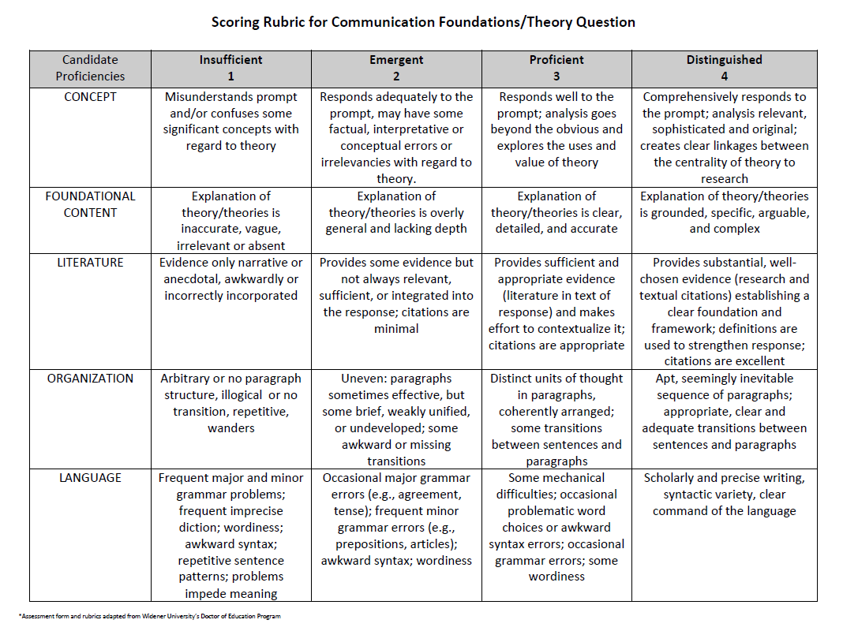

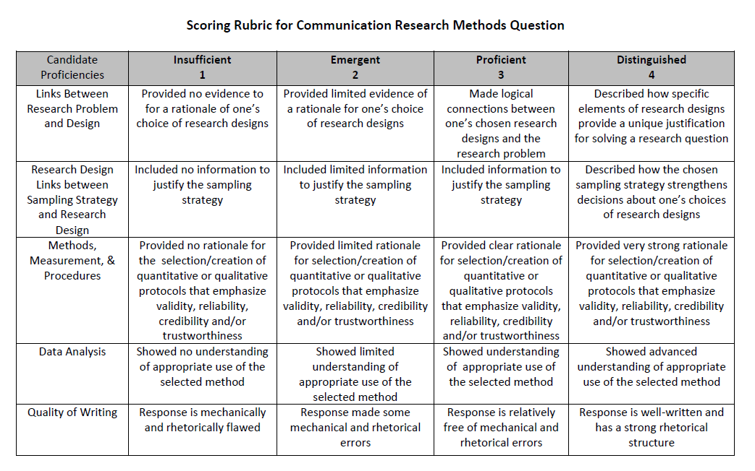

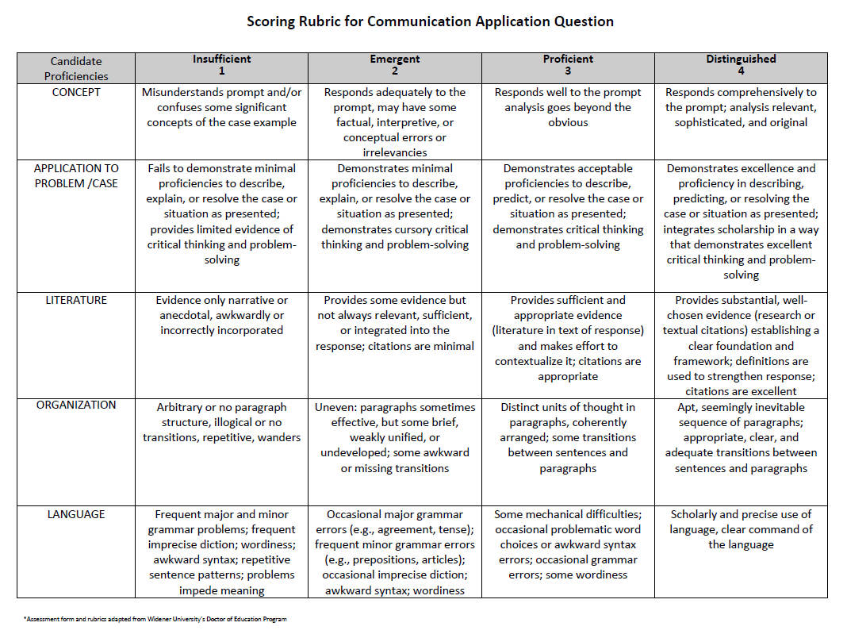
*** Please include Curriculum Map (below/next page) as part of this document
CURRICULUM MAP TEMPLATE
Program name: | M.A. in Organizational Communication (#0012, Thesis track)
Department: | Communication
College: | PCAL
Contact person: | Dr. Jieyoung Kong
Email: | Jieyoung.Kong@wku.edu
KEY:
I = Introduced
R = Reinforced/Developed
M = Mastered
A = Assessed
 |  |  | Learning Outcomes
 |  |  | LO1: | LO2: | LO3: | LO4: | LO5
 |  |  | Demonstrate mastery in research | Demonstrate mastery in written communication | Explain theories and concepts | Identify distinct communication practices of culturally diverse groups | Demonstrate ability to apply communication concepts in organizational contexts
Course Subject | Number | Course Title
COMM | 501 | Qualitative Methods in Communication Research | I/R | I/R | I/R | I | I/R
COMM | 502 | Quantitative Methods in Communication Research | I/R | I/R | I/R | I | I/R
COMM | 547 | Organizational Communication Theory | I | I/R | I/R | I | I/R
COMM | 5xx | (Elective) | R | R/M | R/M | R | R
COMM | 5xx | (Elective) | R | R/M | R/M | R | R
COMM | 5xx | (Elective) | R | R/M | R/M | R | R
COMM | 5xx | (Elective) | R | R/M | R/M | R | R
COMM | 5xx | (Elective) | R | R/M | R/M | R | R
COMM | 599 | Thesis Research/Writing | M/A | M/A | M/A | M/A | M/A
COMM | 599 | Thesis Research/Writing | M/A | M/A | M/A | M/A | M/A

CURRICULUM MAP TEMPLATE
Program name: | M.A. in Organizational Communication (#0012, Non-thesis track)
Department: | Communication
College: | PCAL
Contact person: | Dr. Jieyoung Kong
Email: | Jieyoung.Kong@wku.edu
KEY:
I = Introduced
R = Reinforced/Developed
M = Mastered
A = Assessed
 |  |  | Learning Outcomes
 |  |  | LO1: | LO2: | LO3: | LO4: | LO5
 |  |  | Demonstrate mastery in research | Demonstrate mastery in written communication | Explain theories and concepts | Identify distinct communication practices of culturally diverse groups | Demonstrate ability to apply communication concepts in organizational contexts
Course Subject | Number | Course Title
COMM | 501 | Qualitative Methods in Communication Research | I/R | I/R | I/R | I | I/R
COMM | 502 | Quantitative Methods in Communication Research | I/R | I/R | I/R | I | I/R
COMM | 547 | Organizational Communication Theory | I | I/R | I/R | I | I/R
COMM | 5xx | (Elective) | R | R/M | R/M | R | R
COMM | 5xx | (Elective) | R | R/M | R/M | R | R
COMM | 5xx | (Elective) | R | R/M | R/M | R | R
COMM | 5xx | (Elective) | R | R/M | R/M | R | R
COMM | 5xx | (Elective) | R | R/M | R/M | R | R
COMM | 5xx | (Elective) | R | R/M | R/M | R | R
COMM | 5xx | (Elective) | R | R/M | R/M | R | R
 |  | Comprehensive Exam | M/A | M/A | M/A | M/A | M/A

