|  |  |
| --- | --- |
| **Assurance of Student Learning Report**  **2021-2022** | |
| *Potter College* | *Communication* |
| *Communicating in Healthcare Graduate Certificate #0475* | |
| *Dr. Jieyoung Kong* | |

***Is this an online program***?  Yes  No

|  |  |  |  |
| --- | --- | --- | --- |
| ***Use this page to list learning outcomes, measurements, and summarize results for your program. Detailed information must be completed in the subsequent pages.*** | | | |
| **Student Learning Outcome 1: Evaluate communication behaviors in health care relationships, health care teams (multidisciplinary, interdisciplinary, and transdisciplinary), and health care organizations.** | | | |
| **Instrument 1** | **Direct: Analysis of a course assignment paper.** | | |
| **Instrument 2** |  | | |
| **Instrument 3** |  | | |
| **Based on your results, check whether the program met the goal Student Learning Outcome 1.** | | **Met** | **Not Met** |
| **Student Learning Outcome 2: Identify communication variables (including culture, technology) that affect communicating in healthcare contexts.** | | | |
| **Instrument 1** | **Direct: Analysis of a course assignment paper.** | | |
| **Instrument 2** |  | | |
| **Instrument 3** |  | | |
| **Based on your results, check whether the program met the goal Student Learning Outcome 2.** | | **Met** | **Not Met** |
| **Student Learning Outcome 3: Critique the effectiveness of health communication campaigns.** | | | |
| **Instrument 1** | **Direct: Analysis of a course assignment paper.** | | |
| **Instrument 2** |  | | |
| **Instrument 3** |  | | |
| **Based on your results, check whether the program met the goal Student Learning Outcome 3.** | | **Met** | **Not Met** |
| **Program Summary (Briefly summarize the action and follow up items from your detailed responses on subsequent pages.)** | | | |
| The Communicating in Healthcare Graduate Certificate Program is a 12-credit hour program designed to provide students with an understanding of the role of communication in healthcare contexts. It explores interpersonal as well as organizational factors affecting healthcare and assists students in developing communication strategies and skills. It also prepares students to better understand how culture, including technology and other forms of communication (including printed materials, health communication campaigns, community outreach, and interpersonal communication) are necessary to obtain, process, and understand health information. The program has two core courses students must take and a list of restricted elective courses from communication, public health, health care administration and nursing students can choose from, all of which can be completed fully online. The student learning objectives for the certificate program are as follows: *(1)* *Apply communication and health theories to explain factors that affect the delivery of healthcare, (2) Evaluate communication behaviors in health care relationships, health care teams, and health care organizations, (3) Identify communication variables (including culture, technology) that affect communicating in healthcare contexts, (4) Critique the effectiveness of health communication campaigns, (5) Develop a well-rounded understanding of communication processes within healthcare context, and (6) Understand the centrality of communication in health care administration, public health, and health behavior.* For the 2020-2021 ASL assessment, we assessed learning outcomes 1, 5, and 6. And for 2021-2022, we alternated to assess learning outcomes 2, 3, and 4. The mean scores of the sampled student artifacts for this year’s assessment fell slightly below the self-reported goals for two of the three objectives and significantly below for the third. The assessment result suggest the alignment between the selected core course learning outcomes and program learning outcomes need to be reviewed. In addition, not only is a review needed for a more robust program learning outcome in the future, the two core health communication courses should be taught by a full-time tenure-track faculty instead of an adjunct instructor, because student learning is enhanced by having a faculty member who is on campus to meaningful mentor and engage with students. As such, the department will need to do a search for a full-time tenure-track expert in healthcare communication next year in order to make this promising program viable and sustainable. | | | |

|  |  |  |  |  |  |
| --- | --- | --- | --- | --- | --- |
| **Student Learning Outcome 1** | | | | | |
| **Student Learning Outcome** | **Evaluate communication behaviors in health care relationships, health care teams (multidisciplinary, interdisciplinary, and transdisciplinary), and health care organizations.** | | | | |
| **Measurement Instrument 1** | DIRECT measure of student learning: Student artifacts chosen for this SLO assessment were a 5-page paper where they were required to analyze a health campaign and its communication processes to evaluate its effectiveness in delivering health information. | | | | |
| **Criteria for Student Success** | Success is “proficient” or higher on the rubric developed from program learning outcomes. Scores on the rubric item for this SLO ranged from “insufficient (1 point),” “weak (2 point),” “proficient (3 points),” and “excellent (4 points).” | | | | |
| **Program Success Target for this Measurement** | | 75% | **Percent of Program Achieving Target** | 62.5% | |
| **Methods** | Direct: Artifacts from one of two core courses, COMM 553, were collected from 8 students (*n* = 8) enrolled in the course during the assessment period out of a total of 12 students in the certificate program (*N* = 12) during 2021-22. All identifiers were removed (student name, course name, and faculty name) from the artifact and each were assigned to two full-time graduate faculty who teach in the graduate communication program so that each paper was read twice by two different reviewers. The mean of the reviewer scores were used as the final score. The rubric used for scoring was developed from the program learning outcomes; for this SLO, there was a single corresponding rubric item which could be scored along four different levels. | | | | |
| **Based on your results, highlight whether the program met the goal Student Learning Outcome 1.** | | | | **Met** | **Not Met** |
| **Actions** (Describe the decision-making process and actions for program improvement. The actions should include a timeline.) | | | | | |
| Overall, the result from this assessment indicate that while the mean scores of the sampled student papers did meet the “proficient” level of achievement, but only that the number of student artifiacts needed to meet the “proficient” level stated was 5, instead of 6. The assessment result suggest there was reasonable alignment between the core course learning outcomes and the program learning outcome. While assessment practice needs to be continuously improved in the future, the most meaningful action for program improvement is to have a full-time tenure-track faculty teach the two core courses instead of an adjunct instructor. This is critical because student learning is enhanced by having a faculty member who is on campus to meaningful mentor and engage with students.As such, the department will need to do a search for a full-time tenure-track expert in healthcare communication next year in order to make this promising program viable and sustainable. | | | | | |
| **Follow-Up** (Provide your timeline for follow-up. If follow-up has occurred, describe how the actions above have resulted in program improvement.) | | | | | |
| The adjunct instructor who teaches the core courses in the 0475 graduate certificate program have been consulted before the start of the new AY to assure there is better alignment between course learning objectives, coursework and assignments, and program learning outcomes. | | | | | |
| **Next Assessment Cycle Plan** (Please describe your assessment plan timetable for this outcome) | | | | | |
| The Graduate Program Committee and course instructors will be consulted at the start of the next AY for how to best assess the program for 2022-23. | | | | | |

|  |  |  |  |  |  |
| --- | --- | --- | --- | --- | --- |
| **Student Learning Outcome 2** | | | | | |
| **Student Learning Outcome** | **Identifies communication variables (including culture, technology) that affect communicating in healthcare contexts.** | | | | |
| **Measurement Instrument 1** | DIRECT measure of student learning: Student artifacts chosen for this SLO assessment were a 5-page paper where they were required to analyze a health campaign and its communication processes to evaluate its effectiveness in delivering health information. | | | | |
| **Criteria for Student Success** | Success is “proficient” or higher on the rubric developed from program learning outcomes. Scores on the rubric item for this SLO ranged from “insufficient (1 point),” “weak (2 point),” “proficient (3 points),” and “excellent (4 points).” | | | | |
| **Program Success Target for this Measurement** | | 75% | **Percent of Program Achieving Target** | 25% | |
| **Methods** | Direct: Artifacts from one of two core courses, COMM 553, were collected from 8 students (n = 8) enrolled in the course during the assessment period out of a total of 12 students in the certificate program (N = 12) during 2021-22. All identifiers were removed (student name, course name, and faculty name) from the artifact and each were assigned to two full-time graduate faculty who teach in the graduate communication program so that each paper was read twice by two different reviewers. The mean of the reviewer scores were used as the final score. The rubric used for scoring was developed from the program learning outcomes; for this SLO, there was a single corresponding rubric item which could be scored along four different levels. | | | | |
| **Based on your results, circle or highlight whether the program met the goal Student Learning Outcome 2.** | | | | **Met** | **Not Met** |
| **Actions** (Describe the decision-making process and actions planned for program improvement. The actions should include a timeline.) | | | | | |
| Overall, the result of assessment for this SLO indicate that the the artifact selected was not appropriate for evaluating this particular learning outcome, because the assignment instruction did not require a discussion on communication variable, such as technology or culture, in evaluating a contemporary health campaign. Only 2 out of the 8 student artifact achieved achieved “proficient” score or higher, far short of the stated goal of 6. While assessment practice needs to be continuously improved in the future, the most meaningful action for program improvement is to have a full-time tenure-track faculty teach the two core courses instead of an adjunct instructor. This is critical because student learning is enhanced by having a faculty member who is on campus to meaningful mentor and engage with students.As such, the department will need to do a search for a full-time tenure-track expert in healthcare communication next year in order to make this promising program viable and sustainable. | | | | | |
| **Follow-Up** (Provide your timeline for follow-up. If follow-up has occurred, describe how the actions above have resulted in program improvement.) | | | | | |
| The adjunct instructor who teaches the core courses in the 0475 graduate certificate program have been consulted before the start of the new AY to assure there is better alignment between course learning objectives, coursework and assignments, and program learning outcomes. | | | | | |
| **Next Assessment Cycle Plan** (Please describe your assessment plan timetable for this outcome) | | | | | |
| The Graduate Program Committee and course instructor will be consulted at the start of the next AY for how to best assess the program for 2022-23. | | | | | |

|  |  |  |  |  |  |
| --- | --- | --- | --- | --- | --- |
| **Student Learning Outcome 3** | | | | | |
| **Student Learning Outcome** | **Critiques the effectiveness of health communication campaigns.** | | | | |
| **Measurement Instrument 1** | DIRECT measure of student learning: Student artifacts chosen for this SLO assessment were a 5-page paper where they were required to analyze a health campaign and its communication processes to evaluate its effectiveness in delivering health information. | | | | |
| **Criteria for Student Success** | Success is “proficient” or higher on the rubric developed from program learning outcomes. Scores on the rubric item for this SLO ranged from “insufficient (1 point),” “weak (2 point),” “proficient (3 points),” and “excellent (4 points).” | | | | |
| **Program Success Target for this Measurement** | | 75% | **Percent of Program Achieving Target** | 62.5% | |
| **Methods** | Direct: Artifacts from one of two core courses, COMM 553, were collected from 8 students (*n* = 8) enrolled in the course during the assessment period out of a total of 12 students in the certificate program (*N* = 12) during 2021-22. All identifiers were removed (student name, course name, and faculty name) from the artifact and each were assigned to two full-time graduate faculty who teach in the graduate communication program so that each paper was read twice by two different reviewers. The mean of the reviewer scores were used as the final score. The rubric used for scoring was developed from the program learning outcomes; for this SLO, there was a single corresponding rubric item which could be scored along four different levels. | | | | |
| **Based on your results, circle or highlight whether the program met the goal Student Learning Outcome 3.** | | | | **Met** | **Not Met** |
| **Actions** (Describe the decision-making process and actions for program improvement. The actions should include a timeline.) | | | | | |
| Overall, the result from this assessment indicate that while the mean scores of the sampled student papers did meet the “proficient” level of achievement, but only that the number of student artifiacts needed to meet the “proficient” level of the stated was 5, instead of 6. The assessment result suggest there was reasonable alignment between the core course learning outcomes and the program learning outcome. While assessment practice needs to be continuously improved in the future, the most meaningful action for program improvement is to have a full-time tenure-track faculty teach the two core courses instead of an adjunct instructor. This is critical because student learning is enhanced by having a faculty member who is on campus to meaningful mentor and engage with students.As such, the department will need to do a search for a full-time tenure-track expert in healthcare communication next year in order to make this promising program viable and sustainable. | | | | | |
| **Follow-Up** (Provide your timeline for follow-up. If follow-up has occurred, describe how the actions above have resulted in program improvement.) | | | | | |
| The adjunct instructor who teaches the core courses in the 0475 graduate certificate program have been consulted before the start of the new AY to assure there is better alignment between course learning objectives, coursework and assignments, and program learning outcomes. | | | | | |
| **Next Assessment Cycle Plan** (Please describe your assessment plan timetable for this outcome) | | | | | |
| The Gradaute Program Committee and course instructor will be consulted at the start of the next AY for how to best assess the program for 2022-23. | | | | | |

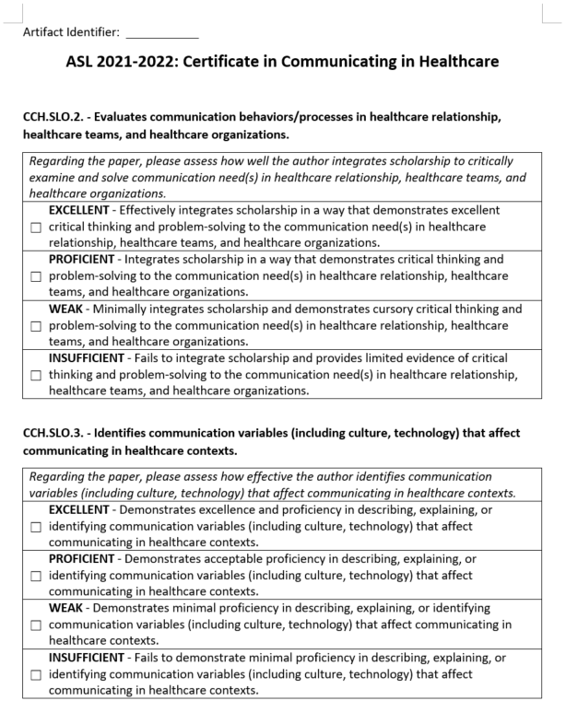

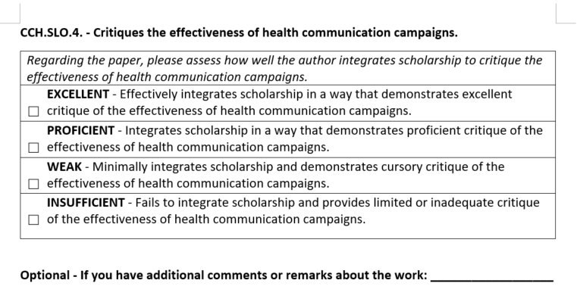

**\*\*\* Please include Curriculum Map (below/next page) as part of this document**

|  |  |  |  |  |  |  |  |  |  |  |  |  |  |
| --- | --- | --- | --- | --- | --- | --- | --- | --- | --- | --- | --- | --- | --- |
| **CURRICULUM MAP TEMPLATE** | | |  |  | | |  |  | |  | | |  |
| **Program name:** | Communicating in Healthcare Graduate Certificate Program (#0475) | | |  | | |  |  | |  | | |  |
| **Department:** | Communication | | |  | | |  |  | |  | | |  |
| **College:** | PCAL | | |  | | |  |  | |  | | |  |
| **Contact person:** | Dr. Jieyoung Kong | | |  | | |  |  | |  | | |  |
| **Email:** | [Jieyoung.Kong@wku.edu](mailto:Jieyoung.Kong@wku.edu) | | |  | | |  |  | |  | | |  |
| **KEY:** I = Introduced R = Reinforced/Developed M = Mastered A = Assessed | | **Learning Outcomes:** LO1: Analyze and apply communication and health theories to help explain factors that affect the delivery of health care.  LO2: Evaluate communication behaviors in health care relationships, health care teams (multidisciplinary, interdisciplinary, and transdisciplinary), and health care organizations. LO3: Identify communication variables (i.e. culture, technology) that affect communicating in health care contexts. LO4: Critique the effectiveness of health communication campaigns. LO5: Develop a well-rounded understanding of communication processes within contexts that apply to healthcare including interpersonal, organizational, and intercultural. LO6: Understand the centrality of communication in health care administration, public health, and health behavior. | | | | | | | | | | | | |
|
|
|
|
|
| **Course Subject** | **Number** | **Course Title** | **Learning Outcomes** | | | | | | | | | | | |
| ***(Core Courses)*** |  |  | **LO1:** | | **LO2:** | **LO3:** | | | **LO4:** | | **LO5** | **LO6** | |
| COMM | 523 | Health Communication | I/R | | I/R/A | I/R | | | I | | I/R/M/A | I | |
| COMM | 553 | Health Communication Campaign | I/R/M/A | |  | I/R/A | | | I/R/A | | I/R | I/R/A | |
| ***(Restricted Elective Courses)*** | |  |  | |  |  | | |  | |  |  | |
| COMM | 528 | Communication in the Nonprofit Sector | I/R | | I/R |  | | |  | | I/R |  | |
| COMM | 564 | Crisis Communication | I | |  | I/R | | | I/R | | I/R | I/R | |
| COMM | 578 | Seminar in Interpersonal Communication | I/R | | I/R |  | | |  | | I/R |  | |
| COMM | 581 | Applied Organizational Communication |  | | I/R | I/R | | |  | | I/R |  | |
| COMM | 586 | Process of Group Communication |  | | I/R | I/R | | |  | | I/R |  | |
| COMM | 590 | Intercultural Communication |  | | I/R | I/R | | |  | | I/R |  | |
| HCA | 540 | Health Care Orgnization and Management | I/R | |  | I | | | I/R | | I | I/R | |
| HCA | 541 | Strategic Management & Marketing of Health Service | I/R | | I/R | I | | |  | | I | I/R | |
| PH | 548 | Community Health Organization | I | | I/R | I | | | I | | I/R | I/R | |
| PH | 578 | Health Disparities | I/R | |  | I/R | | | I/R | |  | I/R | |
| PH | 580 | Introduction to Public Health |  | |  | I/R | | |  | |  | I/R | |
| PH | 581 | Applied Methods in Public Health Practice/Field Epidemiology | I/R | |  | I/R | | | I/R | | I/R | I/R | |
| PH | 587 | Health Behavior | I/R | |  |  | | | I/R | |  | I/R | |
| NURS | 501 | Nrusing, Politics and Health Policy |  | |  | I/R | | | I/R | |  | I/R | |
| NURS | 528 | Leadership and Management in Nursing Administration | I/R | | I/R | I/R | | |  | | I/R | I/R | |