Assurance of Student Learning Report
2022-2023
Ogden College of Science and Engineering |  | School of Engineering and Applied Science
Land Surveying Certificate, 1700
Jason C. Wilson, MS, PE
Is this an online program? Yes No | Please make sure the Program Learning Outcomes listed match those in CourseLeaf . Indicate verification here Yes, they match! (If they don’t match, explain on this page under Assessment Cycle)

Use this page to list learning outcomes, measurements, and summarize results for your program. Detailed information must be completed in the subsequent pages. Add more Outcomes as needed.
Program Student Learning Outcome 1: Ability to identify, formulate, and solve complex surveying problems by applying principles of engineering, science, and mathematics.
Instrument 1 | Apply Rubric to Project Reports from selected courses
Based on your results, check whether the program met the goal Student Learning Outcome 1. |  | Met | Not Met
Program Student Learning Outcome 2: Ability to apply engineering design to produce solutions that meet the specific needs of the surveying industry with consideration of public health, safety, and welfare.
Instrument 1 | Apply Rubric to Project Reports from selected courses
Based on your results, check whether the program met the goal Student Learning Outcome 2. |  | Met | Not Met
Program Student Learning Outcome 3: Ability to acquire and apply new knowledge as needed, using appropriate learning strategies.
Instrument 1 | Apply Rubric to Project Reports from selected courses
Based on your results, check whether the program met the goal Student Learning Outcome 3. |  | Met | Not Met
Assessment Cycle Plan:
The assessment of student performance under Student Learning Outcomes 1, 2 and 3 is acceptable according to rubric-based evaluation of student work. In addition, graduates are completing relevant courses with good grades, and student positive perception of skills learned. Program assessment indicates the curriculum for Land Surveying Certificate prepares graduates with the abilities and skills needed to be successful practicing land surveyors. The WKU Land Surveying Certificate Program will continue to prepare graduates with the same Student Learning Outcome activities and measures of all accrediting bodies.

Student Learning Outcome 1

Student Learning Outcome | Ability to identify, formulate, and solve complex surveying problems by applying principles of engineering, science, and mathematics.
Measurement Instrument 1 | A scoring rubric (attached) specifically structured to directly assess the attributes stated in the outcome is applied to final assessment in CE 380 (Boundary Surveying), which capture key aspects of surveying students’ study. The rubric assesses 4 main attributes of problem solving. The selected courses have, at a minimum, CE 160/161 (Principles of Surveying) and AMS 163 (Architectural Drafting) as pre-requisites and utilize those specific skills in the solution of surveying problems. The CE surveying courses are usually taken in the junior or senior year and students have by then developed strong analytical skills and have experience applying math and science concepts in earlier design course projects and in earlier engineering science courses.
Criteria for Student Success | Numerical results from applying the rubric to student work should reach a minimum value of 3.0 on a 4.0 scale for senior level work. Scores of sophomore/junior level work may be somewhat lower, which can be used to track student development in the curriculum.
Program Success Target for this Measurement |  | Cohort Average of 3.0 on a 4.0 scale | Percent of Program Achieving Target | Cohort Average of 3.33 out of 4.0
Methods | The final assessment from each student in the course is reviewed separately from course grading. Select questions are identified and the outcome rubric applied to assess achievement. Values from each student are recorded, and a class average is determined.
Based on your results, highlight whether the program met the goal Student Learning Outcome 1. |  |  |  | Met | Not Met
Actions (Describe the decision-making process and actions for program improvement. The actions should include a timeline.)
The assessment of student performance under Outcome 1 is acceptable according to rubric-based direct evaluation of student work. At the completion of the course and other relevant courses with satisfactory grades in the curriculum assuring that surveying certificate graduates have the ability to identify, formulate, and solve complex engineering problems by applying principles of engineering, science, and mathematics. The WKU Land Surveying Certificate will continue to prepare graduates with the same curriculum content, and monitor this student learning outcome with these measures. No need for programmatic adjustments has been found.

Follow-Up (Provide your timeline for follow-up. If follow-up has occurred, describe how the actions above have resulted in program improvement.)
None Needed
Next Assessment Cycle Plan (Please describe your assessment plan timetable for this outcome)
The Land Surveying Certificate and Civil Engineering faculty will continue with program assessment on an annual basis. The accrediting agency, ABET, requires continual improvement through systematic assessment of student learning outcomes.

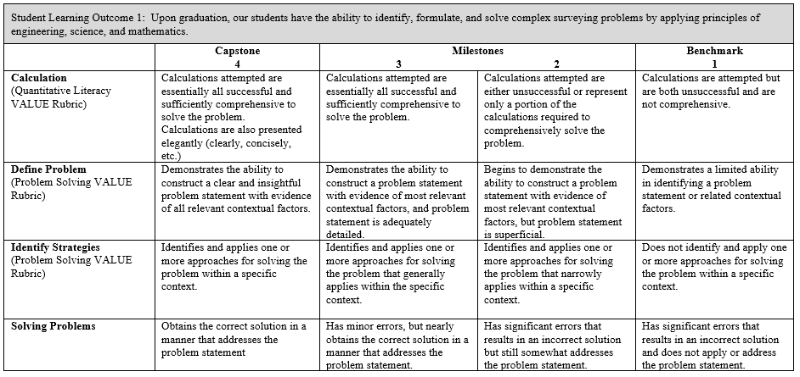

Student Learning Outcome 2
Student Learning Outcome | Ability to apply engineering design to produce solutions that meet the specific needs of the land surveying industry with consideration of public health, safety, and welfare.
Measurement Instrument 1 | Program faculty apply a scoring rubric (attached), specifically structured to directly assess the attributes stated in the outcome, to selected student work from CE 378 (Route Surveying) This course captures the many aspects of public health, safety, and welfare , and the use of engineering judgement that are undertaken to prepare the students to be capable land surveyors. The rubric assesses 6 main attributes. The selected courses have, at a minimum, CE 160/161 (Principles of Surveying) and AMS 163 (Architectural Drafting) as pre-requisites and utilize those specific skills in the solution of surveying problems. The CE surveying courses are usually taken in the junior or senior year and students have by then developed strong analytical skills and have experience applying math and science concepts in earlier design course projects and in earlier engineering science courses.
Criteria for Student Success | Numerical results from applying the rubric to student work should reach a value of 3.0 on a 4.0 scale for senior level work. Scores of sophomore/junior level work may be somewhat lower, which can be used to track student development in the curriculum.
Program Success Target for this Measurement |  | Cohort Average of 3.0 out of 4.0 | Percent of Program Achieving Target | Cohort Average 3.13 out of 4.0
Methods | The final assessment from each team in the course is reviewed separately from course grading. The outcome rubric is applied to assess achievement. Values from each report are recorded, and a class average is determined. This approach captures every student in the assessment year.
Based on your results, circle or highlight whether the program met the goal Student Learning Outcome 2. |  |  |  | Met | Not Met
Actions (Describe the decision-making process and actions planned for program improvement. The actions should include a timeline.)
The assessment of student performance under Outcome 2 is acceptable according to rubric-based direct evaluation of student work. At the completion of the course and other relevant courses with satisfactory grades in the curriculum assuring that surveying certificate graduates have the ability to identify, formulate, and solve complex engineering problems by applying principles of engineering, science, and mathematics. The WKU Land Surveying Certificate will continue to prepare graduates with the same curriculum content, and monitor this student learning outcome with these measures. No need for programmatic adjustments has been found.

Follow-Up (Provide your timeline for follow-up. If follow-up has occurred, describe how the actions above have resulted in program improvement.)
None Needed
Next Assessment Cycle Plan (Please describe your assessment plan timetable for this outcome)
The Land Surveying Certificate and Civil Engineering faculty will continue with program assessment on an annual basis. The accrediting agency, ABET, requires continual improvement through systematic assessment of student learning outcomes.

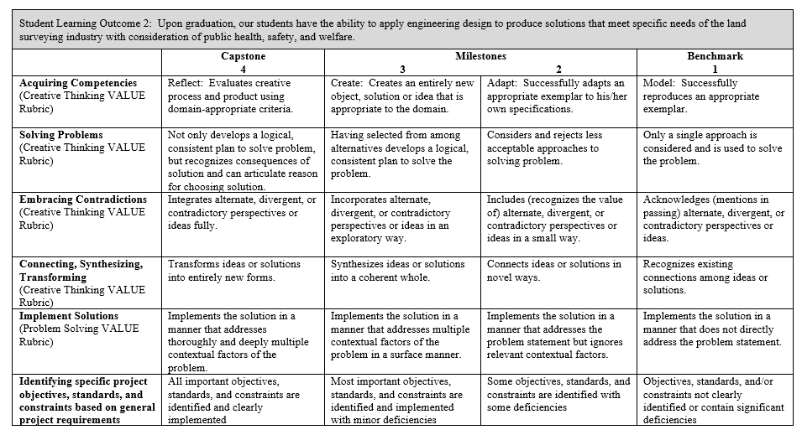

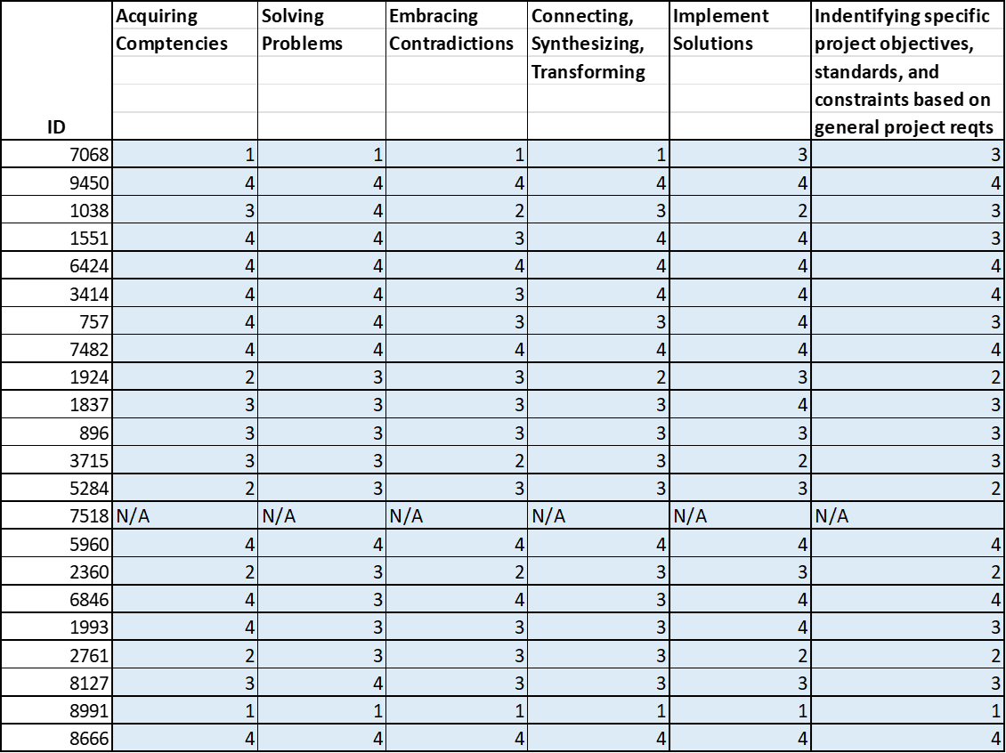

Student Learning Outcome 3
Student Learning Outcome | Ability to acquire and apply new knowledge as needed, using appropriate learning strategies.
Measurement Instrument 1 | Program faculty apply scoring rubrics (attached) specifically structured to directly assess 3 major attributes supporting the outcome, to selected student work from CE 378 (Route Surveying) and CE 380 (Boundary Surveying). These courses capture the many aspects of land surveying that prepare the students to be effective land surveyors. The selected courses have students create artifacts which represent those specific skills.
Criteria for Student Success | Numerical results from applying the rubric to student work should reach a value of 3.0 on a 4.0 scale for senior level work.
Program Success Target for this Measurement |  | Cohort Average 3.0 out of 4.0 | Percent of Program Achieving Target | Cohort Average of 3.46 out of 4.0
Methods | The artifacts from each team in the course is reviewed separately from course grading. The outcome rubric is applied to assess achievement. Values from each report are recorded, and a class average is determined. This approach captures every student in the assessment year.
Based on your results, circle or highlight whether the program met the goal Student Learning Outcome 3. |  |  |  | Met | Not Met
Actions (Describe the decision-making process and actions for program improvement. The actions should include a timeline.)
The assessment of student performance under Outcome 3 is acceptable according to rubric-based direct evaluation of student work. At the completion of the course and other relevant courses with satisfactory grades in the curriculum assuring that surveying certificate graduates have the ability to identify, formulate, and solve complex engineering problems by applying principles of engineering, science, and mathematics. The WKU Land Surveying Certificate will continue to prepare graduates with the same curriculum content, and monitor this student learning outcome with these measures. No need for programmatic adjustments has been found.

Follow-Up (Provide your timeline for follow-up. If follow-up has occurred, describe how the actions above have resulted in program improvement.)
None Needed
Next Assessment Cycle Plan (Please describe your assessment plan timetable for this outcome)
The Land Surveying Certificate and Civil Engineering faculty will continue with program assessment on an annual basis. The accrediting agency, ABET, requires continual improvement through systematic assessment of student learning outcomes.

*** Please include Curriculum Map (below/next page) as part of this document

Curriculum Map
COURSE | SLO 1 | SLO 2 | SLO 3
AS 163
CE 160
CE 161
CE 378 | X |  | X
CE 380 |  | X
*AS 163, CE 160, AND CE 161 are courses taken by many students not seeking the Land Surveying Certificate.

