Assurance of Student Learning Report
2022-2023
OCSE |  | Physics and Astronomy
Homeland Security Science MS 413
Ivan Novikov
Is this an online program? Yes No | Please make sure the Program Learning Outcomes listed match those in CourseLeaf. Indicate verification here Yes, they match! (If they don’t match, explain on this page under Assessment Cycle)

Use this page to list learning outcomes, measurements, and summarize results for your program. Detailed information must be completed in the subsequent pages. Add more Outcomes as needed.
Program Student Learning Outcome 1: Students will demonstrate successful use of critical laboratory methods required for empirical measurements.
Instrument 1 | Successful defense of the MS Thesis
Based on your results, check whether the program met the goal Student Learning Outcome 1. |  | Met | Not Met
Program Student Learning Outcome 2: Students will demonstrate a mastery of empirical methods via written expression.
Instrument 1 | Evaluation of the written thesis document
Based on your results, check whether the program met the goal Student Learning Outcome 2. |  | Met | Not Met
Program Student Learning Outcome 3: Students will demonstrate a mastery of empirical methods via oral expression.
Instrument 1 | Evaluation of the oral portion of the thesis defense
Based on your results, check whether the program met the goal Student Learning Outcome 3. |  | Met | Not Met
Assessment Cycle Plan:
The graduate director meets with the thesis committee after the thesis defense to discuss each student's individual progress and performance. Information gained from these discussions is used as feedback to faculty mentors to inform them of student strengths and weakness so that they may adjust their expectations and training methods accordingly. Follow-up occurs after every thesis defense, which is typically 0-3 times per academic year. 3 thesis defenses occurred during the current assessment period.

Program Student Learning Outcome 1

Program Student Learning Outcome | Students will demonstrate successful use of critical laboratory methods required for empirical measurements.
Measurement Instrument 1 | Successful defense of the MS Thesis
Criteria for Student Success | Students will have successfully defended their MS Thesis
Program Success Target for this Measurement |  | 100% | Percent of Program Achieving Target | 100
Methods | MS student projects are overseen by a committee of faculty who will evaluate their oral (MS defense) and written (MS Thesis) presentation of their thesis project via the attached rubric. The oral thesis defense is judged based on quality of the presentation and the ability of the students to clearly explain their research and answer questions about their experimental methodology. The written thesis is evaluated based on the ability of the students to clearly explain in writing their research and their experimental methodology. In AY 2022-23, the cohort size was 3 students.
Results, Conclusion, and Plans for Next Assessment Cycle (Describe what worked, what didn’t, and plan going forward)
The graduate director meets with the thesis committee after the thesis defense to discuss each student's individual progress and performance. Information gained from these discussions is used as feedback for mentors to better train students in research presentation and informs them of typical student strengths and weakness so that they may adjust their expectations and training methods accordingly. This assessment will continue in the next cycle.

Program Student Learning Outcome 2
Program Student Learning Outcome | Students will develop a mastery of empirical methods via written expression
Measurement Instrument 1 | Evaluation of the Thesis document
Criteria for Student Success | 100% of all students evaluated will have an overall score of good or better.
Methods | The written thesis is evaluated on a rubric (see attached) with the goal that 100% of all students evaluated will have an overall score of good or better. In the 2022-2023 AY, the cohort size was 3 students.
Based on your results, circle or highlight whether the program met the goal Student Learning Outcome 2. |  | Met | Not Met
Results, Conclusion, and Plans for Next Assessment Cycle (Describe what worked, what didn’t, and plan going forward)
Mentors keep track of student results from the written thesis and adjust their mentoring paradigms as appropriate to address identified weakness in student written expression. This item will be assessed in the next cycle.

Program Student Learning Outcome 3
Program Student Learning Outcome | Students will demonstrate a mastery of empirical methods via oral expression
Measurement Instrument 1 | Evaluation of the thesis defense
Criteria for Student Success | Students evaluated will have an overall score of good or better on the oral defense of their thesis
Program Success Target for this Measurement |  | 100 | Percent of Program Achieving Target | 100
Methods | Student oral thesis presentation are evaluated on a rubric (see attached) with the goal that 90% of all students evaluated will have an overall score of good or better.
Based on your results, circle or highlight whether the program met the goal Student Learning Outcome 3. |  |  |  | Met | Not Met
Results, Conclusion, and Plans for Next Assessment Cycle (Describe what worked, what didn’t, and plan going forward)
Mentors keep track of student results from the oral thesis presentations and adjust their mentoring paradigms as appropriate to address identified weakness in student written expression. This item will be assessed in the next cycle.

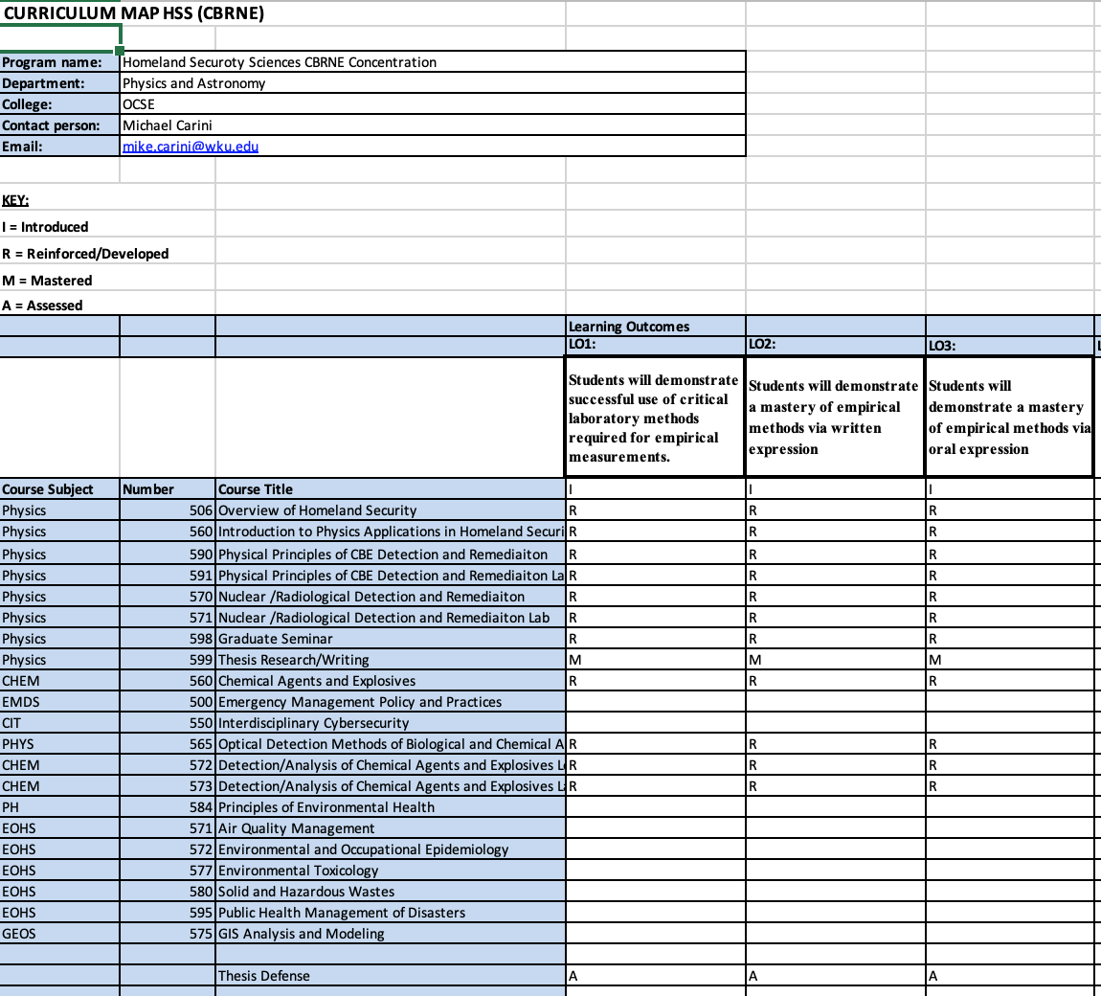

Oral Presentation evaluation rubric
Based on presentation of work in Graduate seminar.
 | 4: Excellent | 3: Good | 2: Needs some improvement | 1: Needs major improvement
Understanding of material | Presentation demonstrated excellent understanding of the topic and its context. | Presentation demonstrated adequate understanding of the topic and its context. | Presentation demonstrated some gaps and/or errors in student understanding of the topic and context. | Presentation demonstrated significant gaps or errors in student understanding of the topic and context.
Presentation organization and flow. | Presentation was well organized and seamlessly presented. | Presentation was logically organized and adequately presented. | There were minor issues with the organization and flow of the presentation. | Presentation was disorganized and/or confusingly presented.
Interaction with audience | Student developed excellent rapport with the audience during the presentation. | Student interacted with the audience and made eye contact most of the time. | Student had a little interaction with the audience and made eye contact some of the time. | Student did not interact with or look at audience.
Answering questions | Student provided thoughtful, quality responses to questions from audience. | Student provided adequate responses to questions from audience. | Student had some difficulties in understanding or answering questions from audience. | Student completely misunderstood or was unable to provide answers to questions from audience.

Scientific Work evaluation rubric
Based on written abstract and presentation
 | 4: Excellent | 3: Good | 2: Needs some improvement | 1: Needs major improvement
Research question | Research question is original, clearly articulated and of compelling importance. | Research question is clear and doable. | Research question is presented but it is poorly articulated, too broad or narrow in scope, or otherwise problematic. | No identifiable research question presented.
Research methodology | Research methodology exceptionally well designed and executed to answer research question. | Employs a research methodology that is appropriate for answering the question. | Research methodology is mismatched or incomplete for answering research question. | No research methodology employed, or that employed seems unrelated to the research question.
Data and theory | Compelling, high-quality data collected & analyzed and/or an ambitious theoretical investigation completed. | Sufficient data collected and analyzed OR theoretical investigation carried out to answer research question. | Some data collected and analyzed OR theoretical investigation conducted giving a suggestive or partial answer to research question. | No/insufficient data collected and analyzed, or incomplete theoretical investigation, such that cannot begin to answer research question.
Conclusions | Clear, articulate and compelling conclusions drawn from investigation. | Appropriate conclusions drawn from investigation. | Conclusions ambiguous or only partially supported by the investigation. | No conclusions presented or the conclusions are unrelated to the scientific investigation.

