Assurance of Student Learning Report
2021-2022
Ogden College of Science and Engineering | Department of Mathematics
Mathematics, 728
Ngoc Nguyen

Use this page to list learning outcomes, measurements, and summarize results for your program. Detailed information must be completed in the subsequent pages.
Student Learning Outcome 1: Students will be prepared for employment in government, industry, or academic settings.
Instrument 1 | Employment prospects of seniors will be monitored in an exit survey.
Based on your results, check whether the program met the goal Student Learning Outcome 1. |  | X Met | Not Met
Student Learning Outcome 2: Students will be able to use technology and apply mathematics to solve problems effectively.
Instrument 1 | Technology usage will be monitored in an exit survey.
Instrument 2 | Completion of a capstone project in MATH 498.
Based on your results, check whether the program met the goal Student Learning Outcome 2. |  | X Met | Not Met
Student Learning Outcome 3: Students will have well-developed abilities to utilize critical thinking and communicate ideas effectively.
Instrument 1 | Completion of a capstone project in MATH 498.
Based on your results, check whether the program met the goal Student Learning Outcome 3. |  | Met | X Not Met
Program Summary (Briefly summarize the action and follow up items from your detailed responses on subsequent pages.)
We will continue to require and work with students on their senior projects to help them improve SLO 3. We plan no major programmatic changes based upon the results.

Student Learning Outcome 1

Student Learning Outcome | Students will be prepared for employment in government, industry, or academic settings.
Measurement Instrument 1 | Employment prospects of seniors will be monitored in an exit survey.
Criteria for Student Success | Students have clear career plan and feel prepared for those types of jobs.
Program Success Target for this Measurement |  |  | 80% |  | Percent of Program Achieving Target | 81%
Methods | Seniors completing the 728 major all take MATH 498, our senior capstone course. These students are required to complete an exit survey as part of that course. Specifically, the students provide responses to the open-ended questions, “What are your career plans?”, “Do you feel that your mathematics major has prepared you well for your intended career? Explain.”, and “Are you searching for employment after graduation? If so, have you had job interviews or offers yet? Please give details.”
Measurement Instrument 2 | Feedback from recent graduates will be monitored at the Career Options Panel at the annual WKU Mathematics Symposium.
Criteria for Student Success | Students that have been working in mathematics/statistics careers are invited back to our annual WKU Mathematics Symposium, and verify that their math major did prepare them for their careers.
Program Success Target for this Measurement |  | 80% |  | Percent of Program Achieving Target |  | N/A
Methods | Due to the COVID-19 pandemic, the WKU Math Symposium was held with one-day schedule instead of two-day and there was no career panel.
Based on your results, highlight whether the program met the goal Student Learning Outcome 1. |  |  |  |  |  | X Met | Not Met
Actions (Describe the decision-making process and actions for program improvement. The actions should include a timeline.)
We made no programmatic changes based on the above data.
Follow-Up (Provide your timeline for follow-up. If follow-up has occurred, describe how the actions above have resulted in program improvement.)
We will continue to collect the career data on our exit survey, and will endeavor to stay in contact with our graduates of the program after they leave WKU.

Next Assessment Cycle Plan (Please describe your assessment plan timetable for this outcome)
We will continue to collect career data on our senior exit survey, invite graduates back to campus to discuss their careers as circumstances allow, and will endeavor to stay in contact with our graduates via social media and other means. We will do this again throughout 2022-23.

Student Learning Outcome 2
Student Learning Outcome | Students will be able to use technology and apply mathematics to solve problems effectively.
Measurement Instrument 1 | Technology usage will be monitored in an exit survey.
Criteria for Student Success | Students feel like they have had adequate exposure to technology in their classes.
Program Success Target for this Measurement |  |  | 80% |  | Percent of Program Achieving Target | 88%
Methods | Seniors completing the 728 major all take MATH 498, our senior capstone course. These students are required to complete an exit survey as part of that course. Specifically, the students provide responses to the open-ended questions, “Do you feel like the mathematics faculty is integrating technology into the curriculum appropriately? Explain.” And “Please list the courses in which assignments required you to use technology, such as a graphing calculator, Mathematics, Geometer’s Sketchpad, etc.”
Measurement Instrument 2 | Completion of a capstone project in MATH 498.
Criteria for Student Success | Students will average a 3 or better on a 4-point scale on rubric measures of the application of mathematics in their senior project.
Program Success Target for this Measurement |  | 80% |  | Percent of Program Achieving Target |  | 73%
Methods | In Fall 2021, students are graded on both an 11-page paper and a 25-minute presentation of their senior project. Each project has three faculty graders, including the faculty member who supervised the student’s project research.  The categories measuring the application of mathematics on the paper are  - Central Message, where a 3 denotes that the “Central message is clear and consistent with the supporting materials, and an appropriate level”; and  - Content Development and Analysis, where a 3 denotes that student “Uses appropriate, relevant, and compelling language to explore ideas, shape the paper, and reveal insightful patterns, differences, or similarities.”  The categories measuring the application of mathematics on the presentation are  - Content Development, where a 3 denotes that the students “Uses appropriate, relevant, and compelling language to explore ideas and shape the presentation”;  - Breadth and Thoroughness, where a 3 denotes that the “Presentation adequately discusses history of the problem, impact and extensions of the solution, and topics for further study”; and  - Analysis, where a 3 denotes that the student “Organizes evidence to reveal important patterns, differences, or similarities related to focus.”  In Spring 22, the rubrics were changed. Students are graded on both an 12-to-20-page paper and a 25-minute presentation of their senior project. Each project has three faculty graders, including the faculty member who supervised the student’s project research.  The categories measuring the application of mathematics on the paper and presentation are  - Project Development, where a 3 denotes that the students are accomplished in showing “Appropriateness of topics/problem, originality, content development and analysis, organization and coherence, etc.”  - Accuracy, where a 3 denotes that the students are accomplished in “Appropriate use of mathematical tools.”  - Understanding, where a 3 denotes that the students are accomplished in “Deeply and thoroughly understands the project, and that the project is the student’s own work.”
Based on your results, circle or highlight whether the program met the goal Student Learning Outcome 2. |  |  |  |  |  | X Met | Not Met
Actions (Describe the decision-making process and actions planned for program improvement. The actions should include a timeline.)
We made no programmatic changes based on the above data.
Follow-Up (Provide your timeline for follow-up. If follow-up has occurred, describe how the actions above have resulted in program improvement.)
We will continue to work with our students to help them succeed with their senior projects, but we acknowledge the reality that we lose one every so often.

Next Assessment Cycle Plan (Please describe your assessment plan timetable for this outcome)
We will continue to require a capstone project for all our 728 seniors, work carefully with them, and help them succeed to the best of their ability. This will be repeated in 2021-2022.

Student Learning Outcome 3
Student Learning Outcome | Students will have well-developed abilities to utilize critical thinking and communicate ideas effectively.
Measurement Instrument 1 | Completion of a capstone project in MATH 498.
Criteria for Student Success | Students will average a 3 or better on a 4-point scale on rubric measures of their utilization of critical thinking and the communication of ideas in their senior project.
Program Success Target for this Measurement |  | 80% | Percent of Program Achieving Target | 74%
Methods | In Fall 2021, students are graded on both an 11-page paper and a 25-minute presentation of their senior project. Each project has three faculty graders, including the faculty member who supervised the student’s project research.  The category measuring critical thinking on the paper is  - Content Development and Analysis, where a 3 denotes that the student “Uses appropriate, relevant, and compelling language to explore ideas, shape the paper, and reveal insightful patterns, differences, or similarities.”  The category measuring critical thinking on the presentation is  - Analysis, where a 3 denotes the student “Organizes evidence to reveal important patterns, differences, or similarities related to focus.”  The categories measuring the communication of ideas on the paper are  - Language and Syntax, where a 3 denotes that the student “Uses straightforward language that generally conveys meaning, with few errors”; and  - Sources and Writing Conventions, where a 3 denotes that the student “Demonstrates consistent proper use of credible, relevant sources and writing conventions such as wording, displays of tables and graphics, and citations.”  The categories measuring the communication of ideas on the presentation are  - Organization, where a 3 denotes that the “Organizational pattern (specific introduction and conclusions, sequenced material within the body, and transitions) is clearly and consistently observable”; and  - Delivery, where a 3 denotes that the “Delivery techniques (posture, gestures, eye contact, and vocal expressiveness) make the presentation interesting, and the speaker appears comfortable.”  In Spring 2022, students are graded on both an 12-to-20-page paper and a 25-minute presentation of their senior project. Each project has three faculty graders, including the faculty member who supervised the student’s project research.  The category measuring critical thinking on the paper and the presentation is  - Project Development, where a 3 denotes that the students are accomplished in showing “Appropriateness of topics/problem, originality, content development and analysis, organization and coherence, etc.”  The categories measuring the communication of ideas on the paper is  - Writing of Paper, where a 3 denotes that the students are accomplished in “Readability, structure, formatting, style, grammar, spelling, citations, references, writing conventions, length, etc.”  The categories measuring the communication of ideas on the presentation is  - Delivery of Presentation, where a 3 denotes that the students are accomplished in showing “Style, comfort, audience engagement, flexibility, tone, length, etc.”
Based on your results, circle or highlight whether the program met the goal Student Learning Outcome 3. |  |  |  | Met | X Not Met
Actions (Describe the decision-making process and actions for program improvement. The actions should include a timeline.)
We will continue to work with students on their senior projects to help them improve SLO 3. We made no programmatic changes based on the above data.
Follow-Up (Provide your timeline for follow-up. If follow-up has occurred, describe how the actions above have resulted in program improvement.)
We will continue to work with our students to help them succeed with their senior projects, but we acknowledge the reality that we lose one every so often.

Next Assessment Cycle Plan (Please describe your assessment plan timetable for this outcome)
We will continue to require a capstone project for all our 728 seniors, work carefully with them, and help them succeed to the best of their ability.

Program name: | General Mathematics
Department: | Mathematics
College: | OCSE
Contact person: | Ngoc Nguyen
Email: | ngoc.nguyen@wku.edu
KEY:
I = Introduced
R = Reinforced/Developed
M = Mastered
A = Assessed
 |  |  | Learning Outcomes
 |  |  | LO1: | LO2: | LO3:
 |  |  | Students will be prepared for employment in government, industry, or academic settings. | Students will be able to use technology and apply mathematics to solve problems effectively. | Students will have well-developed abilities to utilize critical thinking and communicate ideas effectively.
Course Subject | Number | Course Title
MATH | 136 | Calculus I | I | I | I
MATH | 137 | Calculus II | I/R | I/R | I/R
MATH | 237 | Multivariate Calculus | R | R | R
MATH | 307 | Introduction to Linear Algebra | R | R | R
MATH | 310 | Introduction to Discrete Mathematics | R |  | R
MATH | 317 | Introduction to Algebraic System | R |  | R
MATH | 498 | Senior Seminar | R/M/A | R/M/A | R/M/A

Rubric for Math 498 Paper – Fall 2021

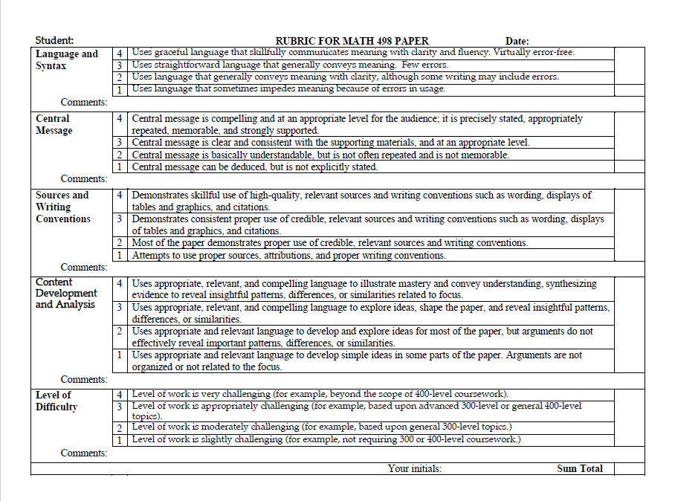

Rubric for Math 498 Presentation – Fall 2021

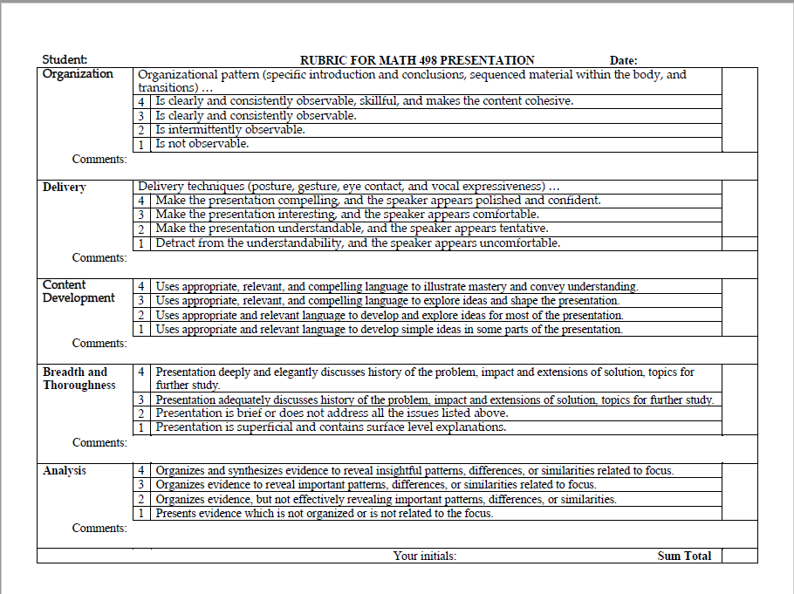

Rubric for Math 498 Paper – Spring 2022

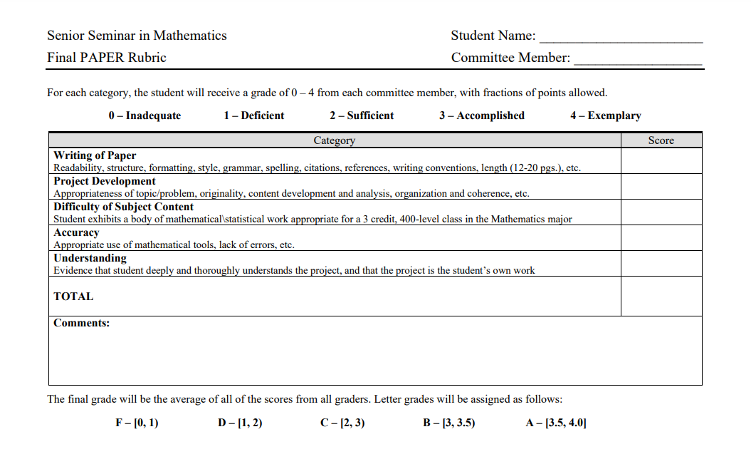

Rubric for Math 498 Presentation – Spring 2022

