Assurance of Student Learning Report
2023-2024
College of Education and Behavior Sciences |  | School of Teacher Education
Special Education for Initial Certification #0456
Dr. Susan Keesey, Director
Is this an online program? ☒ Yes ☐ No | Please make sure the Program Learning Outcomes listed match those in CourseLeaf  Indicate verification here: ☐ Yes, they match! (If they don’t match, explain on this page under Assessment Cycle)
*** Please include Curriculum Map as part of this document (at the end), NOT as a separate file.
Use this page to list learning outcomes, measurements, and summarize results for your program. Detailed information must be completed in the subsequent pages. Add more Outcomes as needed.
Program Student Learning Outcome 1: Understand how exceptionalities impact development and learning, and deliver individualized evidence-based instruction to support learning.
Instrument 1 | SPED 590 Teacher Work Sample (Fa 23, Sp 24)
Instrument 2 | Praxis II Scores
Instrument 3
Based on your results, check whether the program met the goal Student Learning Outcome 1. |  | X Met | ☐ Not Met
Program Student Learning Outcome 2: Students will use multiple means of assessment data to drive instruction and demonstrate understanding of how behavior impacts learning to create safe, inclusive, and culturally responsive learning environments to promote learning. (SLO 2-4 combined)
Instrument 1 | SPED 590 Teacher Work Sample (Fa 23, Sp 24)
Instrument 2

Instrument 3

Based on your results, check whether the program met the goal Student Learning Outcome 2. |  | X Met | ☐ Not Met
Program Student Learning Outcome 3: Students will collaborate effectively with colleagues and parents in addition to demonstrate the attitudes and dispositions of a special educator (SLO 5 and 6).
Instrument 1 | SPED 515 Co teaching assignments (Fa 23, Wi 23/24, Sp 24)  SPED 612 Collaboration assignment (Fa 23)
Instrument 2 | Advanced Dispositions Form (Fa 23 and Sp 24 in SPED 590)
Instrument 3
Based on your results, check whether the program met the goal Student Learning Outcome 3. |  | ☐ Met | X Not Met
Assessment Cycle Plan:
We will be combining/aligning the program assessment processes between ASL and CAEP. We also updated/created an advanced program professional disposition form/rubric and to be reported in the 2024-2025 cycle we will have multiple data collection timepoints [beginning, middle (formative), and final] to gather more information about our students and how they apply feedback to adjust over time through both self- and faculty assessment. This will change the reporting for SLO 3 to be more comprehensive across the program.

Program Student Learning Outcome 1

Program Student Learning Outcome | Understand how exceptionalities impact development and learning, and deliver individualized evidence-based instruction to support learning.
Measurement Instrument 1 | NOTE: Each student learning outcome should have at least one direct measure of student learning. Indirect measures are not required.  SPED 590 Teacher Work Sample (TWS) (rubric starting on pg. 9)  Students prepare a unit plan of teaching including four to ten days of instruction. Students are to assess pre- and post-instructional levels and assess the various, unique characteristics for the students they are instructing. Students provide a written plan as part of the data collection  and have teaching observations as part of their final unit observed by the course instruction. Students also receive final dispositions from faculty and supervisors. Students are in their student teacher semester and expected to have aligned their instructional practices on an individualized level for each student in their class/resource setting.
Criteria for Student Success | Students passing the SPED 590 score indicates proficient completion of the TWS assignment. SPED 590 is a P/F course.
Program Success Target for this Measurement |  |  | We aim to have 100% of students pass SPED 590. |  | Percent of Program Achieving Target | Fall 2023: 9 of 9 (100%) students received a grade of “P” in SPED 590  Spring 2024: 10 of 10 (100%) students received a grade of “P” in SPED 590
Methods | 100% of students enrolled are reflected in our reporting of program success/percent of program achieving target. Data collection is 100% of student submissions accessed via Anthology (Chalk & Wire) and final grades as reported on TopNet.  Below is component level data for the Teacher Work Sample accessed via Anthology (Chalk & Wire) and aligned with the rubric reported in this ASL report. This reports only Spring 24 data.  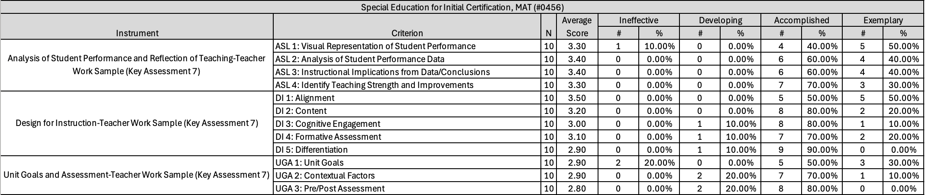
Measurement Instrument 2 | NOTE: Each student learning outcome should have at least one direct measure of student learning. Indirect measures are not required.  Content Area Praxis II (KY > All Grades: Exceptional Education)  LBD: “Learning and Behavior Disorders (P-12)”; test codes 5543 or 5355  MSD: “Moderate and Severe Disabilities (P-12)”; test codes 5545 or 5547
Criteria for Student Success | LBD: (test code and qualifying score); the qualifying score determines if an individual passes the Praxis (the individual receives a score greater than or equal to the qualifying score) or need to re-take the exam (the individual receives a score less than the qualifying score).  - Test code: 5543; qualifying score 154 (this test code is available through August 30, 2024)  - Test code: 5355; qualifying score 139  MSD: (test code and qualifying score); the qualifying score determines if an individual passes the Praxis (the individual receives a score greater than or equal to the qualifying score) or need to re-take the exam (the individual receives a score less than the qualifying score).  - Test code: 5545; qualifying score 154 (this test code is available through August 30, 2024)  - Test code: 5547; qualifying score 149
Program Success Target for this Measurement |  | We aim to have a 100% pass rate (individuals receive a score greater than or equal to the qualifying score) |  | Percent of Program Achieving Target |  | Scores reported here are from 9/1/22 through 8/31/22 as that is the most recent scores that can be obtained.  LBD: 9 of 9 (100%)  MSD: 8 of 8 (100%)
Methods | These data reflect 100% of the students who took the respective Praxis II exams during the most recent reporting period. These scores were obtained through a report pulled from ETS (the reporting system for Praxis test scores) of students who reported their scores to WKU.
Based on your results, circle or highlight whether the program met the goal Student Learning Outcome 2. |  |  |  |  |  |  | X Met | ☐ Not Met
Results, Conclusion, and Plans for Next Assessment Cycle (Describe what worked, what didn’t, and plan going forward)
Results: Yes, we expected this outcome based on our student scores from years past.

Conclusions: Our program continues to prepare teachers for initial certification in LBD and MSD.

Plans for Next Assessment Cycle: We will continue to monitor these data to see if changes are needed. Given the changes to our data collection procedures, in the next reporting cycle we can report on the component level data for the TWS for both semesters (Fa 24 and Sp 25) via Anthology (Chalk & Wire). Additionally, in reporting the Praxis scores, there will likely be reports for both test codes for each respective Praxis (LBD and MSD) since the change in the test codes occurred during the Summer of 2023. Therefore, we will temporarily have test scores across four tests.

Program Student Learning Outcome 2
Program Student Learning Outcome | Students will use multiple means of assessment data to drive instruction and demonstrate understanding of how behavior impacts learning to create safe, inclusive, and culturally responsive learning environments to promote learning. (SLO 2-4 combined)
Measurement Instrument 1 | NOTE: Each student learning outcome should have at least one direct measure of student learning. Indirect measures are not required.  SPED 590 Teacher Work Sample (TWS) (rubric starting on pg. 9)  Students prepare a unit plan of teaching including four to ten days of instruction. Students are to assess pre- and post-instructional levels and assess the various, unique characteristics for the students they are instructing. Students provide a written plan as part of the data collection  and have teaching observations as part of their final unit observed by the course instruction. Students also receive final dispositions from faculty and supervisors. Students are in their student teacher semester and expected to have aligned their instructional practices on an individualized level for each student in their class/resource setting.
Criteria for Student Success | Students passing the SPED 590 score indicates proficient completion of the TWS assignment. SPED 590 is a P/F course.
Program Success Target for this Measurement |  | We aim to have 100% of students pass SPED 590. | Percent of Program Achieving Target | Fall 2023: 9 of 9 (100%) students received a grade of “P” in SPED 590  Spring 2024: 10 of 10 (100%) students received a grade of “P” in SPED 590
Methods | 100% of students enrolled are reflected in our reporting of program success/percent of program achieving target. Data collection is 100% of student submissions accessed via Anthology (Chalk & Wire) and final grades as reported on TopNet.  Below is component level data for the Teacher Work Sample accessed via Anthology (Chalk & Wire) and aligned with the rubric reported in this ASL report. This reports only Spring 24 data.
Based on your results, circle or highlight whether the program met the goal Student Learning Outcome 2. |  |  |  | X Met | ☐ Not Met
Results, Conclusion, and Plans for Next Assessment Cycle (Describe what worked, what didn’t, and plan going forward)
Results: Yes, our students across Fa 23 and Sp 24 passed the class and TWS overall.

Conclusions: However, we did receive some qualitative feedback from students about difficulties in conceptualizing the lesson plan format. Unlike undergraduates in teacher preparation programs who get many semesters over three or four years of teaching exposure, our MAT students do not have as many opportunities to see different lesson planning documents. So, several were intimidated by the full template. So, instead we worked mid-semester (Sp 24) to incorporate an introduction to these types of planning documents so that they are exposed prior to the final semester.

Plans for Next Assessment Cycle: We would like to see greater comfort with the final TWS document after students have been exposed in earlier classes. We also will have those same rubrics incorporated in SPED 531 (LBD) and SPED 615 and 535 (MSD). We also are providing more scaffolded opportunities for graphing to develop the skills needs for visual analysis. Given the changes to our data collection procedures, in the next reporting cycle we can report on the component level data for the TWS for both semesters (Fa 24 and Sp 25) via Anthology (Chalk & Wire).

Program Student Learning Outcome 3
Program Student Learning Outcome | Students will collaborate effectively with colleagues and parents in addition to demonstrate the attitudes and dispositions of a special educator (SLO 5 and 6).
Measurement Instrument 1 | NOTE: Each student learning outcome should have at least one direct measure of student learning. Indirect measures are not required.  SPED 515 Co-teaching assignment (Fa 23, Wi 23/24, Sp 24*) - LBD MAT (rubric starting on pg. 11)  After reading about co-teaching models, and collaborating with another teacher as co-teaching partners, students describe each co-teaching model and develop a scenario in the classroom that would be appropriate for each co-teaching model with rationale for the model chosen. Students also reflect on the common challenges in co-teaching and how they might effectively overcome the challenge in their current or future classroom.  SPED 612 Collaboration assignment (Fa 23) - MSD MAT (rubric starting on pg. 12)  For this assignment, students participate in a simulated parent interaction where the parent is upset. Students are presented with a possible scenario and then “called to the office to meet with the parent”. We will use a live simulation platform known as Mursion. This assignment will occur in two parts. For the first part, students sign up for a 1-hr simulation slot. Students have an opportunity to engage with the parent. For the second part students write a reflection on this experience.
Criteria for Student Success | Students receive a passing grade (C or better; > 70%) on the respective assignment for SPED 515 and/or SPED 612 (depending on program concentration).
Program Success Target for this Measurement |  |  | We aim to have at least 80% of our students receive a passing grade (C or better; > 70%) on the respective assignment for SPED 515 and/or SPED 612 (depending on program concentration). |  | Percent of Program Achieving Target | SPED 515 (LBD)  Fall 2023: 13 of 15 (86.67%) received a passing grade on the assignment  Winter 2023/24: 2 of 3 (66.67%) received a passing grade on the assignment  Spring 2024: 14 of 14 (100%) received a passing grade on the assignment  Across semesters, 29 of 32 (90.63%) received a passing grade on the assignment.  SPED 612 (MSD)  Fall 2023: 6 of 6 (100%)
Methods | We assessed 100% of the MAT-LBD student artifacts in SPED 515 and 100% of the MAT-MSD student artifacts in SPED 612. This is reflected in our reporting of program success/percent of program achieving.
Measurement Instrument 2 | NOTE: Each student learning outcome should have at least one direct measure of student learning. Indirect measures are not required.  Advanced Dispositions Form (Fall 23 and Sp 24 in SPED 590; rubric starting on pg. 13)  This form was created by the end of Fall 23 to be used across graduate programs in the School of Teacher Education. The form assesses seven different areas that were determined to be important to being a professional in a graduate level program.
Criteria for Student Success | Students should receive either a 2 (Approaching) or 3 (Target) across all components/areas within the advanced dispositions form (common advanced preparation program disposition form/rubric).
Program Success Target for this Measurement |  | We aim to have our graduate students have an average score of 2.75 or higher in each component/area/criterion on the advanced dispositions form. (For this report, only final dispositions are analyzed) |  | Percent of Program Achieving Target |  | Fall 2023 Final: 1 of 7 components/areas/criterion (14.29%) had an average greater than or equal to 2.75 across students (n = 9)  Spring 2024 Final: 7 out of 7 components/areas/criterion (100%) had an average greater than or equal to 2.75 across students (n = 10)
Methods | 100% of students enrolled in SPED 590 are reflected in our reporting of program success/percent of program achieving target. Data collection occurred by SPED 590 instructor in Fall 23 (in collaboration with special education faculty). In Spring 24, data collection occurred via Anthology (Chalk & Wire) by special education faculty.  Fall 23  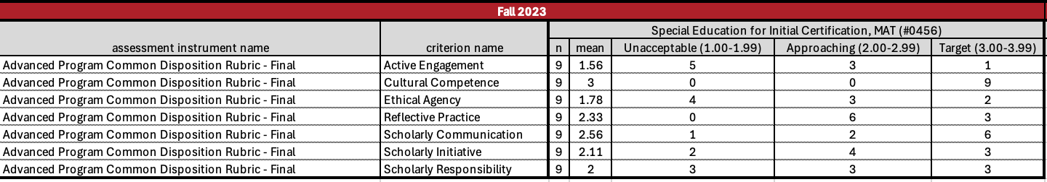  Spring 24  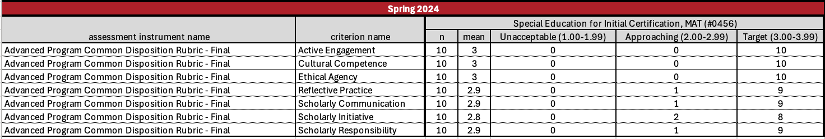
Based on your results, circle or highlight whether the program met the goal Student Learning Outcome 3. |  |  |  |  |  | ☐ Met | X Not Met
Results, Conclusion, and Plans for Next Assessment Cycle (Describe what worked, what didn’t, and plan going forward)
Results: Based on the review of these data, we see that students are able to demonstrate collaborative skills in their courses SPED 515 and 612 (depending on program concentration). However, we also see based on the summative, final ratings of the graduate dispositions of our MAT students there were markedly lower ratings in Fall 2023 compared to Spring 2024.

Conclusions: With respect to the differences in disposition scores from Fall 2023 to Spring 2024, it is clear that there were lower rankings last fall. Fall 2023 was the first semester our program (and school) scored students against the advanced dispositions form. Students struggled with changes in the program, and generally struggled in their student teaching semester. With respect to the students that did not reach the program level success target in SPED 515 specifically, all the respective students did not turn in the assignment at all. Program-wide we are collecting self-assessments of dispositions to assist with increased self-awareness and accountability. We hope this will provide consistently across instructors and adjuncts as well.

Plans for Next Assessment Cycle: There are a few changes to be made for the next assessment cycle.
- SPED 515 and SPED 612
  - Both SPED 515 and SPED 612 will use a 4-point rubric for their respective assignment to then report our “program success target” for this measure as an average total score out of 4.0. Or for SPED 612 (in alignment with CAEP) to receive a 3 on the 4-point Capstone rubric for item 1.1d.
  - Potentially, both artifacts being able to be collected via Anthology (Chalk & Wire)
  - SPED 515 has gone through some course level changes from Fall 23/Winter 23/24 to Spring 24 regarding this assignment (i.e., the assignment is nested within another assignment). For the next assessment reporting cycle, the rubric will reflect the new assignment in alignment with SLO 3 in this ASL report
- Advanced Dispositions Form
  - Students will be completing this form at three different time points throughout their program: beginning, mid (formative), and final. We will then have multiple time points to reflect upon as a part of our assessment analysis in the next reporting cycle. This will also affect our “criteria for student success” and “program success target” for each time point as we anticipate that growth will occur from beginning of the program to the end of the program. We have pilot data to demonstrate this with Spring 2024 formative and Spring 2024 final scores (reported below).

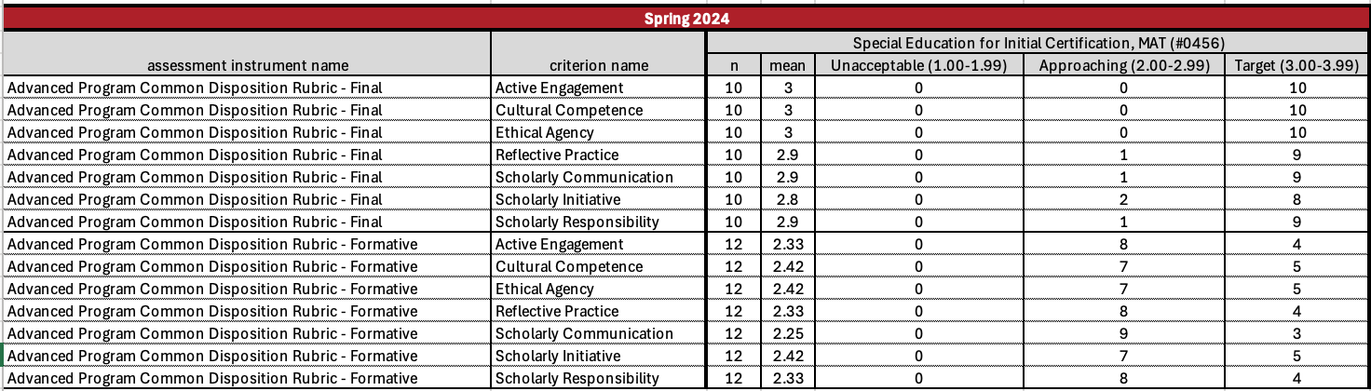

Teacher Work Sample (TWS) Rubric (SPED 590; SLO 1 and 2)

Analysis of Student Performance and Reflection on Teaching (Key Assessment 5B)
Criteria | Beginning | Developing | Proficient | Exemplary
ASL 1  Visual Representation of Student Performance  KTPS 1, 2, 6 | Missing 2 or more visual representations or visuals  do not clearly or accurately communicate data | All graphs included with minor errors. | Use of technology tools to create all 6 graphs/tables that communicate student learning data legibly and accurately. | Developing a unique chart or graph to enhance analysis.
ASL 2  Analysis of Student  Performance Data  KTPS 1, 2, 6 | Minimal or unclear analysis of student performance data. | Some analysis of student performance data | Accurate and logical analysis of the data results to determine the progress of individuals and groups toward learning goals. | Thorough elaboration citing specific and meaningful data beyond the required graphs, data, and student performance.
ASL 3  Instructional Implications from Data/Conclusions  KTPS 1, 2, 5, 6, 7 | Minimal or inaccurate conclusions and instructional implications drawn from data or inaccurate data used to draw conclusions. | Some or unclear conclusions and instructional implications drawn from data and reported using both percentages and raw data. | Accurate and meaningful conclusions and instructional implications are drawn from data referencing trends and patterns in student performance and misconceptions of content. | Thorough elaboration and meaningful implications/conclusions drawn beyond the required criteria, referencing a plan for improving instruction.
ASL 4  Identify Teaching Strength and Improvements  KTPS: 1, 2, 9 | Minimal or inaccurate discussions of strengths and improvements. | Some discussion of teacher’s strengths and improvements | Appropriate, logical, and detailed discussion of 1 of the teacher's strengths and 2 improvements as related to student learning. | Includes extra video clip and/or instructional examples showing thorough elaboration and meaningful understanding of strengths and how to improve as a teacher.
Design for Instruction (Key Assessment 6)
Criteria | Beginning | Developing | Proficient | Exemplary
DI 1: Alignment  KTPS 1, 2, 3, 4, 5, 6, 7 | Misalignment in more than 1 area. | Misalignment in 1 area.  Some omissions or errors. | Unit goals, lesson objectives, targets, Bloom’s levels, strategies, and assessments are in complete alignment. | Visual created that demonstrates complete alignment among all instructional parts.
DI 2: Content  KTPS 4,5,7,8 | Activity-driven instruction; included minimal content. | Content included but not the focus of lessons; some omissions or errors. | Content-driven instruction; content is accurate, adequately defined, and scaffolds learners toward attainment of the Unit Goals. | Content-driven instruction; content is in-depth, accurate, clearly defined, and skillfully scaffolded learners toward attainment of the Unit Goals.  Cite research-based sources.
DI 3: Cognitive Engagement  KTPS 1, 2, 3, 4, 5, 6, 7, 8 | Not fully addressing more than 1 area of engagement | Not fully addressing 1 area of engagement in daily plans | Students are actively involved in high-level thinking tasks, real-world learning, using technology, and a variety of tasks and assessments, as appropriate. Appropriate transitions among strategies. | Engagement tasks are defended by explaining and citing multiple sources of research-based strategies and assessments. Smooth transitions among strategies.
DI 4: Formative Assessment  KTPS 6,7 | Formative assessments included but do not meet validity and reliability standards. | Noted formative assessments; limited variety; most assessments are valid and/or reliable tools with which to document progress toward mastery of the Unit Goals. | Included and adequately described the use of multiple formative assessments; sufficient variety across lessons; assessments are valid and reliable tools with which to document progress toward mastery of the Unit Goals. | Included and fully described the use of multiple formative assessments; significantly variety across lessons; all assessments are valid and reliable tools with which to document progress toward mastery of the Unit Goals.  Cite research-based sources.
DI 5: Differentiation  KTPS 1, 2, 3, 4, 5, 6, 7, 8 | Minimal efforts to differentiate | Several examples of differentiation | Pre-assessment data and contextual factors are utilized to effectively differentiate daily lesson plans by considering student interests, learning preferences, readiness, and learning environment. | Differentiation methods are defended by explaining and citing multiple sources of research-based techniques.
Unit Goals and Assessment (Key Assessment 5A)
Criteria | Beginning | Developing | Proficient | Exemplary
UGA 1: Unit Goals  KTPS: 1, 4, 5 | More than one item is incomplete. | One item is incomplete. | Unit goals are clear with learning outcomes stated in behavioral terms, challenging Bloom’s levels, and appropriate for standards and the consideration of students and learners at different levels. | Cites sources to support the appropriateness of learning goals.
UGA 2: Contextual Factors  KTPS: 2, 7, 8 | Contextual factors are briefly described with minimal implications. | Contextual factors are thoroughly described with 1 important implication per factor. | Thoroughly described contextual factors and implications. Each section has 2 or more important implications for the unit. | Cites data and sources to support contextual factor information and implications.
UGA 3: Pre/Post Assessment  KTPS: 1, 4, 5, 6 | More than one item is incomplete. | One item is incomplete. | Pre/post assessment aligned to learning goals, standards, and Bloom’s level. Appropriate for the grade level. Includes 2 or more assessment types, mastery levels, and scoring tools. | Provides thorough written justification with evidence that the assessment design is reliable and valid. Insert your justification below your pre/post-test table.

SPED 515 Co-Teaching Assignment Rubric (SLO 3)

Component | Excellent | Satisfactory | Unsatisfactory | Poor
Descriptions of Co-Teaching Models  6 pts | Clear descriptions of each co-teaching model with defining features.  5-6 pts | Missing 1 co-teaching model  3-4 pts | Missing more than 1 co-teaching model  1-2 pts | No descriptions of co-teaching models  0 pts
Scenario Using Co-Teaching Model  11 pts | Appropriate scenario for co-teaching model use within individual setting, clear rationale for co-teaching model use, and roles within the model are clearly defined.  9-11 pts | Appropriate scenario for co-teaching model use within individual setting, weak rationale for co-teaching model use and/or missing clearly defined roles within the model.  5-8 pts | Missing multiple components regarding appropriate scenarios, rationale for co-teaching model use, and/or clearly defined roles within the model.  3-4 pts | No scenarios, no rationale, and/or no explanations of roles.  0-2 pts
Challenges in Co-Teaching  3 pts | Identifies common challenges in co-teaching and provides a clear description of how they plan to overcome the identified challenges in their current or future classrooms.  3 pts | Identifies common challenges in co-teaching and provides a weak description of how they plan to overcome the identified challenges in their current or future classrooms.  2 pts | Identifies common challenges in co-teaching but does not provide a description of how they plan to overcome the identified challenges in their current or future classrooms.  1 pt | No challenges presented, or ideas for overcoming challenges are not applied to personal circumstances.  0 pts

SPED 612 Collaboration Assignment Rubric (SLO 3)

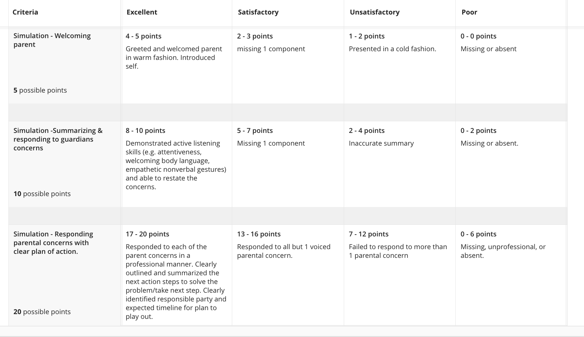
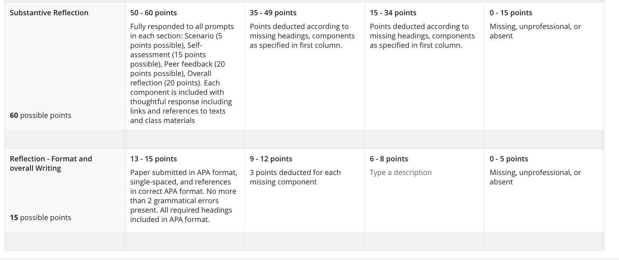

Dispositions Rubric (SLO 3)

Active Engagement | Unacceptable (1) | Approaching (2) | Target (3)
- Maintains purposeful and intensive involvement in the learning  - Invests time, effort, and focus to create and sustain intellectual and emotional connections with both peers and professors  - Pursues appropriate and effective communication with the professor | The graduate student lacks earnest participation in discussions and in the learning in general. They inconsistently access course materials, frequently miss assignment deadlines, and maintain minimal or no communication with the professor. The graduate student’s academic connections with peers and the professor are wanting. | The graduate student demonstrates adequate participation in discussions with occasional insightful contributions that establish academic connections with peers and the professor. They stay involved in the learning, accessing course materials with reasonable consistency. They engage in meetings with the professor as needed, show acceptable interest in academic support, and manage to meet assignment deadlines on most occasions. | The graduate student shows ongoing and deep commitment to the learning. They work to establish and substantiate scholarly connections to peers and to the professor. In discussions, they consistently and meaningfully contribute. They actively participate in meetings as needed with the professor and purposively meet assignment deadlines.
Cultural Competence | Unacceptable (1) | Approaching (2) | Target (3)
- Demonstrates cultural respect, understanding, and equitable treatment for all individuals  - Responds respectfully to diverse opinions and lifestyles  - Supports and institutionalizes cultural knowledge  - Assesses and adapts norms, policies, and values as they pertain to equity | The graduate student needs prompts and supports to identify cultural constructions, barriers, and needs in their course assignments and in class discussions. Cultural or equitable considerations are missing in their proposed solutions or assignments. Respect for diverse opinions and lifestyles is neither consistent nor professional. | The graduate student’s assignments and contributions to discussions in class represent a general understanding of cultural constructions, barriers, and needs. The graduate student requires prompts to go deeper in their consideration of those stakeholders that may be impacted by their proposed instructional or leadership practices. A professional respect for diverse opinions and lifestyles is present. The graduate student’s represented understanding of equity is developing. | The graduate student has a thorough understanding of and demonstrates considerations for cultural and equitable norms in their course assignments and scholarly discourse. The graduate student demonstrates genuine respect for the opinions and lifestyles of all and seeks and is receptive to the interests and opinions of all stakeholders. The graduate student proposes solutions and suggestions that engage stakeholders and remove barriers at the university and in field-related institutions outside of the university.
Ethical Agency | Unacceptable (1) | Approaching (2) | Target (3)
- Functions in line with accepted notions of right and wrong, professional standards, and societal laws  - Exemplifies honesty and integrity  - Complies with university and field-situated policies  - Progresses through the program understanding that faculty are adopting a presumption of competence | The graduate student’s understanding of and adherence to professional standards are, at times, absent. The graduate student is negligent in maintaining the line between right and wrong, not always demonstrating honesty and integrity in their work or interactions with others. University and field-situated policies are often disregarded. The faculty’s presumption of competence in the graduate student is breached by the graduate student. | The graduate student’s demeanor presents as though they are operating within established constructs of right and wrong, professional standards, and societal laws. The graduate student seems to be honest and functioning within university and field- situated policies. The graduate student’s understanding of the faculty’s presumption of competence in them is present but lacks deep effect on their progression through the program of study. | The graduate student demonstrates a dedication to doing the right thing no matter the circumstance. They have a focus on honesty and follow university, district, and school- level policies in all their work. The graduate student understands that their academic journey is situated in the professor’s belief and trust in the graduate student’s competency and abilities; the graduate student acts accordingly.
Reflective Practice | Unacceptable (1) | Approaching (2) | Target (3)
- Accepts responsibility for decisions and actions  - Engages in critical self- reflection  - Integrates feedback  - Makes both data-informed and evidence-based decision  - Bridges theoretical and practical knowledge | The graduate student may recall and summarize without reflection and self-awareness. Additionally, they may blame others for negative outcomes or respond negatively or not at all to feedback. Any decisions are made intuitively or emotionally instead of based on data or evidence. They may convey some practical knowledge, but they do not make connections to theoretical knowledge. They do not demonstrate growth or positive changes in practice. | The graduate student describes their beliefs, biases, decisions, and actions but inconsistently recognizes how their beliefs, biases, decisions, and actions influence both successes and failures. They identify relevant theoretical knowledge but do not clearly connect to practice. Their response to feedback is mostly positive, but they apply the feedback inconsistently, either responding only to selected feedback or not applying feedback to new contexts. Their decisions are informed by examining limited data and evidence, but changes do not lead to significant improvements in outcomes. | The graduate student demonstrates self-awareness by examining the influence of their beliefs, biases, decisions, and actions on both successes and failures. They comprehensively assess practice, articulating the connection between theoretical and practical knowledge. Their response to feedback is positive, seeking and incorporating feedback from diverse sources. Their decisions are informed by examining multiple sources of data and evidence and applying insights to improve student outcomes through improved practice.
Scholarly Communication | Unacceptable (1) | Approaching (2) | Target (3)
- Utilizes professional tonality in all communication  - Employs the academic language and professional discourses of the discipline  - Displays enhanced verbal communication skills, including effective speaking and active listening  - Models person-first language  - Adjusts language and register for all stakeholders as appropriate | The graduate student’s communications are unprofessional. The graduate student’s language does not display the knowledge and beliefs that are acquired through scholarly work in their discipline. Verbal communication skills are weak, and the graduate student appears to have a single language and register for all situations. The graduate student must be reminded often to use person-first language in their spoken and written work. | The graduate student’s communications are mostly professional in tone. The graduate student is proficient in their use of professional discourse and discipline- specific academic language. The graduate student’s speaking and listening skills are adequate, and person-first language is used in most cases. The graduate student shows the ability to adjust their language and register, although the adjustments are not always made smoothly. | The graduate student’s communication skills are highly developed, consistently professional in tone, and include the ability to speak and listen well. The graduate student incorporates the academic language and professional discourses of the discipline in their written work and in discussions in class. The graduate student always uses person-first language. They demonstrate the ability to tactfully adjust their language and register to match and honor the needs of all stakeholders.
Scholarly Initiative | Unacceptable (1) | Approaching (2) | Target (3)
- Demonstrates a proactive pursuit of and persistence toward serious study  - Exhibits enthusiasm for learning  - Presents as a responsible intellectual self-starter, acting and taking charge without prompting while allowing others to lead when their leading may be more effective  - Asks questions out of a curiosity for venturing off the prescribed path toward knowledge as long as the new path aligns with the goals of the graduate program  - Requests feedback that identifies academic weaknesses | The graduate student shows signs of quiet quitting, putting in the minimum amount of academic effort required to complete the program while not appearing to value feedback and guidance toward personal scholarly growth. They ask for outside guidance and for others to take charge of the learning and only respond enough to prompting and guidance to pass courses and receive the degree. | The graduate student’s focus toward scholarly development ebbs and flows. They show enthusiasm and take initiative at times, only to sometimes falter and compel others to finish the task. They appear to welcome and value feedback, but their application of feedback that addresses academic areas for growth is at times inadequate. | The graduate student presents as regarding all course work as valuable; they reflect, discuss, and write with a fervor for expanding knowledge. The graduate student seeks academic feedback and incorporates the feedback into future work. They go above and beyond required tasks, reaching for as much learning as possible. The graduate student’s questions are inquisitive and demonstrate the student’s pondering stance toward academic development.
Scholarly Responsibility | Unacceptable (1) | Approaching (2) | Target (3)
- Demonstrates sincere openness and responsiveness to the ideas of others  - Supports positive and appropriate interaction, even in times of struggle  - Addresses and adjusts to graduate-level administration issues (scheduling, deadlines, bursar requirements, and more)  - Values communication that leads to learning and seeks to resolve conflicts that interfere with said communication | The graduate student’s interaction with others does not indicate a willingness to seek to understand before, or even along with, seeking to be understood. In times of difficulty, they focus on and blame others rather than focusing on the issue that is interfering with their learning. The graduate student shows an ongoing inability to direct their efforts toward learning as the goal, instead allowing their attention to linger on obstacles and delays, regardless of how efficiently those are addressed by graduate faculty and staff. | The graduate student’s focus is on learning but can be drawn away from time to time by problems that may arise along the graduate pathway. The graduate student’s communication is appropriate but not always directed toward learning and knowledge. The graduate student responds to administrative issues but depends on others for support. | The graduate student demonstrates a focus on learning and a sincere desire for understanding in their communication with graduate faculty and other students. They take an active role in determining the direction of their own studies and strive to recognize and acknowledge the scholarly contributions of others. Their efforts and attention concerning administrative issues or conflicts are appropriately directed, allowing the graduate student to expeditiously return to the desired focus on learning.

MAT (#0456) Curriculum Map

