Assurance of Student Learning Report
2023-2024
College of Education and Behavior Sciences |  | School of Teacher Education
Master of Arts in Education: Moderate and Severe Disabilities (0438)
Dr. Susan Keesey, Department Chair
Is this an online program? X Yes ☐ No | Please make sure the Program Learning Outcomes listed match those in CourseLeaf . Indicate verification here ☐ Yes, they match! (If they don’t match, explain on this page under Assessment Cycle)
*** Please include Curriculum Map as part of this document (at the end), NOT as a separate file.
Use this page to list learning outcomes, measurements, and summarize results for your program. Detailed information must be completed in the subsequent pages. Add more Outcomes as needed.
Program Student Learning Outcome 1: Administer assessments, graph and analyze results, and deliver instruction to determine strengths and areas of need for individuals for students with low-incidence disabilities. (SLO 1 and 2 combined)
Instrument 1 | SPED 529 Case Study
Instrument 2 | SPED 615 DTT Lesson
Instrument 3
Based on your results, check whether the program met the goal Student Learning Outcome 1. |  | ☐ Met | X Not Met
Program Student Learning Outcome 2: Demonstrate sufficient content knowledge of students with severe disabilities (SLO 3)
Instrument 1 | MSD Praxis Scores
Instrument 2

Instrument 3

Based on your results, check whether the program met the goal Student Learning Outcome 2. |  | X Met | ☐ Not Met
Program Student Learning Outcome 3:
Instrument 1

Instrument 2

Instrument 3
Based on your results, check whether the program met the goal Student Learning Outcome 3. |  | ☐ Met | ☐ Not Met
Assessment Cycle Plan:
We do plan to update the SLOs for this program this cycle so that they are synced with LBD SPED MAE program with language specific to students with more severe disabilities. Both programs have overlapping courses and content. Therefore, it makes sense to gather similar artifacts and simplify the assessment process. Specifically, we need to combine the program assessment processes between ASL and CAEP. This past year we created a new version of the capstone course for MAE students to gather information on student application of the student’s research application abilities and gather a more holistic view of their abilities at the end of the program. We have also started to implement a professional disposition process including both self- and faculty assessments. The current program SLOs do not include this information at this time.

Program Student Learning Outcome 1

Program Student Learning Outcome | Administer assessments, graph and analyze results, and deliver instruction to determine strengths and areas of need for individuals for students with low-incidence disabilities. (SLO 1 and 2 combined)
Measurement Instrument 1 | SPED 529 Case Study  Throughout the semester, this assignment unfolded in four sequential parts, corresponding to the course modules. The initial phase required gathering background information and reviewing the target student's eligibility and current Individualized Education Program (IEP), alongside scrutinizing past alternative assessment scores and conveying findings in accessible language to parents. Following this, the focus shifted to assessing the student's communication, preferences, and environment, involving the completion of the Communication Matrix and an ecological assessment, with subsequent formulation of relevant IEP goals and support services. The third segment involved academic assessments or preference assessments, data collection, trend line calculation, and the derivation of relevant IEP outcomes and standards for the upcoming year. Finally, the project culminated in progress monitoring and data collection, including the development and execution of an assessment plan for an existing IEP goal, interpretation of results, and submission of the final IEP template alongside accompanying data collection forms. Each module allowed for feedback incorporation and subsequent section submission, leading to the comprehensive final submission encompassing all parts of the assignment. Student artifacts were assessed against the CAEP rubric criteria against 1.1a, 1.1c, and 1.1d (attached).
Criteria for Student Success | As a midpoint, formative check in the semester towards this outcome, we expect students to achieve at least a 2 and 3 on the 4 point scale for this assignment.
Program Success Target for this Measurement |  |  | We aim to have 100% score at least a 2 on this rubric for these three criteria. Or, a 3.0 average for this data collection. |  | Percent of Program Achieving Target | .  12 of 13 met 2 or higher on all three rubric criteria.
Methods | We pulled scores from 100% of the MAE students enrolled in SPED 529 for this assessment cycle. Data were pulled from Anthology.  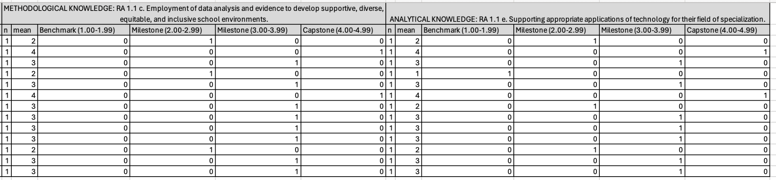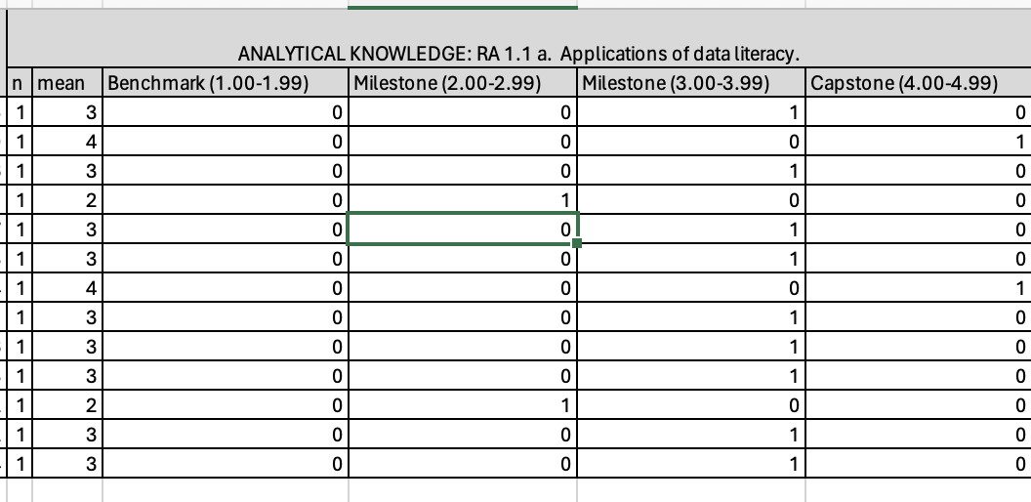
Measurement Instrument 2 | SPED 615 DTT Lesson plan
Criteria for Student Success | Receive at least 48 of 60 points
Program Success Target for this Measurement |  | We would aim for 100% to meet criteria. |  | Percent of Program Achieving Target |  | Spring 2024:  17 of 17 met criteria  Average points; 59.26
Methods | We assessed 100% of the student artifacts in this course. Artifacts are retained in the MAE portfolio
Measurement Instrument 3 | N/A
Criteria for Student Success | N/A
Program Success Target for this Measurement |  | N/A |  | Percent of Program Achieving Target |  | N/A
Methods | N/A
Based on your results, highlight whether the program met the goal Student Learning Outcome 1. |  |  |  |  |  | X Met | ☐ Not Met
Results, Conclusion, and Plans for Next Assessment Cycle (Describe what worked, what didn’t, and plan going forward)
Results: 100% of our students achieved this goal for 615 and 12 of 13 (92%) in the 529 artifact. For 529, 100% of students met criteria for the RA 1.1 a. Applications of data literacy and 100% met criteria for RA 1.1 c. Employment of data analysis and evidence to develop supportive, diverse, equitable, and inclusive school environments. However, one student did not meet criteria for the RA 1.1 e. Supporting appropriate applications of technology for their field of specialization.

Conclusion & Next Steps: We will continue these assessments, but will also consider the CAEP assessment rubric for 615 in the upcoming cycle as well. There is a distinct difference to these two projects. The 615 assignment does provide a video demonstration of the instruction. As seen in the rubric below, use of the points is not as specific as the rubric that is also applied. So, this next cycle we need to either align the points to the 4-point, or, have all students upload an assess the ASL rubric in Anthology. MAT students uploaded, but MAE students did not. We recognize, across programs, student difficulties with applying the technology expectations for being able to manipulate data graphically. We will continue to monitor these data as we adjust program-wide expectations. We are monitoring student registration to prompt students to take courses in the recommended order.

Program Student Learning Outcome 2
Program Student Learning Outcome | Demonstrate sufficient content knowledge of students with severe disabilities (SLO 3)
Measurement Instrument 1 | MSD Praxis Scores (MSD: Test codes 5545 or 5547)
Criteria for Student Success | MSD  Test code 5545 cut score: 154  Test code 5547 cut score: 149
Program Success Target for this Measurement |  |  | 100% pass |  | Percent of Program Achieving Target | 10 of 10 passing scores
Methods | These data reflect 100% of the students who completed the Praxis this semester
Based on your results, circle or highlight whether the program met the goal Student Learning Outcome 2. |  |  |  |  |  | X Met | ☐ Not Met
Results, Conclusion, and Plans for Next Assessment Cycle (Describe what worked, what didn’t, and plan going forward)
Results: Yes, we expected this outcome based on our student scores from years past.

Conclusions: Our program continues to prepare teachers for initial certificate in MSD when they hold another teacher certification.

Plans for next assessment cycle: We will continue to monitor these data to see if changes are needed. We have added a new text book this past year that can be used in multiple courses (introduced in SPED 529). We also will need to modify and update the curriculum map.

Program Student Learning Outcome 3
Program Student Learning Outcome
Measurement Instrument 1 | NOTE: Each student learning outcome should have at least one direct measure of student learning . Indirect measures are not required.
Criteria for Student Success
Program Success Target for this Measurement |  |  |  |  | Percent of Program Achieving Target
Methods
Measurement Instrument 2

Criteria for Student Success

Program Success Target for this Measurement |  |  |  | Percent of Program Achieving Target
Methods

Measurement Instrument 3

Criteria for Student Success

Program Success Target for this Measurement |  |  |  | Percent of Program Achieving Target
Methods

Based on your results, circle or highlight whether the program met the goal Student Learning Outcome 3. |  |  |  |  |  | ☐ Met | ☐ Not Met
Results, Conclusion, and Plans for Next Assessment Cycle (Describe what worked, what didn’t, and plan going forward)

Rubric applied to SPED 529 Case study
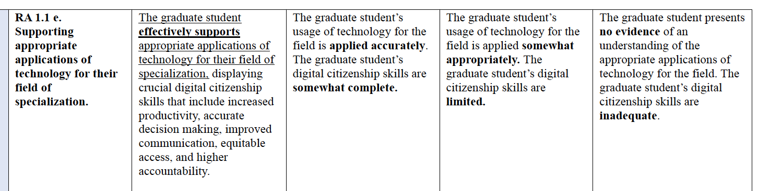
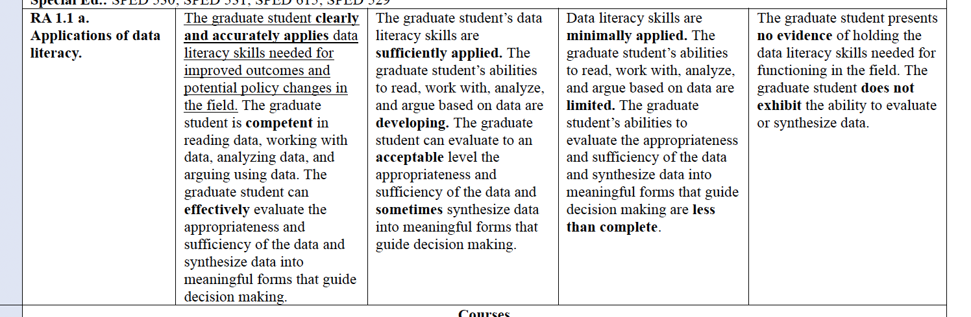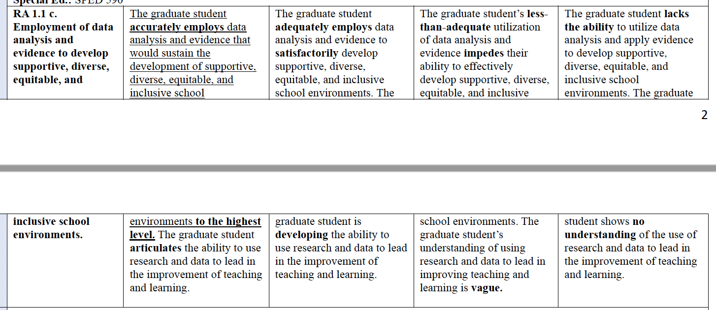

SPED 615 DTT Lesson Rubric
See the rubric below that will be used to grade the assignment.
Hand in: Written Plan, Data Collection Page & Graph, Video, & Reflection
*Note: To achieve an Exemplary on the rubric, a student must meet all the proficient expectations as well as the items in the Exemplary column.
Analysis of Student Performance and Reflection of Teaching
Criteria | Beginning | Developing | Proficient | Exemplary
ASL 1  Visual Representation of Student Performance  KTPS 1, 2, 6 | Missing 2 or more visual representations or visuals  do not clearly or accurately communicate data | All graphs included with minor errors. | Use of technology tools to create all 6 graphs/tables that communicate student learning data legibly and accurately. | Developing a unique chart or graph to enhance analysis.
ASL 2  Analysis of Student  Performance Data  KTPS 1, 2, 6 | Minimal or unclear analysis of student performance data. | Some analysis of student performance data | Accurate and logical analysis of the data results to determine the progress of individuals and groups toward learning goals. | Thorough elaboration citing specific and meaningful data beyond the required graphs, data, and student performance.
ASL 3  Instructional Implications from Data/Conclusions  KTPS 1, 2, 5, 6, 7 | Inaccurate conclusions and instructional implications drawn from data or inaccurate data used to draw conclusions. | Some or unclear conclusions and instructional implications drawn from data and reported using both percentages and raw data. | Accurate and meaningful conclusions and instructional implications are drawn from data referencing trends and patterns in student performance and misconceptions of content. | Thorough elaboration and meaningful implications/conclusions drawn beyond the required criteria, referencing a plan for improving instruction.
ASL 4  Identify Teaching Strength and Improvements  KTPS: 1, 2, 9 | Minimal or inaccurate discussions of strengths and improvements. | Some discussion of teacher’s strengths and improvements | Appropriate, logical, and detailed discussion of 1 of the teacher's strengths and 2 improvements as related to student learning. | Includes extra video clip and/or instructional examples showing thorough elaboration and meaningful understanding of strengths and how to improve as a teacher.

Curriculum Overlap with 0457 Courses

Student Learning Outcomes for Special Education Master’s Programs | 1. Understand how exceptionalities impact develop and learning, and deliver individualized evidence-based instruction to support learning. | 2. Create safe, inclusive, and culturally responsive learning environments to promote learning and positive social interactions for students with disabilities. | 3. Use multiple means of assessment and data to drive instructional decision making. | 4. Understand how behavior impacts learning and develop behavioral interventions to improve social interactions and student learning. | 5. Collaborate effectively with colleagues and parents. | 6. Display the attitudes and dispositions of a special educator.
EDU 502 |  |  |  | ✔
SPED 517
SPED 630 |  |  |  |  | ✔
SPED 618
SPED 590 |  |  |  |  |  | ✔
SPED 501 |  |  | ✔
SPED 610
SPED 612 |  |  |  |  | ✔
SPED 529 |  |  | ✔
SPED 535 |  | ✔
SPED 615 | ✔
SPED 515
LTCY 519
SPED 530 |  |  | ✔
SPED 525 | ✔
SPED 531 |  | ✔

