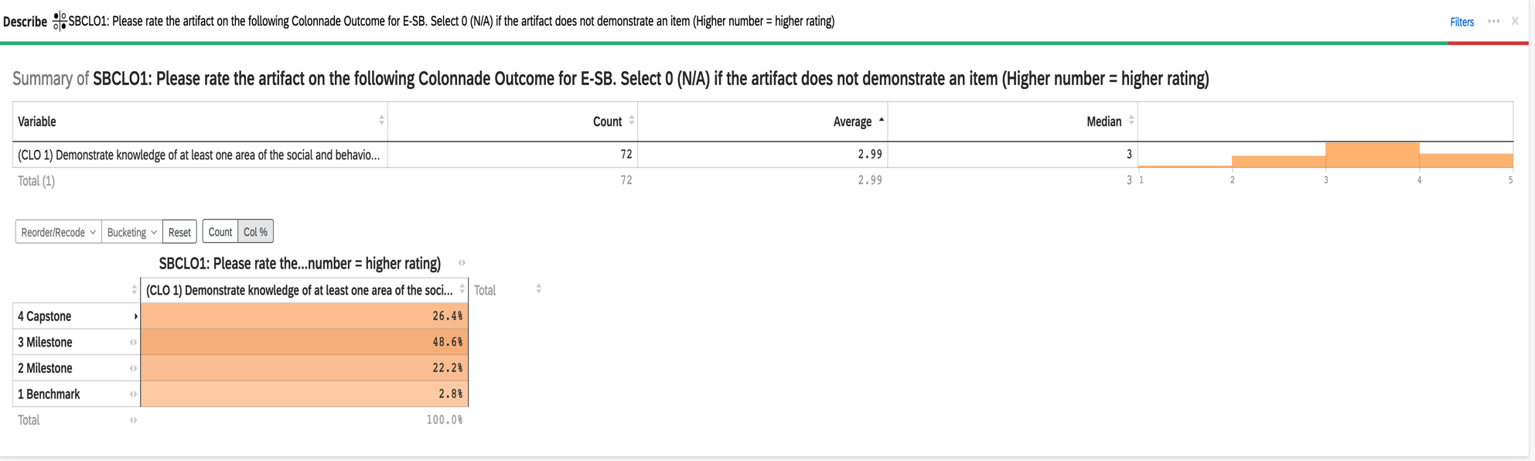
2023-24 Aggregate Data for Explorations E-SB CLO #1: Demonstrate knowledge of at least one area of the social and behavioral sciences

2023-24 Aggregate Data for Explorations E-SB CLO #2: Apply knowledge, theories, and research methods, including ethical conduct, to analyze problems pertinent to at least one area of the social and behavioral sciences

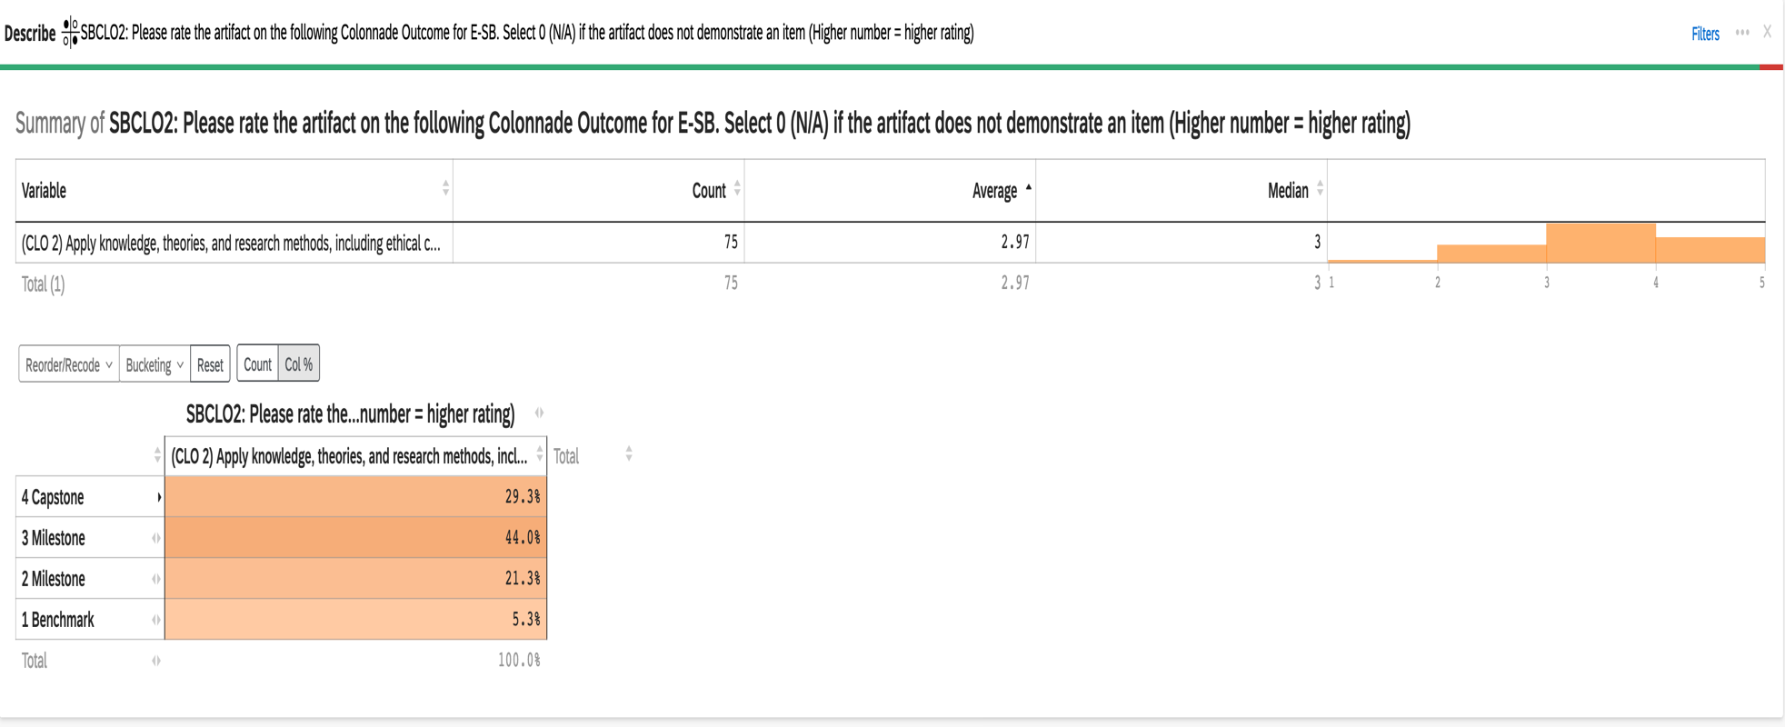

2023-24 Aggregate Data for Explorations E-SB CLO #3: Understand and demonstrate how at least one area of the social and behavioral sciences conceptualizes diversity and the way it shapes human experience

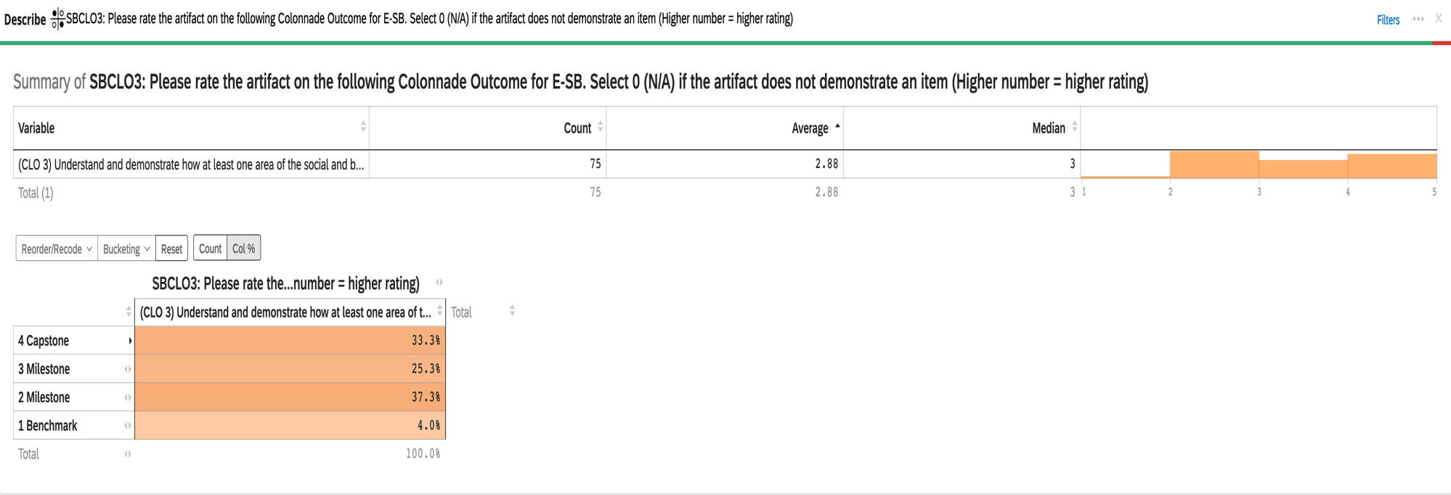

2023-24 Aggregate Data for Explorations E-SB CLO #4: Integrate knowledge of at least one area of the social and behavioral sciences into issues of [personal or public importance

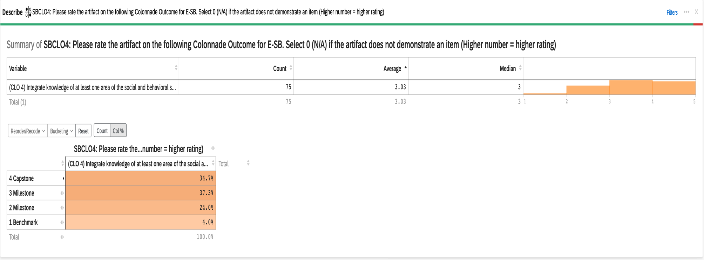

2023-24 Aggregate Data for Explorations E-SB CLO #5: Communicate effectively using the language and terminology germane to at least one area of the social and behavioral sciences

