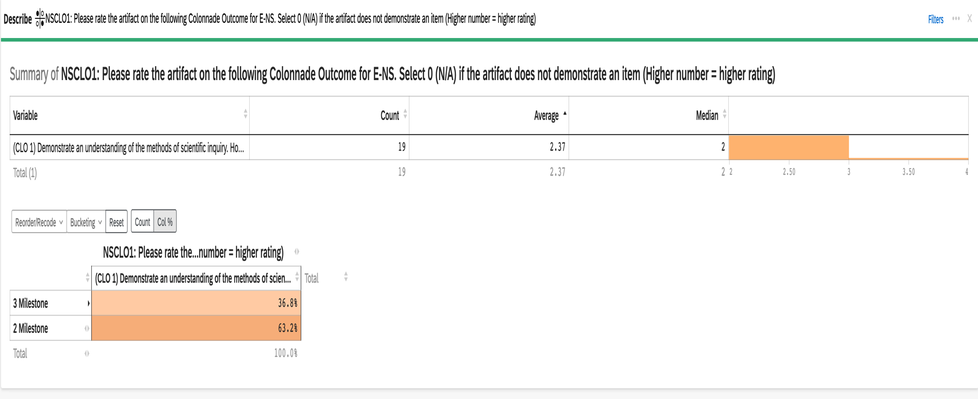
2023-24 Aggregate Data for E-NS CLO #1: Demonstrate an understanding of the methods of scientific inquiry

2023-24 Aggregate Data for E-NS CLO #2: Explain basic concepts and principles in one or more of the sciences
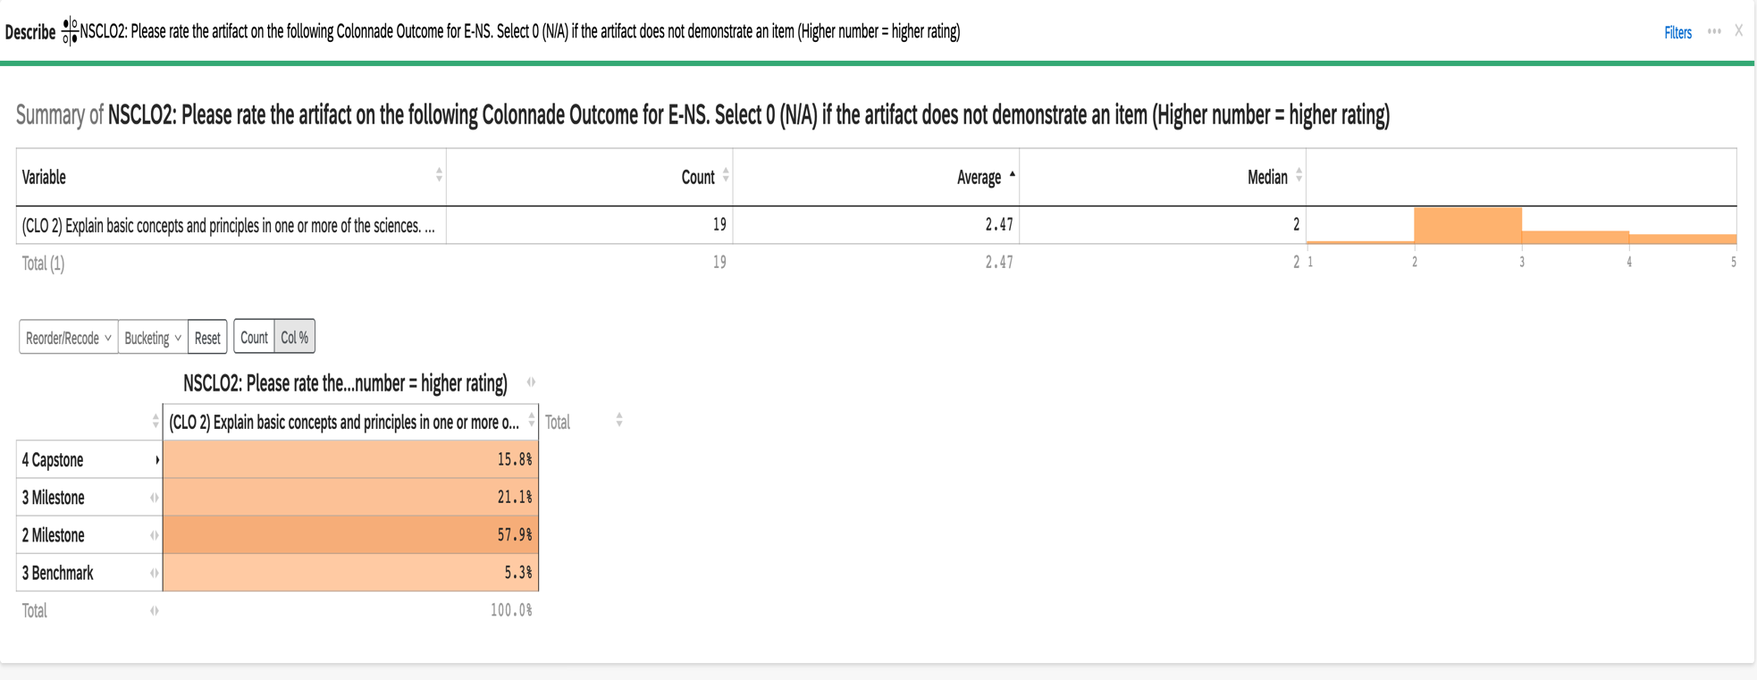

2023-24 Aggregate Data for E-NS CLO #3: Apply scientific principles to interpret and make predictions in one or more of the sciences

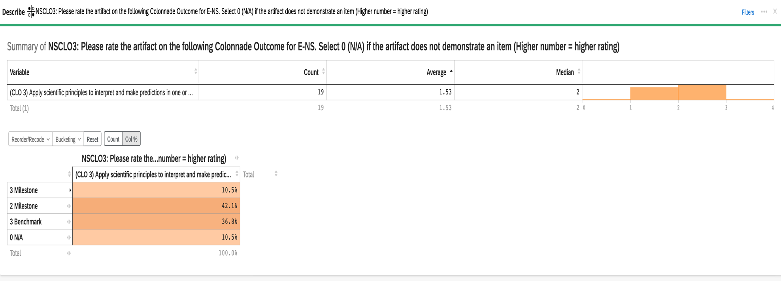

2023-24 Aggregate Data for E-NS CLO #4: Explain how scientific principles relate to issues of person and/or public importance
