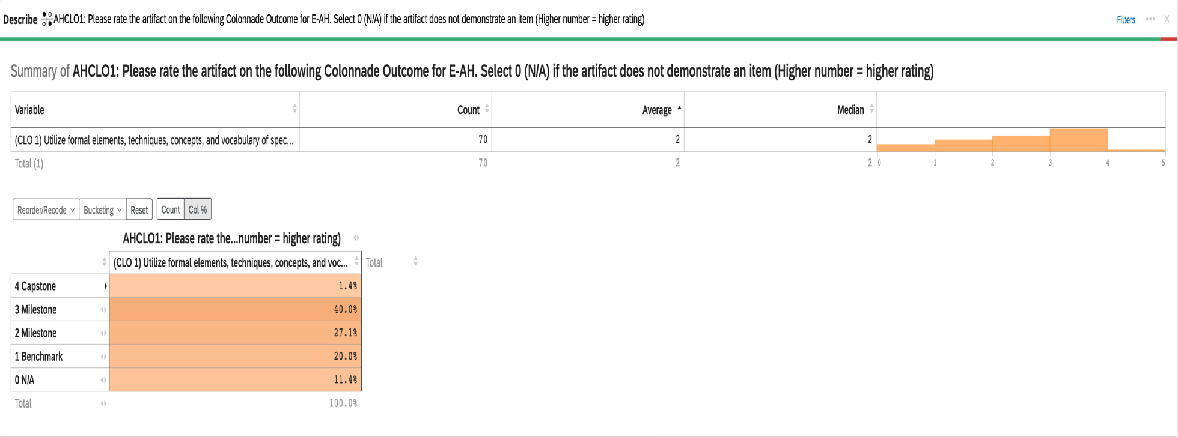
2023-24 Aggregate Data for Connections E-AH CLO #1: Utilize formal element, techniques, and vocabulary of specific disciplines within the arts & humanities

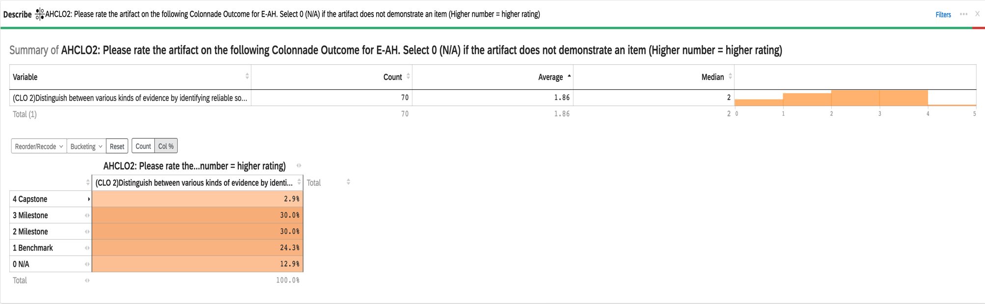
2023-24 Aggregate Data for Connections E-AH CLO #2: Distinguish between various kinds of evidence by identifying reliable sources/valid arguments.

2023-24 Aggregate Data for Connections E-AH CLO #3: Demonstrates how social, cultural, and historical contexts influence creative expression in the arts & humanities

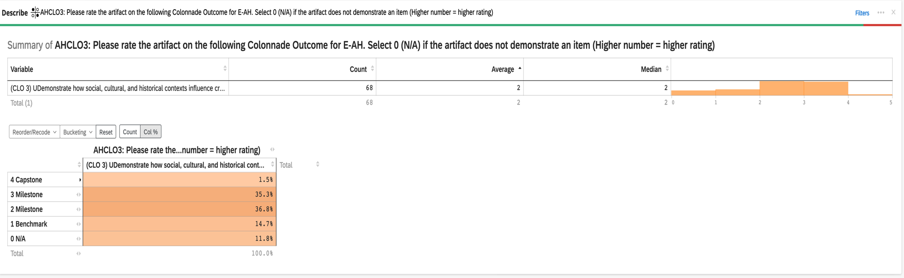

2023-24 Aggregate Data for Connections E-AH CLO #4: Evaluate the significance of human expression and experience in shaping larger social, cultural, and historical context.

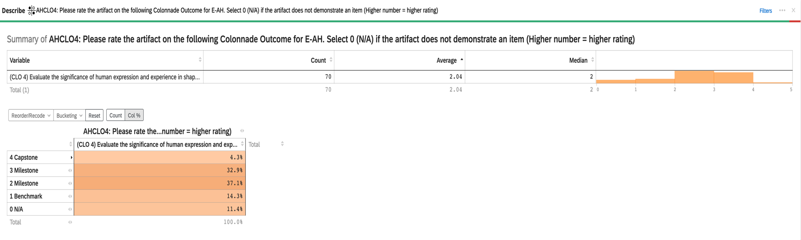

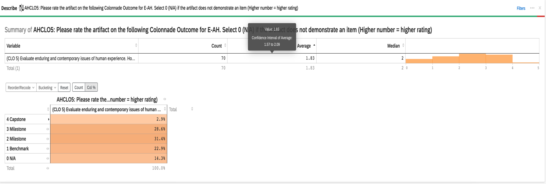
2023-24 Aggregate Data for Connections E-AH CLO #5: Evaluate enduring and contemporary issues of human experience

