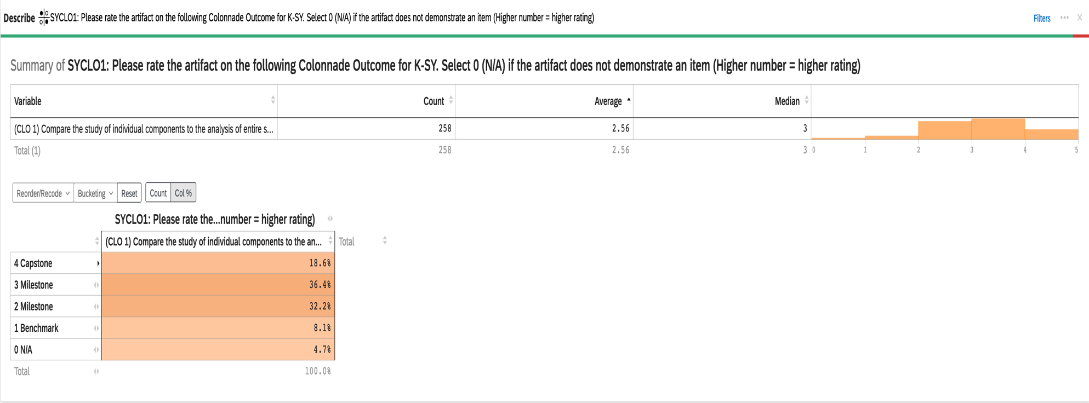
2023-24 Aggregate Data for Connections K-SY CLO #1: Compare the study of individual components to the analysis of entire systems

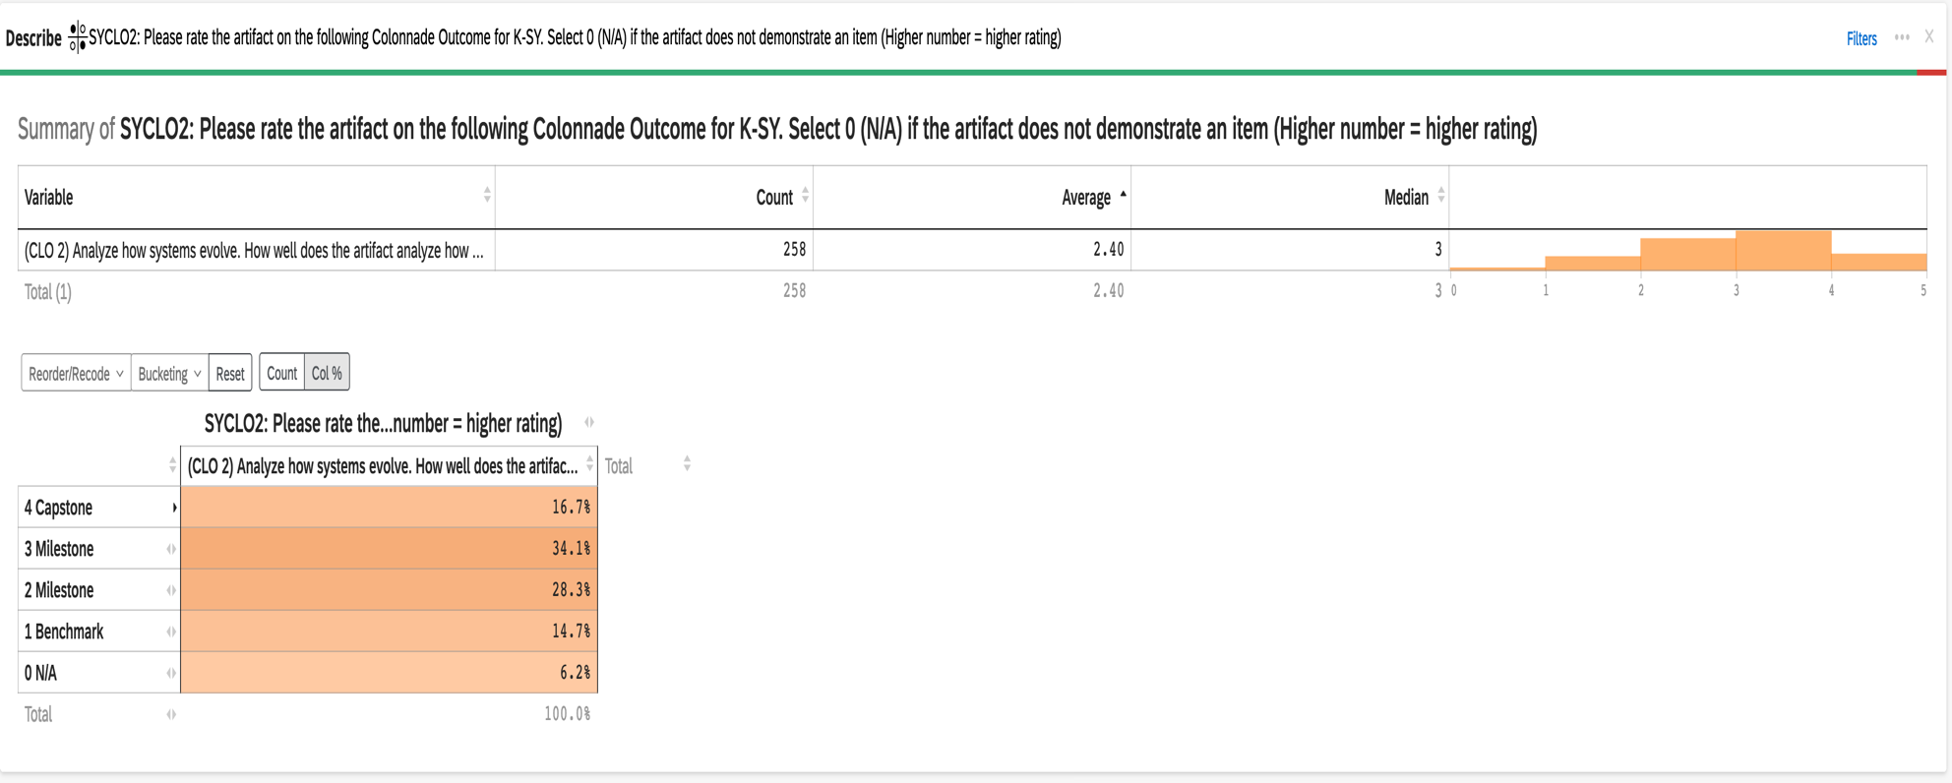
2023-24 Aggregate Data for Connections K-SY CLO #2: Analyze how systems work

2023-24 Aggregate Data for Connections K-SY CLO #3: Evaluate how systems-level thinking informs decision-making

