2023-24 Aggregate Data for Connections K-SC CLO #1: Examine diverse values that form civically-engaged informed members of society

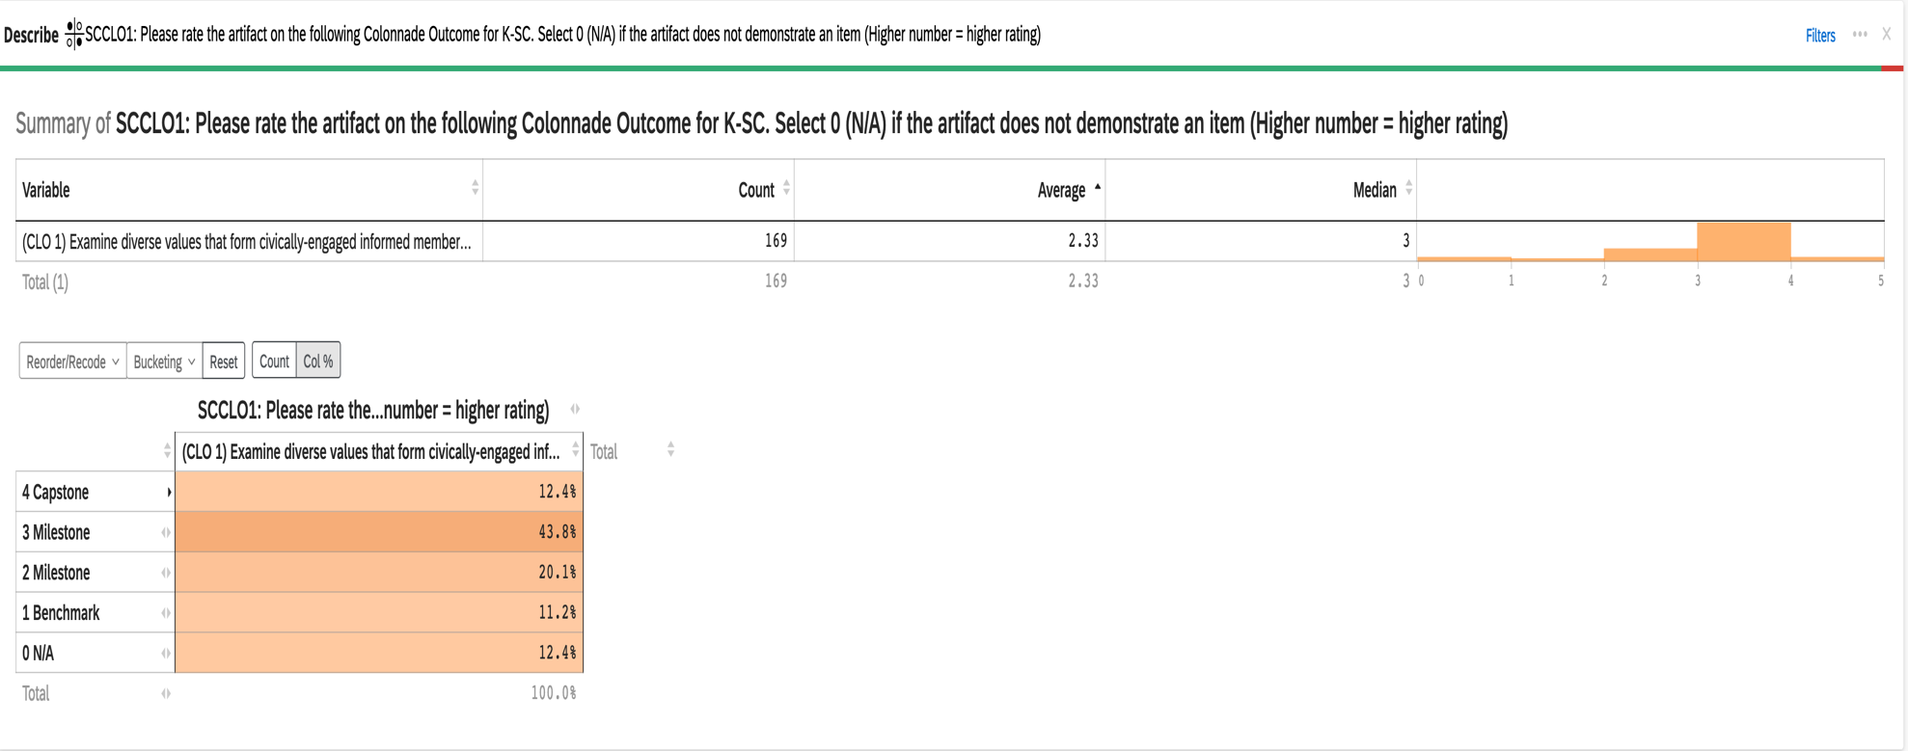

2023-24 Aggregate Data for Connections K-SC CLO #2: Analyze the development of self in relation to other is society

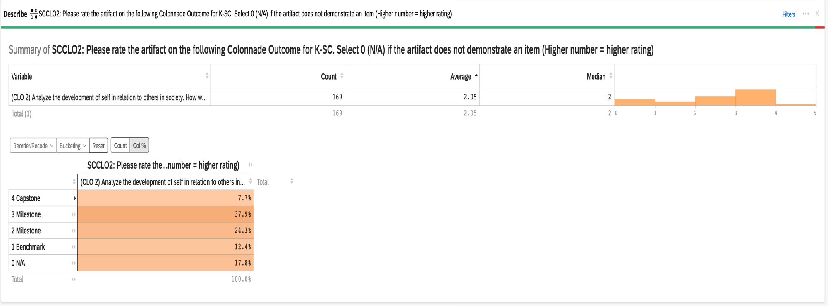

2023-24 Aggregate Data for Connections K-SC CLO #3: Evaluate solutions to real-world socio-cultural problems

