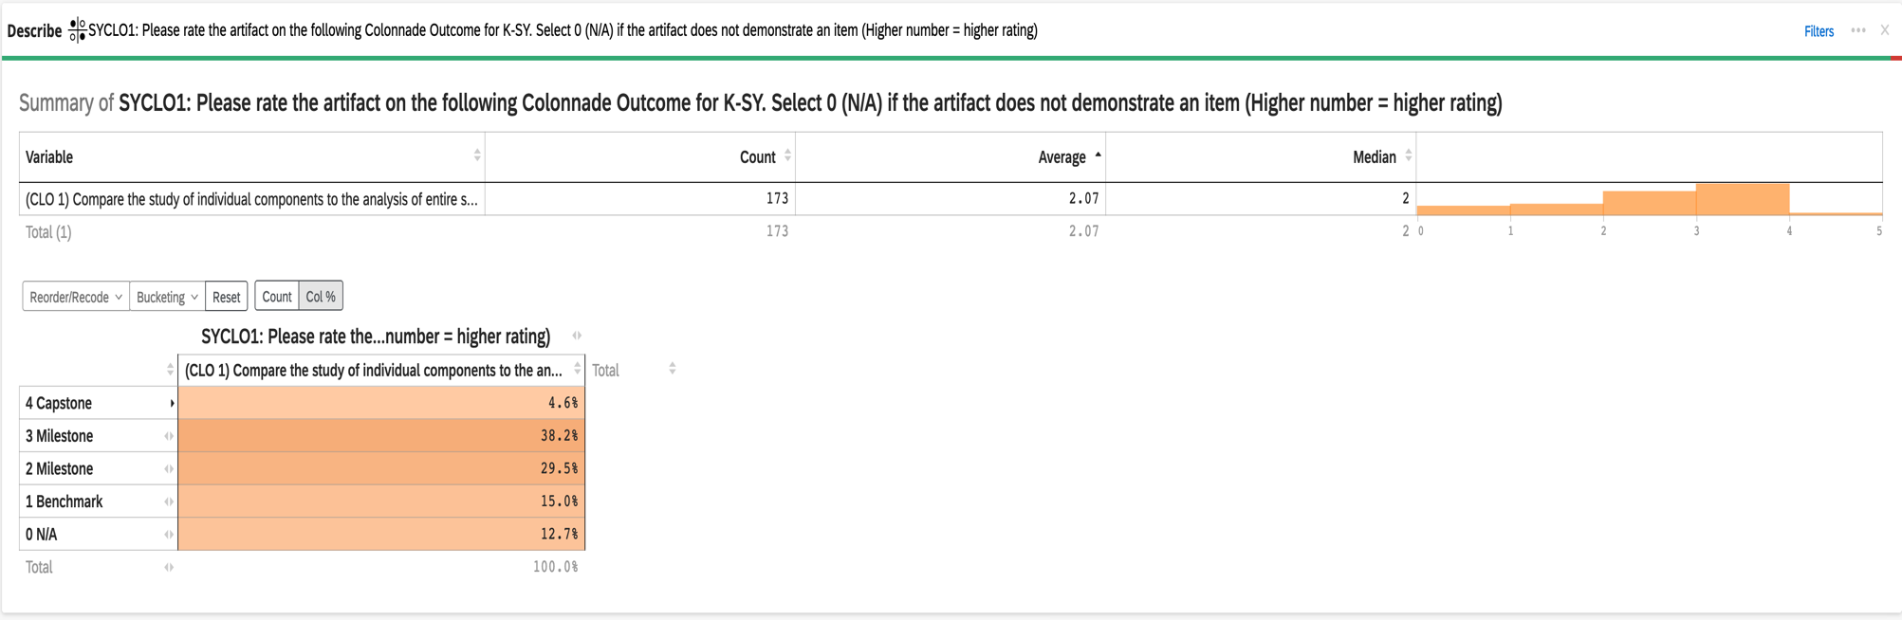
2022-23 Aggregate Data for Connections K-SY CLO #1: Compare the study of individual components to the analysis of entire systems

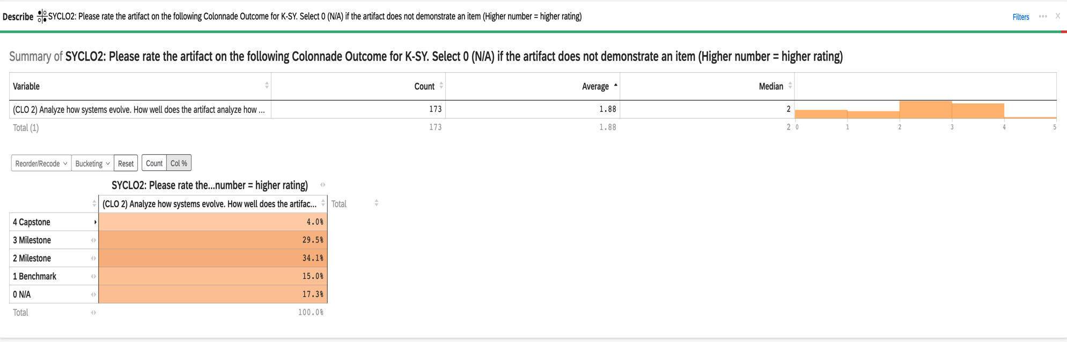
2022-23 Aggregate Data for Connections K-SY CLO #2: Analyze how systems evolve

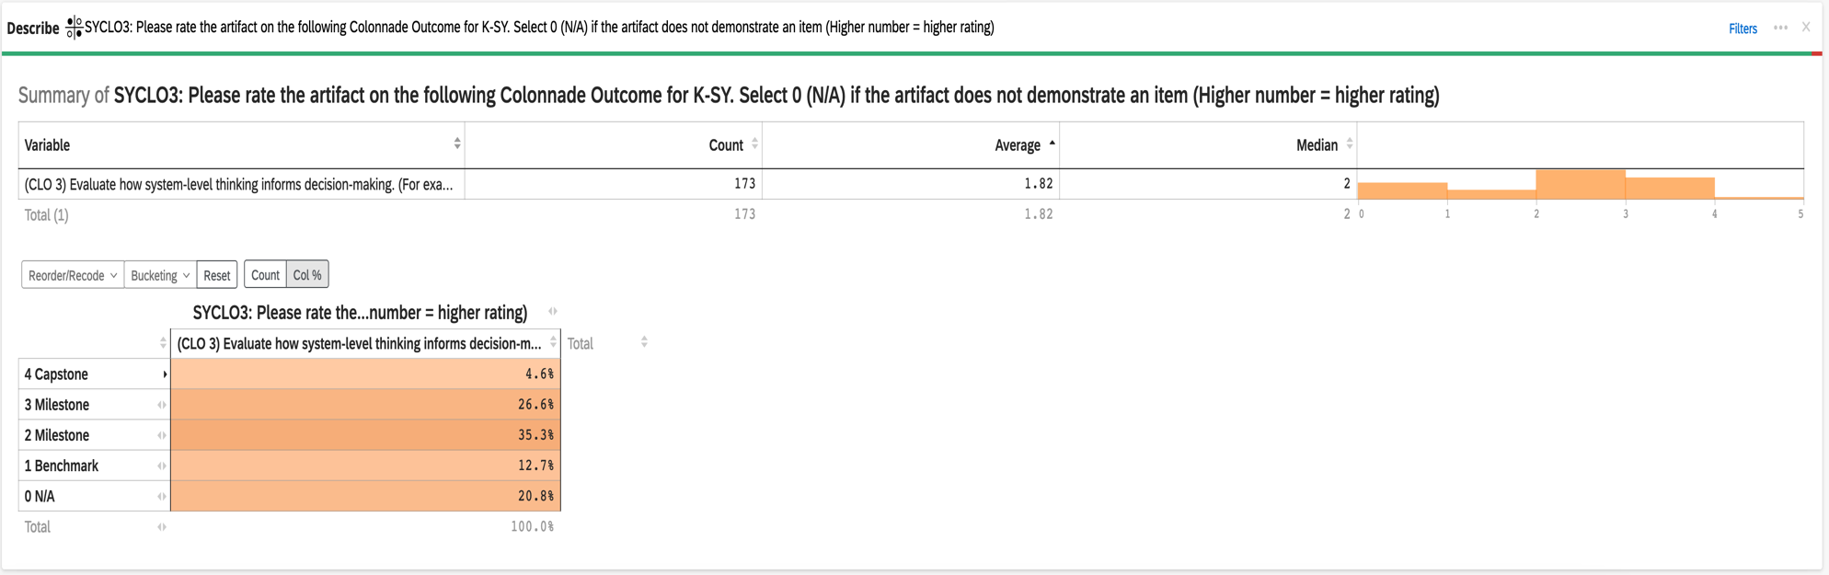
2022-23 Aggregate Data for Connections K-SY CLO #3: Evaluate how system-level thinking informs decision-making.

