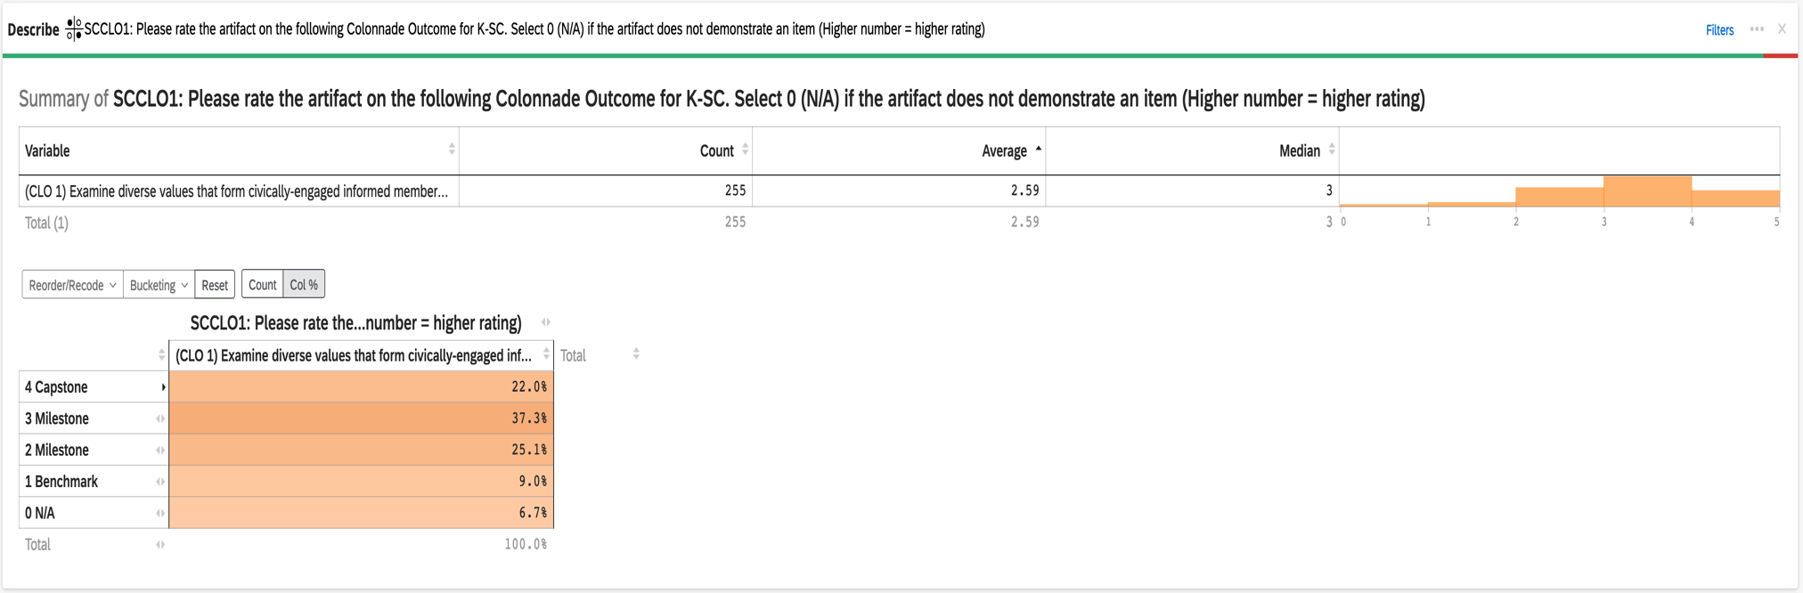
2022-23 Aggregate Data for Connections K-SC CLO #1: Examine diverse values that form civically-engaged informed members of society

2022-23 Aggregate Data for Connections K-SC CLO #2: Analyze the development of self in relation to others in society

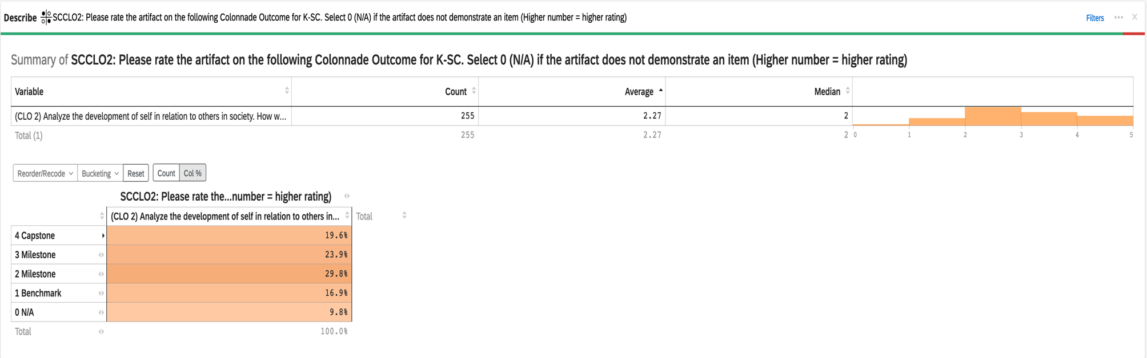

2022-23 Aggregate Data for Connections K-SC CLO #3: Evaluate solutions to real-world socio-cultural problems

