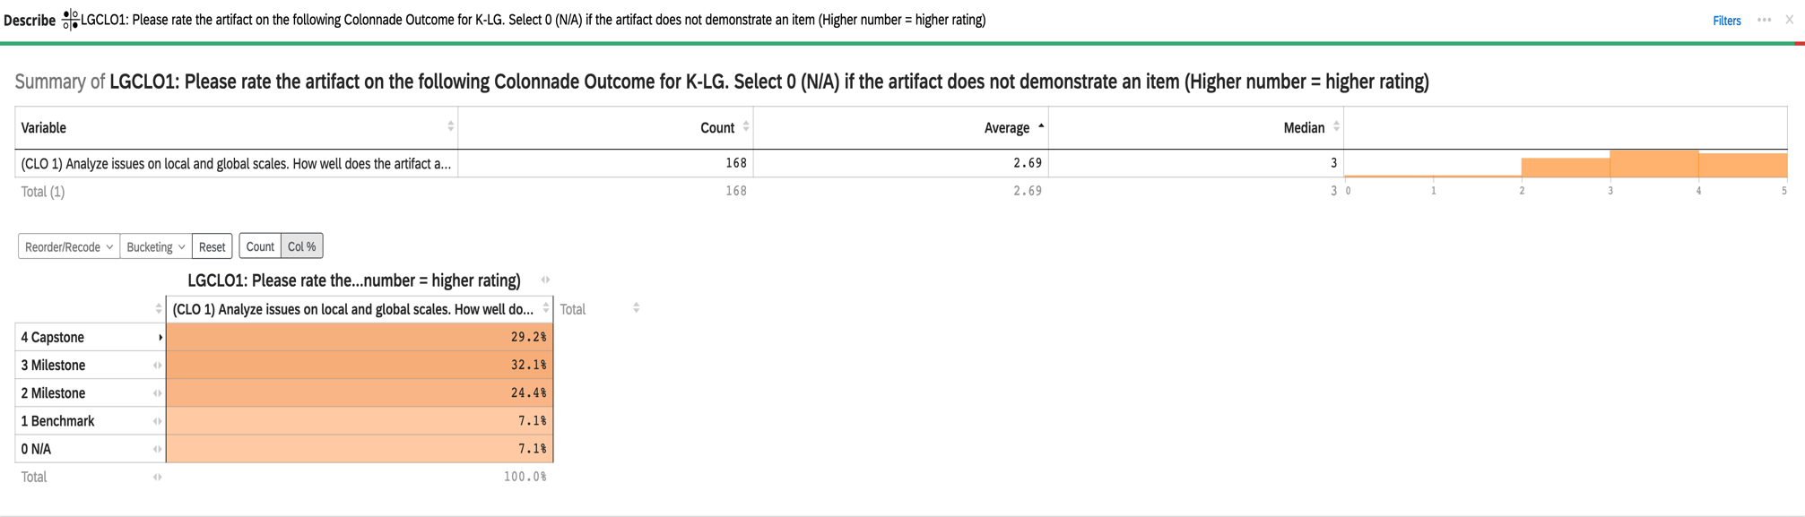
2022-23_Aggregate Data for Connections K-LG CLO #1: Analyze issues on local and global scales

2022-23 Aggregate Data for Connections K-LG CLO #2: Examine the local and global interrelationships of one or more issues

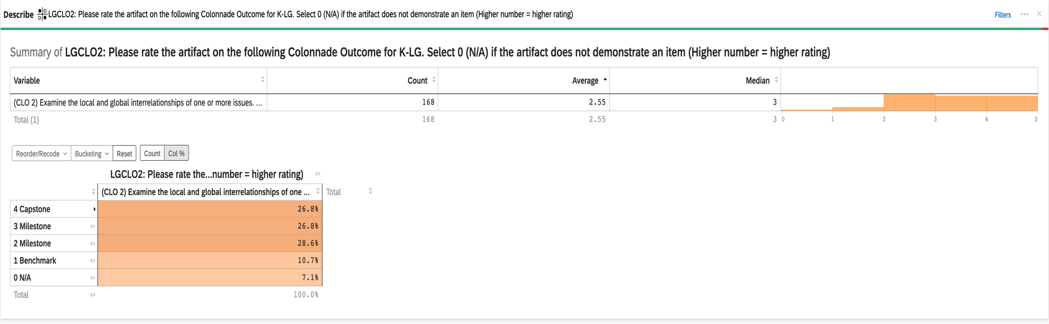

2022-23 Aggregate Data for Connections K-LG CLO #3: Evaluate the consequences of decision-making on local and global scales

