Chapter 4: Adjustments, Financial Statements, and Financial Results
Why Adjustments Are Needed
Accounting systems are designed to record most recurring daily transactions, particularly any involving cash. However, cash is not always received in the period in which the company earns the related revenue; likewise, cash is not always paid in the period in which the company incurs the related expense.
Solution: Adjustments are made to the accounting records at the end of the period to state assets, liabilities, revenues, and expenses at appropriate amounts.
Income Statement:
Revenues are recorded when earned.
Expenses are recorded in the same period as the revenues to which they relate.
Balance Sheet
Assets are reported at amounts representing the economic benefits that remain at the end of the period.
Liabilities are reported at amounts owed at the end of the period.
- Deferral Adjustments
An expense or revenue has been deferred if we have postponed reporting it on the income statement until a later period.
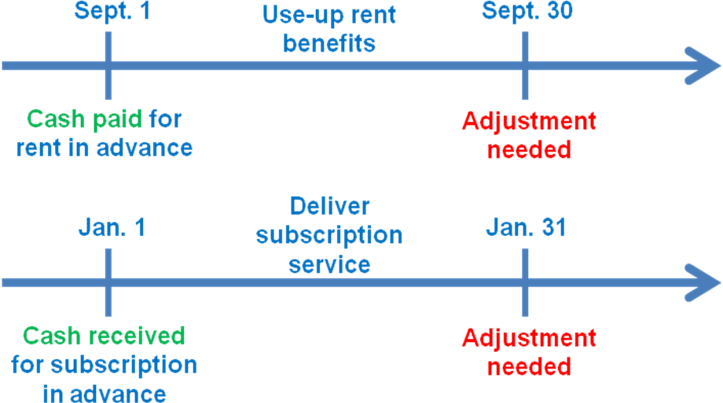
Deferral adjustments are used to decrease balance sheet accounts and increase corresponding income statement accounts.
Each deferral adjustment involves one asset and one expense account, or one liability and one revenue account.
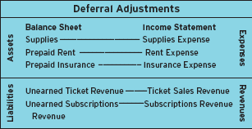

2. Accrual Adjustments
Accrual adjustments are needed when a company has earned revenue or incurred an expense in the current period but has not yet recorded it because the related cash will not be received or paid until a later period.
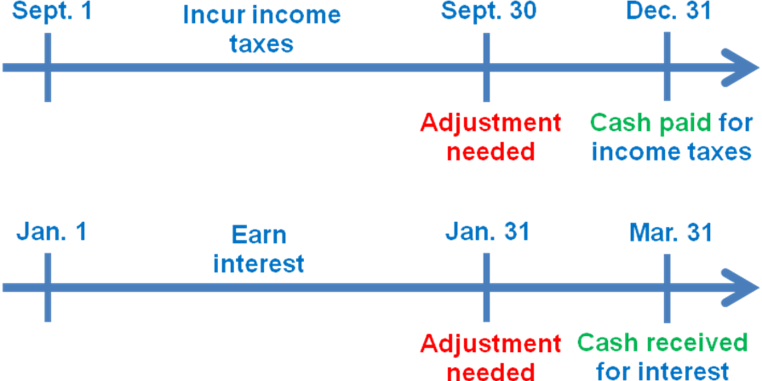
Accrual adjustments are used to record revenue or expenses when they occur prior to receiving or paying cash, and to adjust corresponding balance sheet accounts.
Each accrual adjustment involves one asset and one revenue account, or one liability and one expense account.
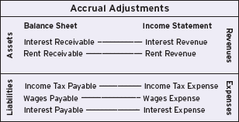

Making Required Adjustments
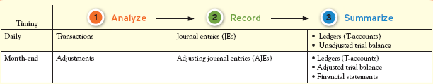
Adjustments are not made on a daily basis because it’s more efficient to do them all at once at the end of each period.

Adjustment Analysis, Recording and Summarizing
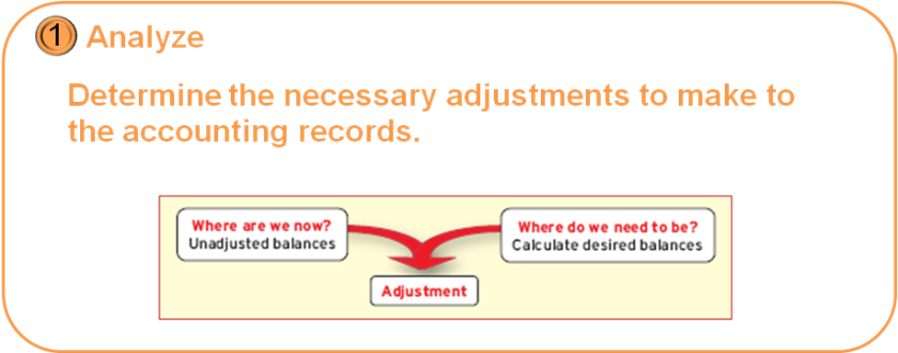
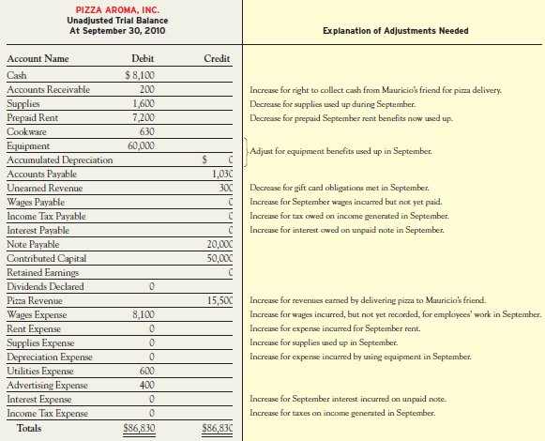

Deferral Adjustments
(a) Supplies used during the period.
Of the $1,600 in supplies received in early September, $400 remain on hand at September 30.
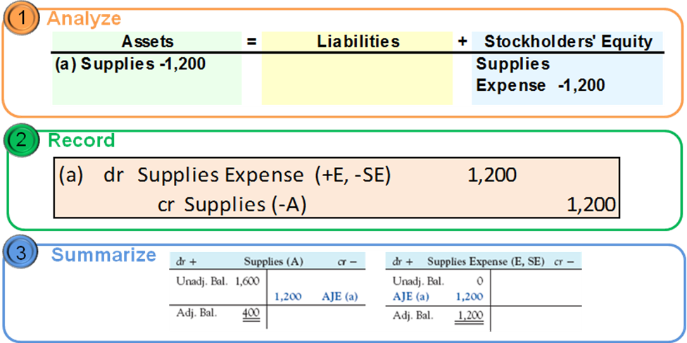
(b) Rent benefits expire during the period.
Three months of rent were prepaid on September 1 for $7,200, but one month has now expired, leaving only two months prepaid at September 30.
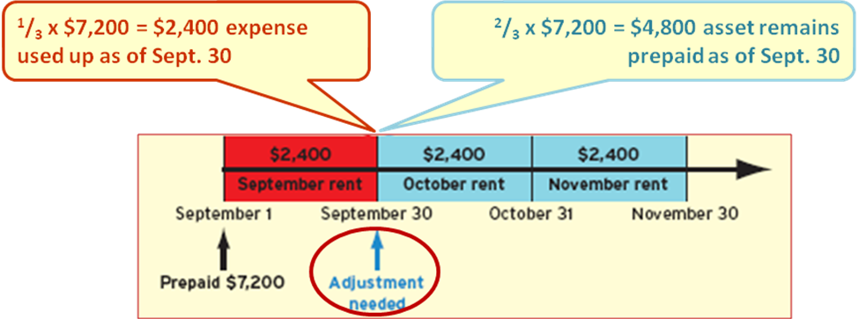

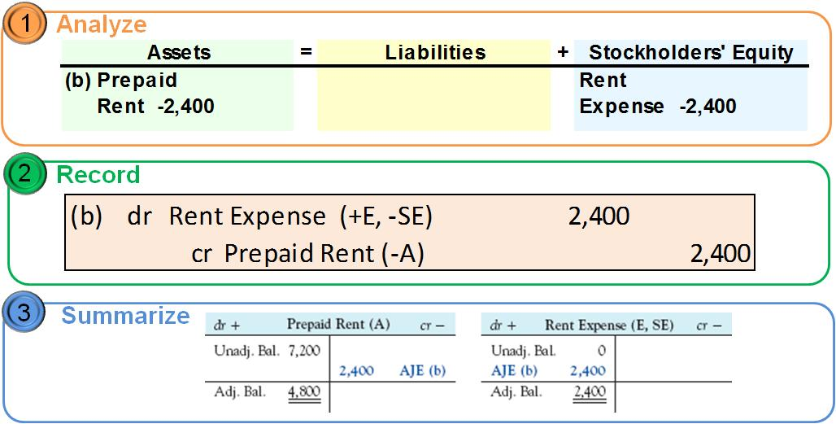

(c) Depreciation is recorded for use of equipment.
The restaurant equipment, which was estimated to last five years, has now been used for one month, representing an estimated expense of $1,000.
Depreciation is the process of allocating the cost of buildings, vehicles, and equipment to the accounting periods in which they are used.
A contra-account is an account that is an offset to, or reduction of, another account.
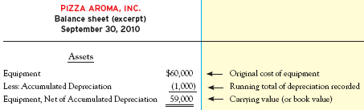
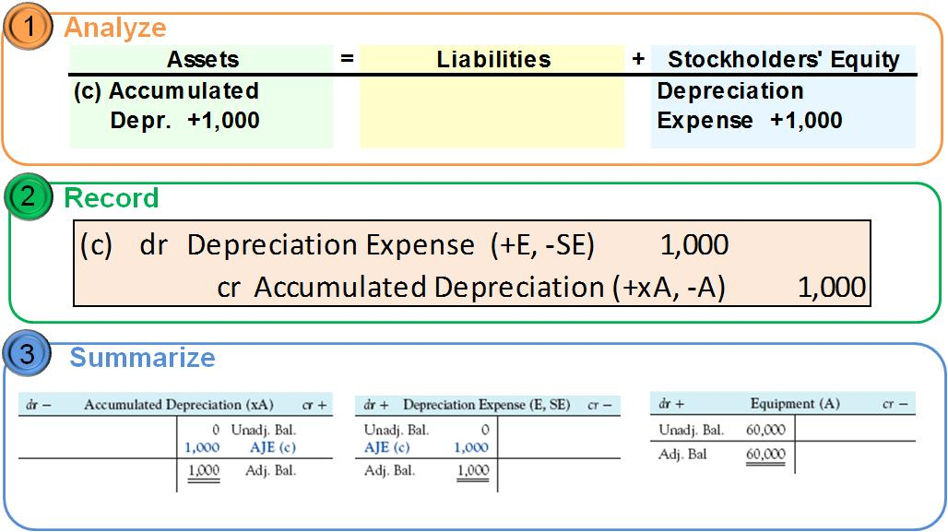
Depreciation
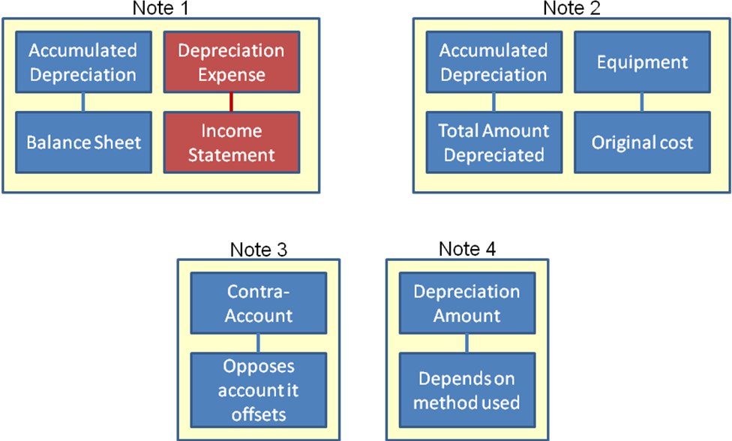
Deferral Adjustments
(d) Gift cards redeemed for service.
Pizza Aroma redeemed $160 of gift cards that customers used to pay for pizza.
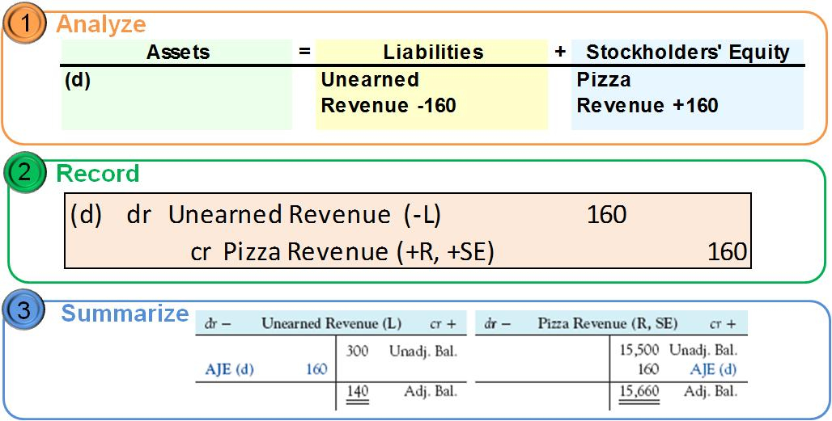
Accrual Adjustments
(e) Revenues earned but not yet recorded.
Pizza Aroma provided $40 of Pizza to Mauricio’s close friend on the last day of September, with payment to be received in October.
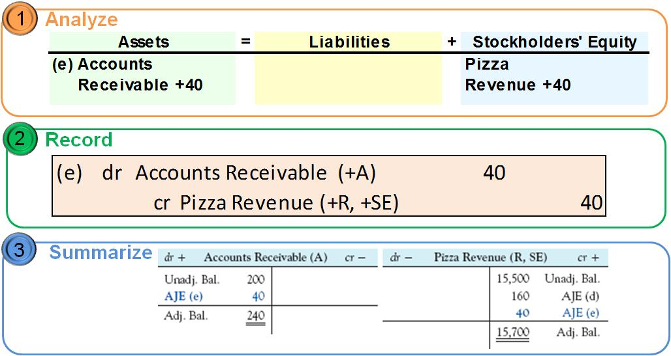
(f) Wages expense incurred but not yet recorded.
Pizza Aroma owes $900 of wages to employees for work done in the last three days of September.
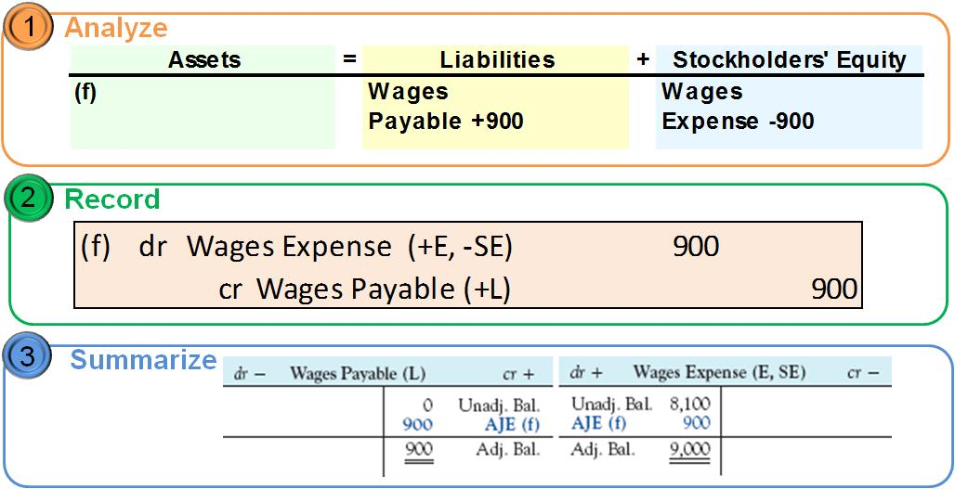

(g) Interest expense incurred but not yet recorded.
Pizza Aroma has not paid or recorded the $100 interest that it owes for this month on its note payable to the bank.
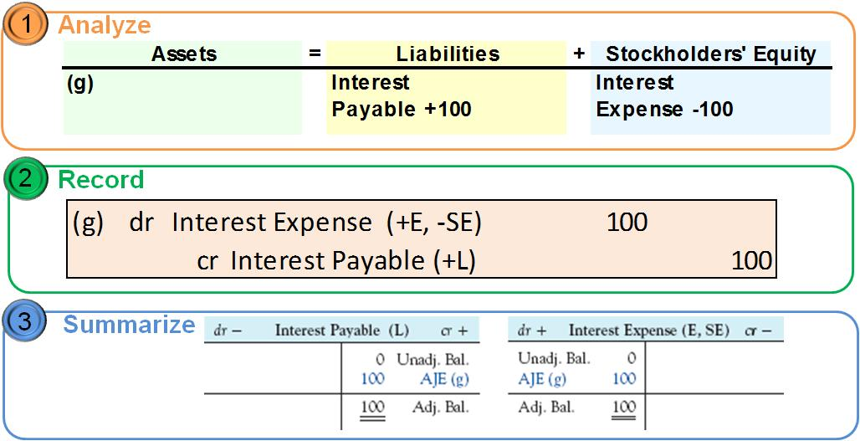

(h) Income taxes incurred but not yet recorded.
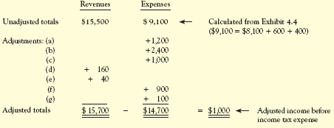
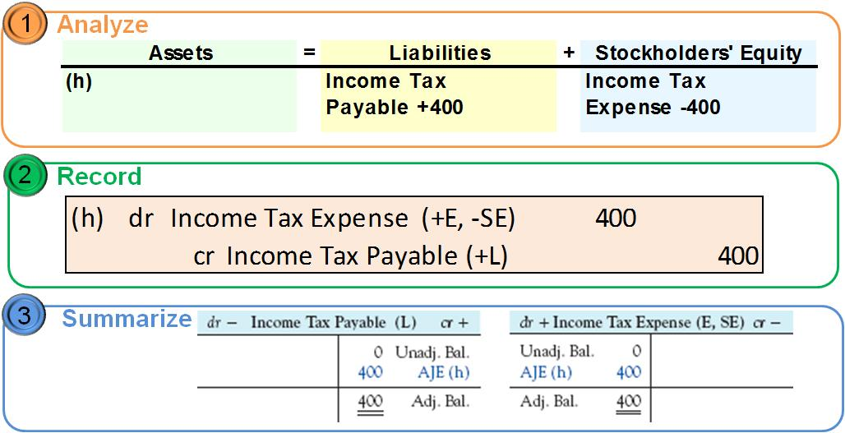
Additional Comments
Adjusting journal entries never involve cash.
Adjusting entries always include one balance sheet and one income statement account.
Dividends are not expenses. Instead, they are a reduction of the retained earnings.

Pizza Aroma’s Accounting Records
(i) Dividend declared and paid.
Pizza Aroma declares and pays a $500 cash dividend.
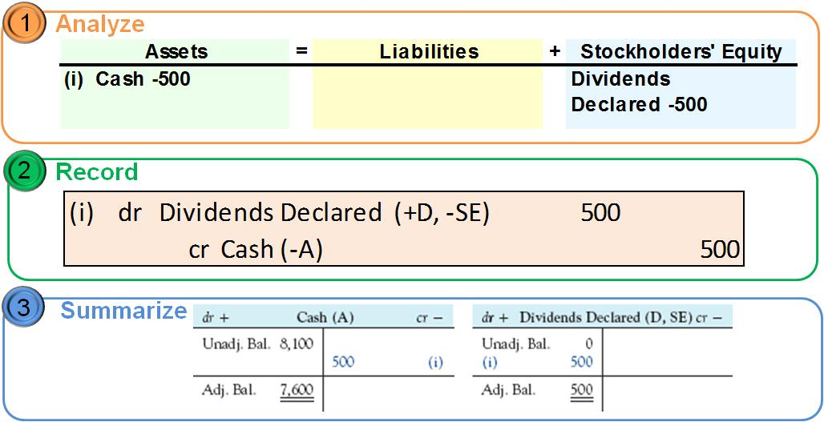

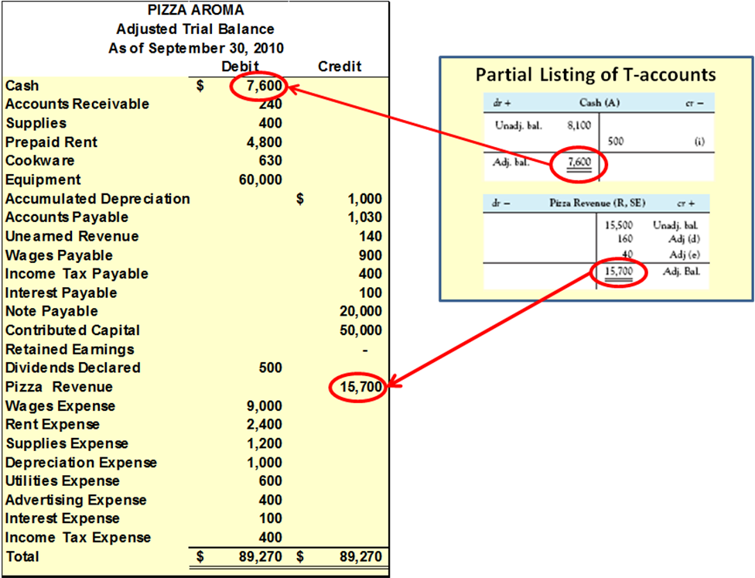

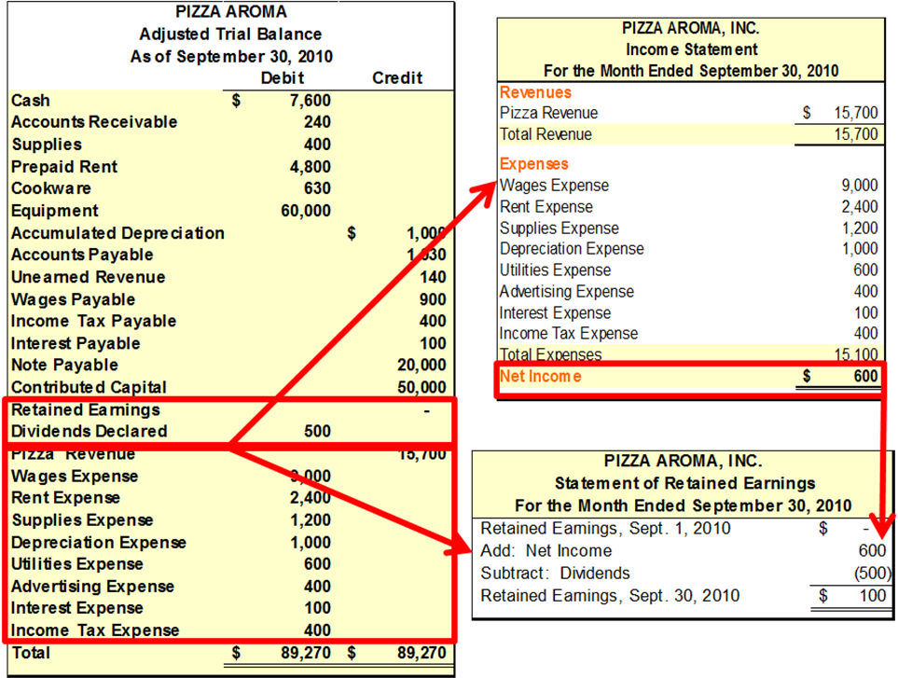

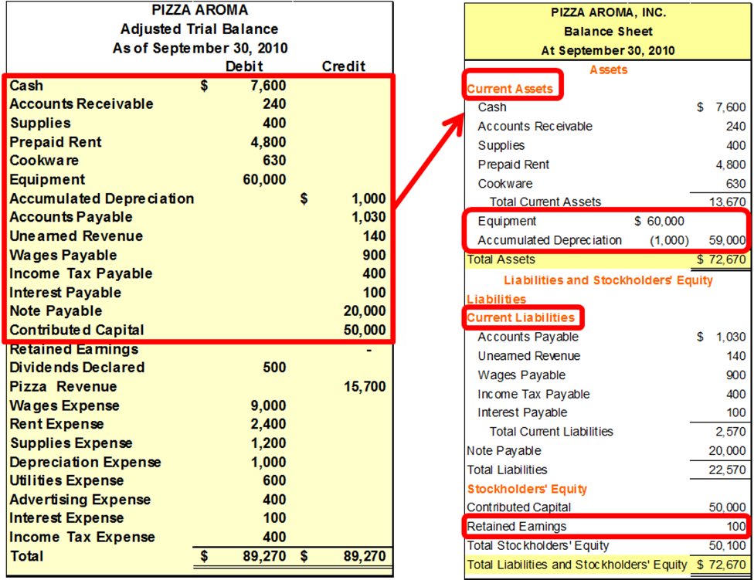
Closing Temporary Accounts
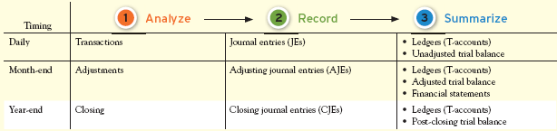
Transfer net income (or loss) and dividends to Retained Earnings.
Establish zero balances in all income statement and dividend accounts.
Temporary accounts track financial results for a limited period of time. (Revenues – Expenses – Dividends)
Permanent accounts track financial results from year to year. (Assets – Liabilities – Equity)
Two closing journal entries are needed.
- Debit Revenue accounts and credit Expense accounts. Debit or credit the difference to Retained Earnings.
- Credit Dividends Declared and debit Retained Earnings.
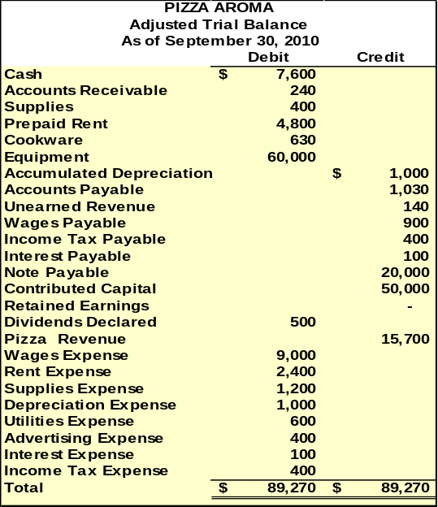
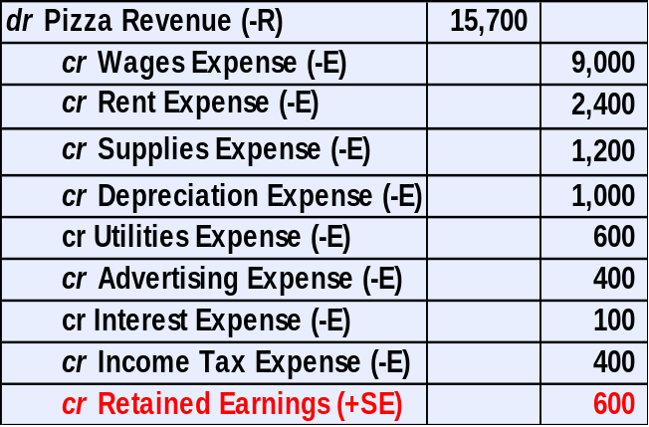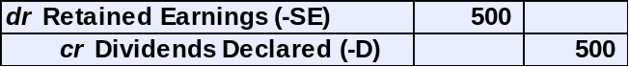

After posting these closing entries, all the income statement accounts and the dividend account will have a zero balance.
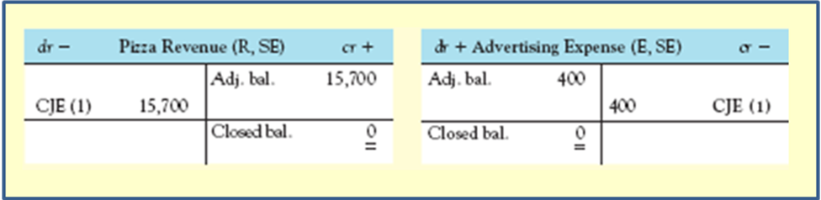
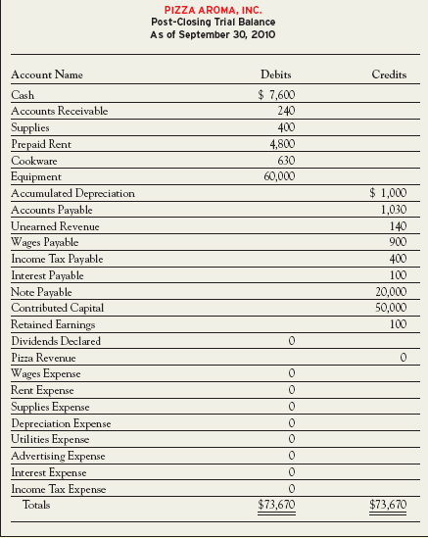
Post-Closing Trial Balance
Final check that all debits still equal credits and that all temporary accounts have been closed.
Contains balances for only permanent accounts.
Is the last step in the accounting process.

Adjusted Financial Results
Adjustments help to ensure that all revenues and expenses are reported in the period in which they are earned and incurred.
Without adjustments, the financial statements present an incomplete and misleading picture of the company’s financial performance.
Exercises
M4-5 Determine Accounting Equation Effects of Adjustments
For each of the following transactions for the Sky Blue Corporation, give the accounting equation effects of the adjustments required at the end of the month on December 31, 2009:
- Collected $1,200 rent for the period December 1, 2009, to February 28, 2010, which was credited to Unearned Rent Revenue on December 1, 2009.
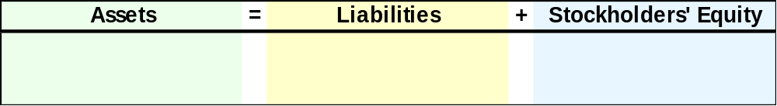

- Paid $2,400 for a two-year insurance premium on December 1, 2009; debited Prepaid Insurance for that amount.

- Used a machine purchased on December 1, 2009 for $48,000. The company estimates annual depreciation of $4,800.
M4-6 Recording Adjusting Journal Entries
Using the information in M4-5, prepare the adjusting journal entries required on December 31, 2009.
M4-9 Preparing Journal Entries for Deferral Transactions and Adjustments
For each of the following independent situations, prepare journal entries to record the initial transaction and the adjustment required at the end of the month indicated.
- Hockey Helpers paid $2,000 cash on September 30, to rent an arena for the months of October and November.
- Super Stage Shows received $6,000 on September 30, for season tickets that admit patrons to a theatre event that will be held twice (on October 31 and November 30).
- Risky Ventures paid $3,000 on September 30, for insurance coverage for the months of October, November, and December.
M4-10 Preparing Journal Entries for Deferral Transactions and Adjustments
For each of the following independent situations, prepare journal entries to record the initial transaction and the adjustment required at the end of the month indicated.
- Magnificent Magazines received $12,000 in December 2010 for subscriptions to magazines that will be published and distributed in January through December 2011.
- Walker Window Washing paid $1,200 cash for supplies on September 1. As of September 30, $200 of these supplies had been used.
- Cartway Racing received $3,000 in September from race participants, for three races. One race is held October 31, and the other two will be held in November.
M4-18 Preparing and Posting Adjusting Journal Entries
At December 31, the unadjusted trial balance of H&R Tacks reports Prepaid Insurance of $7,200 and Insurance Expense of $0. The insurance was purchased on July 1 and provides coverage for 12 months. Prepare the adjusting journal entry on December 31. In separate T-accounts for each account, enter the unadjusted balances, post the adjusting journal entry, and report the adjusted balance.
E4-18 Analyzing, Recording, and Summarizing Business Activities and Adjustments
The following transactions relate to a magazine company called My Style Mag (MSM).
Required: For each event a–f, complete the three missing items using your understanding of the relationships among: (1) business activities, (2) accounting equation effects, (3) journal entries, and (4) T-accounts.
Event a
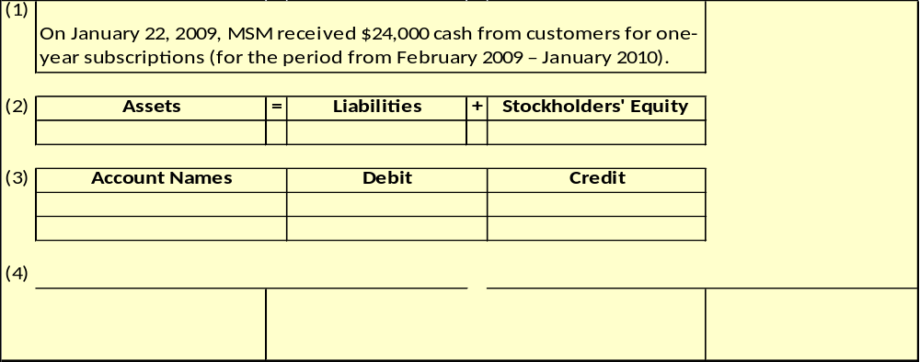

Event b
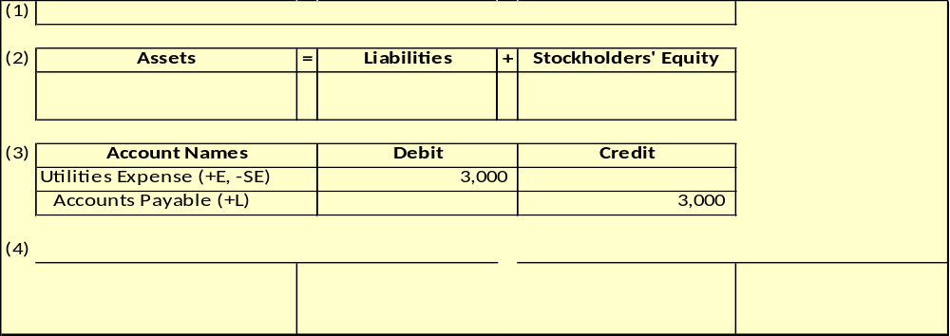

Event c
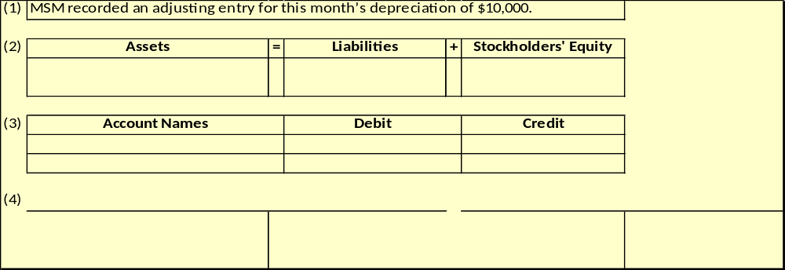

Event d
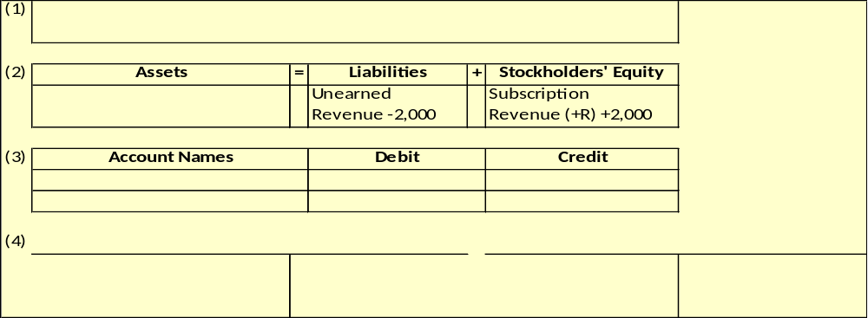

Event e
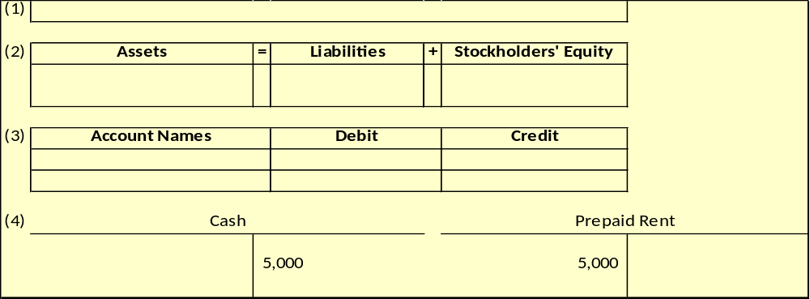

Event f


